How are Pauli parameters inferred from syndromes?

A Pauli qubit channel is defined by 4 probabilities: pI, pX, pY, pZ. Pauli qubit channels act as binary symmetric channels when inputs are the eigenstate of the Pauli operator.

In the X-basis:

$ϵ_{X}​=p_{Y}​+p_{Z}​$

${1-ϵ}_{X}​=p_{X}​+p_{I}​$

So by measuring syndromes in each basis, we can estimate $ϵ_{X}$, $ϵ_{Y}$, $ϵ_{Z}$

The relation between these error rates and Pauli parameters can be written as a matrix equation:

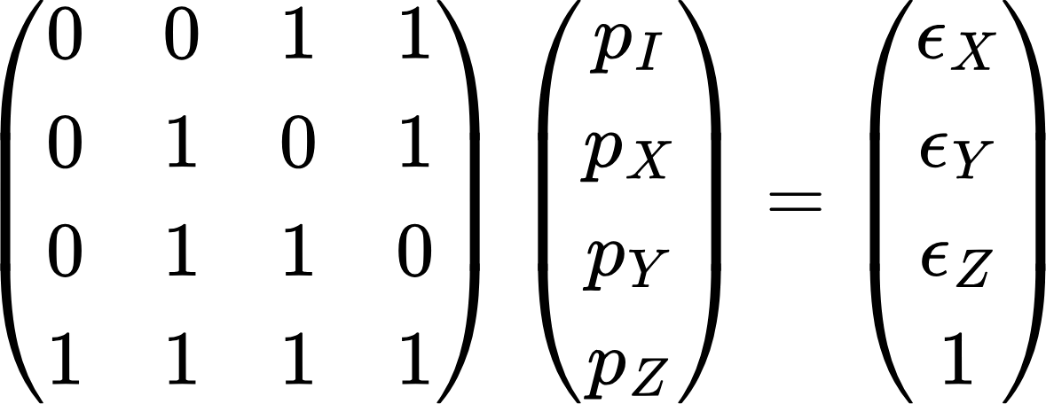

This equation can be solved for $p_{X}, p_{Y}, p_{Z}, p_{I}$. So each Pauli probability is just a linear combination of the observed error rates.