|  |  |
| --- | --- |
| **Deutsches Zentrum für Luft- und Raumfahrt e.V**. |  |

Optimized Trajectories of SpaceLiner 7-3

DRAFT



**Deutsches Zentrum für Luft- und Raumfahrt e.V.**

**SART TN-003/2018**

Sholto Forbes-Spyratos

Optimized Trajectories of SpaceLiner 7-3

DRAFT

Dieser Bericht enthält:

14 Seiten einschl.

19 Abbildungen

0 Tabellen

10 Literaturzitate

**22/03/2018 4:52:00 PM**

**Deutsches Zentrum für Luft- und Raumfahrt e.V.**

**Institut für Raumfahrtsysteme**

**Systemanalyse Raumtransport (SART)**

**28359 Bremen**

**Überblick**

**Stichworte:**

**Abstract**

**Keywords:**

**INHALT**

1 Introduction 1

1.1 Vorgehensweise 1

2 Summary 2

3 References 3

**ABBILDUNGSVERZEICHNIS**

**Es konnten keine Einträge für ein Abbildungsverzeichnis gefunden werden.**

**TABELLENVERZEICHNIS**

**Es konnten keine Einträge für ein Abbildungsverzeichnis gefunden werden.****Nomenklatur**

**Formelzeichen**

|  |  |  |
| --- | --- | --- |
| H | Flughöhe | km |
| M | Machzahl | - |
| T | Temperatur | K |
| q | Wärmestromdichte | W/m2 |
| α | Anstellwinkel | ° |
| ε | Emissionskoeffizient | - |

**Abkürzungen**

|  |  |
| --- | --- |
| CFD | Computational Fluid Dynamics |
| TPS | Thermal Protection System |
|  |  |
|  |  |

# Introduction

To maximise the effectiveness of the SpaceLiner passenger transport, a wide range of mission profiles must be identified. Some mission profiles run the risk of overflying populated areas, which can jeopardise the viability of certain routes. The SpaceLiner will be flying at supersonic and hypersonic speeds, potentially causing significant sonic booms at ground level. High overpressure caused by sonic booms can cause irritation to the overflown populace, or even significant damage to property, and in extreme cases, cause actual bodily harm. To avoid this, the SpaceLiner must avoid populated areas when flying at high speeds, or if it is not possible to route around population centres, fly at high altitudes to remove the potential effects of the sonic boom on the ground. However, flying a trajectory which avoids producing sonic booms over populated areas can be problematic. The SpaceLiner is subject to design constraints of dynamic pressure, heat load and acceleration limits imposed by the vehicle design, and consideration of the comfort of the passengers and crew.

The purpose of this study is to investigate a variety of mission profiles in which the flyover of populated areas is likely. A trajectory optimisation is developed to find a trajectory which minimises the impact of population flyover, while adhering to the strict design limitations of the SpaceLiner.

This study investigates mission profiles connecting east Asia to Europe, with the aim of identifying a suitable launch site which is easily reachable by a large surrounding population. This is complicated by the geography of east Asia, as well as the extremely high populaton density of the region.

## Vorgehensweise

This study calculates the trajectory of each mission using optimal control theory. A control law is found which solves a generic constrained optimisation problem which is posed as follows:

$$\min{J\left(x\right)= \int_{t_{0}}^{t_{f}}{L\left(t,x\left(t\right),u(t)\right) dt }+Φ(t_{0},x\left(t_{0}\right),t_{f},x\left(t_{f}\right))}$$

Subject to the dynamic constraints of the system:

$$\dot{x}=f\left(t,x\left(t\right),u(t)\right)$$

The path constraints:

$$C_{min}≤C\left(t,x\left(t\right),u(t)\right) ≤C_{max}$$

And the boundary constraints:

$$ϕ_{min}≤ϕ\left(t,x\left(t\right),u(t)\right) ≤ϕ_{max}$$

Solving the optimal trajectory problem requires the physical problem to be transcribed into a form which is solvable by a generic optimal control solver. This study utilises the pseudospectral method of transcribing the optimal control problem, which is then solved using a sequential quadratic programming (SQP) solver. The pseudospectral method, or global orthogonal collocation method, approximates the state and control variables as polynomials, collocated at specified nodes. More information on the pseudospectral method can be found in refs X. To solve the optimal control problem, the proprietary pseudospectral solver GPOPS-2 is used. GPOPS-2 takes inputs of the vehicle model, cost function, and system bounds, and computes a minimum cost trajectory.

The simulation is performed in a 6 degree of freedom geodetic rotational reference frame {REF}. The lift and drag coefficients are taken from the SpaceLiner aerodynamic reference database {REF}.

The physical dynamics of the system in GPOPS-2 are defined as ‘states’. These states are the time-variant physical characteristics of the system (altitude, velocity, mass etc.). The vehicle model in GPOPS-2 must take an input of the current states, and output the corresponding time derivatives of the states. GPOPS-2 then solves the optimisation problem, so that the derivatives of the approximated states are equal to the time derivatives calculated by the vehicle model.

The cost function used to drive the optimisation is:

$$C=\int_{t_{0}}^{t_{f}}{\frac{\left({alt}_{target}-alt\right)}{c_{1}}P(lon,lat,alt)+\frac{\dot{Q}}{c_{2}} dt}$$

A 2020 estimated population density distribution map is used as the primary driving cost factor. This is imported as a GeoTiff at 2’30” resolution. The population density cost is scaled by altitude so that the population cost goes to 0 at 80km altitude, and increases linearly as altitude decreases. This drives the optimisation to keep the altitude of the SpaceLiner as high as possible over populated areas, if flying over population is unavoidable.

The secondary cost factor of heating rate minimises the integrated heating at any point where the SpaceLiner is not flying over populated areas. The weighting factors $c_{1}$ and $c_{2}$ have been used to scale the problem for numerical stability, and to weight the parts of the cost function. The heating rate cost has been weighted so that it is negligible compared to the population density cost, when flying over populated areas. When the population flyover is zero, the heating rate is then minimised.

At discrete times, the thrust of the SpaceLiner is reduced, to avoid exceeding the 2.5g maximum constraint on the vehicle. To reduce the thrust of the booster, six of the engines of the booster are turned off sequentially. During the ascent portion of the orbiter trajectory, the maximum acceleration limit is increased to 3g, a necessity as the mass of the orbiter decreases due to fuel usage. The orbiter is effectively throttled by changing the mixture ratio from 6.5 to 5.5, reducing the thrust force. The times for these reductions in thrust are determined within the optimisation routine. Each thrust magnitutde is presented to GPOPS-2 as a separate, sequential phase, with a minimum 1 second operational time.

The heating rate is limited to 1.3MW/m2, the maximum heating flux limit of the SpaceLiner, which is based on the observed maximum heating rates in the reference Australia-Germany trajectory. The descent portion of the trajectory is limited to negative flight path angle, to remove the possibility of ‘skipping’ manoeuvres which may be detrimental to passenger comfort.

GPOPS-2 is initiated using an initial guess of each state, within each phase. This initial guess is used to provide GPOPS-2 with a starting point from which to optimise, and to initially scale the problem. The initial guess does not need to be particularly close to the optimal solution, but it is necessary for it to be close to the correct scale for each state.

# Results

-make sure to mention amount of fuel left

## Australia – Germany Connection

The baseline mission of an Australia to Germany connection is optimised using GPOPS-2 to compare the efficacy of the solution calculated by GPOPS-2 to the existing solution, calculated using TOSCA and SpaceLiner Entry Guidance {REF}. This mission is flown from Rockhampton, Queensland, Australia towards the German North Sea coast.

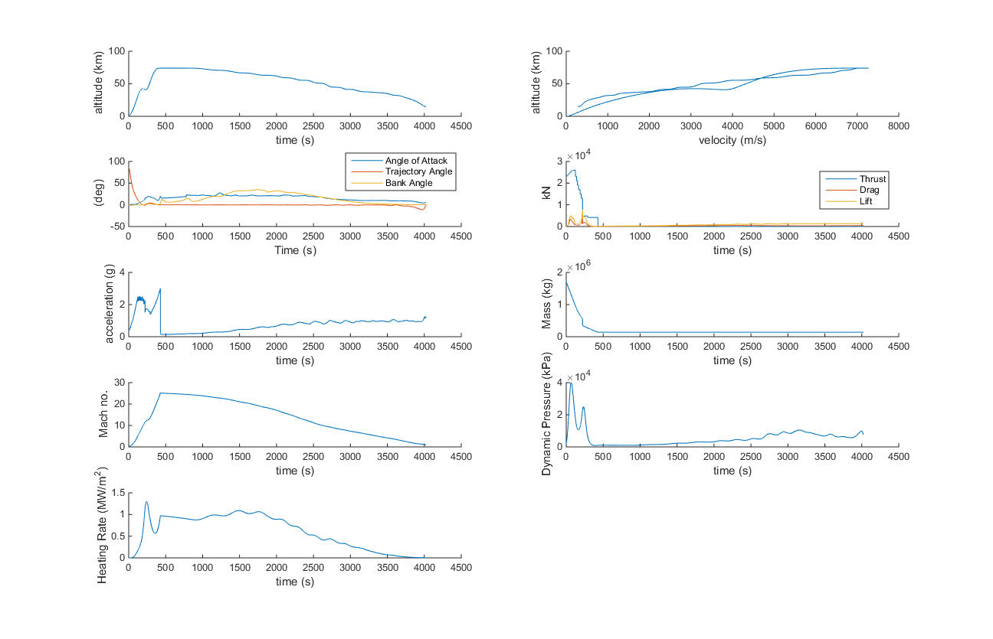

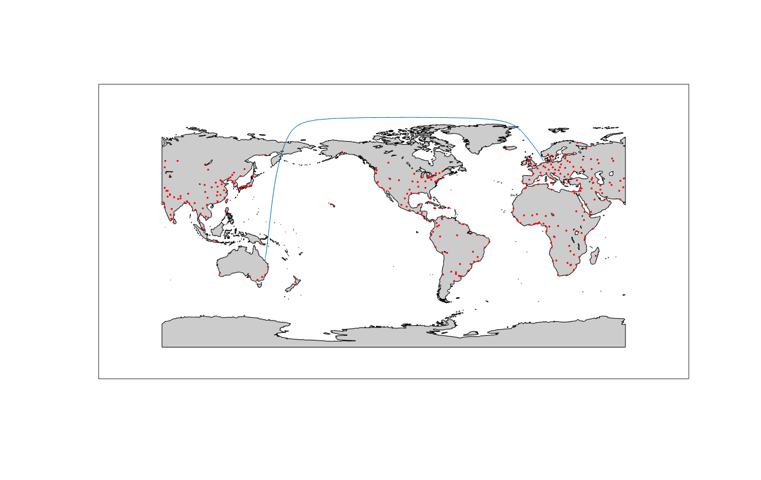

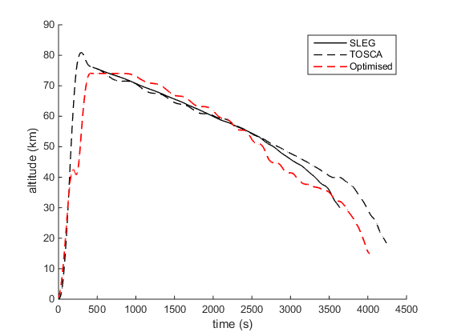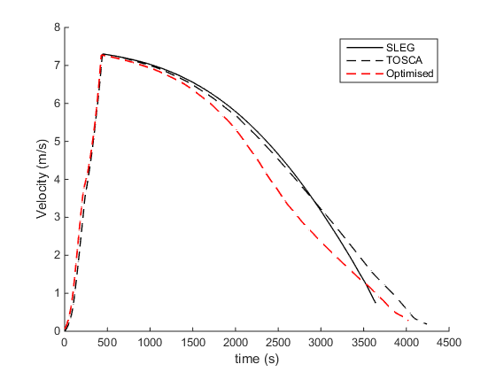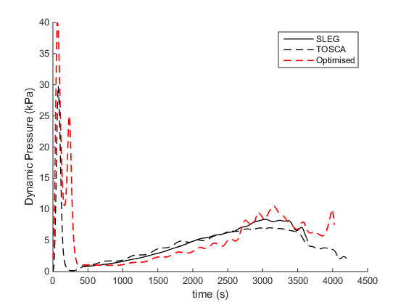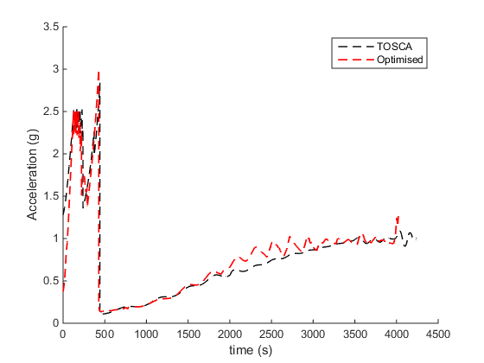

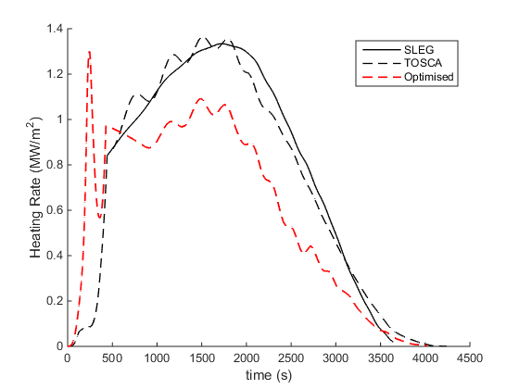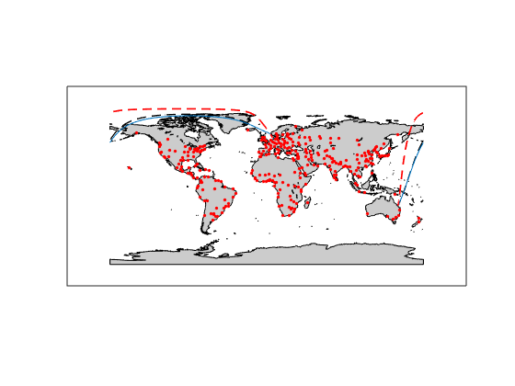

## North Korea – Germany Connection

## Germany – North Korea Connection

## Japan – Germany Connection

## Germany – Japan Connection

# Summary

# References

1. Reisch, U., Streit, T.: Surface Inclination and Heat Transfer Methods for Reacting Hypersonic Flow in Thermomechanical Equilibrium, DLR-AS, DLR IB 129-96/10, August 1996