Mission Analysis of a Rocket-Scramjet-Rocket System for Small Satellite Launch

Sholto O. Forbes-Spyratos, Michael P. Kearney, Michael K. Smart and Ingo H. Jahn

**Introduction**

A largely reusable launch system featuring a scramjet accelerator has the potential to significantly decrease the costs of small satellite launches. One such system is being developed at The University of Queensland, consisting of a reusable first stage rocket, a reusable second stage scramjet, and a disposable third stage rocket. The airbreathing section of this system has been designated the Scramjet Powered Accelerator for Reusable Technology AdvaNcement (SPARTAN). The first stage booster is the Austral Launch Vehicle (ALV) being developed by Heliaq Advanced Engineering. The aim of the current work is to develop an optimal trajectory for small satellite launches utilising this rocket-scramjet-rocket system.

**First Stage Optimisation**

The application of trajectory optimisation to this system allows for an optimal flight path to be calculated, which is necessary for informed vehicle design. The trajectory of the first stage is simulated utilising the multiple shooting method to attain the best trajectory. The multiple shooting method is a direct optimal control technique which separates a trajectory into discrete shooting segments. These shooting segments are initially discontinuous, allowing an optimisation solver flexibility to converge on an optimal solution. Multiple shooting has been chosen for the first stage due to its robustness and stability compared to simpler optimal control techniques such as single shooting. An optimal trajectory is produced for the first stage, so that the conditions necessary for second stage operation (Mach 6 and 50kPa dynamic pressure) are reached, while minimising structural stresses on the first stage vehicle. So far the multiple shooting routine has been completed for a generic first stage, and the aerodynamic coefficients of the combined system are being developed.

**Second Stage Optimisation**

The second stage trajectory is optimised using an existing pseudospectral method routine. This routine was previously used to optimise the trajectory of a larger scale SPARTAN vehicle, producing the results shown in Figures 1 and 2. Producing a solution for a reduced scale SPARTAN requires simple modification of the vehicle model, and implementation of the new third stage simulation.

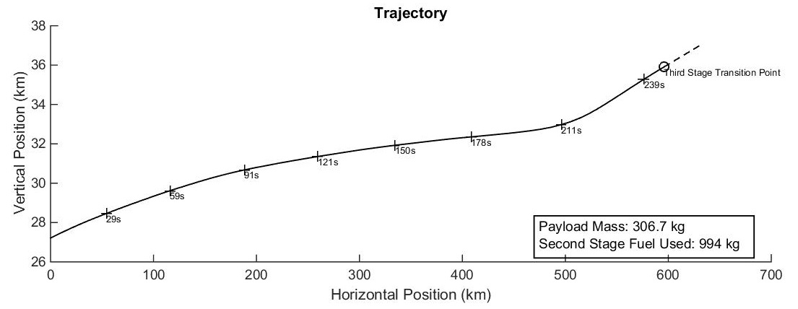

Figure 1: 45kPa limited trajectory of a larger scale SPARTAN vehicle. This trajectory has been produced using a pseudospectral optimal control solver.

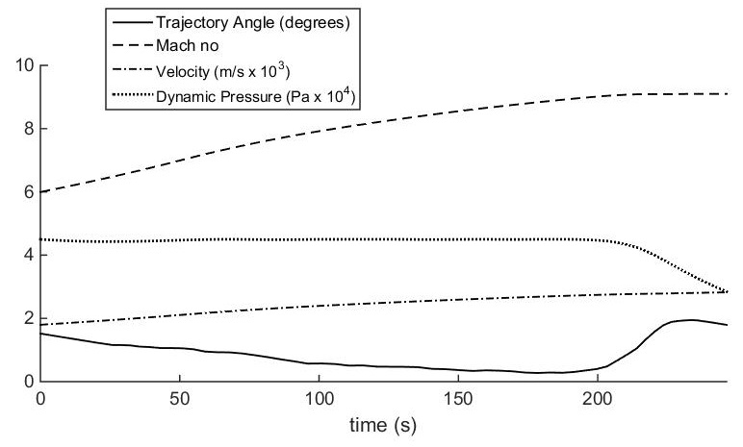

Figure 2: Trajectory information for the 45kPa limited trajectory of a larger scale SPARTAN vehicle.

**Third Stage Optimisation**

The third stage rocket trajectory is to be optimised utilising a combination of direct single shooting and linear tangent guidance. Direct single shooting is a simple discretisation of the vehicle controls solved in an optimisation solver to produce an optimal trajectory. This was chosen due to the simplicity of the third stage optimal control problem, and due to its high computational efficiency compared to more complex methods. Linear tangent guidance is a well-known solution to exoatmospheric rocket trajectories and will be used once the third stage vehicle has reached sufficiently low dynamic pressure. This routine is currently being verified using a test rocket system of smaller scale, with a three stage rocket test shown in Figure 3.

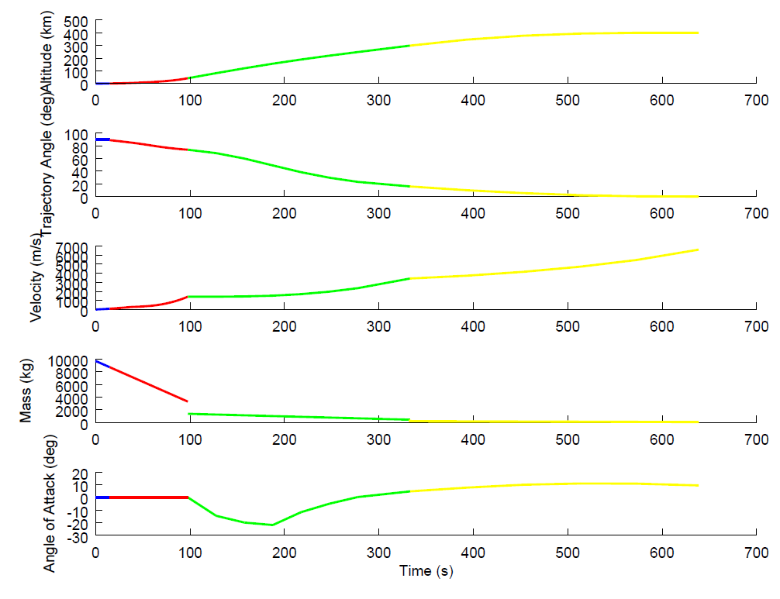

Figure 3: Current single shooting method optimal trajectory result, as applied to a three stage rocket (stages denoted by coloured intervals). Note: no lift coefficients are present leading to large angles of attack.

**Mission Analysis**

Combining these results produces a three stage trajectory simulation. Currently the starting point of the second stage is fixed to ensure optimum scramjet operation, and to provide a reference point for the first stage optimisation. This framework can be used to analyse the launch system performance for various operating requirements. Coupling the different trajectory components is essential to demonstrate the viability of the overall system. In addition previous work has shown that this can also lead to overall performance improvements

Furthermore, this paper will utilise the trajectory simulation developed to present an analysis of a variety of orbital insertion missions for which the use of this small payload launch system may be advantageous. This analysis covers single launches, launches with short response time and constellation launches.

**Conclusion**

Optimal trajectories are to be developed for a partially reusable, partially airbreathing launch system. These trajectories will allow the analysis of the launch mission, and the assessment of the suitability of the launch system for small satellite launches.