GPOPS-2: Evaluate Optimality in IPOPT [2.2]
6DOF Dynamics [4.2.1]

GPOPS-2: Evaluation of Trajectory Iteration $k$ [2.2]

Aerodynamic Databases [3.1.3, 3.2.1, 3.3.3]

Vehicle Models [3]

C-REST Engine Model [3.1.2]

Iteration $\left({t_{k},x}_{k},u_{k}\right)$
Vehicle
Aerodynamics
Propulsion Properties
Scramjet
Thrust
Scramjet
Fuel
Flow
Constraint
Violations
Conical Shock Model [3.1.2]

Engine Inlet
Conditions
Inputs [4.3]

Atmospheric Data

Initial Guesses
Third Stage Unpowered Ascent and Hohmann Transfer Simulation [4.3.7 - 4.3.8]
Integrated Cost (if applicable): $\int_{t_{0},k}^{t_{f},k}{P\left(x_{k},u_{k}\right)}dt$

Cost: $J\left({t_{k},x}_{k},u_{k}\right)=M\left({t_{f,k},x}_{f,k},u_{f,k}\right)+\int_{t_{0},k}^{t_{f},k}{P\left(x_{k},u_{k}\right)}dt$

Rocket Engine Models [3.2, 3.3]

Rocket
Thrust
Rocket
Fuel
Flow
Endpoint Cost (Payload Mass):
$$M\left({t_{f,k},x}_{f,k},u_{f,k}\right)$$

Aerodynamic
Coefficients
Derivatives: ${\dot{x}}_{k}$

Path Constraints: $λ\left({t_{k},x}_{k},u_{k}\right)≤0$

Event, Path and Bound Constraints

States and Controls

Optimised Solution Analysis [4.4]

Output

Optimised Solution

Most Accurate Solution

Initiation of Parallel Loop

Termination of Parallel Loop

Nodes
New Iteration k

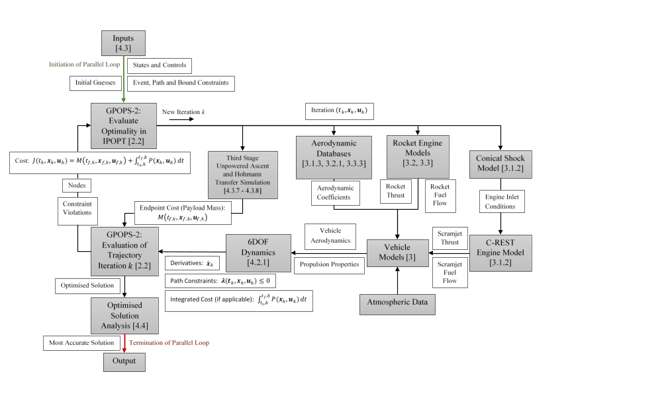

Trajectory Solution Node Mesh
Vehicle Dynamics
Payload-to-Orbit

Constraints
Cost

Updated Solution
4
3
2
1
IPOPT
LODESTAR
Optimal Solution
GPOPS-2

