Task Completion/Findings

Starting Docker—PostgreSQL setup (Running demo)
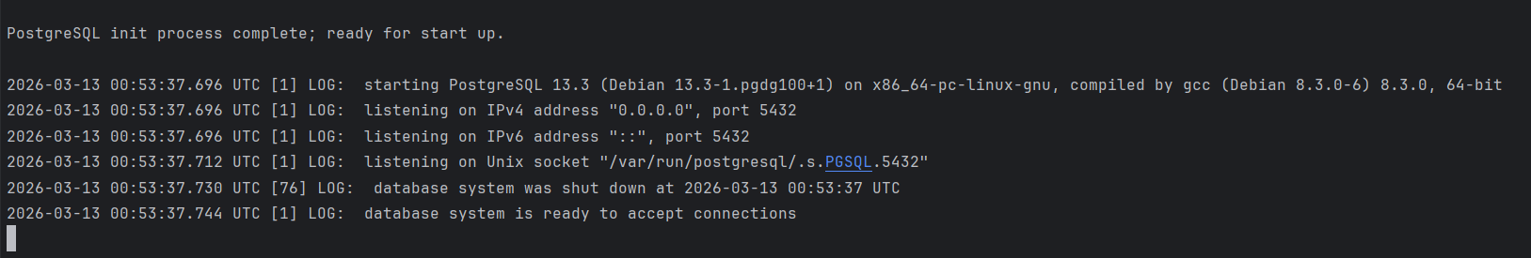
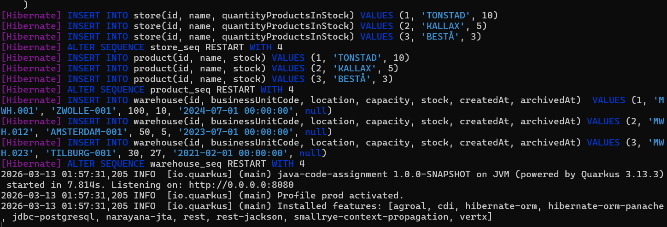
Task 1 — LocationGateway.resolveByIdentifier
- Implemented lookup using Java Streams.
- Chose IllegalArgumentException for now; will replace with domain-specific exception if available.
- Verified that LocationGateway uses an in-memory list, not a database.
- This method is required for Warehouse creation and replacement validations.

After code changes- Postman test results

For Store- endpoints

POST
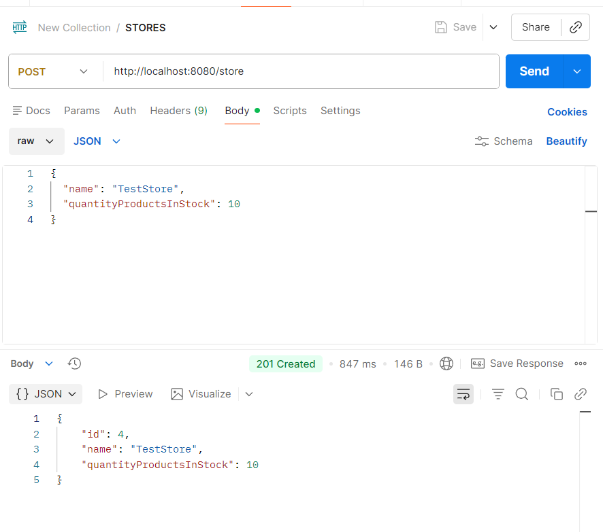

GET ALL
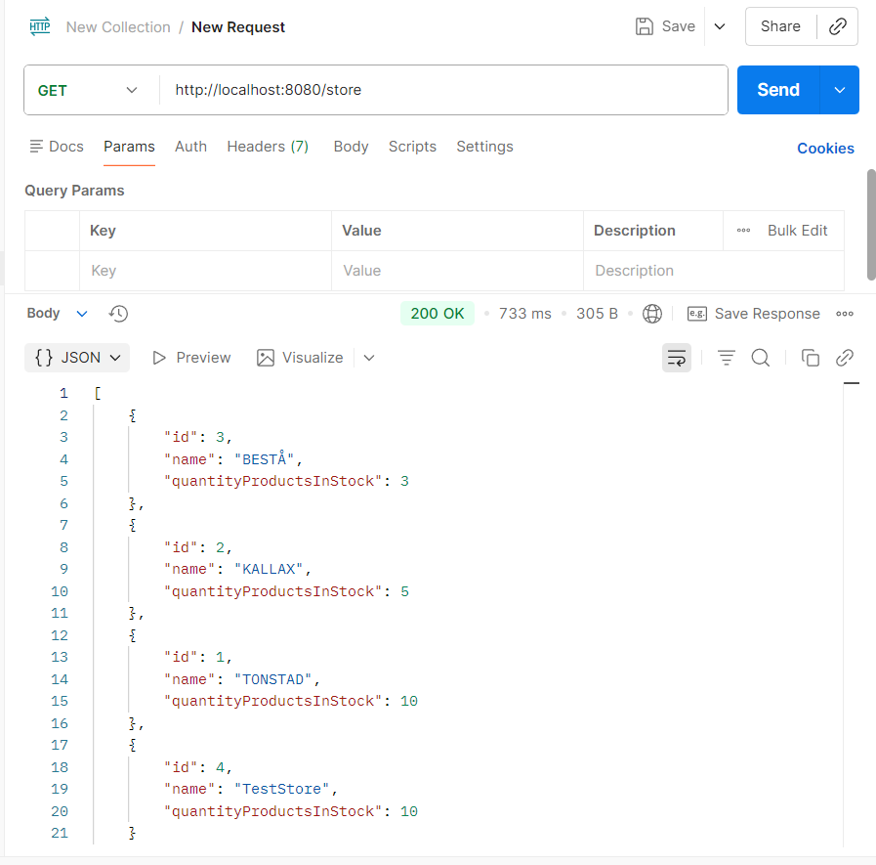

PUT
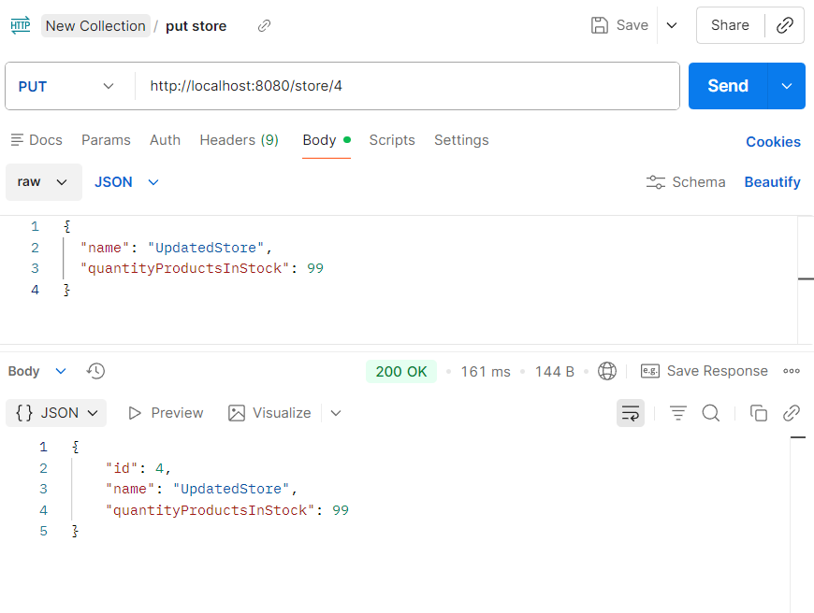

PATCH
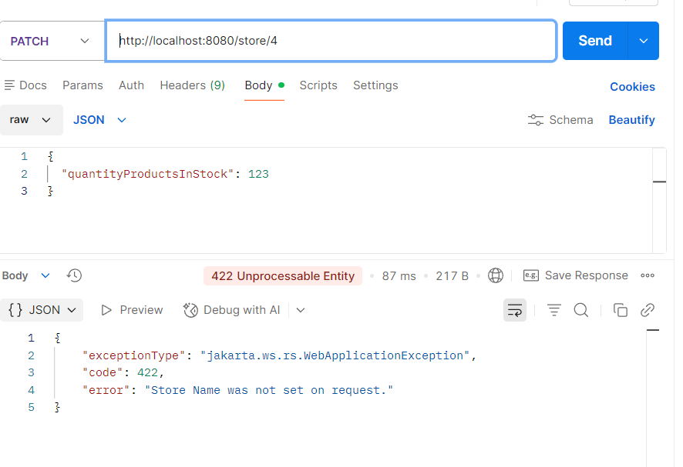

DELETE
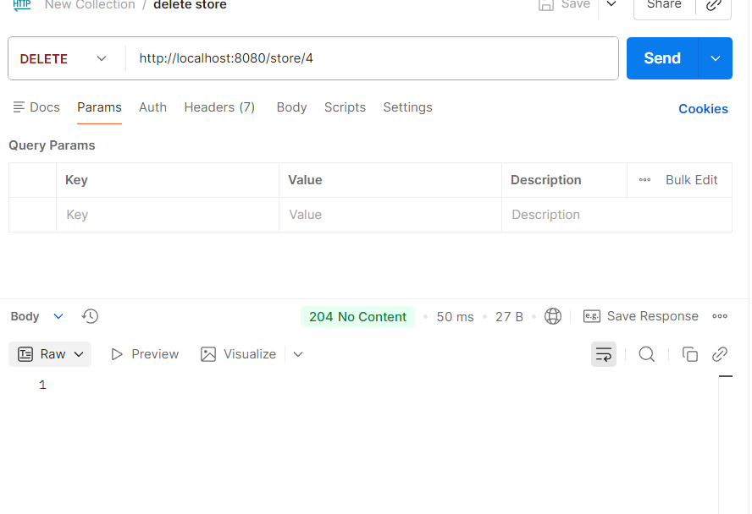

LEGACY GATEWAY AFTER COMMIT
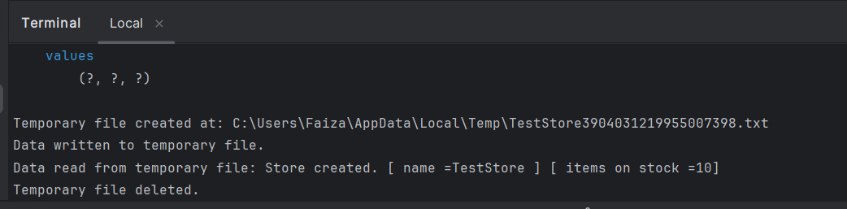

For WAREHOUSE
Changes opted:
replaced archive(Warehouse warehouse) with archive(Long id) because:
- API deletes warehouses by ID
- Use cases should accept the minimal input needed
- Passing a full Warehouse object breaks clean architecture
- IDs are the correct identifier for deletion
- The assignment does not forbid this and replace logic still uses BU code exactly as required

POST
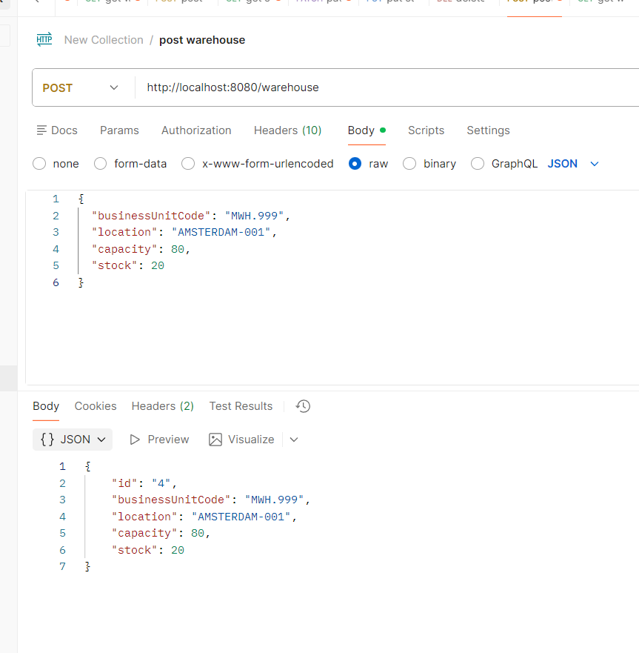

POST WITH CAPACITY ERROR
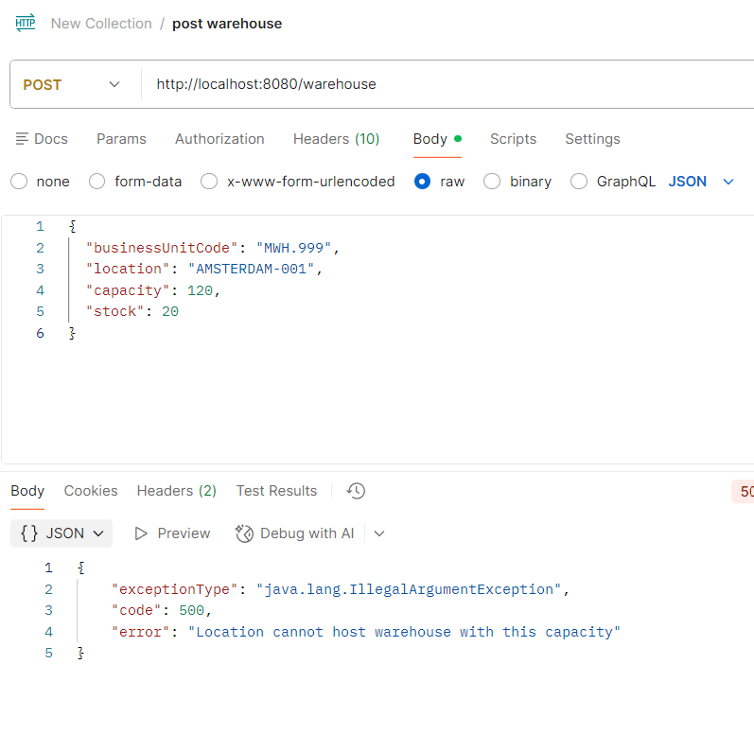

GET ALL
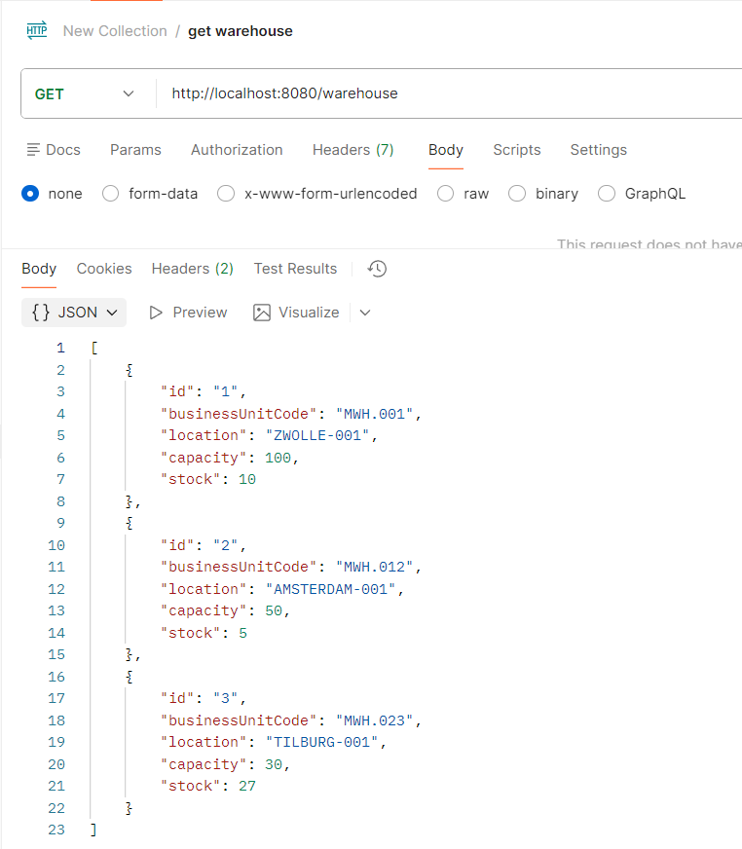

GET BY ID

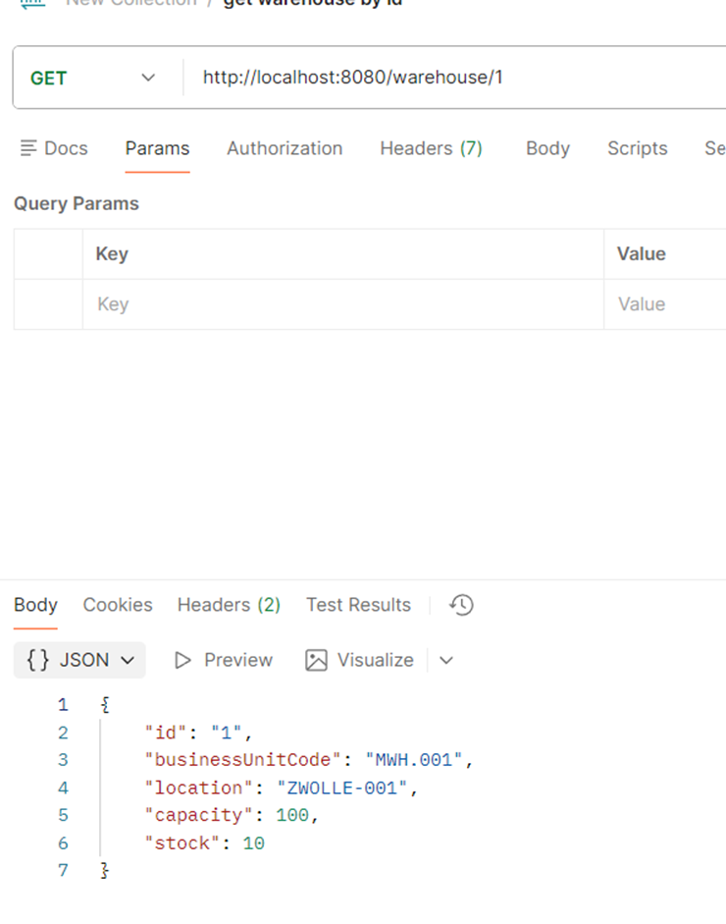

DELETE
(SOFT DELETE- modified GET ALL method by displaying only ACTIVE warehouses- rest remain in ARCHIVE)
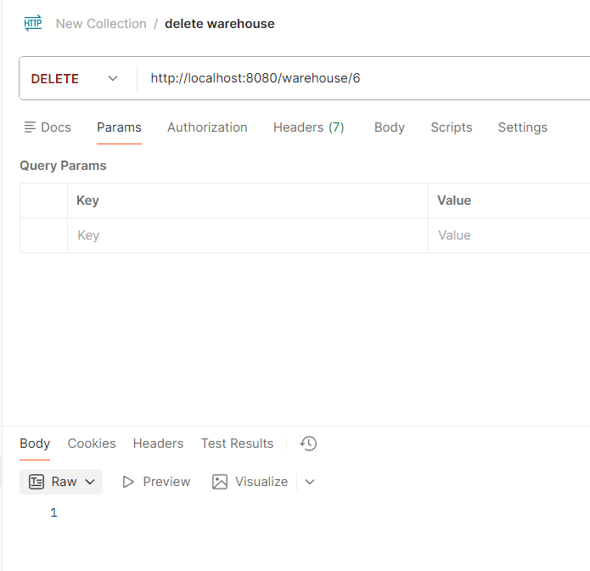

TEST CASES passed AND JACOCO REPORT 91% COVERAGE
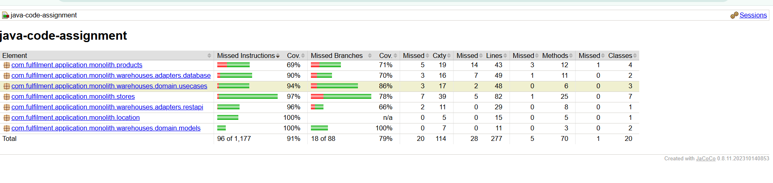

HEALTH CHECK:
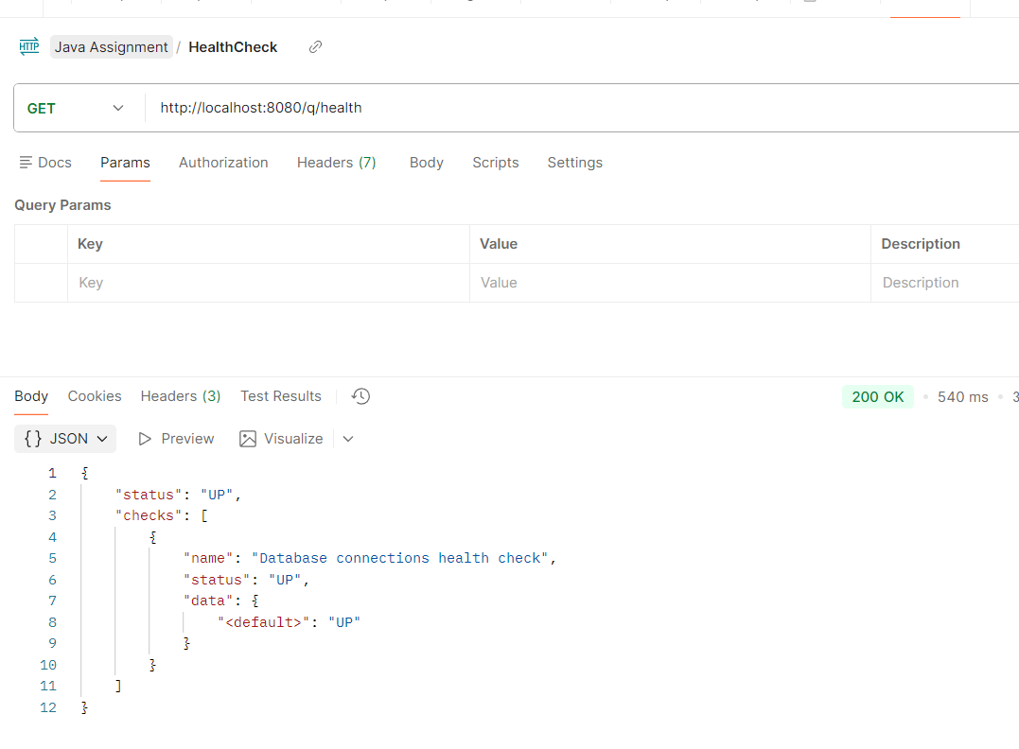

Github ACTIONS- PIPELINE
