SALESTORM
Flash-Sale E-Commerce Platform
Member 1 Deliverable - System Architect
Requirements, Assumptions, System Context, HLD, Container and Deployment Architecture
Team SYSCRAFTERS | SYSCRAFTERS 2026 Design Challenge
Version 1.0 | October 2026 | Status: Draft for team review

Table of Contents

(If the page numbers are blank, right-click the table in Word and choose Update Field.)

1. Purpose and Scope
This document is the System Architect (Member 1) deliverable for SALESTORM. It establishes the business problem, the requirements and assumptions, and the architecture that Members 2, 3 and 4 will refine: System Context, High-Level Design (HLD), Container and Deployment views, together with the scalability strategy, service boundaries, synchronous/asynchronous communication rules, bottlenecks and failure boundaries.
The driving question for this architecture is:
If 10,000 customers simultaneously try to buy 100 available products, how should the complete system be structured so that it remains scalable, correct, reliable and recoverable?
What this document does NOT do: it does not define the final inventory concurrency algorithm (Member 4), the database schema and API contracts (Member 3), or the class-level design and patterns (Member 2). Where those decisions affect the architecture, this document records a proposed position and lists it in Section 14 as an item to confirm with the owner.

1.1 Deliverables covered
# | Deliverable | Where
1 | Requirements and Assumptions | Sections 2 - 4
2 | System Context Diagram | Section 5 (Figure 1)
3 | HLD Architecture | Section 6 (Figure 2)
4 | Container Diagram | Section 8 (Figure 3)
5 | Deployment Diagram | Section 9 (Figure 4)
6 | Scalability, bottlenecks, failure boundaries, jury Q&A | Sections 10 - 13

2. Business Problem
SALESTORM is a high-scale e-commerce platform that runs limited-stock flash sales. Traffic arrives in sudden, extreme spikes, and many customers compete for very little stock.
Critical scenario | Required outcome
100 units of Product X are available | At most 100 units are ever sold. Never 101.
10,000 customers click BUY NOW at roughly the same moment | About 9,900 requests are rejected cleanly as OUT_OF_STOCK instead of overselling.
About 2% of requests are duplicates | Duplicates never create a second reservation, payment or order (idempotency).
Order Service is unavailable for about 30 seconds | No successful payment is lost, no customer is charged twice, and the order is created once recovery happens.

Business objectives: scalability, inventory protection, reservation expiry and release, idempotent payments, order consistency, and failure recovery.

2.1 Guarantees versus targets
The architecture separates what must always be true from what we aim for.
Type | Item | How it is treated
Hard guarantee | Never sell more units than exist (max 100 of 100) | Enforced at the single inventory consistency boundary. Correctness wins over availability for this boundary.
Hard guarantee | No duplicate reservation, payment or order for the same request | Idempotency keys at reservation, payment and order creation.
Hard guarantee | No successful payment is silently lost | Durable payment record plus transactional outbox plus reconciliation.
Target | Low latency on the purchase path | Keep the critical path short; push non-critical work to async.
Target | High availability during spikes | Multi-AZ, autoscaling, graceful degradation.
Target | Reason about up to 500,000 req/sec | Capacity reasoning in Section 10. We do not claim it as a guaranteed figure.

3. Requirements

3.1 Functional requirements
ID | Capability | Requirement
FR1 | Product discovery | Browse products, view details and availability, and identify flash-sale products.
FR2 | Cart | Add and remove items, update quantity, proceed to checkout.
FR3 | Inventory check | Before purchase confirmation, determine whether enough stock exists. If available is 0, reject the reservation.
FR4 | Inventory reservation | Temporarily reserve stock. A reservation holds: Reservation ID, Product ID, Quantity, Customer ID, Status, Expiry time and Idempotency key.
FR5 | Reservation expiry | RESERVED, then TIMEOUT, then RELEASED: unpaid reservations return stock to availability. Stock is never locked forever by an abandoned checkout.
FR6 | Checkout | Coordinate reservation, then payment, then order.
FR7 | Payment | Handle success, failure, timeout, duplicate request and gateway outage. Payment must be idempotent.
FR8 | Order | Create orders for successful purchases and manage the lifecycle: CREATED, PAYMENT_PENDING, CONFIRMED, PROCESSING, SHIPPED, OUT_FOR_DELIVERY, DELIVERED.
FR9 | Fulfilment and shipment | After confirmation: fulfilment, then shipment, then delivery.
FR10 | Notification | Send notifications for order confirmation, payment failure, shipment and delivery. Asynchronous, so they never block the purchase path.

3.2 Non-functional requirements
Quality | Requirement and architectural response
Scalability | Normal load about 10,000 req/sec. Flash-sale design reasons about up to 500,000 req/sec using CDN, WAF, load balancing, horizontal scaling, cache, queues and database scaling.
Concurrency | 10,000 simultaneous purchase requests against 100 units yields a maximum of 100 successful allocations.
Consistency | Strong consistency for inventory. Only one of two simultaneous requests may reserve the last unit. Eventual consistency is acceptable for browsing data, notifications and analytics.
Availability | The platform stays up during spikes. Browsing, cart and status pages degrade gracefully; the inventory boundary prioritises correctness.
Reliability | Recover from service failures, database problems, payment failures and timeouts, Order Service outage and message-processing failures.
Performance | Minimise latency on the critical path: Inventory, Checkout, Payment, Order. Notification, analytics and shipment run after the response.
Security | Authentication, authorization, HTTPS, rate limiting, input validation, secure payment handling, audit logs and secrets management.
Observability | Logs, metrics, distributed tracing and alerts, so we can answer: what happened to this customer's purchase?

Key metrics to monitor: request rate, latency (p50/p95/p99), error rate, reservation failures, payment failures, order conversion, queue depth, consumer lag and dead-letter count.

4. Assumptions and Constraints

4.1 Assumptions
ID | Assumption | Impact on design
A1 | Main test scenario: Product X has 100 units. | Inventory contention on a single hot record or key.
A2 | About 2% of requests are duplicates (retries, double-clicks). | Idempotency keys are mandatory end to end.
A3 | Payment is an external dependency that can succeed, fail, time out or be unavailable. | Timeouts, retries, idempotent calls, status reconciliation.
A4 | Order Service can be unavailable for about 30 seconds. | Payment outcome is durably stored and published through an outbox; the order is created later without recharging.
A5 | Inventory correctness matters more than accepting every request. | About 9,900 of 10,000 requests are rejected rather than oversold.
A6 | Reservation hold time is 10 minutes (configurable per sale). | TTL on reservation; expiry sweeper releases stock.
A7 | Deployment is a single cloud region with 3 Availability Zones. | Multi-region active-active is out of scope; noted as a future extension.
A8 | Per-pod capacity numbers used in Section 10 are illustrative. | Must be validated by load testing before being quoted as fact.

4.2 Constraints
- Inventory must never exceed its physical quantity, whatever the load.
- Payment gateway rate limits and latency are outside our control.
- Notification and shipment must not be able to fail a purchase.
- The design must be explainable and defensible in the jury presentation, so it favours clear boundaries over exotic technology.

5. System Context (Deliverable 2)
The context diagram answers one question: who interacts with SALESTORM, and which external systems does it depend on? It deliberately shows SALESTORM as a single box. How it is built inside is the HLD.
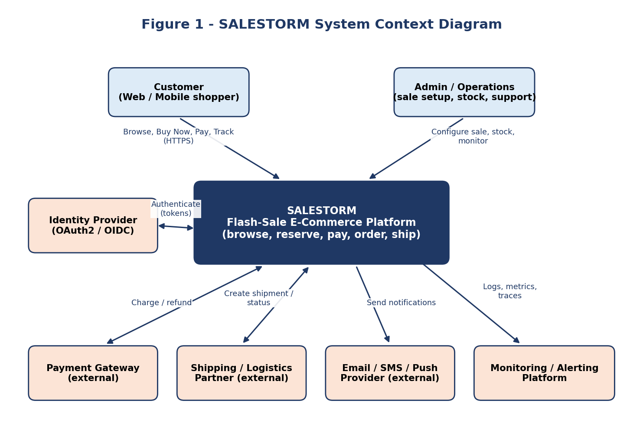
Actor / external system | Interaction
Customer | Browses products, adds to cart, clicks Buy Now, pays, tracks the order (HTTPS, web and mobile).
Admin / Operations | Configures the sale, stock and pricing; monitors health; handles support cases.
Payment Gateway | Charges and refunds. Can be slow, rate-limited or unavailable.
Shipping / Logistics Partner | Receives shipment requests and returns delivery status.
Email / SMS / Push Provider | Delivers notifications.
Identity Provider | Authenticates users (OAuth2 / OIDC) and issues tokens.
Monitoring Platform | Receives logs, metrics and traces; raises alerts.

6. High-Level Design (Deliverable 3)
The HLD follows the reference flow of the brief: Users, CDN/WAF, Load Balancer, API Gateway, Product/Cart/Sale services, Inventory/Reservation, Checkout, Payment, Order, then Shipment and Notification. Supporting infrastructure is cache, message broker, SQL databases, monitoring, logging and tracing.
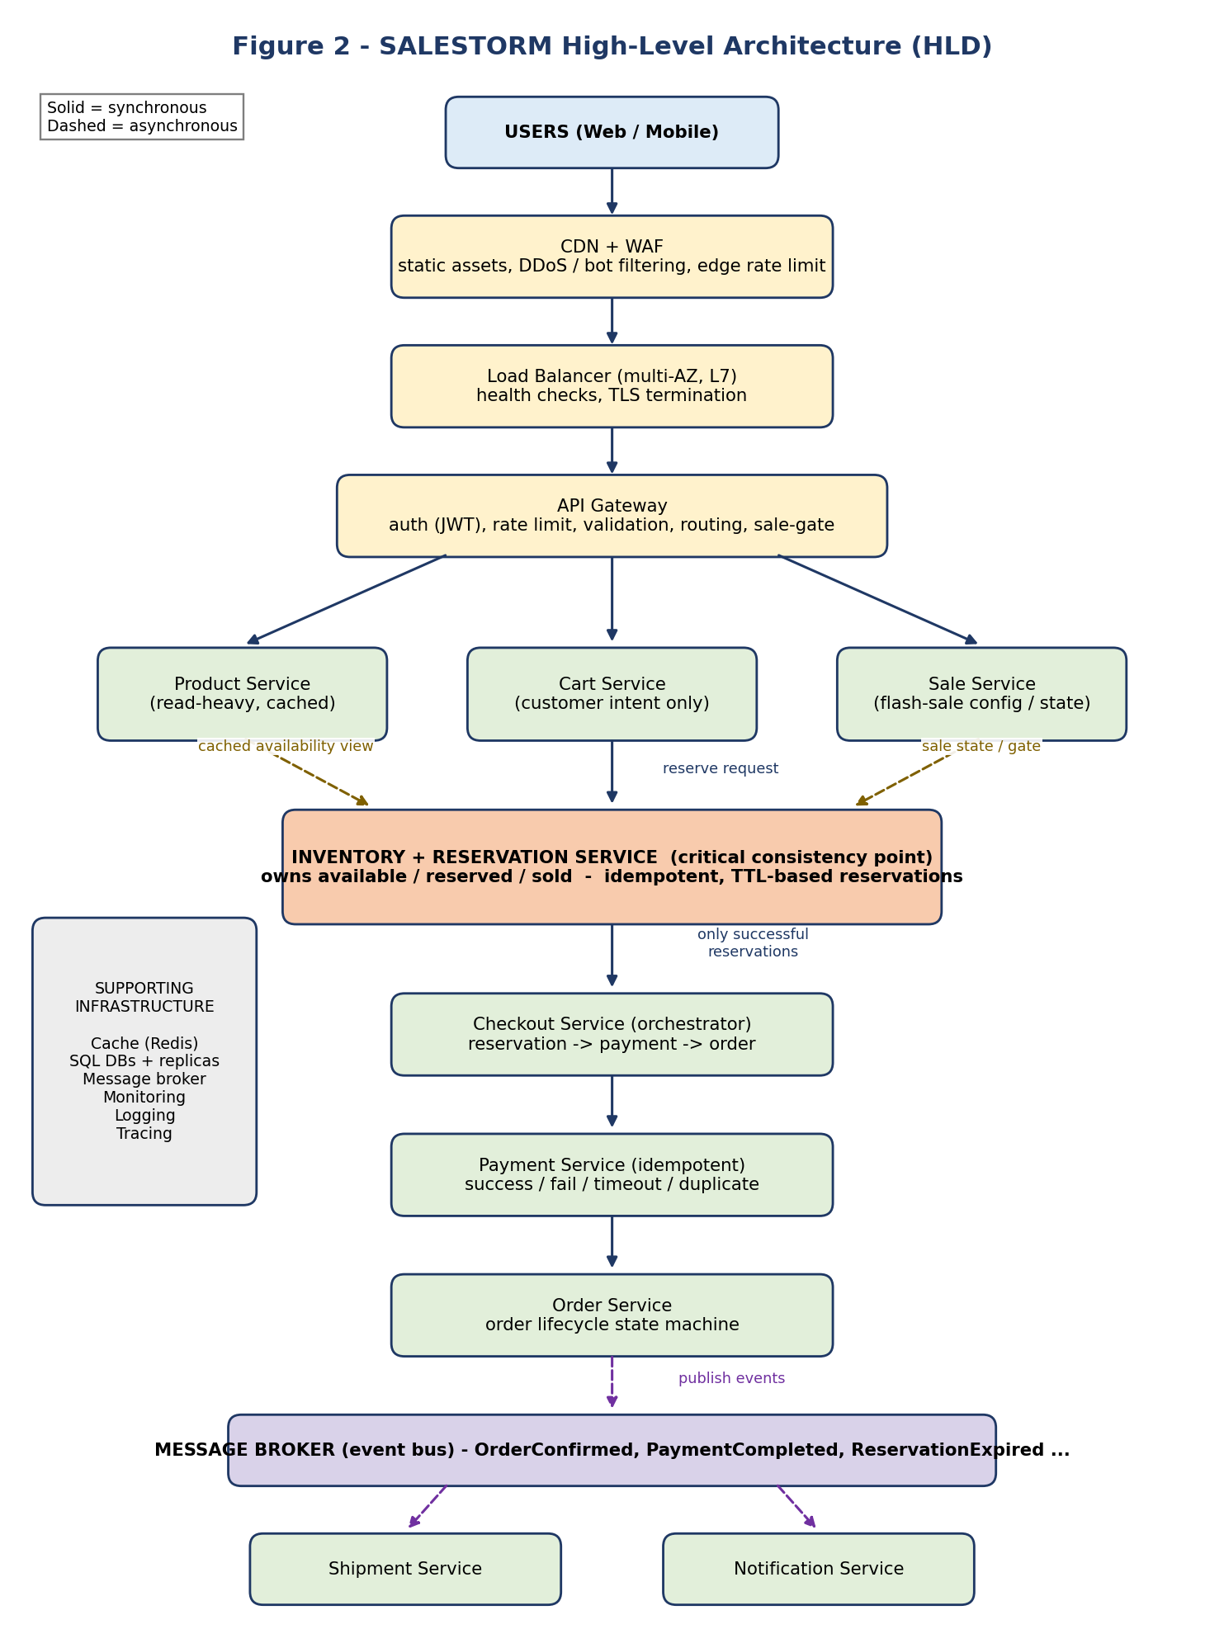

6.1 Why each component exists
Component | Purpose and justification
CDN | Serves static assets, images and frontend content from the edge, which removes a large share of requests before they reach the backend.
WAF | Blocks malicious traffic, common web attacks, bots and abusive clients at the edge.
Load Balancer | Spreads traffic over many stateless instances across Availability Zones; health checks remove failed instances so one failure does not become an outage.
API Gateway | Single entry point: JWT authentication, authorization, rate limiting, request validation, routing and API-level metrics. Can also act as a sale gate (reject immediately when the sale is not open or is already sold out).
Product Service | Owns product, category, price and detail data. Read-heavy, so it is cached aggressively and served from read replicas.
Cart Service | Owns the customer's intent (items and quantities). It does NOT own stock truth. Cart says 'I want 2'; Inventory decides 'can you have 2'.
Sale Service | Owns flash-sale configuration and state: start and end time, per-customer limit, sale-open flag, sold-out flag.
Inventory + Reservation Service | The critical service. Owns available, reserved and sold quantities and reservation records. It is the only component allowed to change stock.
Checkout Service | Orchestrator for reservation, then payment, then order. Holds workflow state but no heavy business rules.
Payment Service | Wraps the external gateway. Idempotent, with timeouts, retries and status reconciliation.
Order Service | Owns the order record and lifecycle state machine.
Message Broker | Carries domain events so that downstream work (shipment, notification, analytics, reservation-expiry handling) is decoupled from the customer response.
Shipment Service | Creates and tracks shipments for confirmed orders. Consumes events.
Notification Service | Sends email, SMS and push messages. Consumes events; failure never fails an order.
Cache (Redis) | Hot reads (product, sale state), cart state, and the fast atomic stock gate for the flash sale.

6.2 Service boundaries
Service | Owns (source of truth) | Must NOT do
Product | Product, category, price | Hold stock counts as truth
Cart | Cart and cart items | Decide availability
Sale | Sale windows, rules, flags | Change stock
Inventory + Reservation | Available / reserved / sold; reservations | Call the payment gateway
Checkout | Checkout workflow state | Own stock, payment or order data
Payment | Payment transactions, idempotency records | Create orders or change stock directly
Order | Orders and lifecycle | Charge customers
Shipment | Shipments and tracking | Change order payment state
Notification | Message log and delivery status | Block any purchase step

7. Request Flows and Communication Style

7.1 End-to-end purchase flow
Say this out loud in the viewing: a customer request first enters through the CDN and WAF. The load balancer distributes traffic across horizontally scaled application instances. The API Gateway authenticates, validates, rate-limits and routes the request. Product and cart operations use caching where appropriate. For a purchase, the request reaches the Inventory/Reservation boundary, which is the critical consistency point. Only successfully reserved inventory proceeds to checkout and payment. After successful payment the order is created, and downstream work such as shipment and notification is handled asynchronously through events.
Step | Action | Mode and notes
1 | Customer clicks Buy Now | Sync. Edge checks, then LB, then Gateway (JWT, rate limit, idempotency key present).
2 | Sale gate | Sync, cache only. Reject if sale closed or sold-out flag set. No DB hit for these rejections.
3 | Reserve stock | Sync. Atomic decrement at the inventory boundary. Success creates a reservation with TTL; failure returns OUT_OF_STOCK. No payment is started on failure.
4 | Checkout starts | Sync. Only the roughly 100 successful reservations reach this step.
5 | Payment | Sync with timeout. Idempotency key sent to the gateway. Result: SUCCESS, FAILED, TIMEOUT (resolved by status query).
6 | Order created | Sync. Order moves CREATED, then PAYMENT_PENDING, then CONFIRMED. Reservation becomes CONFIRMED and stock becomes sold.
7 | Response to customer | Order confirmation returned. Critical path ends here.
8 | Events published | Async. OrderConfirmed is consumed by Shipment, Notification and Analytics.
9 | Failure paths | Payment failed or reservation expired: reservation RELEASED and stock returns. Customer is notified asynchronously.

7.2 Synchronous versus asynchronous
Interaction | Style | Reason
Gateway to Product / Cart / Sale | Sync | The customer is waiting for the page.
Reserve inventory | Sync | Customer needs an immediate yes or no.
Checkout to Payment | Sync with timeout | Customer needs a result; timeouts resolved by status polling and reconciliation.
Payment success to Order creation | Sync, backed by outbox | Normal case is immediate; if Order Service is down, the outbox delivers it later.
Order confirmed to Shipment | Async (event) | Not needed to answer the customer.
Order confirmed to Notification | Async (event) | Email failure must not fail the order.
Order confirmed to Analytics | Async (event) | Reporting only.
Reservation expiry to stock release | Async (timer plus event) | Background correctness maintenance.

Rule of thumb: if the customer must see the result of an operation before the response, it is synchronous. Everything else is an event.

8. Container Diagram (Deliverable 4)
The container view zooms into SALESTORM and shows each deployable service, its data store, and the shared infrastructure.
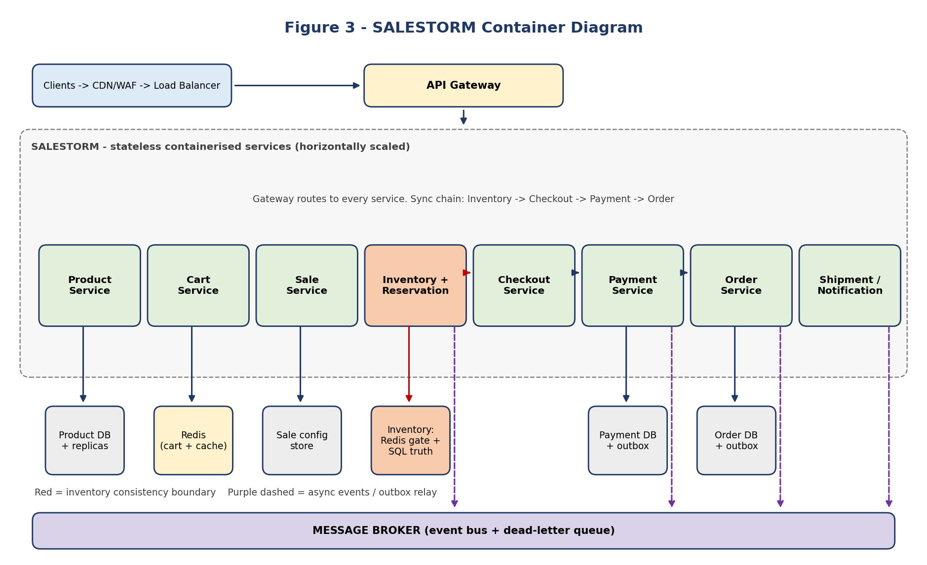

8.1 Data ownership (proposed, to confirm with Member 3)
Service | Data store | Reasoning
Product | Product DB with read replicas, plus Redis cache | Read-heavy, tolerant of slight staleness.
Cart | Redis (with persistence) | Fast, short-lived, per-customer data.
Sale | Small config store, cached | Rarely changes, read very often.
Inventory + Reservation | Redis atomic gate in front of a SQL source of truth | Fast rejection under load plus durable, auditable correctness.
Payment | Payment DB with idempotency table and outbox | Durable record of every attempt; outbox guarantees event publication.
Order | Order DB with outbox | Order lifecycle and event publication.
Shipment / Notification | Own lightweight stores | Event-driven, replayable.

Design note: we do NOT blindly create one database per service just because the style is microservices. Where strong consistency is needed (inventory plus reservation) they stay together. Where services are independent (payment, order) they are separated, and consistency is achieved through idempotency, the outbox pattern and reconciliation. Final schemas are Member 3's decision.

9. Deployment Diagram (Deliverable 5)
This view answers: where does everything run? Services run as stateless containers on an autoscaled Kubernetes cluster across three Availability Zones. State lives in managed, replicated data services.
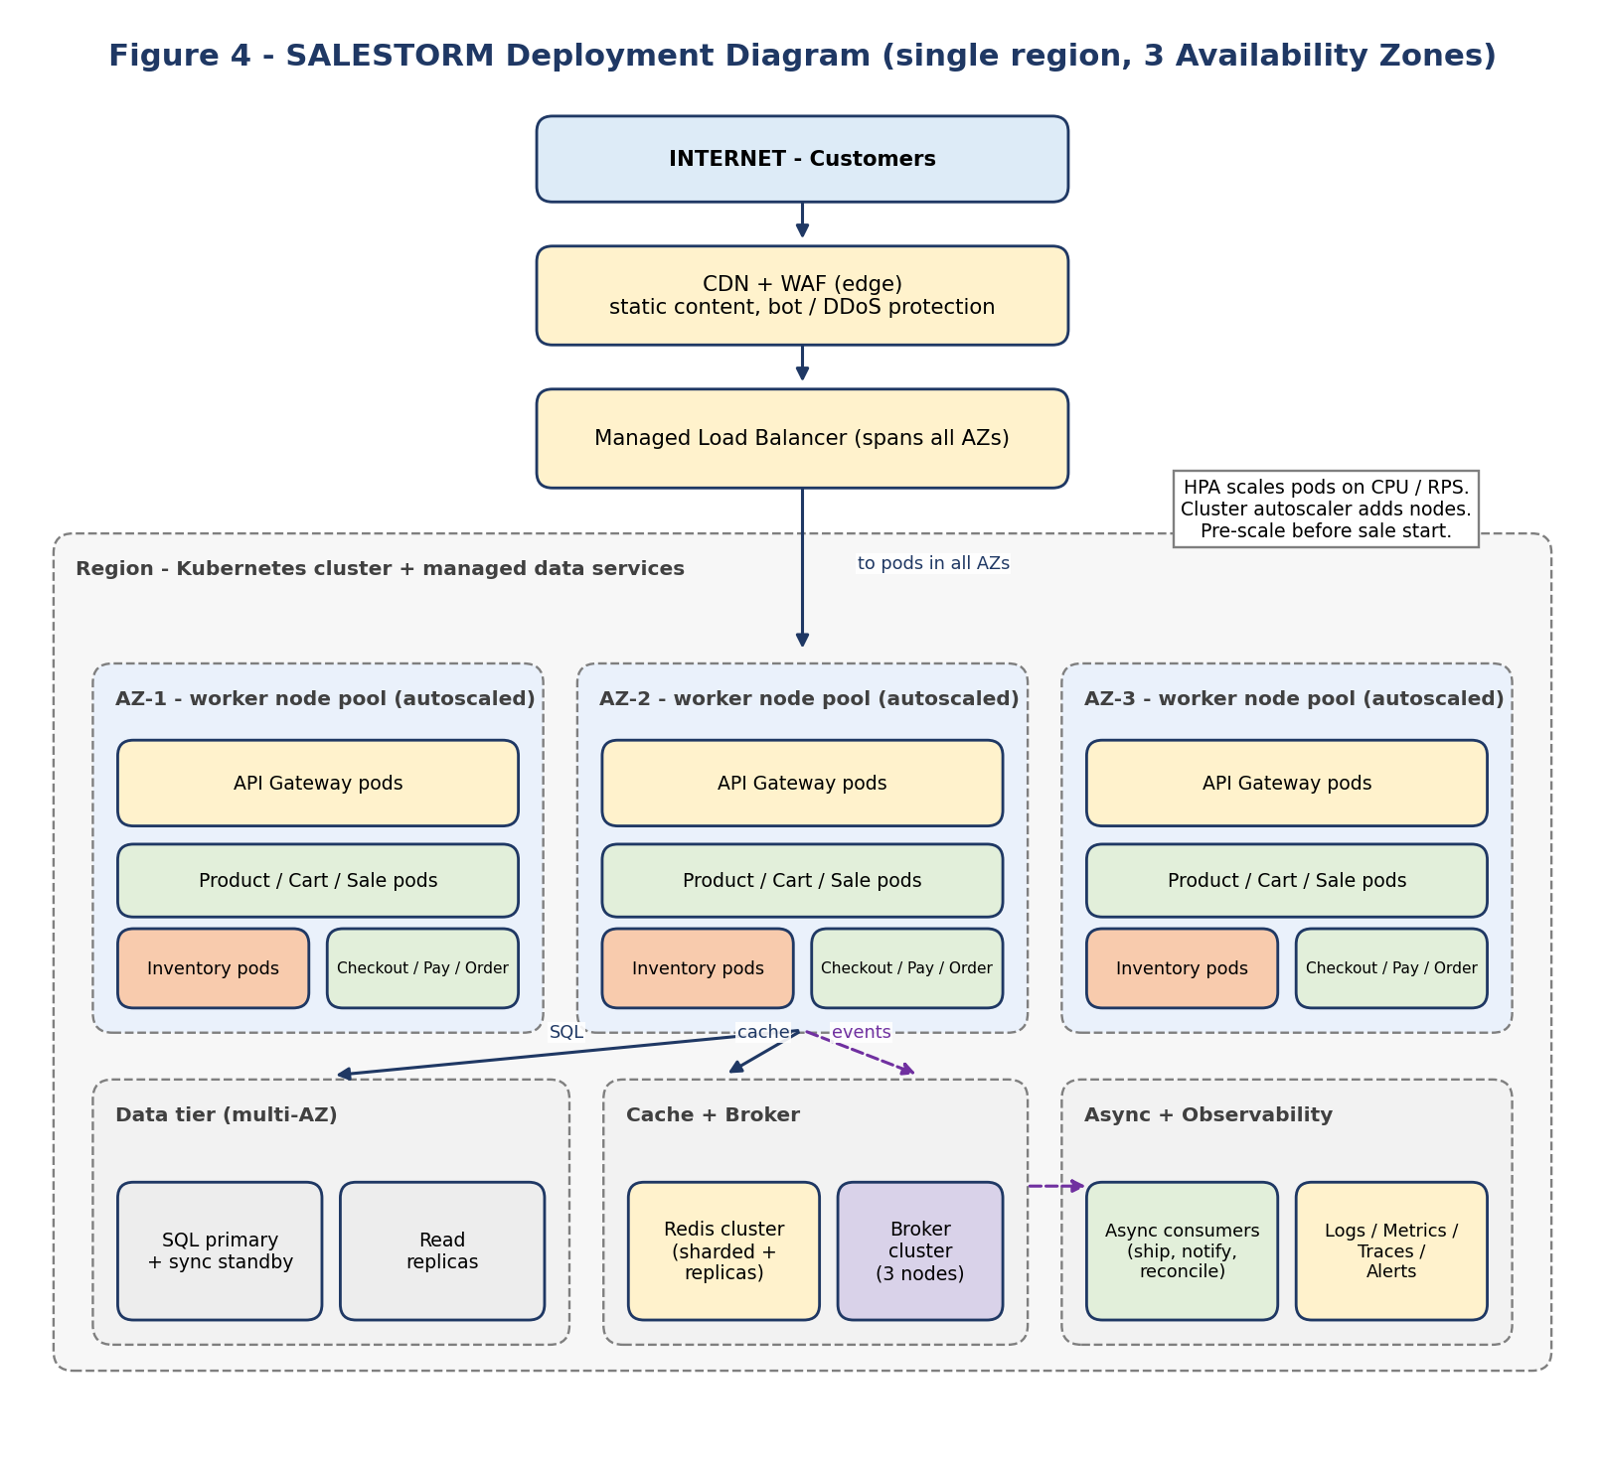
Runtime element | Deployment approach
Edge | CDN and WAF in front of the managed load balancer.
Application tier | Stateless pods spread across 3 AZs. Horizontal Pod Autoscaler scales on CPU and requests per second; the cluster autoscaler adds nodes.
Inventory pods | Scaled independently from the rest. Stock correctness comes from the atomic inventory boundary, not from running a single instance.
SQL | Primary with synchronous standby in another AZ for failover, plus read replicas for catalogue reads. Connection pooling in front.
Redis | Sharded cluster with replicas for product cache, cart state and the stock gate.
Message broker | 3-node cluster, replicated topics, dead-letter queues, partitioned by order or reservation ID.
Async consumers | Separate deployments that scale on queue depth: shipment, notification, reconciliation, reservation expiry.
Observability | Central logging, metrics, tracing and alerting.
Pre-warming | Before a scheduled sale, scale pods and caches up in advance, and warm product and sale caches. Autoscaling alone reacts too slowly for a spike that begins in seconds.

10. Scalability Strategy
The core principle: do not push all 10,000 purchase requests equally through the whole system. Filter at every layer so that only the roughly 100 successful reservations reach checkout, payment and order.
Layer | Mechanism | Effect
1 | CDN | Static and cacheable content never reaches the backend.
2 | WAF and rate limiting | Abusive, bot and excess traffic is rejected at the edge; per-user and per-IP limits at the gateway.
3 | Load Balancer | Spreads load across instances and AZs; removes unhealthy nodes.
4 | Horizontal app scaling | Stateless services scale out by adding pods.
5 | Cache | Product, sale and sold-out state served from memory, taking read load off the databases.
6 | Queue / broker | Absorbs asynchronous work so spikes there do not slow the purchase path.
7 | Database scaling | Indexes, read replicas, connection pooling, and partitioning or sharding by product if needed.

10.1 Funnel effect
Stage | Approx. volume | Who is stopped here
Edge (CDN/WAF/rate limit) | 500,000 req/sec peak | Static requests, bots, floods
Gateway and sale gate | Far fewer | Unauthenticated, invalid, sale not open, flagged sold-out
Inventory atomic gate | About 10,000 purchase attempts | About 9,900 rejected OUT_OF_STOCK
Checkout and Payment | About 100 (plus retries) | Failed payments release stock
Orders | Up to 100 | -

10.2 Illustrative capacity reasoning for 500,000 req/sec
This is reasoning, not a guarantee (assumption A8):
- Assume the CDN and edge cache absorb a large part of the traffic (static assets and cached product pages), leaving a fraction as dynamic API calls.
- If one gateway or app pod comfortably handles about 2,000 simple requests per second, roughly 250 pods plus headroom serve 500,000 req/sec; about 300 to 400 with a safety margin. Real numbers must come from a load test.
- Only the purchase path touches the inventory gate. Redis handles on the order of tens to hundreds of thousands of atomic operations per second per shard, and a single hot product key is one shard, so rejection is cheap because it never touches SQL.
- Because stock is 100 units, after the first 100 successes the sold-out flag is cached, and later requests are rejected at the gateway with no inventory call at all.

10.3 What changes at 50x traffic
- Scale stateless application pods and nodes horizontally; pre-scale before the sale.
- Increase cache capacity and shard Redis; extend CDN caching of product pages.
- Tighten rate limiting and admission control, and optionally add a virtual waiting room that releases customers to the purchase path in controlled batches.
- Scale queue partitions and consumers; monitor consumer lag.
- Add read replicas; shard or partition by product ID where write contention requires it.
- Protect the payment gateway with a concurrency limiter and circuit breaker, since only reserved stock may reach it.
- The hard inventory guarantee does not change; what changes is how cheaply and quickly we say no.

11. Bottlenecks
Bottleneck | Why it is a problem | Mitigation
Inventory record (most critical) | 10,000 requests contend for one product record or key. | Atomic, conditional update at a single boundary; Redis gate absorbs rejection; sold-out flag; Member 4 owns the exact algorithm.
Database | Connection exhaustion and write pressure. | Pooling, replicas, keep rejected traffic off SQL, short transactions.
Payment gateway | Latency, rate limits, outages. | Only reserved stock reaches it; timeouts, circuit breaker, concurrency cap, idempotent retries.
Message broker | Backlog under load. | Partitioning, scale consumers, monitor depth, lag and dead letters.
API Gateway / LB | Single entry for all traffic. | Multiple instances across AZs, edge rate limiting.
Thundering herd at sale start | Everyone arrives in the same second. | Pre-scaling, cache warming, waiting room, jittered client retry.

12. Failure Boundaries and Recovery
Failure | Architectural response
Order Service down for 30 s after payment succeeds | Payment result is stored durably and an PaymentCompleted event is written in the same transaction (transactional outbox). The broker retains it. When Order Service returns, the consumer creates the order idempotently using the reservation or payment ID as the key. The customer sees 'payment received, order being confirmed' and is never charged again. A reconciliation job finds any payment without an order.
Payment timeout | Do not assume failure. Keep the reservation, query the gateway by idempotency key, and resolve to success or failure. If unresolved at reservation expiry, the payment is refunded or voided and the stock is released.
Duplicate payment request | Same idempotency key returns the stored result; no second charge.
Payment gateway down | Circuit breaker opens; customer gets a retry-later response; reservation stays within TTL; stock is released if time runs out.
Customer abandons checkout | Reservation TTL expires; sweeper marks RELEASED; stock becomes available again.
Inventory reaches zero | New reservations return OUT_OF_STOCK; no payment is initiated.
Application pod or node failure | LB health check removes it; other pods continue; requests are idempotent so client retries are safe.
Database primary failure | Standby promoted in another AZ; connections re-established; in-flight requests retried through idempotency.
Redis failure | Replica promoted. SQL stays the source of truth, so the stock gate can be rebuilt from it. Until rebuilt, fall back to guarded SQL conditional updates.
Consumer failure / poison message | Retries with backoff, then dead-letter queue and alert; replay after the fix.
Notification or shipment failure | Isolated: order unaffected; retried independently.

13. Security and Observability

13.1 Security
- Authentication via OAuth2/OIDC with JWT validated at the gateway; authorization per role (customer, admin).
- HTTPS everywhere (TLS at the LB, mTLS between services where required).
- Rate limiting at edge and gateway; WAF rules; bot protection.
- Input validation at the gateway and in each service.
- Secure payment handling: no card data stored by SALESTORM; tokenised through the gateway; PCI scope minimised.
- Audit logs for stock changes, payments, refunds and admin actions.
- Secrets in a managed vault, never in code or images.

13.2 Observability
- Structured logs carrying a correlation ID, customer ID, reservation ID, payment ID and order ID.
- Metrics: request rate, latency percentiles, error rate, reservation failures, payment failures, order conversion, queue depth, consumer lag.
- Distributed tracing from gateway to order, so one purchase can be followed end to end.
- Alerts: oversell invariant breach (sold + reserved greater than total), payment-without-order, DLQ growth, replica lag, error-rate spikes.

14. Key Decisions and Open Items

14.1 Architecture decision record
# | Decision | Rationale | Alternative rejected
D1 | Microservices with clear ownership, not one monolith | Independent scaling of inventory, payment and read paths; clearer failure boundaries. | Single ECommerceService
D2 | Inventory is a separate, protected consistency boundary | Prevents overselling; isolates the hot spot. | Inventory logic inside Cart or Payment
D3 | Cart does not own stock truth | Cart is intent; Inventory is truth. | Cart holding available counts
D4 | Only successful reservations proceed to payment | Protects gateway and downstream services. | Send all requests to payment
D5 | Event-driven for shipment, notification, analytics | Failures cannot block the order. | Synchronous chain
D6 | Transactional outbox plus reconciliation for payment to order | Survives Order Service outage without double charge. | Fire-and-forget call
D7 | Redis atomic gate in front of SQL source of truth | Fast cheap rejection plus durable correctness. | Pessimistic SQL locks for every request
D8 | Pre-scale and warm caches before sale | Autoscaling is too slow for instant spikes. | Reactive autoscaling only
D9 | No claim of guaranteed 500K req/sec | Brief asks us to reason about it. | Unsupported guarantee

14.2 Items to confirm with other members
With | Item | Why it matters
Member 4 | Exact inventory concurrency mechanism (Redis atomic script, SQL conditional update, optimistic lock, or a combination) and reservation expiry sweeper. | Defines the inventory consistency boundary shown in red.
Member 4 | Payment timeout resolution, retry policy and outbox/reconciliation details. | Defines failure behaviour in Section 12.
Member 3 | Final database ownership: which services share a database and which are separate; schemas, indexes, partitioning. | Changes the container diagram.
Member 3 | API contracts and idempotency-key header conventions. | Used by the gateway and every service.
Member 2 | Class-level design inside each service boundary and design patterns (state, strategy, saga/orchestrator). | Must fit the boundaries in 6.2.

Warning: do not freeze the final HLD in isolation. Review the inventory consistency boundary with Member 4 and database ownership with Member 3 before the diagrams are finalised for submission.

15. What Not To Do
- Do not put everything in one service. Boundaries become unclear and scaling impossible.
- Do not put payment logic inside Inventory. They have different responsibilities and failure modes.
- Do not make Notification synchronous. If email fails, the order must not fail.
- Do not let Cart own inventory truth.
- Do not assume the database alone solves concurrency. A concurrency strategy must be chosen and defended explicitly.
- Do not claim 500K requests/sec is guaranteed. Explain how it scales and where bottlenecks appear.
- Do not send all 10,000 requests to payment.

16. Jury Questions and Prepared Answers
Q1. Why an API Gateway?
It is the centralised entry point for routing, authentication, rate limiting, request validation and observability before traffic reaches internal services.
Q2. Why a Load Balancer?
To distribute traffic across multiple service instances, enabling horizontal scaling and isolating instance failures.
Q3. What happens when traffic increases 50x?
We scale stateless instances horizontally, pre-scale and expand cache capacity, scale queue consumers, add read replicas and partitioning, and tighten rate limiting and admission control, optionally with a waiting room. The inventory guarantee does not change; we only make rejection cheaper.
Q4. Where is the most critical bottleneck?
Inventory, because thousands of concurrent requests contend for the same limited stock record.
Q5. Why not send all requests to payment?
Only successfully reserved inventory should proceed to payment. Sending everything would overload checkout and the external gateway for no benefit.
Q6. Why asynchronous communication?
To decouple non-critical downstream work such as notification and shipment from the critical purchase path, improving resilience and reducing customer-facing latency.
Q7. What if Order Service is down for 30 seconds after payment succeeds?
The payment outcome is persisted with an outbox event in one transaction. The broker retains it and the order is created idempotently when the service recovers; reconciliation catches any gaps. The customer is not charged again.
Q8. What happens when inventory reaches zero?
New reservation requests are rejected with OUT_OF_STOCK. No payment is initiated. A cached sold-out flag lets the gateway reject even earlier.
Q9. How do you guarantee no overselling?
Stock changes only at the Inventory boundary through an atomic conditional decrement (available must be at least the requested quantity), with idempotent reservations. The exact mechanism is detailed in Member 4's design.
Q10. Why not one database per service everywhere?
Strongly consistent data (inventory and reservations) is kept together; independent data is separated and kept consistent via idempotency, outbox and reconciliation.

17. Submission Folder and Final Checklist

17.1 Folder structure
Folder | Member 1 content
01_Requirements/ | Requirements_Assumptions (Sections 2 - 4 of this document)
02_HLD/ | System_Context_Diagram.png, HLD_Architecture.png, Container_Diagram.png, Deployment_Diagram.png
03_LLD/ onward | Owned by Members 2, 3 and 4
12_Presentation/ | Architecture slides drawn from Sections 5 - 12

17.2 Checklist
☐ Functional requirements documented
☐ Non-functional requirements documented
☐ Assumptions and constraints documented
☐ 10K concurrent users and 100-unit inventory understood
☐ 500K req/sec treated as a reasoning target
☐ Hard guarantees identified
☐ System Context Diagram
☐ HLD
☐ Container Diagram
☐ Deployment Diagram
☐ Service boundaries defined
☐ Synchronous and asynchronous flows identified
☐ Infrastructure identified
☐ CDN, WAF, LB, API Gateway, cache, queue, DB scaling
☐ Bottlenecks identified
☐ Can explain 50x traffic, zero inventory and Order Service failure
☐ Can explain how payment is protected from overload
☐ Inventory boundary reviewed with Member 4
☐ Database ownership reviewed with Member 3

