Game Design Document

Fill up the following document

1. Write the title of your project.

Protect The Cake

1. What is the goal of the game?

To protect the cake from ants who are trying to eat it and win the game by killing them all.

1. Write a brief story of your game.

You want to eat a cake you made but some ants are troubling you. Fight them and Kill them all to be able to eat it peacefully. Don’t let the ants eat your cake otherwise you will lose.

RULES:

* You can move in all directions by using the arrow keys.
* You will lose if the ants eat your cake and you fail to protect it.
* You will win if you kill all the ants and are successful in protecting the cake .
* You should use the power-ups when they are available or they will go away gradually.
* You will gain points in the game overtime.
* You will lose points very quickly when ants eat the cake.

1. Which are the playing characters of this game?

* Playing characters are the ones who respond to the user based on the input from the user.
* Cars, monkeys, dinos, wizards, etc., are the playing characters in the game.

|  |  |  |
| --- | --- | --- |
| Number | Character Name | What can this character do? |
| 1 | Suzie | Protect the cake, Fight the ants by coming near them, Gain points. |

1. Which are the Non-Playing Characters of this game?

* Non-Playing characters are the ones that don't have an action or behavior when the user interacts with the game.
* Hurdles, stones, bananas, coins, etc., are non-playing characters in the game.

|  |  |  |
| --- | --- | --- |
| Number | Character Name | What can this character do? |
| 1 | Ants | Obstruct the PCs by eating parts of the cake which makes them lose points. |
| 2 | Cake | It is the thing the player has to protect. |
| 3 | Reppelent Spray | This will appear randomly and help to kill the ants. |
| 4 | Magic Bubble | This will apear very rarely but will protect the cake by building a bubble around it for some seconds. |

1. Draw your imagination of this game. What does this game look like?

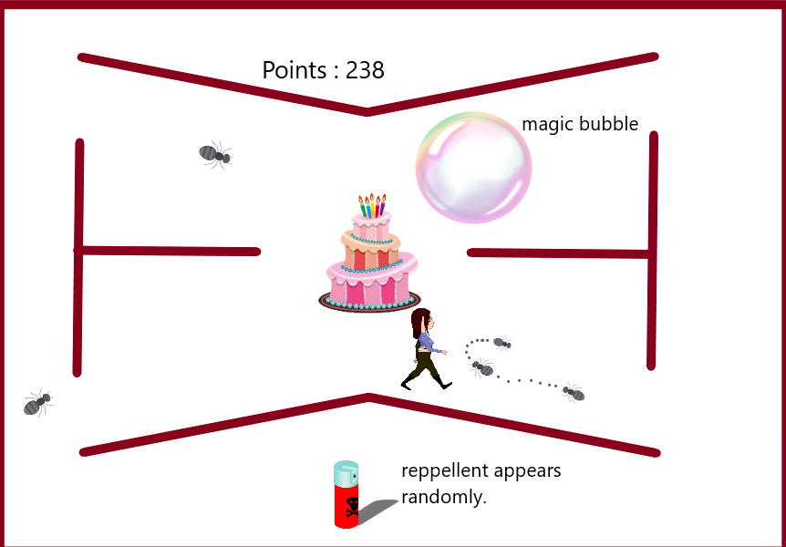

1. How do you plan to make your game engaging?

I plan to increase the difficulty level after a certain period of time which will be challenging. There are many power-ups which offer different – different purposes and make the game interesting.