Azure Data Factory
Azure Data Factory (ADF) is a cloud-based data integration service that allows you to create, schedule, and orchestrate data pipelines. It acts as a data mover and scheduler, enabling data transfer between various sources and destinations. ADF can automate data movement, including scheduled transfers such as midnight batch jobs.

Features of Azure Data Factory
- Data Compression: During the Data Copy activity, it is possible to compress the data and write the compressed data to the target data source. This feature helps optimize bandwidth usage in data copying.
- Extensive Connectivity Support for Different Data Sources: Azure Data Factory provides broad connectivity support for connecting to different data sources. This is useful when you want to pull or write data from different data sources.
- Custom Event Triggers: Azure Data Factory allows you to automate data processing using custom event triggers. This feature allows you to automatically execute a certain action when a certain event occurs.
- Data Preview and Validation: During the Data Copy activity, tools are provided for previewing and validating data. This feature helps you ensure that data is copied correctly and written to the target data source correctly.
- Customizable Data Flows: Azure Data Factory allows you to create customizable data flows. This feature allows you to add custom actions or steps for data processing.
- Integrated Security: Azure Data Factory offers integrated security features such as Entra ID integration and role-based access control to control access to dataflows. This feature increases security in data processing and protects your data.

Real-Time Use Cases:
- Automated Data Migration: A global e-commerce company transfers large volumes of transaction data from its on-premises database to Azure Blob Storage every night. By enabling data compression, the company reduces bandwidth usage and speeds up the transfer process.
- Multi-Source Data Integration: A healthcare organization integrates patient records from SQL Server, Oracle, and Salesforce into a centralized Azure Data Lake using ADF’s extensive connectivity support.
- Event-Driven Processing: A retail chain updates its inventory system whenever new sales data files arrive in Azure Blob Storage. Custom event triggers start the pipeline immediately, ensuring real-time updates.
- Data Validation for Compliance: A financial institution migrates sensitive transaction data to Azure SQL Database. Before committing, the team uses ADF’s preview and validation feature to confirm accuracy and prevent errors.
- Custom Data Transformation: A media streaming company processes raw user activity logs to generate personalized recommendations. With ADF’s customizable data flows, they add transformations like filtering and aggregating before sending data to Azure Synapse Analytics.
- Secure Data Handling: A government agency handles confidential citizen data. By leveraging ADF’s integrated security features, they ensure only authorized personnel can access pipelines and sensitive datasets.

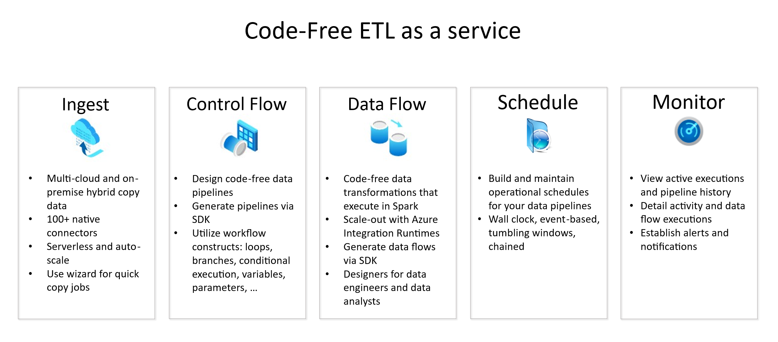

Azure Data Lake
A data lake is a single, centralized repository where you can store all your data, both structured and unstructured. A data lake enables your organization to quickly and more easily store, access, and analyze a wide variety of data in a single location. With a data lake, you don't need to conform your data to fit an existing structure. Instead, you can store your data in its raw or native format, usually as files or as binary large objects (blobs).
Azure Data Lake Storage is a cloud-based, enterprise data lake solution. It's engineered to store massive amounts of data in any format, and to facilitate big data analytical workloads. You use it to capture data of any type and ingestion speed in a single location for easy access and analysis using various frameworks

Real-Time Use Cases:
- Storing raw IoT sensor data for later processing and analysis.
- Maintaining historical logs and clickstream data for user behavior analysis.
- Serving as a central repository for data scientists to access diverse datasets.

Azure Databricks
Azure Databricks is a unified, open analytics platform for building, deploying, sharing, and maintaining enterprise-grade data, analytics, and AI solutions at scale. The Databricks Data Intelligence Platform integrates with cloud storage and security in your cloud account, and manages and deploys cloud infrastructure for you
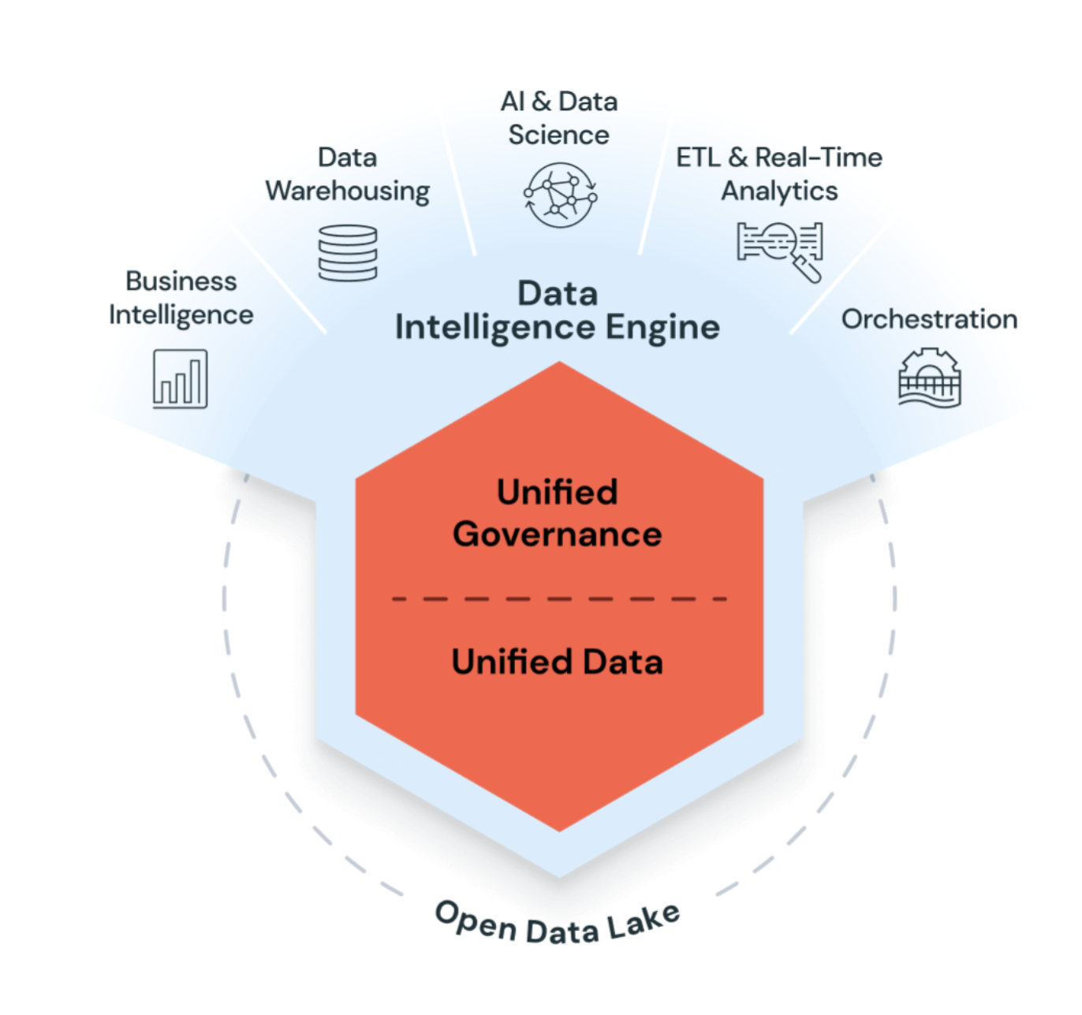

Real-Time Use Cases:
- Enterprise Data Lakehouse
Combine data lakes and data warehouses into a unified platform for consistent data access, reducing complexity and enabling a single source of truth for analytics and operations.
- ETL and Data Engineering
Build scalable ETL pipelines using Apache Spark and Delta Lake for data ingestion, cleaning, and transformation. Automate workflows with tools like Auto Loader and Lakeflow Spark Declarative Pipelines.
- Machine Learning, AI, and Data Science
Develop and deploy ML models using MLflow and Databricks Runtime for Machine Learning. Enable advanced analytics and predictive modelling for business insights.
- Large Language Models (LLMs) and Generative AI
Fine-tune foundation models like GPT or Hugging Face Transformers on enterprise data for domain-specific tasks. Integrate OpenAI models and leverage AI functions directly in SQL workflows.
- Data Warehousing, Analytics, and BI
Run SQL queries and create dashboards on massive datasets using scalable compute clusters and notebooks supporting Python, R, Scala, and SQL.
- Data Governance and Secure Sharing
Use Unity Catalog for centralized governance, access control, and secure data sharing within and outside the organization via Delta Sharing.
- DevOps, CI/CD, and Task Orchestration
Automate deployment of ETL pipelines, ML models, and dashboards. Integrate with Git for version control and use Databricks Asset Bundles for programmatic resource management.
- Real-Time and Streaming Analytics
Process streaming data with Apache Spark Structured Streaming and Delta Lake for real-time insights and incremental data updates.
- Online Transactional Processing (OLTP)
Manage transactional workloads using Lakebase, a fully managed Postgres database integrated with the Databricks platform.

Azure Synapse Analytics
Azure Synapse is an enterprise analytics service that accelerates time to insight across data warehouses and big data systems. Azure Synapse brings together the best SQL technologies used in enterprise data warehousing, Spark technologies used for big data, Data Explorer for log and time series analytics, Pipelines for data integration and ETL/ELT, and deep integration with other Azure services such as Power BI, Cosmos DB, and AzureML.
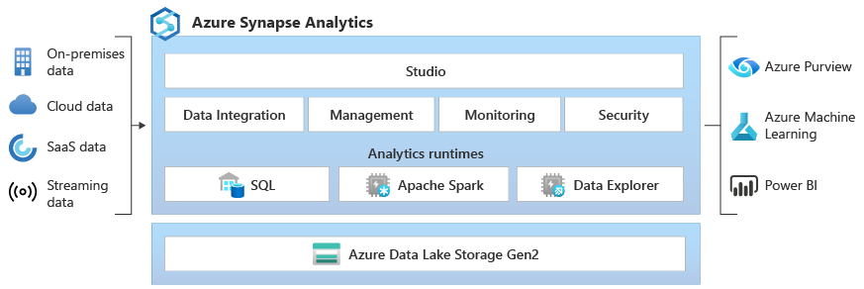

Real-Time Use Cases:
- Creating dashboards for business intelligence using Power BI integrated with Synapse.
- Running ad-hoc queries on petabytes of data for financial analysis.
- Combining structured and unstructured data for advanced analytics and reporting.

