Data Formats: Parquet, ORC, Avro

Introduction:
In modern data engineering, choosing the right file format is crucial for performance, storage efficiency, and processing speed. The three most widely used columnar and row-based formats are Parquet, ORC, and Avro. Each has its strengths and specific use cases.

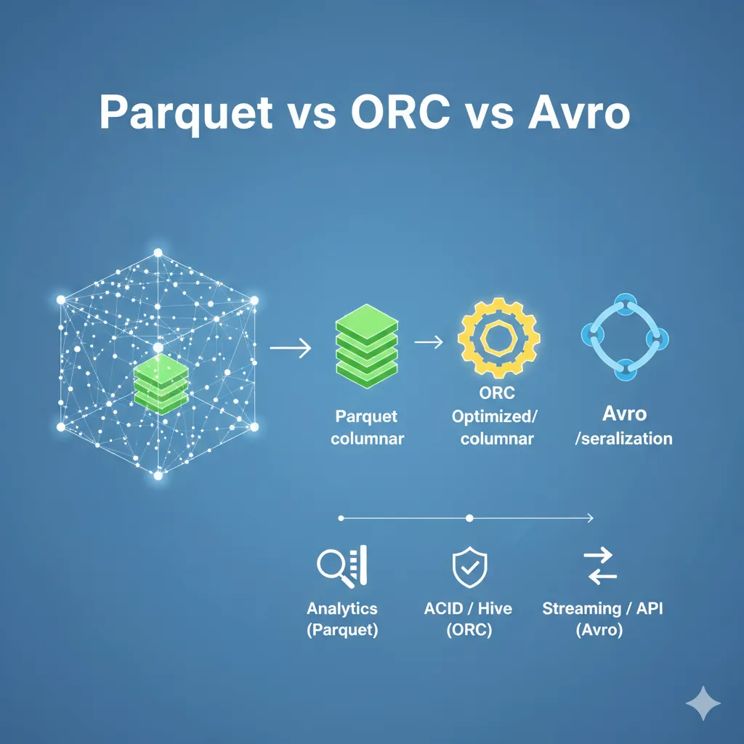

Parquet
Overview:
Parquet is a columnar storage format designed for efficient data storage and retrieval. It is highly optimized for analytical queries and is compatible with the Hadoop ecosystem.
Key Features:
- Columnar format → reads only the required columns, reducing I/O.
- Supports schema evolution.
- Good compression and encoding techniques (Snappy, Gzip).
- Works well with Spark, Hive, Presto, and other analytics engines.
Use Cases:
- Analytical workloads like aggregations, group-by’s, and reporting.
- Storing large datasets where selective column reading improves performance.
- Example: Storing e-commerce orders and running monthly revenue aggregations.

ORC (Optimized Row Columnar)
Overview:
ORC is another columnar format that provides high compression and fast read performance. It is tightly integrated with Hive but also works with Spark and other tools.
Key Features:
- Highly optimized for large historical datasets.
- Lightweight compression with Zlib or Snappy.
- Includes lightweight indexes for faster queries.
- Supports schema evolution.
Use Cases:
- Large-scale historical data storage.
- High-performance analytics on massive datasets.
- Example: Archiving several years of sensor data for batch analytics.

Avro
Overview:
Avro is a row-based format commonly used for streaming data and messaging. It stores the schema along with the data, making it ideal for serialization and deserialization.
Key Features:
- Row-based format → optimized for write-heavy workloads.
- Supports schema evolution and versioning.
- Compact and fast for serializing/deserializing data.
- Popular with Kafka and other streaming platforms.
Use Cases:
- Real-time data ingestion.
- Messaging and streaming pipelines.
- Example: Streaming user activity logs from a web application into a data lake.

Comparison Summary
Feature | Parquet | ORC | Avro
Storage Type | Columnar | Columnar | Row-based
Compression | High | Very High | Medium
Read Performance | Fast for columns | Very Fast | Fast for rows
Write Performance | Moderate | Moderate | Fast
Use Case | Aggregations & Analytics | Large Historical Data | Streaming & Messaging
Supports Schema Evolution | Yes | Yes | Yes

Conclusion
- Parquet → Best for analytical workloads and aggregation queries.
- ORC → Ideal for storing large historical datasets due to high compression.
- Avro → Excellent for real-time streaming and messaging data pipelines.

