**BUKIDNON NATIONAL SCHOOL OF HOME INDUSTRIES WEB-BASED EXAMINATION SYSTEM:**

**EXAMINATION MANAGEMENT MODULE**

**CHRISTIAN CANTON TAMPUS**

**AN UNDERGRADUATE CAPSTONE PROJECT SUBMITTED TO THE FACULTY OFTHE INSTITUTE OF COMPUTER APPLICATIONS, COLLEGE OF  
ENGINEERING, CENTRAL MINDANAO UNIVERSITY**

**BACHELOR OF SCIENCE IN INFORMATION TECHNOLOGY**

**MAY 2017**

**CHAPTER I  
INTRODUCTION**

* 1. **Background of the Study**

Throughout the history of education, teachers normally assess their students to see what they have learned, they create tests to measure their students' understanding or their capabilities based on what they have taught to their students. Tests are used to evaluate the student’s learnings, skill level growth, and academic achievements at the end of an instructional period such as the end of a lecture, grading period, or school year.

Bukidnon National School of Home Industries, a technical vocational school institution run by a government and located at Poblacion Maramag Bukidnon is an example of school institution having a large scale of students to assess with. Assessing a large scale of students consumes extra time and effort for the teachers in which technology tries to prevent.

Bukidnon National School of Home Industries Web-based Examination System is a web application designed to make assessment tests in a convenient way. An application that can minimize the human effort on assessing students by providing tests through computers application and maximizing the accuracy of recording results of the assessments.

* 1. **Statement of the Problem**

Teachers of Bukidnon National School of Home Industries are assessing students with an existing application, but they are having a problem on recording the scores of the students because they want to centralized the data to a server in which the existing application they are using cannot do. They also want the feature of having an item analysis.

* 1. **Objectives of the Study**

**1.3.1 General Objectives**

The main objective of this project is was to develop Examination Module for Bukidnon National School of Home Industries Web-based Examination System.

**1.3.2 Specific Objectives**

This module specifically aims to:

1. To create examination with four different types of questions, namely: multiple choice, identification, enumeration, and true or false;
2. To provide user interface that can manage examination data;
3. To set schedule, time limit and privacy for the examination created;
4. To provide user interface with a timer for answering the examination; and
5. To produce reports of student scores and analysis of items on the examination.
   1. **Scope and Limitations**

This web application was intended for Bukidnon National School of Home Industries for providing examination to their students through computer technologies. The system can create questions for examination and can be published to a certain subject, students who enrolled to that subject can answer the examination. Publishing examinations includes setting date and time of the examination along with the time limit and password. Question types in this system are limited on four types; True or false, Multiple choices having a limit of 10 choices, identification with two extra similar answers, and enumeration type having 10 answers only. The system also generate the scores of the students and item analysis of the examination.

**1.5 Significance of the Study**

Bukidnon National School of Home Industries web-based examination system would have a great help for the teachers in assessing or evaluating their students with an easy and convenient way. The process of creating tests will become easier and less effort, with item analysis feature, evaluating each questions become more accurate and can be generate right away after examination period. The system will also improve the accuracy of student test results.

Overall, the significance of this study would greatly improve BNSHI on assessing methods via examination system.

**CHAPTER II  
TECHNICAL BACKGROUND**

**PHP**

PHP is a server scripting language and a powerful tool for making dynamic and interactive web pages. What distinguishes PHP from something like client-side JavaScript is that the code is executed on the server which is generating HTML which is then sent to the client. The client would receive the results of running that script, but would not know what the underlying code was (What is PHP? n.d.).

**MySQL**

MySQL is an open source relational database management system. databases are typically used for web application development (often accessed using PHP). It can be accessed (queried) directly using: C, C++, Eiffel, Java, Perl, PHP and Python computer languages. MySQL databases are queried using a subset of the standard Structured Query Language (SQL) commands (MySQL, n.d.).

**HTML5 DOCTYPE**

HTML5 is the latest evolution of the standard that defines HTML. The term represents two different concepts. It is a new version of the language HTML, with new elements, attributes, and behaviors, and a larger set of technologies that allows the building of more diverse and powerful Web sites and applications. This set is sometimes called HTML5 & friends and often shortened to just HTML5 (Introduction to HTML5, 2018).

**CSS**

[CSS](https://developer.mozilla.org/en-US/docs/Glossary/CSS) (Cascading Style Sheets) is used to style and lay out web pages — for example, to alter the font, colour, size and spacing of your content, split it into multiple columns, or add animations and other decorative features. This module gets you started on the path to CSS mastery with the basics of how it works, including selectors and properties, writing CSS rules, applying CSS to HTML, how to specify length, colour, and other units in CSS, cascade and inheritance, and debugging CSS (Introduction to CSS, 2018).

**Javascript**

JavaScript is a scripting or programming language that allows you to implement complex things on web pages — every time a web page does more than just sit there and display static information for you to look at — displaying timely content updates, interactive maps, animated 2D/3D graphics, scrolling video jukeboxes, etc. — you can bet that JavaScript is probably involved. It is the third layer of the layer cake of standard web technologies, two of which ([HTML](https://developer.mozilla.org/en-US/docs/Learn/HTML) and [CSS](https://developer.mozilla.org/en-US/docs/Learn/CSS)) we have covered in much more detail in other parts of the Learning Area (What is Javascript, 2018).

**jQuery**

jQuery is a cross-platform Javasript Library designed to simplify the [client-side scripting](https://en.wikipedia.org/wiki/Client-side_scripting) of [HTML](https://en.wikipedia.org/wiki/HTML). It is [free, open-source software](https://en.wikipedia.org/wiki/Free_and_open_source_software) using the permissive [MIT License](https://en.wikipedia.org/wiki/MIT_License). [Web](https://en.wikipedia.org/wiki/World_Wide_Web) analysis indicates that it is the most widely deployed JavaScript library by a large margin.

jQuery's syntax is designed to make it easier to navigate a document, select DOM elements, create animations, handle events, and develop Ajax applications. jQuery also provides capabilities for developers to create plugins on top of the JavaScript library. This enables developers to create abstractions for low-level interaction and animation, advanced effects and high-level, themeable widgets. The modular approach to the jQuery library allows the creation of powerful dynamic web pages and Web applications (Introduction to Jquery, 2010).

**Ajax**

(Ajax is not a programming language or a tool, but a concept. Ajax is a [client-side script](https://www.seguetech.com/client-side-scripting-performance/) that communicates to and from a server/database without the need for a [post back](http://www.c-sharpcorner.com/uploadfile/2f73dd/what-is-postback-in-Asp-Net/) or a complete page refresh. The best definition I’ve read for Ajax is “the method of exchanging data with a server, and updating parts of a web page – without reloading the entire page.” Ajax itself is mostly a generic term for various [JavaScript](https://www.seguetech.com/blog/2013/02/15/java-vs-javascript) techniques used to connect to a web server dynamically without necessarily loading multiple pages. In a more narrowly-defined sense, it refers to the use of [XmlHttpRequest](http://en.wikipedia.org/wiki/XMLHttpRequest) objects to interact with a web server dynamically via JavaScript (Segue Techonologies, 2013).

**Bootstrap**

Bootstrap is a free front-end framework for faster and easier web development. It includes HTML and CSS based design templates for typography, forms, buttons, tables, navigation, modals, image carousels, and many other as well as optional JavaScript plugins. It also gives the ability for the developers to easily create responsive designs which automatically adjust themselves to look good on all devices from small phones to large desktops (Bootstrap, n.d.).

**XAMPP**

XAMPP stands for Cross-Platform (X), Apache (A), MySQL (M), PHP (P) and Perl (P). It is a simple, lightweight Apache distribution that makes it extremely easy for developers to create a local web server for testing purposes. Everything you need to set up a web server – server application (Apache), database (MySQL), and scripting language (PHP) – is included in a simple extractable file. XAMPP is also cross-platform, which means it works equally well on Linux, Mac and Windows. Since most actual web server deployments use the same components as XAMPP, it makes transitioning from a local test server to a live server is extremely easy as well. Web development using XAMPP is especially beginner friendly, as this popular PHP and MySQL for beginners class will teach you as stated by Kasia Mikoluk (2013).

**CHAPTER III**

**REVIEW OF RELATED LITERATURE**

**3.1 Review of Related Concept**

Online examination system has been widely applied in teaching, especially in the teaching of computer courses. Presently the online exam system model has two types: Browser/Server model (B/S) and Client/Server model (C/S). The (B/S) model based on browser is a kind of Thin Client, the main advantage of examination system based on (B/S) model is easy to install and maintain, but cannot make full use of the client's resources, all the examination's managements are assumed by server, which not only increase the server's burden, but also increase network traffic by transmitting data between client and server, at the same time, this model is unable to operate client's files and is unable to grade student's examination files etc. Therefore this model is not suitable for examination system of knowledge points with complex operation, is only suitable for the simple online examination system of objective questions. On the contrary, Rich Client(C/S) examination system model can make full use of the resources of client, access to the disk of client and get the application program interface (API). At the same time, the system based on C/S transmits the data only between client and server, needn't transmit the interface, so the examination system based on C/S executes faster than the system based on B/S. The main faults of the examination system based on C/S are due to the complicated work for installation, maintenance and deployment. And restrictions and requirements for client are strict and the examination system can't achieve reuse of program of cross-platform. In order to solve these problems, the paper puts forward an online examination system based on web service and COM components. (Li Jun, 2009)

A Web-based operational skills examination and evaluation system is designed and implemented for computer courses. It consists of four systems, including preparation, examination, monitor and auto-grading subsystem. Various techniques involving DCOM, mark-method and fuzzy-match are adopted in this system, and a universal approach is generalized to enable auto-grading system suitable for different operated results. This system has been successfully applied in operational skills' evaluation and training, such as programming, editing documents, using Microsoft Windows (Zhang, July 2006)

The rapid uptake of campus‐wide Learning Management Systems (LMS) is changing the character of the on‐campus learning experience. The trend towards LMS as an adjunct to traditional learning modes has been the subject of little research beyond technical analyses of alternative software systems. (Coates, James, & Baldwin, 2010)

Academic integrity has been a perennial issue in higher education. Undoubtedly, the advent of the Internet and advances in user-friendly technological devices have spurred both concern on the part of faculty and research interest in the academic community regarding inappropriate and unethical behavior on the part of students. There is a study designed to gauge the attitudes of business students toward various issues and behaviors when taking an examination "online" and obtain an estimate of the extent of "cheating" in traditional versus online coursework from the perspective of college students. The results, based on a sample of 121 undergraduate business students from a university in the South, indicate that respondents felt quite liberal in their views of potentially "cheating" behaviors when there was no test-taking policy set by the course instructor. In addition, 73.6% of the students in the sample held the perception that it is easier to cheat in an online versus traditional course. We believe that, based on prior research, the current results would be applicable to general student populations in other academic disciplines. The findings are discussed in light of prior research on academic integrity issues and recommendations for future research are noted. (King, Chula G.; Guyette, Roger W., Jr.; Piotrowski, Chris, 2009)

Faculty satisfaction is considered an important factor of quality in online courses. A study was conducted to identify and confirm factors affecting the satisfaction of online faculty at a small research university, and to develop and validate an instrument that can be used to measure perceived faculty satisfaction in the context of the online learning environment. The online faculty satisfaction survey (OFSS) was developed and administered to all instructors who had taught an online course in fall 2007 or spring 2008 at a small research university in the USA. One hundred and two individuals completed the web‐based questionnaire. Results confirm that three factors affect satisfaction of faculty in the online environment: student‐related, instructor‐related, and institution‐related factors. (Bolliger & Wasilik, 2009)

Active learning methodologies based on Information and Communication Technology (ICT) are, nowadays, one of the most important tools in addressing the change that is taking place in Higher Education. When active learning is compared to traditional teaching methods, students achieve better comprehension, retain the information longer and enjoy the class more. In fact, a major benefit of the use of active methodologies is that they contribute to students developing the capacity actively to research and undertake responsibility for their own learning process, and to solve problems with their own resources. (Regueras, Verdu, Munoz, Perez, de Castro, & Verdu M., 2009)

Computer aided instruction (CAI) encompasses a broad range of computer technologies that supplement the classroom learning environment and can dramatically increase a student’s access to information. Criticism of CAI generally focuses on two issues: it lacks an adequate foundation in educational theory and the software is difficult to implement and use. It is shown that the use of CAI is pedagogically effective and that currently available applications are easy to integrate into the student’s in-class experience. For student evaluations, mean responses were compared on ten questions believed to be influenced by the switch from traditional homework assignments to CAI-based homework assignments. While differences were generally in the expected direction, it could not be shown that CAI had a direct impact on student evaluations of either the course or the instructor. For student grades, final exam grades were compared before and after the adoption of CAI. (Collins, Deck, & McCrickard, 2011)

Increasing numbers of universities are offering courses in online and hybrid formats. One challenge in online assessment is the maintenance of academic integrity. We present a thorough statistical analysis to uncover differences in student performance when online exams are administered in a proctored environment (i.e., in class) versus an unproctored environment (i.e., offsite). Controlling for student grade point average (GPA), no significant differences in mean overall course performance or exam performance between the two groups were found, nor were there any differences in the mean vectors of individual exam scores. The study reveals that the group taking online exams in the unproctored environment has significantly more variation in their performance results. In examining potential causes of the greater variation, analyses were performed to assess whether an increased level of possible cheating behavior could be observed from performance results for students in the unproctored section. No evidence of cheating behavior was found. (Hollister & Berenson, 2009)

In the situation of giving an online examination, there are security factors to consider beyond simple password authentication for access to the examination. It is not unreasonable to assume that a student may willingly give their password to someone else, with the intent that the other person will take the examination for the student.

Online examinations pose a unique problem for distance-based education, in that it can be very difficult to provide true user authentication. Due to the inherent anonymity of being online, compared to taking an examination in a classroom environment, students may attempt to artificially boost their scores in online examinations by having another individual take the exam for them, which a typical user/password authentication scheme cannot detect. (Flior, 2010)

The Federal Trade Commission has declared the privacy and security of consumer information to be two major issues that stem from the rapid growth in e-commerce, particularly in terms of consumer-related commerce on the Internet. Although prior studies have assessed online retailer responses to privacy and security concerns with respect to retailers’ disclosure of their practices, these studies have been fairly general in their appr*o*aches and have not explored the potential for such disclosures to affect consumers. The authors examine online retailer disclosures of various privacy- and security-related practices for 17 product categories. They also compare the prevalence of disclosures to a subset of data from a consumer survey to evaluate potential relationships between online retailer practices and consumer perceptions of risk and purchase intentions across product categories. (Martin, 2015)

**3.2 Review of Related System**

**Moodle**

Moodle is a Learning Platform or course management system (CMS) a free Open Source software package designed to help educators create effective online courses based on sound pedagogical principles.

Moodle is a free and open-source learning management system written in PHP and distributed under the GNU General Public License. Developed on pedagogical principles, Moodle is used for blended learning, distance education, flipped classroom and other e-learning projects in schools, universities, workplaces and other sectors.

With customizable management features, it is used to create private websites with online courses for educators and trainers to achieve learning goals. Moodle (acronym for modular object-oriented dynamic learning environment) allows for extending and tailoring learning environments using community sourced plugins.

**QuizBase**

QuestBase is the on-line quiz creator that allows teachers and trainers to create tests and assessments. Easily build quizzes and exams for students or employees with powerful customizable features, such as question banks, data security, privacy options, automated grading and personal certificates.

QuestBase is more than a simple quiz maker or test creator software because it comes with a full range of options and it's very easy to use: you can create and publish your first assessment in a few minutes!

**Webquiz**

WebQuiz XP allows you to customize the graphical layout of your quizzes and tests. With just a mouse click you can choose one of the available templates and, after applying it, the quiz will be immediately changed with the new settings. ASP quizzes, instead, come with complete source code, so you can edit them according to your needs (for example, you can add logos, change texts, pictures and layout,etc.). SmartLite can also create custom templates built specifically for your website or your project. Answers given by test takers can be collected and saved to a database; this way, you can use this database to interact with the program. For example, if you have a web training class, you can link a WebQuiz assessment file directly from your pages, users take the test and then you can check their scores in the database.

**Edmodo**

Edmodo is an educational social media site/application, wherein the teacher and their students can interact and communicate. The teacher can create quiz, activities, post topics, assignments and record scores for their children. The students can take the online quiz and online exam and get the result automatically.

**EasyLMS**

It’s easy to get started with our online examination software. First you are able to write a short introduction. In this introduction you can write what participants can expect from your exam. After that, you can add questions (multiple choice, fill in the blanks or free text). To make your exam livelier, you can add an image, audio or video. An explanation of the answer will be shown after you’ve made the exam. The creator is able to set a time limit for the whole exam or per question. You can decide the start date and the end date (including hours) for your participants to have access to the exam. After you’ve created the exam, it gives you the chance to put it online. By sharing the URL, participants are able to click on the link that will lead them to the exam. After participants made the exam, the creator is able to view the progress of participants. You’re able to view the statistics per user or get an overall view of the performance of the group.

**CHAPTER IV  
METHODOLOGY**

**4.1 Research Approach**

The research concept discussed in the previous chapter is web application. Hence, a qualitative research approach based on observations, document studies and interviews taken from real world modeling projects is argued for in order to meet the research objectives. However, a few alternative research approaches will also be discussed.

**4.2 System Development Methodology**

**4.2.1 Iterative SDLC Model**

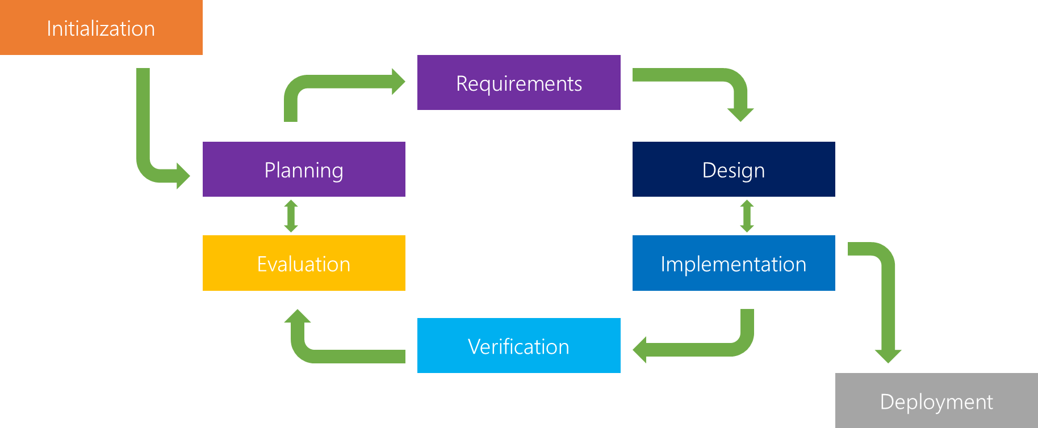Iterative model is a particular implementation of a software development life cycle (SDLC) that focuses on an initial, simplified implementation, which then progressively gains more complexity and a broader feature set until the final system is complete. When discussing the iterative method, the concept of incremental development will also often be used liberally and interchangeably, which describes the incremental alterations made during the design and implementation of each new iteration.

SOURCE: (Powell-Morse, 2016)

Figure 4.1 Iterative Model

**4.3 System Requirements Specifications**

**4.3.1 Functional Requirements**

This section are the technical details and specific functionality that the system can do.

* **Creating Examination:** The general objective of the system was to create an examination, Hence these are the details on creating an examination:
  + **Multiple Choice:** In this functionality, it can create a multiple choice type of question and can be answered also in multiple answers. This functionality has a minimum choices of two and maximum of 10.
  + **True or False:** A question that has only two different choices, true or false.
  + **Identification:** This functionality is to create a question that has only one answer, but in this system, another two similar answer will be provided and can be count as one answer.
  + **Enumeration:** In this functionality, the system can create a question having a multiple answers without choices. The answers are limited to 10 inputs.
  + **Publishing Exam:** Publishing exam is the most important upon creating examination. For the students to take the exam, the examination must be published.
* **Checking Examination:** After creating an examination, a student has to take or answer the exam.
  + **Shuffling Choices and Questions:** In order to minimize the cheating possibilities, questions and choices are shuffled by default.
  + **Case Sensitiveness:** Upon checking the answers of the student on examinations, case sensitiveness has been eliminated.
  + **Scoring:** In examination, scoring is the last part. Each answer count as one score in all types of questions, however multiple choice has different scoring, If the questions has multiple answers, score of this question is based on how many answer that the question provided, but if the student answers have at least one mistake, automatically the score of the question is zero.
* **Table of Specification:** Report of the exams which shown the difficulty of the question based of the total mistakes of the students.
* **Examination Timer:** Upon creating the examination, time limit must be provided. During examination, if the time got used up, the answers of the student automatically submitted and checked by the system.

**4.3.2 Input Requirements**

* **Questions:** One of the most important input of the system is the questions.
  + **Choices:** In multiple choice, choices is needed to be input.
  + **Answers:** All question types have its own answers.
* **Examination Password:** Exam must have a password for securities.
* **Answers:** Students answer.

**4.3.3 Output Requirements**

* **Examination Data:** All questions created are displayed on the students views.
* **Examination Result:** Report of student scores can be export to .pdf, .xlsx, .csv and can be copied to clipboard.

**4.3.4 Software Requirements**

* **Operating System:** Acts as an intermediary between the user of a computer and the computer hardware that will control the web browser.
* **Web Browser:** Preferred web browsers like Google Chrome in order to launch the system
* **MySQL Database:** It is an open source relational database management system that uses structured query language (SQL). The information would be stored in the MySQL Database that contained the tables and fields responsible for the storage and relationship.
* **Apache HTTP Server:** allows you to develop PHP server-side scripting applications without the need for a remote web server, offering you the opportunity to work faster, develop stuff more securely, and work on your apps without an internet connection.

**4.3.5 Hardware Requirements**

To use this system, any computer can be used as long as it is functional and connected on a network.

**4.4 System Analytics**

This section describes the analytical requirements of this module. This module should have/to do the following:

* The system can manage the operation of web examination.
  + Add/Edit/Delete Questions
  + Privacy of the exam
  + Examination Details
* The system can compute the scores accurately of each student after submitting the exam.
* The system can produce reports in form of .pdf, .csv, .xlsx files.
  + Class records
  + Examination results

**4.5 Data Dictionary**

|  |  |  |  |  |
| --- | --- | --- | --- | --- |
| **TABLE NAME** | **TABLE DESCRIPTION** | **ATTRIBUTE** | **DATA TYPE** | **ATTRIBUTE DSCRIPTION** |
| exams | Contains the basic descriptions of an examination. | exam_no | INTEGER | act as the primary key of the table |
| exam_name | VARCHAR | hold the examination names |
| class_code | INTEGER | ID of the class |
| exam_description | VARCHAR | description of the exam |
| time_limit | DOUBLE | time limit of the exam |
| exam_date | DATETIME | date and time of exam to be available |
| exam_date_expired | DATETIME | date and time of exam to be expired |
| exam_password | VARCHAR | password of the exam |
| date_created | DATETIME | date and time of exam created |
| date_publish | DATETIME | date and time of the exam published |
| teacher_account_no | INTEGER | ID of the teacher who created the exam |
| availability | VARCHAR | determine if the exam is available |
| exam_details | Contains the questions and answers of the exam | exam_no | INTEGER | act as the foreign key of the table |
| question_id | INTEGER | ID of every question |
| question_type | VARCHAR | type of every question |
| question | TEXT | holds the question |
| question_no | INTEGER | holds the ordering of the questions |
| answer1 | TEXT |  |
| answer2 | TEXT |  |
| answer3 | TEXT |  |
| answer4 | TEXT |  |
| answer5 | TEXT |  |
| answer6 | TEXT |  |
| answer7 | TEXT |  |
| answer8 | TEXT |  |
| answer9 | TEXT |  |
| answer10 | TEXT |  |
| choice1 | TEXT |  |
| choice2 | TEXT |  |
| choice3 | TEXT |  |
| choice4 | TEXT |  |
| choice5 | TEXT |  |
| choice6 | TEXT |  |
| choice7 | TEXT |  |
| choice8 | TEXT |  |
| choice9 | TEXT |  |
| choice10 | TEXT |  |
| exam_results | holds the examination results | exam_result_no | INTEGER | ID of the exam result |
| score | INTEGER | holds the total scores |
| student_account_no | INTEGER | id of the student |
| exam_no | INTEGER | id of the exam |
| exam_result_details | description of score in the exam (results) | exam_result_dtls_no | INTEGER | id of the detail |
| question_id | INTEGER | id of the exam item |
| remarks | INTEGER | remarks of the student |
| exam_result_no | INTEGER | foreign key of the field |
| courses | holds the basic description of the class | class_code | VARCHAR | primary key and ID of the class |
| teacher_account_no | INTEGER | ID of the teacher |
| course_title | VARCHAR | Subject name of the class |
| course_code | VARCHAR | code of the class |
| course_description | VARCHAR | description of the class |
| status | VARCHAR | status of the class |
| datecreated | DATETIME | date and time of the class created |
| posts | contains all the post in the class | post_no | INTEGER | post ID |
| class_code | VARCHAR | class ID |
| posted_date | DATETIME | date and time of post |
| post_type | VARCHAR | type of the post |
| post_title | VARCHAR | title of the post |
| post_desc | VARCHAR | description of the post |
| file_details | contains the file details of the posts | file_idno | INTEGER | id of file |
| post_no | INTEGER | foreign key, ID of post |
| file_name | TEXT | name of the file |
| file_link_or_path | TEXT | link or path of the file |
| activities | contains all the logs and activities of every users | activity_no | INTEGER | act as the primary key |
| activity_time | DATETIME | time or logs of activity |
| activity_name | TEXT | activity made by the user |
| usertype | INTEGER | user type of each user |
| user | INTEGER | user id |
| student_requests | holds all the requests of the students | request_no | INTEGER | id no of the request |
| teacher_account_no | INTEGER | teacher account no received the request |
| student_account_no | INTEGER | student id send request |
| class_code | VARCHAR | id of the class where request happened |
| request_date | DATETIME | date and time of the request |
| status | VARCHAR | status of the request |
| accounts_student | Contains the information of the student accounts | student_account_no | INTEGER | basic information of the student account |
| student_firstname | VARCHAR |
| student_lastname | VARCHAR |
| student_middleinitial | VARCHAR |
| student_username | VARCHAR |
| student_password | VARCHAR |
| student_email | VARCHAR |
| student_province | VARCHAR |
| student_street | VARCHAR |
| student_bdate | VARCHAR |
| student_gender | VARCHAR |
| student_about | VARCHAR |
| student_phone | VARCHAR |
| student_fb | VARCHAR |
| student_twitter | VARCHAR |
| student_gplus | VARCHAR |
| student_site | VARCHAR |
| student_program | VARCHAR |
| student_major | VARCHAR |
| student_yl | VARCHAR |
| student_confirmationcode | VARCHAR |
| accounts_teacher | Contains the information of the teacher accounts | teacher_account_no | INTEGER | basic information of the teacher account |
| teacher_firstname | VARCHAR |
| teacher_lastname | VARCHAR |
| teacher_middleinitial | VARCHAR |
| teacher_username | VARCHAR |
| teacher_password | VARCHAR |
| teacher_email | VARCHAR |
| teacher_province | VARCHAR |
| teacher_street | VARCHAR |
| teacher_bdate | VARCHAR |
| teacher_gender | VARCHAR |
| teacher_about | TEXT |
| teacher_phone | VARCHAR |
| teacher_fb | VARCHAR |
| teacher_twitter | VARCHAR |
| teacher_gplus | VARCHAR |
| teacher_site | VARCHAR |
| teacher_program | VARCHAR |
| teacher_major | VARCHAR |
| teacher_yl | VARCHAR |
| teacher_confirmationcode | VARCHAR |
| accounts_admin | Contains the information of the admin accounts | admin_account_no | INTEGER | basic information of the admin account |
| admin_account_no | INTEGER |
| admin_firstname | VARCHAR |
| admin_lastname | VARCHAR |
| admin_middleinitial | VARCHAR |
| admin_username | VARCHAR |
| admin_password | VARCHAR |
| admin_email | VARCHAR |
| admin_province | VARCHAR |
| admin_street | VARCHAR |
| admin_bdate | VARCHAR |
| admin_gender | VARCHAR |
| admin_about | TEXT |
| admin_phone | VARCHAR |
| admin_fb | VARCHAR |
| admin_twitter | VARCHAR |
| admin_gplus | VARCHAR |
| admin_site | VARCHAR |

**4.6 Design**

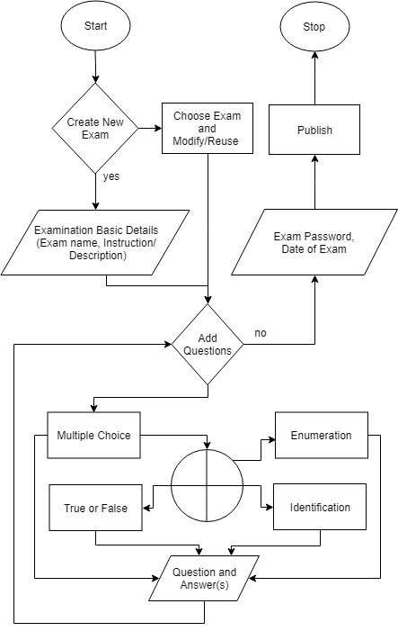 **4.6.1 Flowchart**

*Figure 4.2: Flowchart*

**4.6.2 Context Level Diagram**

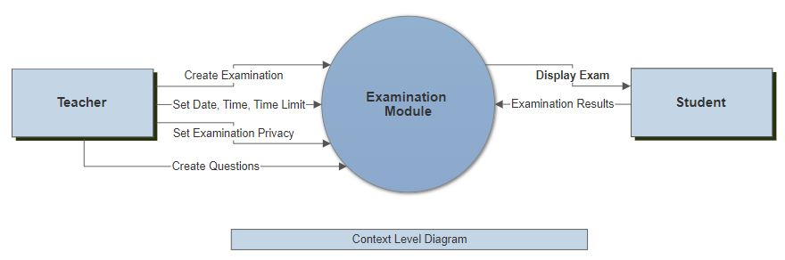

*Figure 4.3: Context Level Diagram*

**4.6.3 Explosion Level Diagram**

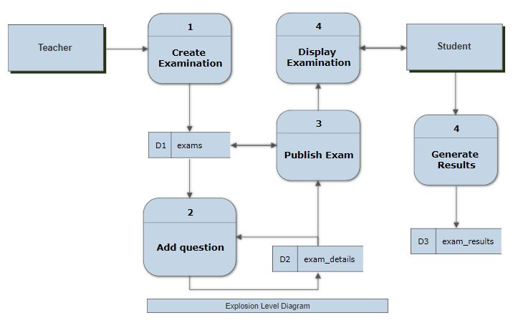

*Figure 4.4: Explosion Level Diagram*

**4.6.4 Second Explosion Data Flow Diagram**

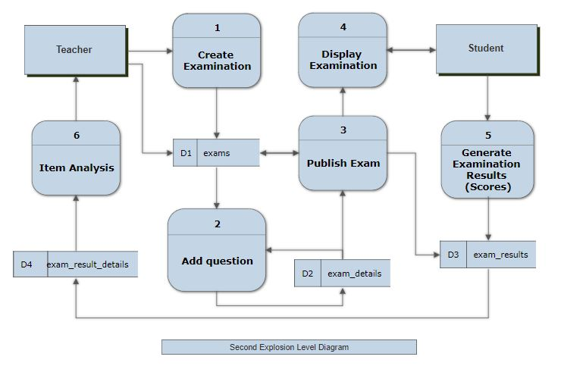

*Figure 4.5: Second Explosion Data Flow Diagram*

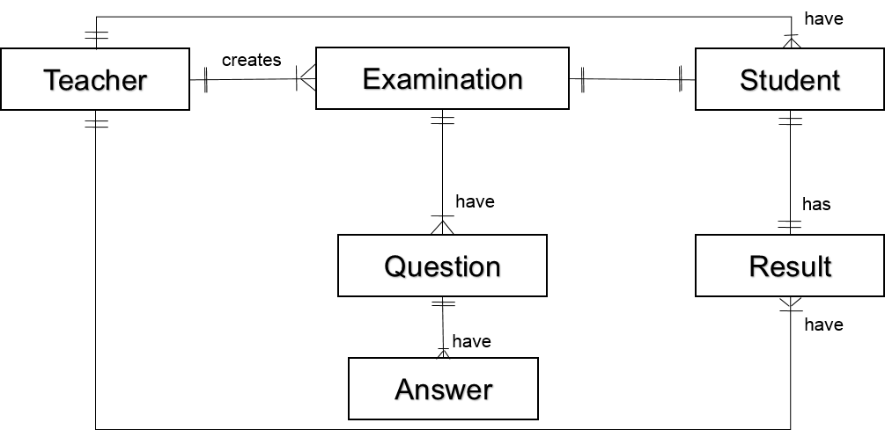**4.6.5 Entity Relationship Diagram**

*Figure 4.6: ERD*

**4.6.5 Use Cases**

**Use Case 1**

|  |  |  |
| --- | --- | --- |
| Use-case Number | UC-01 | |
| Use-Case Name | Create Examination | |
| Priority | High | |
| Actor | Teacher | |
| Description | This use case describes how to create examination | |
| Precondition | Click button (Create New Exam) | |
| Post-condition | If the use case was successful, the actor can now manage questions for that specific exam. | |
| Basic course of Action | **User Action** | **System Response** |
| * The actor must click the button (Create New Exam) * Actor must input the following Examination details (Examination Name/Title with optional Instruction/Directions) | * System dialog box will appear for new examination to fill in. * Exam is now created, The actor will be redirected to the createexam page. * Use case Exit |

|  |  |  |
| --- | --- | --- |
| Use-case Number | UC-02 | |
| Use-Case Name | Create Questions | |
| Priority | High | |
| Actor | Teacher | |
| Description | This use case describes how to create question for the exam created | |
| Precondition | Create Examination | |
| Post-condition | If the use case was successful, the actor can now publish the examination created. | |
| Basic course of Action | **User Action** | **System Response** |
| 1. The actor will choose what type of question to add. (Multiple Choice, True or False, Identification, Enumeration. 2. Actor must input the question and its answer. And save. | 1. System dialog box will appear for a new a question to fill in      1. Notification from the system will appear(successful/ unsuccessful) 2. Use case Exit |
| Alternate course of Action | 5.1 If the actor wants to add another question then goes back or returns to step 1 of basic course of Action to enter again. | |

**Use Case 2**

|  |  |  |
| --- | --- | --- |
| Use-case Number | UC-03 | |
| Use-Case Name | Publish Examination | |
| Priority | High | |
| Actor | Teacher | |
| Description | This use case describes how to publish the exam created | |
| Precondition | Create Questions | |
| Post-condition | If the use case was successful, the student can answer the examination. | |
| Basic course of Action | **User Action** | **System Response** |
| 1. The actor click button(Publish Exam)     3 Actor must input the required fields. And click publish to submit. | 1. System dialog box will appear for publication details. (Exam time limit, Date and time, and password) 2. The actor will be redirected to mycourse page 3. Use case Exit |

**Use Case 3**

**Use Case 4**

|  |  |  |
| --- | --- | --- |
| Use-case Number | UC-04 | |
| Use-Case Name | Answer Examination | |
| Priority | High | |
| Actor | Student | |
| Description | This use case describes how student to take the exam created | |
| Precondition | Published Exam (By the Teacher) | |
| Post-condition | If the use case was successful, the student can view results. | |
| Basic course of Action | **User Action** | **System Response** |
| 2 The actor inputs the password of examination.  4 Actor must submit the answers. | 1. System dialog box will appear asking the examination password. 2. The actor can answer the questions provided. 3. The actor automatically viewed the result. 4. Exit use case |

REFERENCES

[1] Benefits of a Web Based System (n.d.). Retrieved October 22, 2017 from http://www.pjweb.co.uk/blog/benefits-of-a-web-based-system/

[2] Bringing MySQL to the web. Retrieved October 26, 2017, from https://www.phpmyadmin.net/

[3] Faculty of Engineering, Prince of Songkla University, Examination information system, https://infor.eng.psu.ac.th/exam/.

[4] HTML – Overview. Retrieved October 24, 2017, from Tutorials Point Website: <https://www.tutorialspoint.com/html/html_overview.htm>

[5] LIU Li-ping, WANG Wen-jie “Design of Web-Based Exam-question with Self-study and Adaptive Adjusting” Computer System and Applications (in Chinese). Apr. 2006, pp.45–47

[6] Mikoluk K. (2013) Xampp Tutorial: How to use xampp to run your own web server*.* Retrieve October 28, 2017, from <https://blog.udemy.com/xampp-tutorial/>

[7] Vasupongayya, S., Noodam, W. and KongyongImplemention P. (2013) Vol:7, No:7, 2013, Developing Examination Management System: Senior Capstone Project, a Case Study. Retrieved October 25, 2017, from http://waset.org/publications/16548/developing-examination-management-system-senior-capstone-project-a-case-study

[8] What is CSS? Retrieved October 23, 2017, from Tutorials Point Website: <https://www.tutorialspoint.com/css/what_is_css.htm>

[9] What is Mysql? *MySQL is a database management system. MySQL databases are relational****.*** Retrieved October 26, 2017, from <https://dev.mysql.com/doc/refman/5.7/en/what-is-mysql.html>

[10] What is SQL? Retrieved October 25, 2017, from http://www.sqlclass.com/intro.html

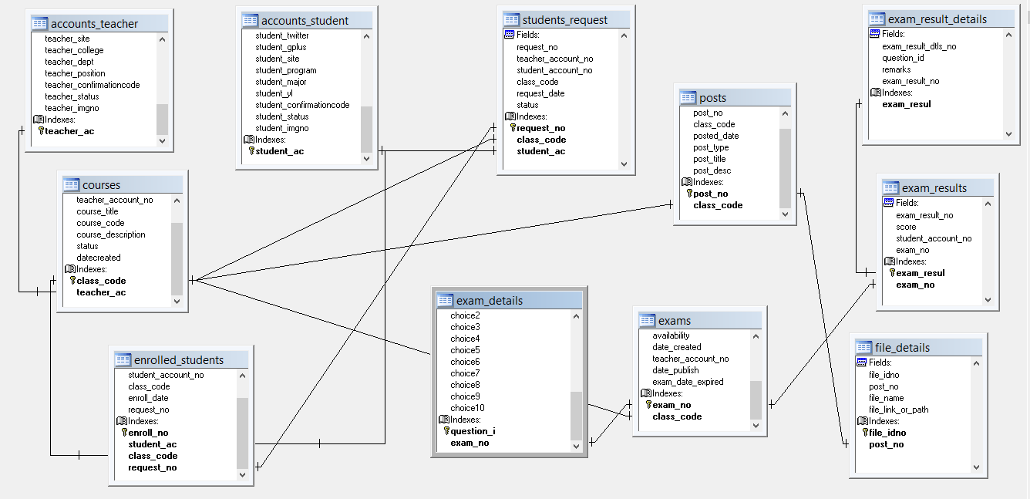**Appendix A. Database Model**