**System Guide**

**Code Plagiarism Detector**

12/6/17

**Team Members**

Jonathan Gregory

Joshua Gregory

James Rinella

Sami Shukri

Kevin Smith

# Node.js/Electron

1.1 Node.js/npm installation

- Download the Windows installer from nodejs.org

- Run the installer

- Restart is required

- Test if node.js and npm install was successful

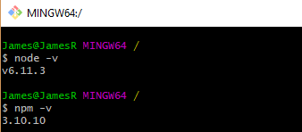

1.2 Dependencies (Bundled with project)

- Electron

- JQuery

- Bootstrap

- Firebase

1.3 Other

- An internet connection is required to authenticate with Google Firebase

# Python Parser

# MOSS