DEEPFAKE NEWS DETECTION

## Team Members: -

* **Ananya Jain - E23CSEU0378**
* **Diya Upadhyay - E23CSEU0389**
* **Srijan - E23CSEU0364**

Under the guidance of **Dr. Yajnaseni Dash**

Department Of Computer Science

Bennett University

Greater Noida, Uttar Pradesh, India

Certificate

This is to certify that the project report entitled: **“Deepfake News Detection”**

submitted by **Diya Upadhyay** **(Roll No: E23CSEU0389)** in partial fulfillment of the requirements for the award of the degree of **Bachelor of Technology in Computer Science**, is a record of original work carried out by him under my supervision and guidance.

To the best of my knowledge, this project report has not been submitted earlier, either in part or full, for the award of any degree or diploma in any university or institute.

Project Guide   
**Dr. Yajnaseni Dash**

Bennet University, Greater Noida  
April 2025

Acknowledgement

We, the project team, would like to express our heartfelt gratitude to our project guide, **Dr. Yajnaseni Dash**

, for her invaluable guidance, motivation, and continuous support throughout the course of this project. Her expertise and insightful suggestions played a pivotal role in shaping the direction and outcome of our work.

We are also thankful to one another for the strong sense of teamwork, mutual support, and dedication that each member brought to the project. The spirit of collaboration was crucial in overcoming challenges and ensuring the successful completion of this work.

Our sincere thanks extend to our friends for their encouragement and moral support, and to our families for their patience, understanding, and constant motivation during the entire journey.

This project would not have been possible without the collective efforts and support of all the individuals mentioned above.

* **Team Members:**
* Ananya Jain - E23CSEU0378
* Diya Upadhyay - E23CSEU0389
* Srijan - E23CSEU0364

1. Introduction

With the surge of online information dissemination, fake news has emerged as a significant threat to public trust, political stability, and personal reputations. The goal of this project is to develop a machine learning-based system capable of detecting fake news articles by analyzing textual content. Our approach utilizes the Passive Aggressive Classifier,a fast and efficient algorithm for large-scale classification tasks. We deployed the model using a simple web interface to allow real-time interaction with users.

2. Objective

To build a reliable and efficient fake news detection model using a Passive Aggressive Classifier, capable of differentiating between real and fake news articles based on their textual features, while exploring the intricacies and ethical concerns of misinformation in the digital age.

3. Tools & Technologies Used

• **Programming Language:** Python  
• **Libraries & Frameworks:** Pandas, NumPy, Scikit-learn, TfidfVectorizer  
• **Machine Learning Model:** Passive Aggressive Classifier  
• **Deployment Platform:** Flask

4. Methodology

**4.1 Data Collection**

The dataset was sourced from open repositories like Kaggle, consisting of labeled news articles marked as either real or fake. The dataset included a balanced mix of political, social, and financial news items.

https://www.kaggle.com/datasets/saurabhshahane/fake-news-classification

**4.2 Preprocessing & Feature Extraction**

• Data cleaning included removing stop words, punctuation, and unnecessary HTML tags.  
• Text was vectorized using **TF-IDF (Term Frequency-Inverse Document Frequency)** to highlight important terms while reducing the impact of commonly used words.  
• This converted raw text into numerical vectors for model training.

**4.3 Model Development**

• **Passive Aggressive Classifier :**  was chosen due to its efficiency in handling large datasets and ability to update dynamically with new data.  
• The model is ideal for binary classification and works well in online learning scenarios where data arrives in streams.  
• Hyperparameter tuning was performed to achieve optimal regularization and iteration counts.

**. Logistic Regression : :**  was chosen due to its efficiency in handling large datasets and ability to update dynamically with new data.

**4.4 Model Deployment**

• A minimal web interface was developed (using Streamlit or Flask) to allow users to paste or upload news content and receive a prediction (Fake or Real) in real time.  
• Backend integration ensured the classifier responded dynamically to user inputs, simulating a production environment.

**4.5 Confusion Matrix**

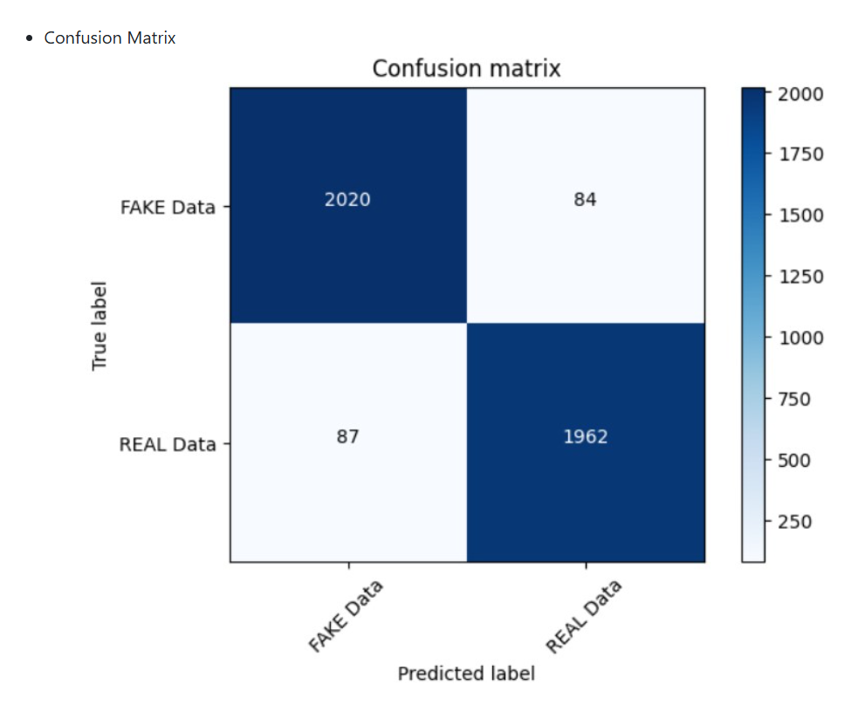

**5. Challenges Faced**

• **Textual Ambiguity:** Differentiating fake news from real news purely through text can be difficult due to subtle manipulations in language.  
• **Data Quality:** Some datasets contained biased or repetitive samples. This was addressed via deduplication and balanced sampling.  
• **Real-Time Performance:** Ensuring the model worked efficiently with live input without latency.  
• **Interpretability:** Making the model's decision-making understandable to non-technical users was a challenge.

**6. Results & Evaluation**

• **Accuracy:** The Passive Aggressive Classifier achieved high accuracy (~96%) on validation datasets.  
• **Speed:** The model was lightweight and responded quickly to inputs.  
• **User Experience:** The simple web interface made testing accessible and engaging.  
• **Metrics Used:** Accuracy, Precision, Recall, F1-Score, Confusion Matrix. The classifier showed strong generalization and robustness.

As we used two models :

**Passive Aggressive Classifier:**

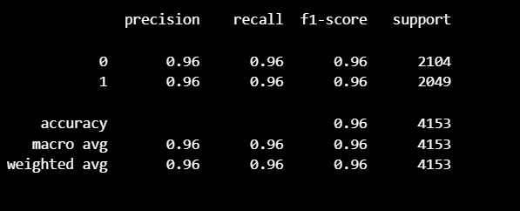

**Logistic Regression**:

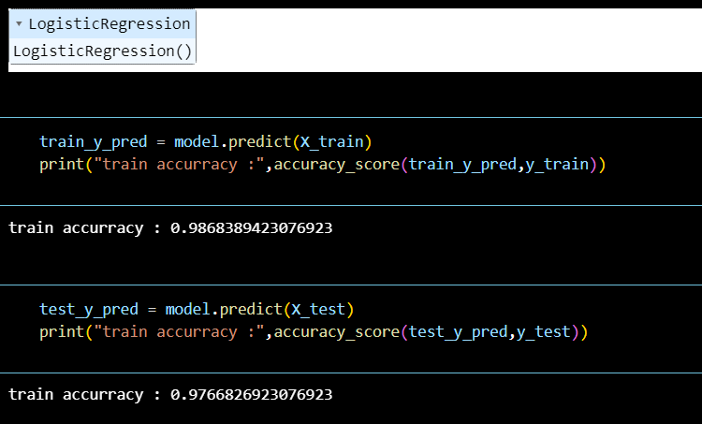

**7. Process Flow Diagram**

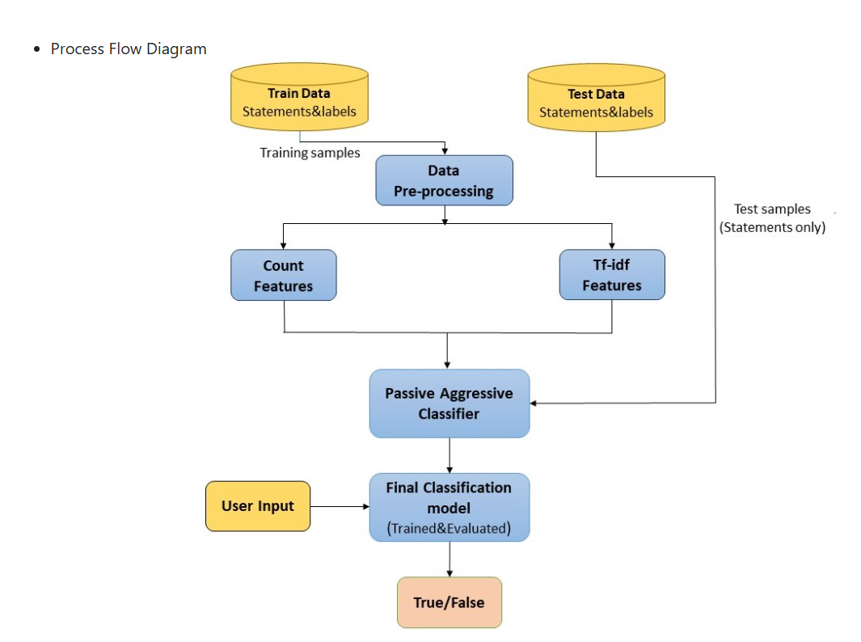

**8. Block Diagram**

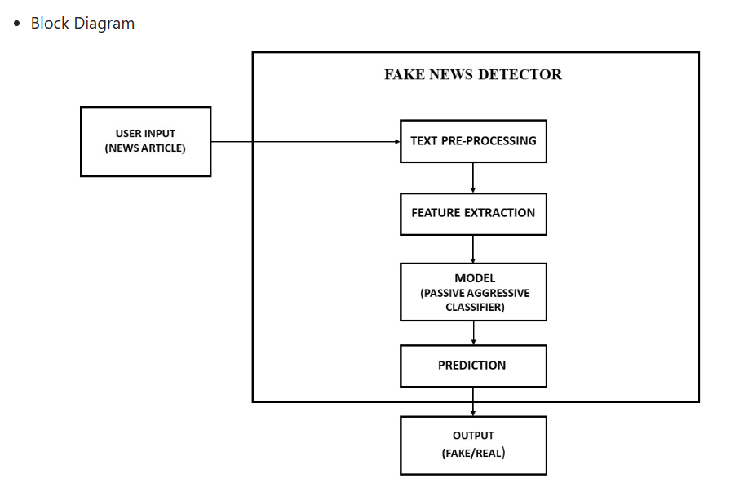

**9. Learnings**

• Deepened understanding of text preprocessing, feature engineering with TF-IDF, and binary classification techniques.  
• Gained exposure to dealing with real-world NLP challenges.  
• Learned how to deploy machine learning models into user-friendly applications.  
• Improved team collaboration and project management skills.

**10. Conclusion**

This project demonstrated the potential of traditional machine learning models in addressing fake news detection. The Passive Aggressive Classifier, when paired with strong text preprocessing and TF-IDF vectorization, delivered impressive results in identifying misinformation. It serves as a foundational approach that can be expanded upon with more complex models and larger datasets.

**11. Future Scope**

• Integrate deep learning models like RNNs or Transformers (e.g., BERT) for improved linguistic understanding.  
• Expand dataset with multilingual news articles for broader application.  
• Introduce fact-checking APIs for real-time article verification.  
• Add sentiment and source credibility analysis for multi-layered fake news detection.

**Team Members:** Ananya Jain, Diya Upadhyay, Srijan

**Subject:** CSET-301   
**Semester:** 4th Semester