**Tribhuvan** **University**

**Faculty of Humanities and Social Science**

**“DREAMGHAR- A PROPERTY LISTING”**

**A PROJECT PROPOSAL**

**Submitted To Department of Computer Application**

**Lumbini City College**

**In partial fulfillment of the requirements for the Bachelors in Computer Application (BCA)**

**Submitted By:**

**Dipika Shrestha(11340008)**

**Bibek Bhandari(11340004)**

# **INTRODUCTION**

The growing need for digital solutions in the real estate sector is where the concept of developing a **DREAMGHAR** - **Property Listing** website first emerged. Any company functioning in this sector must now have a website because more and more customers are using the internet to look for homes and communicate with agents. THIS website will offer a practical for buyers and sellers a platform to connect, explore properties, and exchange information and provide a variety of services and tools that make it simpler for buyers and sellers to manage the buying and selling process.

# **PROBLEM STATEMENT**

* It becomes difficult for individuals or businesses to display their properties to potential buyers or renters. This can result in a lack of visibility and a reduction in the number of potential leads.
* Without a centralized platform to manage property listings, the process of advertising, marketing, and managing properties can become inefficient and time-consuming.
* Traditional methods of property listing such as print advertising, signage, and word-of-mouth can be costly and may not yield the desired results.

# **OBJECTIVES**

The Objectives of this project are:

* To design a user-friendly website that will highlight available homes and offer helpful information.
* To create a platform where anyone trying to sell their possessions can upload photographs and descriptions of the real state.

1

# **METHODOLOGY**

## **Requirement Identification**

### **Literature Review**

The procedure for purchasing and Real estate has changed as the world gets more computerized. Real Estate websites have become a well-liked platform for connecting and conducting online transactions between buyers and sellers. But with so many websites out there, it's critical for these platforms to provide users with competitive features and services like pricing, simplicity of use, comfort, and excellent client service are all important factors in determining whether a consumer will stick with a certain website or not.

Dream Ghar is a comprehensive real estate platform that offers a range of services, including buying, selling, and renting of properties. One of the key advantages of the platform is its user-friendly search feature, which enables consumers to identify homes that meet their needs quickly. Customers don't need to wade through endless listings. They may obtain a variety of homes in that area by simply typing the desired location into the search bar.

### **Requirement Collection**

1. **Functional Requirements**

* **Search Module:** Client can search up properties as well as reach out to the vendor by phone or messaging.
* **Post Module**: Users can post their property listing.
* **Admin Module**: Administrator can monitor user; login requests and has authority over the property listing.

1. **Non-Functional Requirement**

The non-functional requirement of Property Listing are as follows:

* **Usability:** The program will be simple enough for average consumers to utilize, no matter their level of expertise. The system is simple to use seven for non-techies.
* **Reliability:** The system will be high as it will be able to perform operations without errors.
* **Performance:** The application will generate the requested Content with little time or without delay.

2

**b) Feasibility Study**

### **Technical Feasibility**

The system is technically feasible to implement. The technology and tools required for the development of the proposed system are easily available i.e., HTML, JavaScript, CSS, MySQL, PHP.

### **Operational Feasibility**

The system will be operational 24hrs a day and users can use the features of the website at any time.

### **Economic Feasibility**

The proposed system is economically feasible because it does not require highly cost resources and more manpower.

## **C) High Level Design of System**

### **Methodology**

For the development of our system, a Prototyping Methodology has been chosen considering all the requirements. The **Prototyping Model** is a highly effective approach to systems development that involves building and testing a series of prototypes until a final product is achieved. The key to success with this model is careful planning and execution. The prototyping model is an iterative and collaborative process that involves ongoing communication and feedback between the developer and the client. [1]

3

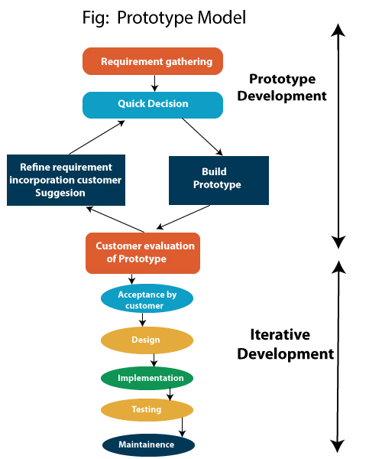

**Fig 4.1: Prototyping Model**

4

### **Flow Chart**

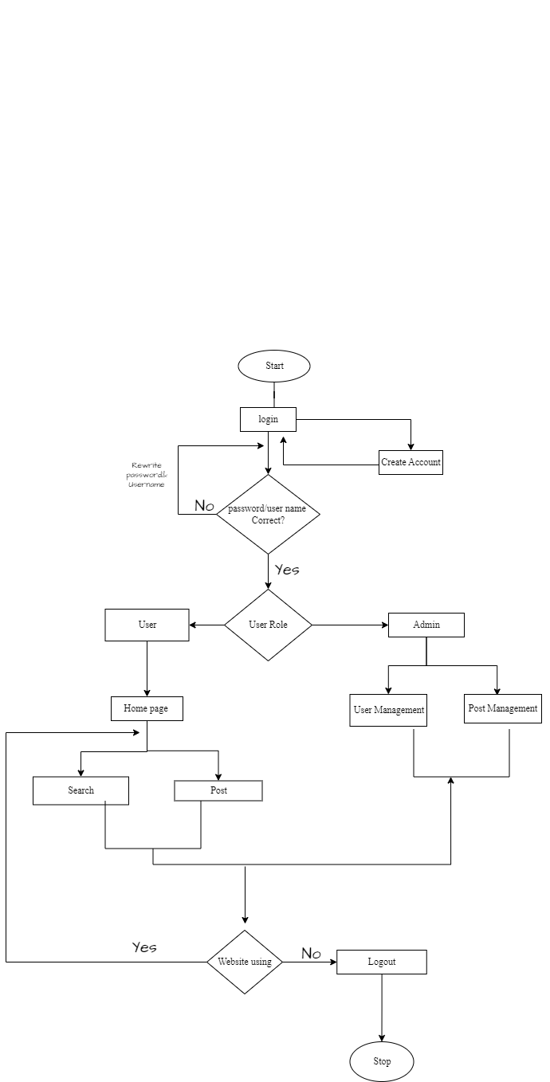

**Fig 4.2: Flow Chart**

5

# **GANTT CHART**

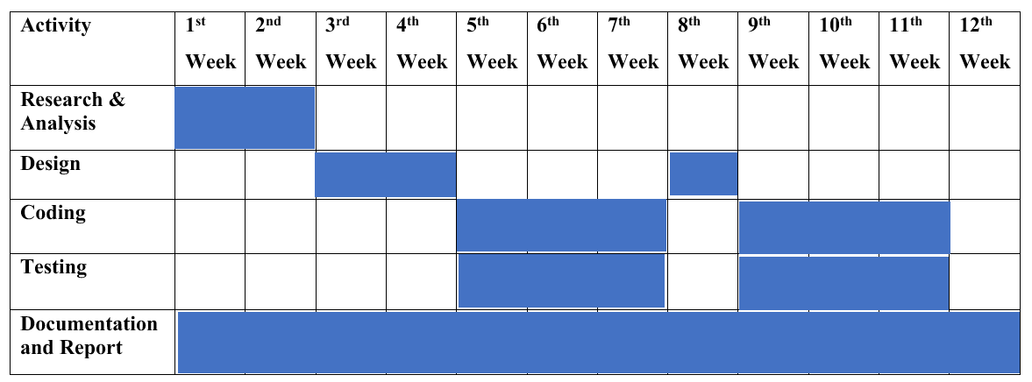

**Fig 5.1: Gantt Chart**

# **EXPECTED OUTCOME**

When the project is completed, the users will be able to register into the application and search for property and list their own properties. Users will be able to contact the vendor.

# **7.REFERENCES**

[1] M. Martin, “Prototype model in software engineering,” *Guru99*, 01-Feb-2023. [Online]. Available: https://www.guru99.com/software-engineering-prototyping-model.html. [Accessed: 28-Mar-2023].

6