

**Tribhuvan University**

**Faculty of Humanities and Social Sciences**

**A Project Proposal On**

**“Food Ordering System”**

**Submitted to:**

**Lumbini City College**

**Department of Computer Application**

**Tilottama - 4, Rupandehi**

***In the partial fulfillment of the requirement for the Bachelor of Computer Application***

**Submitted by:**

Suman Khatri

Chitra Bahadur Thapa

**Under the Supervision of**

Mr. Suraj Khatri

**TABLE OF CONTENTS**

CHAPTER 1: INTRODUCTION 3

1.1 Introduction 3

1.2 Problem Statement 3

1.3 Objectives 4

1.4 Tools Used………………….....................................................................................4

1.5 Scope And Limitations 4

Scope: 4

Limitations: 4

CHAPTER 2: BACKGROUND STUDY AND LITERATURE REVIEW 5

2.1 Background Study 5

2.2 Literature Review 6

Chapter 3: System and Design Analysis 6

3.1 Research Methodology 6

3.1.1 Functional Requirements: 7

3.1.2 Non-functional Requirements: 7

3.2 Feasibility Analysis 8

3.2.1 Technical Feasibility 8

3.2.2 Operational Feasibility 9

3.2.3 Economic Feasibility 9

3.2.4 Legal Feasibility 9

3.3 Use Case Diagram 10

3.4 System Flowchart 11

3.5 Gantt Chart 12

3.6 DataFlowDiagram 14

3.7 Expected Outcome…………………………………………………..........……….14

Chapter 4: ………………………………………………………15

# CHAPTER 1: INTRODUCTION

## 1.1 Introduction

This project has been submitted in the fulfilment of the requirements for the Bachelor of Computer Application. We the team members of this project, take pleasure in presenting the detail project report that reflects our efforts in this semester.

Our project name is Food Ordering System. This system aims to provide an easy and convenient way for customers to order food online from different restaurants. With the increasing trend of online food ordering, this system will be a useful tool for customers to order food in a hassle-free way. The system will provide a user-friendly interface that will enable customers to place their orders quickly and easily.

The Food Ordering System will consist of a user-friendly interface that allows customers to browse menus, select items, and place their order with just a few clicks. The system will also allow restaurant owners to manage their menu from a centralized platform.

With the increasing trend of online food ordering, there is a need for a system that provides customers with an easy and convenient way to order food online. The Food Ordering System aims to fulfil this need by providing a platform for customers to order food online.

## 1.2 Problem Statement

The traditional method of ordering food in person or over the phone has become increasingly inconvenient and time-consuming for customers. Additionally, restaurant owners are struggling to manage orders and ensure efficient delivery of food items. These issues have led to a need for a more streamlined food ordering system that can simplify the process of ordering food for both customers and restaurant owners. The current systems often lack a user-friendly interface, efficient order management, and accurate order tracking, resulting in delays, errors, and dissatisfied customers. Therefore, there is a need for a reliable and efficient food ordering system that can improve the customer experience and enhance the overall efficiency of the food ordering process.

## 1.3 Objectives

We have made the Food Ordering System to simplify the process of ordering food online. Some of the specific objectives of this system are listed below:

1. To provide customers with a fast and convenient method of ordering food.
2. To improve accuracy in the order taking process.
3. To streamline the delivery process.
4. To provide customers with a user-friendly and intuitive ordering interface.
5. To enable restaurant owners to manage orders.

## 1.4 Tools Used

The following tools will be used for the development of the Food Ordering System:

1. HTML, CSS, and JavaScript for the front-end development.
2. PHP and MySQL for the back-end development.

## 1.5 Scope and Limitations

## Scope:

The scope of the food ordering system includes providing customers with a wide range of options, including both vegetarian and non-vegetarian dishes. The system will have a menu and item management module to add, remove, and update traditional Nepali food items on the menu. The ordering process will be simplified, and real-time updates will be provided on the status of orders. The system will be user-friendly and secure, ensuring the privacy and security of customer data. Overall, the food ordering system will provide a seamless and convenient experience for customers, allowing them to easily browse through the menu, select their desired items, and place orders from the comfort of their homes or workplaces.

### Limitations:

The limitations of this project are given below:-

1. Delivery limitations: Online food ordering systems are dependent on third-party delivery services, which may have limitations on delivery range, delivery times, and delivery fees. This can impact the convenience and overall experience of the customer.
2. No Order tracking: It is very complex process to order track so we will not use order tracking.

# CHAPTER 2: BACKGROUND STUDY AND LITERATURE REVIEW

## Background Study

A food ordering system is a digital platform that allows customers to place orders for food delivery or pickup from restaurants or food establishments. To develop an effective food ordering system, a background study should be conducted to consider various aspects, including market research, user requirements, technical requirements, user experience, security and privacy, and maintenance and support. Market research helps to identify the target audience, competition, and current trends in the food industry, which helps to determine the unique features and functionalities that the system should offer. User requirements should also be considered, including payment options, delivery preferences, and order tracking. Technical requirements should be identified, such as the hardware, software, and database requirements, as well as necessary integrations with other systems, like payment gateways and delivery services. The user experience will be designed to provide a user-friendly interface that allows customers to navigate the platform easily and complete their orders efficiently. The system's security and privacy are essential to protect customer data and payment information. Finally, establishing a plan for maintenance and support is critical to ensuring ongoing system operation and customer satisfaction. By considering these factors, businesses can create an effective and robust food ordering system that meets customer needs while improving operational efficiency.

## Literature Review

The use of online food ordering systems has become increasingly popular in recent years, with more and more consumers opting for the convenience and ease of ordering food online. According to a report by Statista (2021), the global revenue of the online food ordering industry is projected to reach $151.5 billion by 2024, up from $72.9 billion in 2020. This highlights the significant growth potential of the industry and the increasing demand for online food ordering systems.

Studies have shown that online food ordering systems can improve customer satisfaction and loyalty (Wang & Tsai, 2017). Customers appreciate the convenience of being able to order food from anywhere, at any time, without having to wait in long queues or make phone calls. This is particularly true for younger generations who are accustomed to using technology in their daily lives (Mishra & Sharma, 2017).

Moreover, online food ordering systems can also help restaurants to increase their sales and revenue by offering customers an easy and user-friendly way to place orders (Wang & Tsai, 2017). This is particularly relevant during the COVID-19 pandemic, where many customers are opting for delivery and takeaway options over in-person dining.

However, online food ordering systems also have their limitations. Technical issues, such as software bugs or server downtimes, can impact the overall performance of the system (Batra, 2020). Additionally, the implementation and maintenance costs of an online food ordering system can be relatively high, making it challenging for small businesses to adopt (Mishra & Sharma, 2017).

In conclusion, online food ordering systems offer significant benefits for both customers and restaurants, including convenience, increased sales, and improved customer satisfaction.

# 

# Chapter 3: System and Design Analysis

## 3.1 Research Methodology

For the development of an online food ordering system, the research methodology would follow the waterfall model. This would start with the requirements gathering phase, where stakeholders would define all the requirements for the system, including features, functionality, and performance. Once the requirements are gathered, the design phase would begin, where the system architecture, database design, and user interface would be designed. The implementation phase would then start, where the development team would begin writing code and implementing the features and functionality based on the design. After implementation, the system would undergo testing to ensure that it meets all requirements and functions as intended. Once testing is complete, the system would be deployed to a production environment for use by end-users. Finally, ongoing maintenance and support would be required to ensure the system continues to function as intended.

## 3.1.1 Functional Requirements:

1. User registration and authentication: Users will be able to create an account, log in, and manage their profile information.
2. Ordering process: The system should provide a user-friendly interface for customers to browse menu items, add them to their cart, and specify any special instructions or preferences. The system should also handle payments securely.
3. Restaurant management: Restaurants will be able to view and manage their orders and update their menu.
4. Customer support: The system will provide customer support features such as FAQs, chat support, and email support.

## 3.1.2 Non-functional Requirements:

1. Performance: The system will be designed to handle high traffic and load without significant downtime or slowdowns.
2. Security: The system will use encryption and other security measures to protect user data, payment information, and other sensitive information.
3. Reliability: The system will be reliable and available 24/7, with minimal downtime for maintenance or upgrades.
4. Usability: The system will be user-friendly and easy to navigate, with clear instructions and feedback for users.
5. Compatibility: The system will be compatible with a variety of devices and platforms, including desktop and mobile devices, various operating systems, and different web browsers.
6. Accessibility: The system should be designed to be accessible to users with disabilities, including support for assistive technologies like screen readers and keyboard navigation.
7. Scalability: The system should be scalable, able to handle increasing amounts of data and traffic as the business grows.
8. Maintainability: The system should be easy to maintain and update, with a modular design and clear documentation for developers.

## Feasibility Analysis

A feasibility study is conducted to determine the practicality and viability of implementing an online food ordering system for a restaurant. This study will consider the technical, economic, operational, and legal feasibility of the proposed system.

## 3.2.1 Technical Feasibility

This system is technically feasible to implement. The technical feasibility of the proposed system will be evaluated by considering the hardware and software requirements, internet connectivity, and any technical barriers that could affect the system's performance. .

## 3.2.2 Operational Feasibility

The operational feasibility of the proposed system will be evaluated by considering how the system will integrate with the restaurant's existing operations. The system would be available 24/7.

## 3.2.3 Economic Feasibility

This system is economically feasible to implement. The economic feasibility of the proposed system will be evaluated by considering the costs involved in implementing and maintaining the system. This will include hardware and software costs, website design and development costs, and ongoing maintenance and support costs.

## 3.2.4 Legal Feasibility

Like other feasibility this system is legally feasible to develop. The legal feasibility of the proposed system will be evaluated by considering any legal or regulatory requirements that need to be met, such as data privacy and security regulations. The restaurant will need to ensure that the system complies with all relevant laws and regulations to avoid any legal issues.

## 

## 3.3 Use Case Diagram

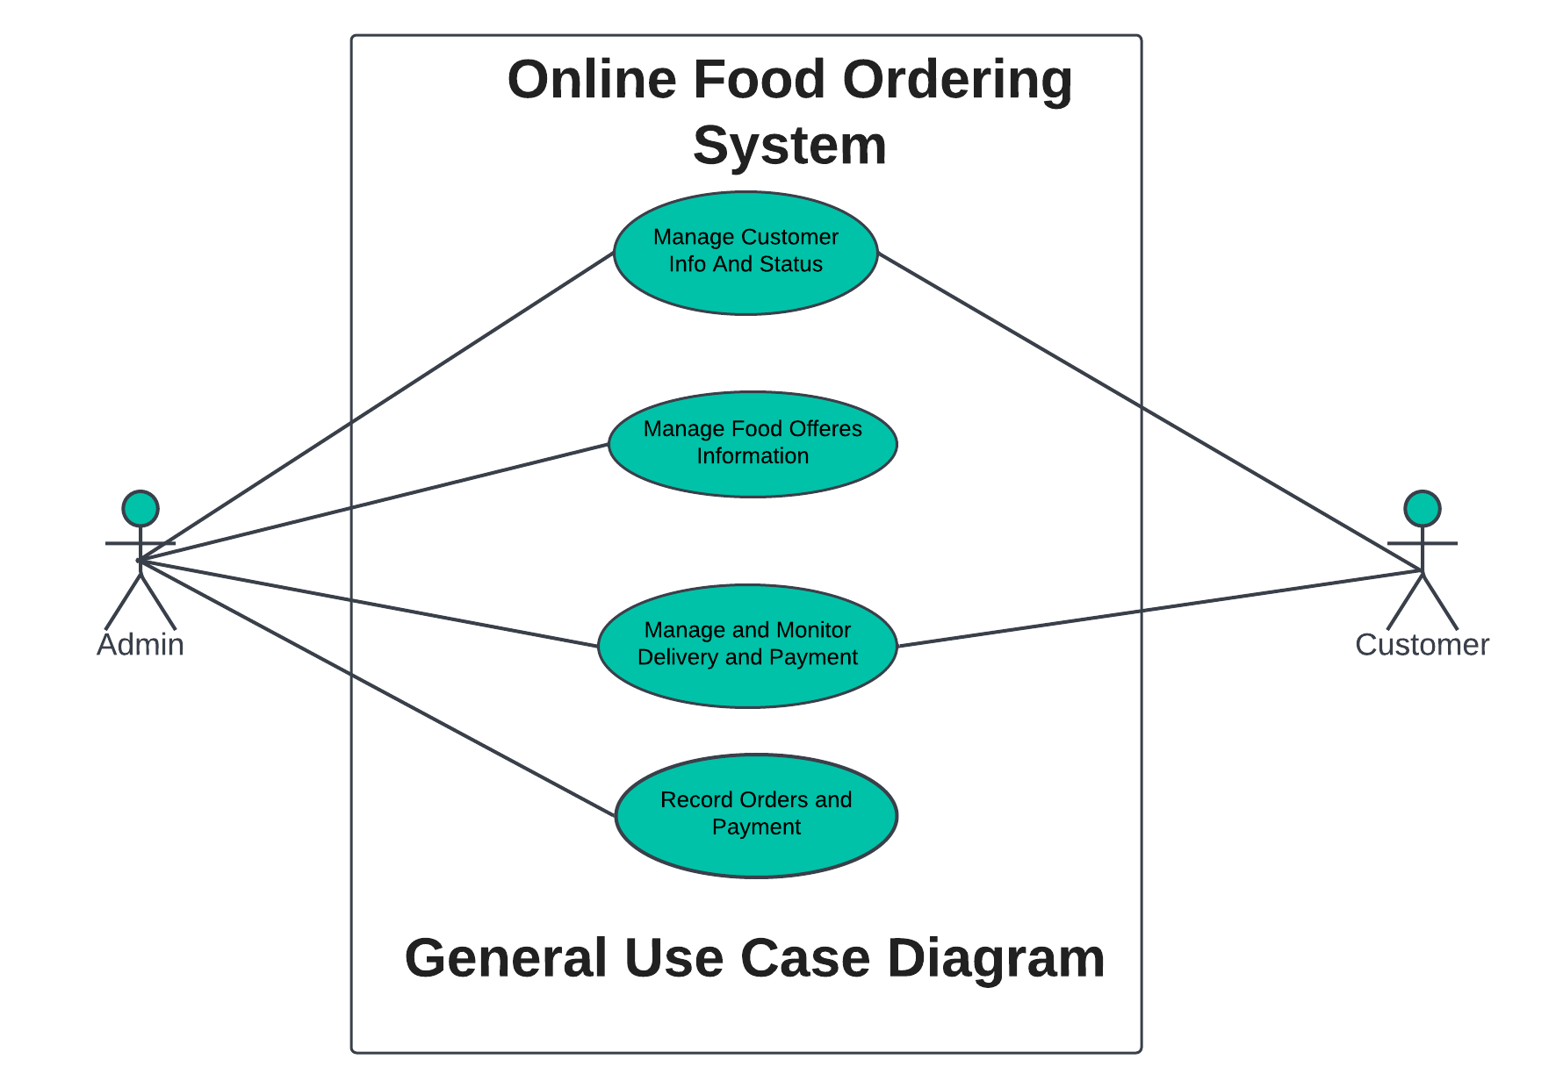

***Fig: Use Case of Food Ordering System.***

## 3.4 System Flowchart

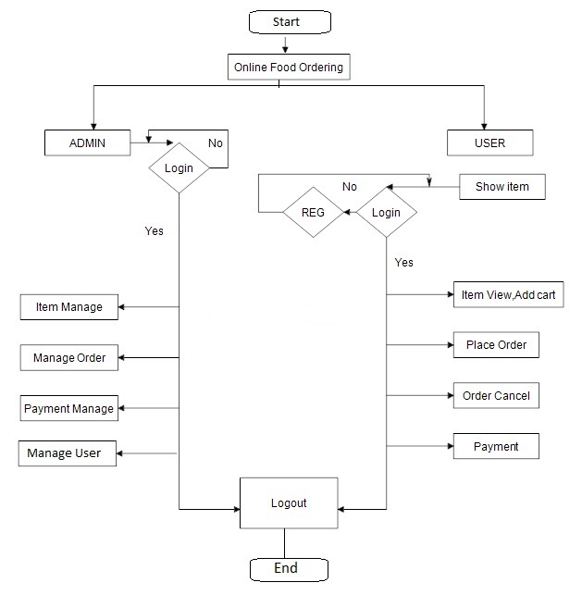

Fig: System Flowchart.

## 3.5 Gantt Chart:

Fig: Project’s Timeline using Gantt chart.

**3.6 Data Flow Diagram**

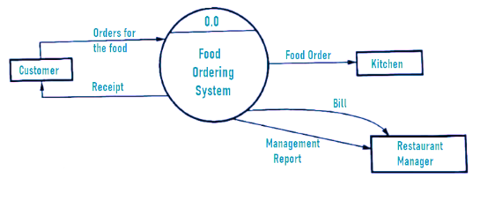

Admin

Fig: Level 0 DFD (Context Diagram).

## 3.7 Expected Outcome

1. At the end of the project, customers will be able to order food online from their preferred restaurant.
2. The system will provide a user-friendly interface for customers to place an order.
3. Customers will be able to view the menu and select items of their choice.
4. The system will provide real-time updates on order status, including estimated delivery time.
5. Customers will be able to pay for their order online.
6. The system will provide an efficient and hassle-free food ordering experience to customers.

# 4. REFERENCES

1. Foodmandu. [Online]. Available: <https://foodmandu.com/>

Foodmandu is an online food delivery platform based in Nepal. It offers a wide range of food options from various restaurants in Kathmandu, Lalitpur, and Bhaktapur.

1. Khaanpin. [Online]. Available: <https://khaanpin.com.np/en/ktm>

Khaanpin is another online food ordering and delivery platform based in Nepal. It offers a variety of food options from different restaurants in Kathmandu.

1. Bhojdeals. [Online]. Available: <https://www.bhojdeals.com/>

Bhojdeals is an online platform that offers deals and discounts on food items from various restaurants in Nepal. Customers can browse the deals and purchase vouchers through the website.

# References

foodmandu. (2019, 02 12). *foodmandu*. Retrieved from foodmandu: https://blog.foodmandu.com/five-dishes-that-feel-like-summer/