

**Tribhuvan University**

**Faculty of Humanities and Social Science**

**“COSMO MART”**

**A PROJECT REPORT**

**Submitted to**

**Department of Computer Application**

**Lumbini City College**

**In Partial Fulfillment of the Requirements for the Bachelors in**

**Computer Application (BCA)**

**Submitted By:**

**Puja Gyawali (T.U. Reg. No: 6-2-1134-54-2019)**

**Muna Rana (T.U. Reg. No: 6-2-1134-46-2019)**

**(July, 2023)**

**Under the Supervision of**

**Mr. Kamal Shrish**

# Supervisor’s Recommendation

The project work report entitled **“Cosmo Mart”** submitted by Puja Gyawali and Muna Rana of Lumbini City Campus, (Drivertole-04, Rupendehi),is prepared under my supervision as per the procedure and format requirements laid by the Faculty of Humanities, Tribhuvan University, as partial fulfillment of the requirements for the award of the degree of Bachelor of Computer Application (BCA). I, therefore, recommend the project work report for evaluation.

**…………………….**

**Kamal Shrish**

**Supervisor**

Lumbini City College

# Letter of Approval

This is to certify that this project prepared by **Puja Gyawali** and **Muna Rana** entitled **“cosmo mart”** in partial fulfillment of the requirements for the degree of bachelor in computer application has been evaluated. In our opinion it is satisfactory in the scope and quality as a project for the required degree.

|  |  |
| --- | --- |
| **……………….**  **Kamal Shrish**  **Supervisor**  **Lumbini City College** | **…………………….**  **Bishal Kandel**  **Program coordinator**  **Lumbini City College** |
| **…………………….**  **Internal Examiner**  **Lumbini City College** | **…………………….**  **External Examiner**  **FOHSS, Tribhuvan University** |

# Acknowledgement

First of all we would like to express our sincere thanks to the department of computer application for providing us a golden opportunity to carry out this project work on **“cosmo mart”.** We extend our sincere and heartfelt thanks to our project supervisor, **Mr. Kamal Shrish**, for his continuous guidance, support, valuable and compressive suggestion, inspiration, help and co-operation, which are indispensable to prepare this project on this form.

Our heartfelt gratitude goes to **Mr. Bishal Kandel** coordinator for his constructive feedback and support.

We also express a deep sense of gratitude to our teachers, **Mr. Bishnu** **Chaudhary, Mr. Suraj Khatri, Mr. Pharsuram Bhattarai, Mr. Bhuban Panthee AND Mr. Lalit Ashok Gurung** for their suggestion and guidance inspiration cooperation of academic prospective.

At last, we would like to thank all the supportive friends and our family members.

# Student’s Declaration

We hereby declare that project report entitled **“Cosmo Mart”** submitted in the partial fulfillment of the requirement for Bachelor’s degree of Bachelor in Computer Application of Tribhuvan University, is our original work and not submitted for the award of any other degree, diploma, fellowship, or any other similar title or prize.

**…………………**

**Puja Gyawali**

(T.U. Reg. No: 6-2-1134-54-2019)

Lumbini City College

**…………………**

**Muna Rana**

(T.U. Reg. No: 6-2-1134-46-2019)

Lumbini City College

Abstract

This project involves designing a framework for executing complex applications i.e. **“cosmo mart”** website is an online platform retail store chain that provides a wide range of products for customers seeking high-quality and affordable cosmetic goods and services related to comprehensive information, personal care and products related to beauty and wellness. The website offers a wide range of content, including articles, shop for beauty products and reviews on various topics such as skincare, haircare, latest makeup trends and personal hygiene. The store's mission is known for its high-quality products, competitive pricing, and exceptional customer care service with a commitment to providing a satisfying shopping experience, customers with products that meet their needs and preferences .Overall, cosmo mart is a one-stop-shop for all cosmetic needs, providing convenience, affordability and quality products. cosmo mart strives to maintain a welcoming atmosphere and a diverse selection of products, catering to customers of all ages and lifestyles.

**Keywords:**  Cosmo Mart, Beauty Products, Cosmetics

Table of Contents

Supervisor’s Recommendation i

Letter of Approval ii

Acknowledgement iii

Student’s Declaration iv

Abstract v

List of Figures viii

List of Tables ix

Abbreviations x

Chapter 1: Introduction 1

1.1 Introduction 1

1.2 Problem Statement 1

1.3 Objectives Statement 2

1.4 Scope and Limitation 2

1.5 Report organization 3

Chapter 2: Background Study and Literature Review 4

2.1 Background Study 4

2.2 Literature Review 5

Chapter 3: System Analysis and Design 7

3.1 Research Methodology 7

3.2 System Analysis 7

3.2.1 Requirement Analysis 7

3.2.2 Feasibility Study 7

3.3 System Modelling 9

3.3.1 Data Modelling: ER-Diagram 9

3.3.2 Use–Case Diagram 9

3.3.3 Process Modelling: Data Flow Diagram (DFD) 10

3.3.4 Gantt Chart 12

3.4 System Design 13

3.4.1 Database Schema Design 13

3.4.2 Interface Design (UI/UX) 14

3.4.3 Architectural Design 16

Chapter 4: Implementation and Testing 17

4.1 Implementation 17

4.1.1 Tools Used (CASE tools, Programming languages, Database platforms) 17

4.1.2 Implementation Details of Modules (Description of procedures/functions) 19

4.2 Testing 19

4.2.1 Test Cases for System Testing 19

4.2.2 Test Cases for Unit Testing 19

4.2.3 Integration Testing 21

Chapter 5: Conclusion and Future Recommendations 22

5.1 Conclusion 22

5.2 Future Recommendations 22

Reference 24

# List of Figures

Figure 3.1.: E-R Diagram....................................................................................................9

Figure 3.3.2: Use Case Diagram….….…………………………………………………..10

Figure 3.3.1: Level 0 DFD…............................................................................................10

Figure 3.3.2: Level 1 DFD………………………….……...............................................11

Figure 3.3.2: Level 2 DFD…............................................................................................12

Figure 3.3.4: Gantt Chart ……………..….……………………………………………..12

Figure 3.4.1: Database Schema Design………………………………….………………13

Figure 3.4.2: Interface Design……………………………………………….…………..16

Figure 3.4.3: Architectural Design ………………………………………………..….....16

# List of Tables

Table 4.2.1: Test case for integration testing……………………………….…………....21

Table 4.2.2: Test cases for unit testing…………………………………………………...22

# Abbreviations

CASE : Computer Aided Software Engineering

DFD : Data Flow Diagram

ER : Entity Relationship

RAM : Random Access Memory

SRS : Software Requirement Specification

UI : User Interface

UX : User Experience

# Chapter 1: Introduction

## 1.1 Introduction

With tremendous increase in technology, information technology is a fast developing field. Technology which is in vogue today might become redundant tomorrow. This ever changing scenario makes it possible to provide the latest and most modern IT solutions to various businesses and institutions. Online shopping has become a popular trend in recent years. The ease of shopping from the comfort of your home, the wide range of products available, and the ability to compare prices and features have made it a preferred choice for many customers. This report aims to introduce an online shopping ecommerce site and its features likely, product categories, product details, search functionality, customer reviews, secure payment options, discounts and offers. Things have changed significantly since 1994. Now, consumers can discover and purchase a wide range of products and services through lots of different websites and online platforms. It has truly transformed how merchants sell products. No longer are they restricted to selling their goods through a brick-and-mortar store.

The online cosmetic mart ecommerce site is a platform that offers a wide range of cosmetic products for customers to purchase online. The site has a user-friendly interface that allows customers to easily browse through products, compare prices, and place orders. The site offers a variety of cosmetic products such as skincare, makeup, haircare, and more.

Overall, Cosmo Mart is the online cosmetic shopping ecommerce site is a convenient platform for customers to purchase cosmetic products online. With its user-friendly interface, wide range of products, detailed product information, and secure payment options, it offers a hassle-free shopping experience. The site's regular discounts and offers make it an attractive option for customers looking to purchase high-quality cosmetic products at affordable prices.

## 1.2 Problem Statement

There are several problems that online cosmetic mart websites may face. One of the primary concerns is the lack of physical interaction between customers and products. This can make it challenging for customers to accurately assess the color, texture, and scent of cosmetics before making a purchase. In addition, customers may be concerned about the authenticity of the products they are purchasing online, particularly if they are buying from an unfamiliar website. Another challenge faced by online cosmetic marts is the high level of competition. With so many online stores selling cosmetics, it can be difficult for a website to stand out and attract customers. This can lead to price wars and a focus on discounts rather than providing high-quality products and services. So that our website solve this kinds of several problem associated with online platform cosmetic marts which offer convenience and a wide selection of products, they must overcome these and other challenges to build a successful online presence.

## 1.3 Objectives Statement

.There is some objectives for an online cosmetic mart website are as follows:

* Provide a user-friendly interface for customers to browse and purchase products.
* This website will include building brand awareness through the blog or article.
* To showcase product details, images, and reviews to help customers make informed purchase decisions

## 1.4 Scope and Limitation

An online cosmetic mart has a significant scope in today's digital age, as more and more consumers are turning to the internet to purchase their favorite beauty products. The global beauty industry is expected to grow steadily in the coming years, and online cosmetic mart offers a convenient way for customers to shop for their favorite products from the comfort of their own homes. Additionally, an online cosmetic mart can reach a wider audience compared to traditional brick-and-mortar stores. A project report on the scope of an online cosmetic mart could explore market trends, customer behavior, e-commerce platforms, digital marketing strategies, and competitive analysis..

Although there are various scopes, the project has some limitations also which are as follows: -

* Internet connectivity is required.
* Users and must have proper technical knowledge to operate within the web.
* Younger participants are more likely to use the internet to use this service but people with internet access problem at ruler areas may face difficulties to use this service.
* Limited accessibility
* Limited product selection

## 1.5 Report organization

This report is divided into five chapters. Each chapter is further divided into different headings. The preliminary section contains the overall information about the project. This section includes abstract, table of contents, list of figures, and abbreviations.

* **Chapter 1** gives an introduction to the Cosmo Mart. The problem definition, objectives, scopes, and limitations of this system are discussed.
* **Chapter 2** contains a background study of the system and a literature review section where the research works done in the field of the system are discussed in brief.
* **Chapter 3** discusses in detail the analysis and design of the system. It provides information about the existing system, data collection methods, analysis part, feasibility study, and system configuration. It also gives information about overall system architecture, class diagram, sequence diagram, and database diagram.
* **Chapter 4** gives information about the system development models, implementation techniques, tools used, and test cases of the system for testing.
* **Chapter 5** includes the future scope of the project and necessary future recommendations along with the conclusion.

# Chapter 2: Background Study and Literature Review

## 2.1 Background Study

As ecommerce is growing much faster than retail, many people opt for online shopping and some of the young generation started to set up an e-commerce business. This project is motivated to make contribution to the consumers by providing them a convenient way to shop online with simple steps, capable of for easy browsing, online tracking, 24/7 online shopping and simple payment method. In addition, the purpose of this project is to motivate both sellers and buyers to use this website for purchasing their beauty and skincare products. [1] [R. Shah, the Future of Commerce, 31-Mar-2023].

This project entitled cosmo mart is decided to work due to the present context. Pandemic has brought upon many problems in one’s lives. Shopaholics are deprived of doing shopping because they cannot be physically available at physical stores due to strict lockdown imposed by the government. So, this project’s objective is to develop an e-commerce site where buyers can do window shopping through the internet without any safety issues. In addition, the purpose of this project is to motivate both sellers and buyers to use this mobile application for purchasing their beauty and skincare products. [2]

The cosmo mart is a virtual store available on the internet where buyers can choose and select high-quality and affordable cosmetic goods and services related to comprehensive information, competitive pricing, and exceptional customer care service with a commitment to providing a satisfying shopping experience, customers with products that meet their needs and preferences. we target audience of the website could be women of a particular age group, location, or income level who are interested in buying cosmetics or learning about new beauty trends. The features of the website may include product catalogs, customer reviews, tutorials, blogs, following social media trends, and a secure payment gateway. They can order and search for the specific cosmetic items that is available on the site and purchases it directly by placing an order. One of the threats that customer faces while doing window shopping is they are somehow still having second thoughts while placing purchase. So, to tackle this we have cash on delivery system as well as e-pay system likely e-sewa. Unlike other e-commerce site who excessively charges the amount of product delivery on each item, we have decided to provide free delivery on every item that our customer places.[2]

The expected implementation of website selling beauty and skincare products is allow users to purchase beauty and skincare high-quality products and affordable goods or services related to comprehensive information, competitive pricing, and exceptional customer care service with a commitment to providing a satisfying shopping experience, customers with products that meet their needs and preferences without travelling, quick searching items by keywords and quick recognizing products by images.

## 2.2 Literature Review

Cosmo mart is the online cosmetic shopping ecommerce site is a convenient platform for customers to purchase cosmetic products online. The site has a user-friendly interface that allows customers to easily browse through products, compare prices, and place orders. The cosmetic mart is a one-stop-shop for skincare, makeup, hair care, and personal care products. A literature review on cosmetic marts aims to provide insight into the cosmetics market, including its size, trends, and consumer behavior. [2]

Size of the Cosmetics Market: The cosmetics market is a massive industry, and it is estimated to be worth $805 billion globally. It is projected to grow at a compound annual growth rate (CAGR) of 6.4% from 2021 to 2028, reaching a value of $1,212 billion by 2028 [3]. This growth is driven by the increasing demand for beauty products, particularly in emerging economies, the rising popularity of e-commerce platforms, and the growing adoption of natural and organic cosmetic products.

Consumer Behavior: Consumer behavior plays a significant role in the cosmetics market. Consumers have become increasingly conscious of the ingredients used in cosmetic products, and they are more likely to purchase products that are environmentally friendly, natural, or organic. According to a survey conducted by McKinsey & Company, 62% of respondents said that they prefer to buy natural or organic products, while 66% said that they are willing to pay more for environmentally friendly products [4].

Trends in the Cosmetics Market: One of the most significant trends in the cosmetics market is the growing popularity of e-commerce platforms. E-commerce sales of beauty products are expected to grow at a CAGR of 8.3% from 2021 to 2027 [5]. This growth is driven by the increasing adoption of smartphones, the rising popularity of social media platforms, and the convenience of online shopping.

Another trend in the cosmetics market is the growing demand for personalized beauty products. Consumers are seeking customized products that cater to their specific needs, preferences, and skin types. This trend has given rise to several startups that use artificial intelligence and machine learning to create personalized beauty products.

Product Development: Product development is an essential aspect of the cosmetic mart industry. According to a study by Euro monitor International [2020], the use of natural and organic ingredients in cosmetic products is a growing trend in the industry. The study further revealed that consumers are increasingly demanding clean and sustainable beauty products, which has led to the development of eco-friendly cosmetic products. Another study by Kim and Jang [2020] examined the impact of packaging design on consumer perception of cosmetic products. The study found that packaging design positively influenced consumer perception, indicating the importance of product packaging in the industry.

# Chapter 3: System Analysis and Design

## 3.1 Research Methodology

The project will follow the waterfall methodology. The waterfall methodology is a linear/structure approach that involves a sequence of steps, starting with planning and ending with testing and deployment. This methodology may be useful for a cosmetic mart that has a clear and well-defined idea of what we want in their website. Overall, developing an ecommerce site for a cosmetic mart requires careful planning and execution. By following a structured or linear methodology, we can create a successful site that meets the needs of our customers and drives sales for our business.

## 3.2 System Analysis

### 3.2.1 Requirement Analysis

**A) Functional Requirements**

Functional requirements for a cosmetic mart website might include:

1. User registration and login
2. Product catalog, shopping cart, and product reviews
3. Payment processing ,order and inventory management
4. Search and wish list functionality
5. Shipping options ,checkout process and notification system for user activity
6. Profile management
7. Moderation and administration panel

**B) Non-Functional Requirements:**

Non-functional requirements are the characteristics or qualities of a website that cannot be directly observed by end-users, but still crucial for the website's overall performance and user experience. Here are some non-functional requirements for a cosmetic mart website

1. Security measures for data protection
2. User-friendly and responsive design
3. Availability, usability and scalability
4. High-performance system with low latency
5. Compatibility with different browsers and devices

### 3.2.2 Feasibility Study

**A) Technical Feasibility**

Technical feasibility centers on the existing manual system of the test management process and to what extent it can support the system. According to feasibility analysis procedure the technical feasibility of the system is analyzed and the technical requirements such as software facilities, procedure, inputs are identified. It is also one of the important phases of the system development activities. The system offers greater levels of user friendliness combined with greater processing speed. Therefore, the cost of maintenance can be reduced. Since, processing speed is very high and the work is reduced in the maintenance point of view management convince that the project is operationally feasible .Technologies are as follows:

1. Front-end development: HTML5, CSS3, JavaScript, and Bootstrap.
2. Back-end development: PHP and MySQL access database.

**B) Economic Feasibility**

Economic analysis is most frequently used for evaluation of the effectiveness of the system. More commonly known as cost/benefit analysis the procedure is to determine the benefit and saving that are expected from a  system and compare them with costs, decisions is made to design and implement the system. This part of feasibility study gives the top management the economic justification for the new system. A simple economic analysis that gives the actual comparison of costs and benefits is much more meaningful in such cases.

In the system, the Cosmo Mart is most satisfied by economic feasibility. Because, if the mart implements this system, it need not require any additional hardware resources as well as it will be saving lot of time.

**C) Operational Feasibility**

Operational feasibility for a cosmetic mart refers to the ability of the mart to operate effectively and efficiently in the current business environment. A cosmetic mart needs to have a solid operational plan in place to succeed. By considering these factors, the mart can increase its chances of success and ensure that it can operate effectively and efficiently in the current business environment.

**D) Legal Feasibility**

The website must comply with all relevant laws and regulations related to e-commerce, data protection, and consumer protection. This includes registering the website with relevant authorities, securing proper licenses and permits, and complying with taxation laws.

## 3.3 System Modelling

### 3.3.1 Data Modelling: ER-Diagram

An ER diagram, also known as ER model, is a graphical representation of entities and their relationships to each other. Typically it's used in computing regarding the organization of data within database or information system. The basic components of an ER diagram are entities, attributes, and relationship between and among those entities. The ER diagram for the cosmo mart is as follows.

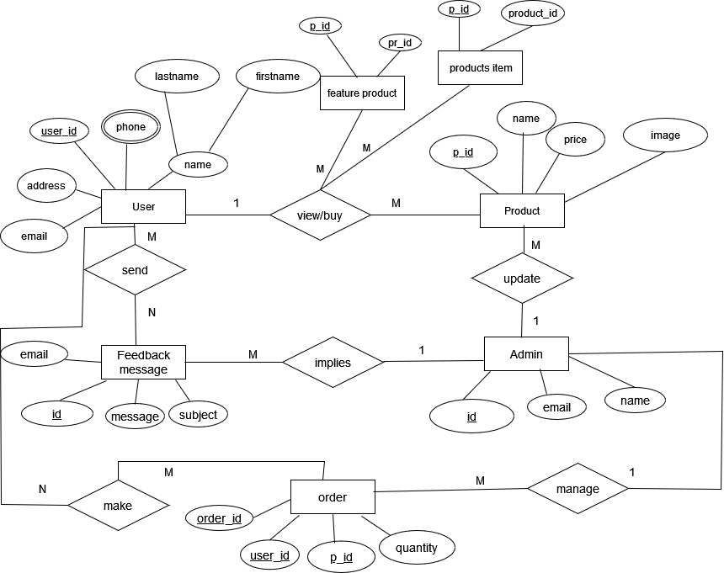

***Fig 3.3.1: ER Diagram of Cosmo Mart***

### 3.3.2 Use–Case Diagram

A use case is a technique used in software development and system design to identify, clarify, and organize the requirements of a system or software application. It defines the interactions between users and the system, as well as the steps and conditions involved in completing a specific task or goal. Use-cases help ensure that a system or software application meets the needs and expectations of its users, and they can also serve as a basis for testing and validation.

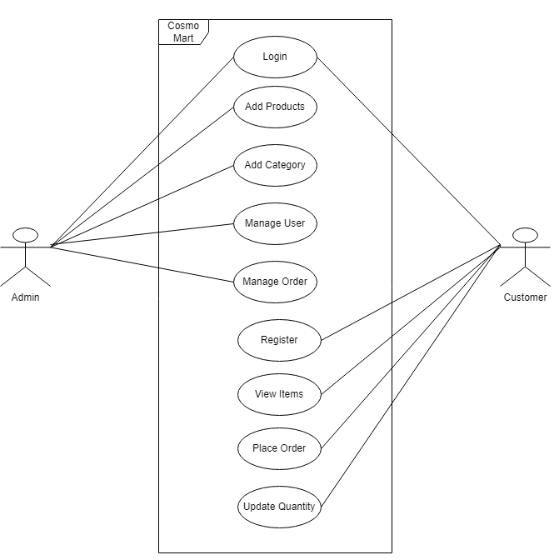

***Fig 3.3.2: Use-Case Diagram of Cosmo Mart***

### 3.3.3 Process Modelling: Data Flow Diagram (DFD)

**A) Zero level DFD (Context Diagram)**

A zero-level Data Flow Diagram (DFD) is the simplest type of DFD, which provides a high-level view of the system, without going into much detail. It shows the overall flow of data within a system and the external entities that interact with it. It typically consists of a single process symbol, which represents the entire system, and the external entities, which represent the sources and destinations of data. The zero-level DFD is often used as a starting point for developing more detailed DFDs and other system documentation.

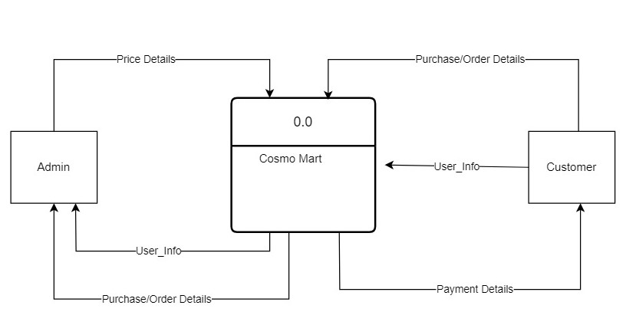

***Fig 3.3.3:1 Zero level DFD of Cosmo Mart***

**B) Level 1 Data Flow Diagram**

A Level 1 Data Flow Diagram (DFD) is a high-level representation of a system's processes and flows of data between them. It provides an overview of the system and its main processes, without going into the details of how each process works.

At Level 1, the system is typically divided into major processes or functions that represent the system's main capabilities. The data flows between these processes are also identified, showing how data is input, processed, and output by the system. The external entities that interact with the system are also represented, along with the data they input or receive from the system.

Overall, a Level 1 DFD provides a simple and clear overview of the system's main processes and data flows, making it an important tool for system analysts to understand the system's overall architecture and functionality

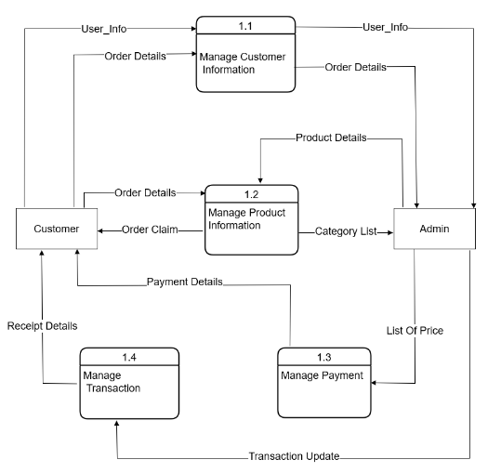

***Fig 3.3.3:2 Level 1 DFD of Cosmo Mart***

**B) Level 2 Data Flow Diagram**

A level 2 data flow diagram (DFD) provides a more detailed view of the processes, data stores, and data flows depicted in a level 1 DFD. . It breaks down the processes and data flows from the level 1 DFD into smaller, more manageable sub-processes, and shows how data is transformed and stored within the system. Level 2 DFDs are typically used to further refine and clarify the system requirements and to provide a blueprint for the implementation of the system and developers and analysts to gain a more thorough understanding of how a system works and to identify potential improvements or inefficiencies. 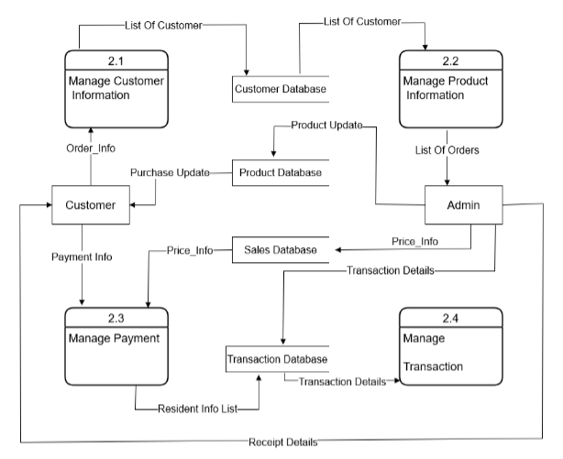

***Fig 3.3.3:3 Level 2 DFD of Cosmo Mart***

### 3.3.4 Gantt Chart

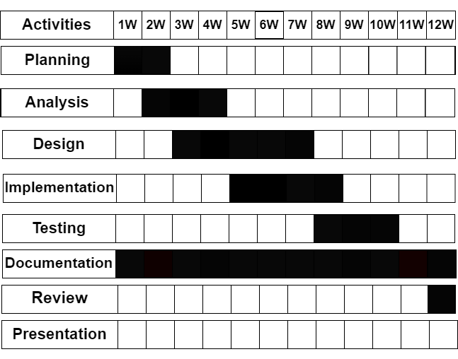

***Fig 3.3.4: Gantt chart of Cosmo Mart***

## 3.4 System Design

System design is the process of defining the architecture, components, modules, interfaces, and data for a system to satisfy specified requirements. It involves identifying the key functionalities of the system, selecting appropriate technologies and frameworks, and designing a scalable and maintainable solution that meets the desired performance, security, reliability, and usability criteria. A good system design should consider factors such as performance, scalability, reliability, maintainability, security, and usability, and should be flexible enough to accommodate changing requirements and evolving technology trends.

### 3.4.1 Database Schema Design

Database schema design involves creating a blueprint for organizing and structuring data in a database. It includes defining tables, columns, and data types, relationships between tables, and constraints to ensure data integrity. A well-designed schema is crucial for efficient data management and querying. Some key principles of database schema design include normalization, data modeling, and understanding the requirements of the system and its users.

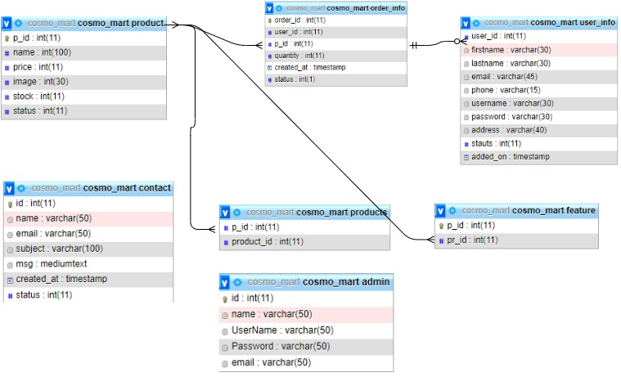

***Fig 3.4.1:*** ***Database Schema of Cosmo Mart***

### 3.4.2 Interface Design (UI/UX)

Interface Design, also known as UI/UX design, is the process of creating user interfaces for digital products such as websites, mobile apps, and software. UI (User Interface) refers to the design of the visual elements that a user interacts with, while UX (User Experience) refers to the overall experience a user has while interacting with a product. The goal of UI/UX design is to create interfaces that are aesthetically pleasing and user-friendly in order to enhance the user's overall experience and satisfaction with the product.

* **Home Page**

Home page shows list of feature along with its pictures and buttons to sign up and login. For new users, signup is necessary to visit website or take a services. The ‘Sign Up’ option is provided on the home page.

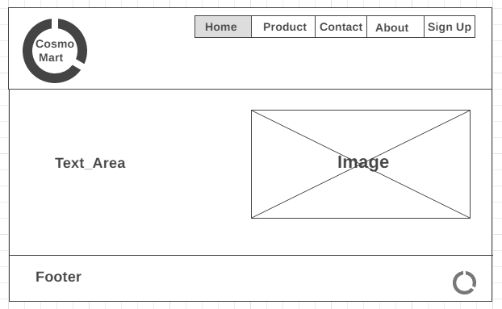

* **About Us Page**

An about us page should provide a way for visitors to get in touch with us. Users are able to view wide range of content, including articles, comprehensive information, personal care such as skincare, haircare, latest makeup trends and products related to beauty and wellness.

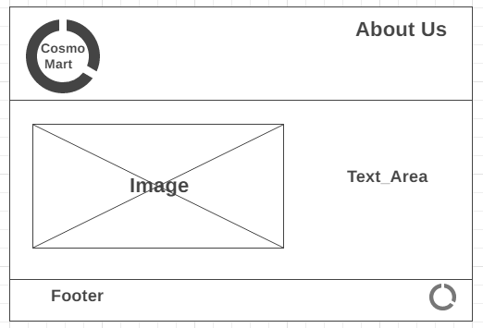

* **Product Page**

A product page should provide a wide range of products for customers seeking high-quality and affordable cosmetic goods.

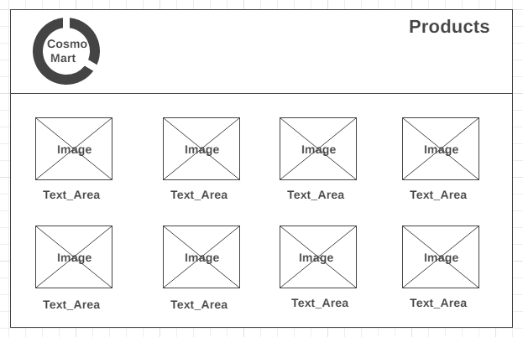

* **Contact Us Page**

A contact page should provide a way for customers to get enter their email address, password along with a message. The page has validation features implemented to check the format of the email, name.

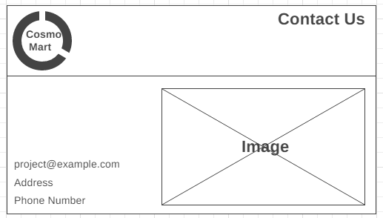

* **Sign Up Page**

For un-login user, the sign up page prompts the user to create a new account. For new create a new account the user enter their first name, last name, email address, password along with confirm password. For login user login page prompts for only enter the username and password. The page has validation features implemented to check the format of the first name, last name, email address, password. The page also checks for the new registrant to have a unique username by checking the database for a match against the existing usernames.

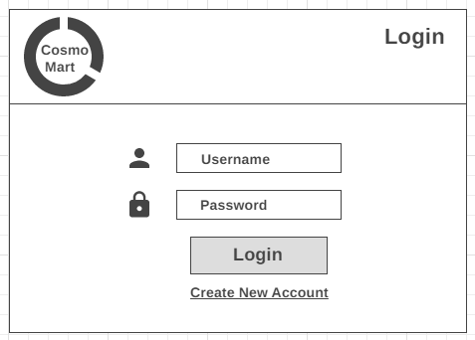

***Fig 3.4.2 Interface Design of Cosmo Mart***

### 3.4.3 Architectural Design

Architectural design is the process of planning, creating, and implementing the design of a building or structure. It involves considering the functionality, aesthetics, safety, and sustainability of the design, as well as the materials, technology, and budget available. The final goal of architectural design is to create a space that meets the needs of its occupants and enhances the overall built environment.

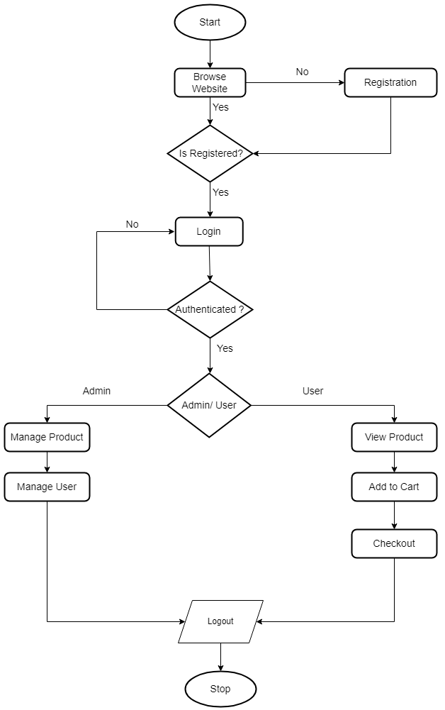

***Fig 3.4.3: Flowchart of Cosmo Mart***

# Chapter 4: Implementation and Testing

## 4.1 **Implementation**

### 4.1.1 Tools Used (CASE tools, Programming languages, Database platforms)

**CASE**

Case tools (computer-aided software engineering tools) are software applications designed to support the software development life cycle (SDLC) by automating various tasks such as requirement gathering, analysis, design, testing, and maintenance. Here are some of the most common case tools and their brief descriptions:

* Requirements Gathering Tools: These tools help in capturing, organizing, and managing requirements. They also help in generating test cases from requirements.
* Analysis Tools: These tools help in modeling the requirements using different techniques such as data flow diagrams, use case diagrams, and entity-relationship diagrams.
* Design Tools: These tools help in transforming the analysis models into detailed design specifications. They also help in generating code from the design models.
* Testing Tools: These tools help in testing the software by automating test case generation, test execution, and test reporting.
* Maintenance Tools: These tools help in maintaining the software by analyzing the code and identifying any bugs or defects. They also help in managing changes to the software.

Overall, case tools help in improving the quality and productivity of software development by reducing the time and effort required for various tasks in the SDLC.

**Case tools used in this project are:**

**1) Diagram Tools**

The components of the system, data flow, control flow among the various components of software and the structure of the system can be represented in graphical form using diagram tools. Example: flow chart maker tool.

**2) Process Modeling**

The software process model can be created using process modelling tools for software development. The managers can choose a process model using process modelling tools or make modifications depending upon the software product requirements.

**3) Programming**

The programming environments like integrated development environment, library consisting of in-built modules, simulation is all included in programming tools. The development of software product is aided by these and simulation and testing features are included.

**4.1.1.2 Programming languages**

1. **HTML:**

For the implementation in the front-end HTML was used. It was indeed used for a better looking and make user feel with the display of the contents of the design and the system. Different mark-up tags are used like anchor tag for link bold tag for making the font bold.

1. **CSS:**

For the style implementation CSS is used.CSS made our system more decorative which can make the users feel good looking site. Taking margins, providing sizes, color filling for various pages and contents and other several designs are implemented using the concept of the CSS.

1. **Java Script:**

JavaScript is most used as a client-side scripting language. This means that JavaScript code is written into an HTML page. When a user requests an HTML page with JavaScript in it, the script is sent to the browser and it's up to the browser to do something with it.

1. **MY SQL**

For the database connection MY SQL is used in this project. Various queries are used to interact with the database. Insertion, edit, delete selection of the data are performed through queries. Databases have various tables like registration table, login table, book details table etc. it is always written inside the PHP tag.

1. **PHP**

Hypertext Pre-processor PHP is used to validate in the server side. Project was dynamically implemented by using PHP. There is a dynamic page content in our site. User can dynamically access the system and interact with the facilities which they want, to make this success and possible PHP has been used in the system. Admin handle the site dynamically only with the use of different PHP variables, functions, and methods.

### 4.1.2 Implementation Details of Modules (Description of procedures/functions)

1. **User module implementation:**

User module functions include user registration, user login, and user purchase, check order, and modify information.

1. **Administrator module implementation:**

Administrator module functions include login, manage cosmetic items, process orders, manage users, and provide feedback.

## 4.2 Testing

Testing is the process of evaluating a product or system to identify any errors, bugs, or defects that need to be corrected before it is released to the public. It involves executing a system or application with the intent of finding errors, defects, or other issues Testing can be done manually or with the help of automated tools, and it involves running a variety of tests to ensure that the product or system functions as intended and meets the required specifications. The goal of testing is to improve the quality and reliability of the product or system, and to minimize the risk of errors or failures that could cause harm to users or damage to property.

### 4.2.1 Test Cases for System Testing

System testing is a type of software testing that evaluates the entire system or software application as a whole, rather than testing individual modules or components. The objective of system testing is to verify that the software meets its specified requirements and performs as expected in its intended environment. To ensure comprehensive testing, it is essential to design and execute a set of effective test cases that cover all possible scenarios and functionalities of the software system.

Overall, effective test cases in system testing should be designed to identify defects, errors, and issues that may arise in the system and ensure that it meets the specified requirements and performs as intended in its real-world environment.

### 4.2.2 Test Cases for Unit Testing

Unit testing is a software testing technique that tests individual units or components of a software application in isolation to ensure that they are functioning as expected. Test cases for unit testing are designed to test the smallest units of code, typically at the function or method level. Unit testing tests a unit of code (module or program) after coding of that unit is tested. Integration testing tests whether the various program that makes up a system, interface with each other as desired, fit together and whether the interface between the programs is correct. System testing ensures that the system meets its stated design specifications. Acceptance testing is testing by the user to ascertain whether the system developed is a correct.

|  |  |  |  |  |  |  |  |  |  |  |
| --- | --- | --- | --- | --- | --- | --- | --- | --- | --- | --- |
| **Test No.** | **Test case** | | **Precondition** | | **Input data test** | | **Expected result** | **Actual result** | | **Pass/fail** |
| 1 | Test if user can register | | User should not have this account | | Correct data such as  correct form of Gmail, password | | User must successfully register. | User is registered successfully. | | pass |
| 2 | | Test if user is not able to register | User should not have this account | Incorrect data as incorrect form of  Gmail, password | | | User must not be able to register and error message should toast. | User is not registered and gets error message. | pass | |
| 3 | Test if user is not able to register | | User should have registered with this account | | Correct data as correct form of  Gmail, password | User must not be able to register  and gets error message. | | User is not registered and  gets message  “Already registered, enter new email”. | pass | |
| 4 | Test if user can log in | | User should have registered. | | Correct Email and password. | User must be  successfully logged in. | | User is logged in  successfully and enters profile page. | pass | |
| 5 | Test if user is not able to login | | User should have registered | | Incorrect  Email and password | User must not be able to login. | | User is not able to log in  and get error message “incorrect email or password” | pass | |
| 6 | Test if user is not able to register | | User should not have  registered the account | |  | User must not be able to log in. | | User is not able to log in and gets  message  “incorrect email and password”. | pass | |
| 7 | Test if user can edit information | | User should have those fields already | | New updated information | User information must be updated. | | User’s information is updated | pass | |
|  |  | |  | |  |  | |  |  | |

***Table 1: Test case for unit testing***

## 4.2.3 Integration Testing

Integration testing is a type of testing that focuses on the interactions between different components or modules of a software system. The purpose of integration testing is to ensure that these components work together as expected, without any issues or errors.

|  |  |  |  |  |
| --- | --- | --- | --- | --- |
| Test no. | Test case | Expected result | Actual result | Pass/fail |
| 1 | Test if after registration the user can have login successful | After registering the user must have log in successful. | The user signs up and the login is successful. | Pass |
| 2 | Test if after login the user is in  dashboard page and can search information. | After login the user must get into  dashboard and can search information. | The user login and get into its dashboard  activity and can easily search information. | Pass |
| 3 | Test if after editing the  information the change is  reflected in the database | The change must be reflected in the database. | The new information is saved in the database. | Pass |

***Table 2: Test cases for integration testing***

# Chapter 5: Conclusion and Future Recommendations

## 5.1 Conclusion

The cosmo mart website has transformed the way people shop for beauty products. With the convenience of browsing and purchasing products from the comfort of their own homes, online shopping has become increasingly popular in recent years. The expected outcome of an online cosmo mart is a significant increase in the availability and accessibility of cosmetic products to consumers worldwide.

The cosmo marts provide a wide range of products, including makeup, skincare, hair care, and latest makeup trends. With the availability of these products at their fingertips, consumers can choose from a diverse selection of high-quality products from different brands, which they may not have access to in their local stores .This variety of products can also lead to an increase in consumer awareness and education about different types of cosmetics, their ingredients, and collecting customer feedback to improve the quality of products and services their benefits.

The convenience of shopping online also offers several benefits to consumers. Cosmo marts provide detailed product descriptions, reviews, and ratings, which can help consumers, make informed decisions about their purchases. Additionally, online cosmo marts often offer discounts, and free shipping, which can help consumers save money and make their shopping experience even more convenient.

In conclusion, the expected outcome of an online cosmetic mart is an increase in the availability, accessibility, and convenience of cosmetic products to consumers worldwide. With the convenience of shopping from home, a diverse selection of products, and educational resources available, online cosmetic marts are set to transform the way people shop for beauty products. Overall, the expected outcome of a cosmetic mart website is to provide a convenient and enjoyable shopping experience for customers while also generating revenue for the business.

## 5.2 Future Recommendations

This project is currently limited to consultation, vaccines, and neutering guidance. Following modules are recommended to be included in the portal.

1. Maintaining a central database for accessing information of customer.
2. Adding up more database security to ensure confidentiality and security of customer’s information.
3. In future, change the waterfall model methodology in agile methodology.
4. In future, this website will convert into mobile application.
5. 24/7 consultation and online chat service.
6. Increase the customer loyalty.

# Reference

[1] R. Shah, *The Future of Commerce*, 31-Mar-2023. [Online]. Available: https://www.the-future-of-commerce.com/. [Accessed: 31-Mar-2023].

[2] “Covid-19 has changed online shopping forever, survey shows,” *UNCTAD*, 08-Oct-2020. [Online]. Available: https://unctad.org/news/covid-19-has-changed-online-shopping-forever-survey-shows. [Accessed: 01-Apr-2023].

[3] “Cosmetics market size, share, Industry Trends & Analysis 2021-2027,” *Allied Market Research*. [Online]. Available: https://www.alliedmarketresearch.com/cosmetics-market. [Accessed: 25-Mar-2023].

[4] “Online beauty and personal care market,” *Transparency Market Research*. [Online]. Available: https://www.transparencymarketresearch.com/online-beauty-personal-care-market.html. [Accessed: 25-Mar-2023].

[5] “Overview: McKinsey Digital,” *McKinsey & Company*. [Online]. Available: https://mckdev.mckinsey.com/business-functions/mckinsey-digital/leap/overview. [Accessed: 25-Mar-2023].

[6] Nitesh C, Himanshu V , Roshan D, “Cosmetics market size, share, Industry Trends & Analysis 2021-2027,” *Allied Market Research*, Feb-2021. [Online]. Available: https://www.alliedmarketresearch.com/cosmetics-market. [Accessed: 25-Mar-2023].