

**Tribhuvan University**

**Faculty of Humanities and Social Sciences**

**A Project Proposal On**

**Machine Learning Integrated E-Commerce Application**

**Submitted to:**

**Lumbini City College**

**Department of Computer Application**

**Tilottama - 4, Rupandehi**

***In the partial fulfillment of the requirement for the Bachelor of Computer Application***

**Submitted by:**

Bishwa Bhusal

[6-2-1134-15-2018]

**Under the Supervision of**

Mr. Kamal Bahadur Shrish

# Table of Contents

Chapter 1: Introduction 1

1.1 Introduction 1

1.2 Problem Statement 1

1.3 Objectives 2

1.4 Scope and Limitations 2

Chapter 2: Background Study and Literature Review 4

2.1 Background Study 4

2.2 Literature Review 4

Chapter 3: System and Design Analysis 6

3.1 Research Methodology 6

3.1.1 Functional Requirements: 6

3.1.2 Non-functional Requirements: 7

3.3 Use Case 8

3.4 Gantt Chart 9

3.5 Expected Outcome 10

REFERENCES 11

# Chapter 1: Introduction

## 1.1 Introduction

A machine learning integrated e-commerce application is an online platform that uses machine learning algorithms to help online retailers better understand their customer's behavior, preferences, and purchasing patterns, and then provide personalized and targeted recommendations and marketing strategies.

By leveraging the vast amounts of data generated by online shoppers, machine learning algorithms can identify trends and patterns that are not immediately apparent to human analysts, and then use this information to improve the shopping experience for customers and increase revenue for retailers.

Some common applications of machine learning in e-commerce include product recommendations based on a customer's browsing and purchasing history, personalized search results based on a customer's preferences and behavior, fraud detection and prevention, and dynamic pricing strategies based on real-time supply and demand data.

Overall, a machine learning-integrated e-commerce application can help online retailers gain a deeper understanding of their customers and market trends, improve the customer experience, and increase revenue through personalized and targeted marketing strategies.

## 1.2 Problem Statement

The e-commerce industry is rapidly growing and becoming more competitive, and there is a need for e-commerce applications that can provide personalized experiences to customers to improve their shopping experiences. Traditional e-commerce applications are limited in their ability to understand customer behavior, preferences, and purchase patterns, which results in a lack of personalized recommendations and promotions. To address this issue, we propose the development of a machine learning integrated e-commerce application that can analyze customer data to provide personalized recommendations, promotions, and a seamless shopping experience. The application should be able to analyze customer behavior, preferences, and purchase patterns to generate relevant and personalized product recommendations, optimize pricing and promotions to maximize sales, and provide an easy-to-use interface that enhances the shopping experience. By developing such an application, we aim to provide a competitive edge to e-commerce businesses and improve customer satisfaction, retention, and loyalty.

## 1.3 Objectives

1. To develop an e-commerce application that provides a personalized and seamless shopping experience to customers.
2. To integrate machine learning techniques into the e-commerce application to enhance the customer experience.
3. To develop a recommendation system that suggests products to customers based on their browsing and purchase history.
4. To implement a search engine that provides personalized search results to customers based on their search history and preferences.
5. To develop an intelligent product categorization system that automatically categorizes products based on their attributes.

## 1.4 Scope and Limitations

Machine learning (ML) integrated e-commerce applications have become increasingly popular due to their ability to personalize user experience, improve customer service, and increase revenue. However, like any technology, they also have their scope and limitations.

**Scope:**

1. Personalization: One of the main advantages of ML-integrated e-commerce applications is their ability to personalize the user experience. Machine learning algorithms can analyze customer data and behavior to make personalized recommendations, predict purchasing patterns, and offer relevant products or services.
2. Fraud detection: ML algorithms can be trained to detect fraudulent activities and protect e-commerce businesses from financial losses.
3. Inventory management: ML algorithms can analyze data on customer preferences, seasonal demand, and product popularity to optimize inventory management and avoid stockouts.
4. Customer service: ML can automate customer service tasks such as responding to frequently asked questions and providing personalized support.
5. Marketing: ML can help optimize marketing campaigns by predicting customer behavior and targeting specific audiences with personalized advertisements.

**Limitations:**

1. Data quality: ML algorithms heavily rely on the quality of the data they are fed. Inaccurate or biased data can lead to incorrect predictions or recommendations.
2. Lack of human oversight: While automation can help streamline processes, it's important to have human oversight to ensure that the algorithms are making the right decisions.
3. Cost: Implementing ML-integrated e-commerce applications can be costly, especially for small businesses.
4. Privacy concerns: The use of customer data can raise privacy concerns, and e-commerce businesses must ensure that they are following ethical and legal guidelines for data collection and usage.
5. Complexity: ML algorithms can be complex and difficult to understand, which can make it challenging for businesses to implement them effectively.

# Chapter 2: Background Study and Literature Review

## 2.1 Background Study

Machine learning-integrated e-commerce applications have become increasingly popular in recent years, as businesses seek to gain a competitive advantage in the rapidly evolving online marketplace. To develop such applications, it is important to have a strong background in both machine learning and e-commerce.

Firstly, a thorough understanding of machine learning is essential. This involves knowledge of various machine learning algorithms, such as neural networks, decision trees, and clustering techniques. Additionally, proficiency in programming languages such as Python and R is crucial, as well as familiarity with popular machine learning libraries such as TensorFlow and Scikit-Learn.

Overall, the integration of machine learning and e-commerce has the potential to transform the way we shop online. By leveraging the power of machine learning algorithms, e-commerce businesses can provide a more personalized and efficient shopping experience for their customers, leading to increased sales and improved profitability.

## 2.2 Literature Review

Machine learning (ML) integrated e-commerce applications have gained significant attention in recent years. This is due to the immense potential of ML in improving the customer experience and increasing sales for e-commerce businesses. In this literature review, we explore the research conducted on ML-integrated e-commerce applications.

One of the key benefits of ML in e-commerce applications is personalization. By leveraging customer data, ML algorithms can predict customer preferences and behaviors, allowing businesses to deliver personalized recommendations and offers. In their study, Liu et al. (2020) proposed a personalized recommendation system that used a combination of collaborative filtering and deep learning techniques. The results showed that the proposed system outperformed traditional recommendation methods in terms of accuracy and customer satisfaction.

Another area where ML has been applied is fraud detection. With the increasing prevalence of online fraud, it has become crucial for e-commerce businesses to implement effective fraud detection systems. ML algorithms can be trained on historical data to identify fraudulent transactions in real time. In their study, Lai et al. (2019) proposed a fraud detection system based on a random forest classifier. The system achieved high accuracy and was able to detect fraudulent transactions in real time.

ML can also be used to optimize pricing strategies. By analyzing customer behavior and market trends, ML algorithms can predict the optimal price for a product that maximizes revenue. In their study, Gao et al. (2021) proposed a dynamic pricing strategy for e-commerce businesses that used a reinforcement learning algorithm. The results showed that the proposed strategy outperformed traditional pricing methods in terms of revenue and customer satisfaction.

Finally, ML can be used to improve supply chain management in e-commerce businesses. By analyzing data from suppliers, inventory, and logistics, ML algorithms can optimize inventory levels and delivery times, reducing costs and improving efficiency. In their study, Chen et al. (2021) proposed a supply chain optimization framework based on a deep reinforcement learning algorithm. The framework was able to optimize inventory levels and delivery times, resulting in significant cost savings for the e-commerce business.

In conclusion, ML-integrated e-commerce applications have enormous potential to improve the customer experience and increase sales for e-commerce businesses. The research conducted in this area has demonstrated the effectiveness of ML in personalization, fraud detection, pricing optimization, and supply chain management. As e-commerce businesses continue to expand, the use of ML will likely become even more widespread and essential.

# Chapter 3: System and Design Analysis

## 3.1 Research Methodology

As a solo developer for my project, I have decided to use the waterfall model as my research methodology. This model is a linear and sequential approach to project management, which is suitable for my project's scope and objectives. The project's development process will involve the following stages: requirements gathering and analysis, design, implementation, testing, and maintenance. Each stage will be completed before moving on to the next stage. I will be responsible for all aspects of the project development process, from requirements gathering to maintenance. I will ensure that the requirements are clear and that the implementation meets the project's quality standards. I will also test the implementation thoroughly to ensure that the final product meets the requirements and expectations of the stakeholders.

## 3.1.1 Functional Requirements:

1. Product Recommendation: The application should be able to suggest products based on the user's purchase history, browsing behavior, and demographics.
2. Search Functionality: The application should have a robust search functionality that can retrieve products quickly based on keywords, product descriptions, and other search parameters.
3. User Authentication: The application should require users to log in before they can make purchases, and should have a secure authentication mechanism.
4. Payment Gateway: The application should integrate with a payment gateway to enable users to make purchases using different payment methods.
5. Inventory Management: The application should track inventory levels to prevent overselling of products that are out of stock.
6. Order Tracking: The application should provide users with the ability to track their orders and receive updates on the status of their purchases.
7. User Reviews: The application should allow users to post reviews of products they have purchased, and display those reviews on product pages.
8. Customer Support: The application should provide users with a way to contact customer support, whether through email, phone, or chat.

## 3.1.2 Non-functional Requirements:

1. Performance: The application should be fast and responsive, with minimal latency when retrieving search results, product recommendations, and other data.
2. Scalability: The application should be able to handle a large number of users and transactions, without slowing down or crashing.
3. Security: The application should be secure and protect user data, including passwords, payment information, and personal information.
4. Reliability: The application should be reliable, with minimal downtime or service interruptions.
5. Usability: The application should be user-friendly and intuitive, with a clear and easy-to-use interface.
6. Compatibility: The application should be compatible with a range of devices, browsers, and operating systems, to ensure that users can access the application from anywhere.
7. Maintainability: The application should be easy to maintain and update, with clear documentation and modular code that can be easily modified or extended.

## 3.3 Use Case

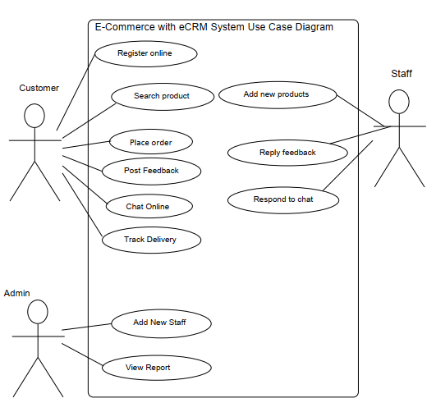

***Fig 3.5.1: Use Case of E-Commerce Application***

## 3.4 Gantt Chart

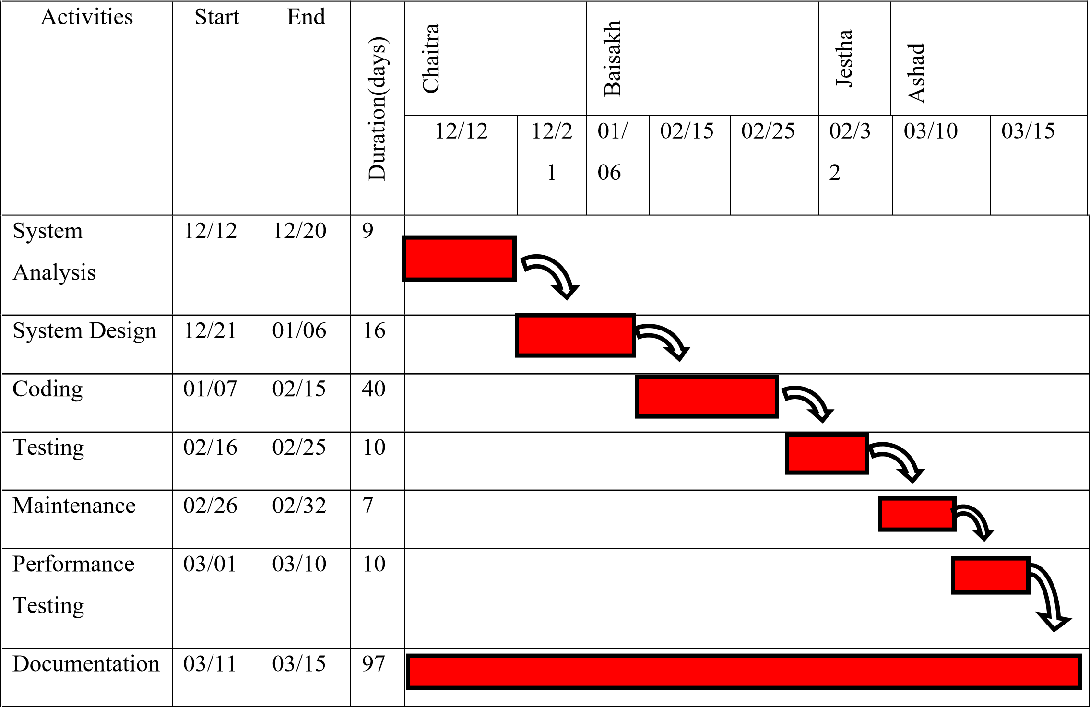

***Fig 3.5.1: Gantt chart***

## 3.5 Expected Outcome

Integrating machine learning into an e-commerce application can lead to a variety of potential outcomes, depending on the specific use case and implementation. Here are some possible outcomes:

1. Personalized Recommendations: One of the most common uses of machine learning in e-commerce is to provide personalized product recommendations to customers based on their browsing and purchase history. By analyzing large amounts of data on customer behavior, machine learning algorithms can identify patterns and make accurate recommendations that are more likely to result in a purchase.
2. Improved Inventory Management: Machine learning can also help e-commerce businesses better manage their inventory by predicting demand and adjusting supply accordingly. This can reduce overstocking and understocking, leading to cost savings and improved customer satisfaction.
3. Fraud Detection: Machine learning can be used to detect fraudulent transactions in real-time, reducing the risk of chargebacks and other types of financial loss for e-commerce businesses.
4. Customer Service Automation: By using natural language processing (NLP) and chatbots, machine learning can automate many customer service interactions, freeing up staff to focus on more complex issues. This can also improve response times and customer satisfaction.
5. Improved Search Results: Machine learning can be used to improve the accuracy and relevance of search results on e-commerce sites, making it easier for customers to find what they're looking for.

# REFERENCES

1. L. Li, Y. Zhang, and S. Cheng, "A Machine Learning Based E-Commerce Recommendation System," in 2017 IEEE 3rd Information Technology and Mechatronics Engineering Conference (ITOEC), Chongqing, China, 2017, pp. 236-240.
2. S. H. S. Salleh, S. B. M. Jusoh, and M. K. Yaacob, "Machine Learning Techniques for Personalized E-Commerce," in 2018 IEEE Conference on e-Learning, e-Management and e-Services (IC3e), Langkawi, Malaysia, 2018, pp. 1-6.
3. Y. Wang, W. Zeng, and Y. Xie, "A Machine Learning Based E-Commerce Fraud Detection System," in 2018 IEEE International Conference on Intelligence and Security Informatics (ISI), Miami, FL, USA, 2018, pp. 119-121.
4. S. S. Saha, S. S. Islam, and M. R. Kabir, "Machine Learning Based Online Fraud Detection System for E-commerce," in 2019 IEEE International Conference on Big Data, Cloud Computing, and Data Science Engineering (BCD), Tiruchirappalli, India, 2019, pp. 127-132.