

**Tribhuvan University**

**Faculty of Humanities and Social Science**

**A PROJECT PROPOSAL**

**“MAKEOVER(Appointment Booking)”**

**Submitted to**

**Department of Computer Application**

**Lumbini City Collage**

***In partial fulfillment of the requirements for the Bachelors in Computer***

***Application***

**Submitted by**

Rashish Regmi (6-2-1134-50-2020)

Pushpanjali Dewan(6-2-1134-49-2020)

07-03-2023

Under the Supervision of

**Deepak Sapkota**

**Abstract**

This project proposal aims to fulfill the requirements for the Bachelor of Computer Application. Our team takes pleasure in presenting the detailed project report that reflects our efforts in this semester.

Our project is Makeover that have become a popular way for individuals to refresh their appearance and express their personal style. A makeover typically involves a consultation with a professional stylist or makeup artist to discuss the individual’s goals and preferences. The stylist or artist will use a range of beauty techniques and products to enhance the individual’s features and create a new look that suits their personality and style. Hair styling may involve a cut, color, or treatment to achieve the desired effect. Makeup application may include contouring, highlighting, and experimenting with different colors and textures. Skin treatment such as facials or chemical peels can improve the texture and appearance of the skin, while manicures and pedicures can give hands and feet a polished look. The ultimate goal of a makeover is to leave the individual feeling confident and satisfied with their new appearance. With the help of a skilled professional and a little creativity.

Overall, a makeover can be fun and transformative experience that leaves one feeling confident and ready to take on the world with a fresh new look.

**Acknowledgement**

Firstly, we would like to thank Lumbini City College for providing us this platform to gain

knowledge about different aspects of Computer Science and Information Technology to explore our interest and ideas in the software development field through this project. We would also like to thank our Academic Coordinator **Mr. Bishal Kandel** who played an important role in providing us advice and suggestion towards the selection of our project and topic as well as for providing us with necessary content and classes regarding the project. We are also grateful for the valuable time, suggestion, help, support, supervision, and guidance support from our supervisor **Mr. Deepak Sapkota** for providing with all necessary suggestions and corrections that are needed to be done for our project. In addition, we also want to thank our friends and classmates for helping us directly or indirectly with the guidelines we needed during the completion of our project.

Table of Contents

**Chapter 1:Introduction**…………………………………………1

* 1. **Introduction ………………………………………………………….....**1
  2. **Problem Statement……………………………………………………..**2
  3. **Objectives……………………………………………………………….**2
  4. **Scopes…………………………………………………………………....**3
  5. **Limitations ……………………………………………………………..**4

**Chapter 2:Background Study and Literature Review…………**5

**2.1 Background Study ………………………………………..……………**5

**2.2 Literature Review………………………………………………………**5

**Chapter 3:System Analysis and Design…………………………**6

**3.1 System Analysis………………………………………………**6

**3.1.1 Requirement Analysis…………………………………………...**6

**i. Functional Requirements…………………………………..**6

**ii. Non Functional Requirements…………………………….**6

**3.1.2 Feasibility Analysis………………………………………………..**6

**i. Technical……………………………………………………**.6

**ii. Operational…………………………………………………**6

**iii. Economical…………………………………………………**6

**3.2 System Design………………………………………………..**7

**3.2.1 Use Case Diagram……………………………………….…….**7

**3.2.2 Flow Chart……………………………………………………..**8

**3.2.3 Gantt Chart……………………………………………………**9

**Chapter 4: Expected Outcomes and References……………...**10

**4.1 Expected Outcomes……………..…………………………………….**10

**4.2 Appendices…………………………………………………………….**10

**4.2.1 Screenshots………………………………………………..**10-13

**4. References………………………………………………………………**13

**Chapter 1: Introduction**

* 1. **Introduction**

Our project name is Makeover. Makeover typically refers to the process of making changes to one’s appearance or surrounding in order to achieve desired result. However, makeover in our project is related to beauty parlour where it involves changes to one’s appearance.

A makeover is essentially a way for individuals to refresh and update their appearance. The process typically involves a series of beauty treatments and styling techniques that aim to enhance the natural features of the individual, while also reflecting their personality and preferences. People may choose to undergo a makeover for a variety of reasons. For instance, they may wish to boost their self-confidence or prepare for a special event, such as a wedding or job interview. Alternatively, they may simply be looking for a change of style and want to experiment with new looks.

Makeover services can include a range of treatments and techniques, such as hairstyling, makeup application, skincare treatments, and wardrobe styling. These services can be carried out at home with the help of friends or family members, or by professionals at a beauty salon or spa. In any case, the ultimate goal of a makeover is to create a new and improved look that the individual feels comfortable and confident with. By taking the time to enhance their appearance and invest in self-care, individuals can improve their overall sense of well-being and satisfaction with their appearance.

1

**1.2 Problem Statement**

Waiting for extended periods of time until their turn has been an ongoing issue for customers of beauty parlours, resulting in a negative impact on the overall customer experience. This issue can contribute to dissatisfaction with the service, leading to decreased customer loyalty and reduced revenue for the business. Customers may become frustrated with the wait time, which can result in a negative perception of the business and its services.

In context of Nepalese modern appointment booking website has incomplete website. For example: the website have the appointment booking interface but it is incomplete and outdated. So, this provide inconvenience for customer for appointment booking.

To address this issue, beauty parlours should consider implementing strategies to reduce wait times and improve the overall customer experience. This may involve optimizing appointment scheduling and managing staff resources more effectively to minimize wait times. It may also involve investing in technology solutions that can streamline the booking process and provide customers with real-time updates on wait times.

**1.3 Objectives**

1. To reduce the issue of waiting for extended periods of time.
2. To ensure customer satisfaction with the service they needed.
3. To reduce miscommunication and dissatisfaction.
4. To improve the customer experience by providing a comprehensive and user friendly platform.

2

**1.4 Scopes**

1. User Interface: The website will have an intuitive and user-friendly interface that is optimized for desktop and mobile devices.
2. Appointment Booking: Makeover will allow customers to book appointments for beauty services with a few clicks. Customers will be able to browse through available services, choose the preferred date and time, and pay for the service securely.
3. Service Provider Management: Makeover will provide service providers with a dashboard to manage their appointments, availability, and services. The dashboard will also allow service providers to view their ratings and reviews, and update their profiles.
4. Online Reviews: Makeover will allow customers to leave online reviews and ratings for service providers. The reviews and ratings will be visible to other customers and will help in building the reputation of service providers on the platform.
5. Reminder System: Makeover will implement a reminder system to remind customers of their appointments. The reminder system will help in reducing the number of no-shows and enhancing customer satisfaction.

3

**1.5 Limitations**

1. Limited scope: A makeover is typically focused on enhancing one's appearance through beauty treatments such as hair styling, makeup, and skin care. While these treatments may improve one's physical appearance, they do not address other important aspects of well-being such as mental health, emotional wellness, and personal growth.
2. Unrealistic beauty standards: The beauty industry often promotes unrealistic beauty standards, which can negatively impact individuals' self-esteem and body image. A focus on appearance can perpetuate these standards and contribute to an unhealthy preoccupation with one's physical appearance.
3. Temporary results: Makeover treatments provide temporary results and require ongoing maintenance to sustain the desired appearance. This can create a cycle of constant treatments and spending, which may not be sustainable or affordable for everyone.
4. Limited accessibility: Beauty treatments and makeovers can be expensive and may not be accessible to everyone, particularly those on lower incomes. This can contribute to inequality and perpetuate societal beauty standards that favor certain groups.
5. Limited impact: While a makeover may provide a temporary boost in confidence, it may not address underlying issues that contribute to low self-esteem or body image concerns. A holistic approach to well-being that addresses mental health, physical health, and personal growth may have a more significant and lasting impact on an individual’s well-being.

4

**Chapter 2: Background Study and Literature Review**

**2.1 Background Study**

Makeover typically refers to the process of improving or transforming someone's appearance or image through various means such as changing their hairstyle, makeup, clothing, and sometimes even their lifestyle. The goal of a makeover is to enhance a person's physical appearance, confidence, and self-esteem. Makeovers are often associated with fashion, beauty, and entertainment industries, but can also be used in personal development and self-improvement contexts. The process of a makeover may involve consulting with professionals such as stylists, makeup artists, and fitness trainers to achieve the desired result. Makeovers can be temporary or permanent, and can range from subtle changes to a complete transformation.

**2.2 Literature Review**

A study by Kuo et al. (2018) on the factors influencing user adoption of online appointment booking systems found that perceived usefulness, ease of use, and trust were the most significant factors affecting user adoption. The study also found that the reputation of the service provider and the quality of services provided were important factors influencing user adoption. This study highlights the importance of user experience and trust in the success of appointment booking websites.

Another study by Lee et al. (2019) on the determinants of customer satisfaction with online beauty service platforms found that website design, ease of use, and perceived value were significant factors affecting customer satisfaction. The study also found that customer satisfaction had a significant impact on customer loyalty. This study reinforces the importance of user experience and how it impacts the success of appointment booking websites.

Another study by Wang et al. (2019) on the impact of online word-of-mouth on customer purchase intention in the beauty service industry found that online word-of-mouth significantly influenced customer purchase intention. The study also found that perceived value and website quality significantly impacted online word-of-mouth. This study reinforces the importance of user experience and perceived value in the success of appointment booking websites.

5

**3. Chapter: System Analysis and Design**

**3.1. System Analysis**

**3.1.1 Requirement Analysis**

**1. Functional**

* + 1. Appointment booking
    2. Services
    3. Review

1. **Nonfunctional**
2. **Performance**: The system should be able to handle a large number of concurrent users without experiencing any performance issues or slowdowns.
3. **Security:** The system should have strong security measures in place to protect user data and prevent unauthorized access.
4. **Usability**: The system should be easy to use and navigate, with clear instructions.
5. **Reliability:** The system should be reliable and able to recover quickly in the event of a failure.

**3.1.2. Feasibility Analysis**

1. **Technical:**

While going through with the project we will use html, css and javascript in Frontend, php in Backend and mysql for database.

1. **Operational:**

Our website will be available for the service for 24/7,to ensure our customers have access to support whenever they need it.

1. **Economical:**

During this project makeover, we will be utilizing all resources at no cost to ensure maximum benefit and value to our project.

6

**3.2 System Design**

**3.2.1. Use Case Diagram**

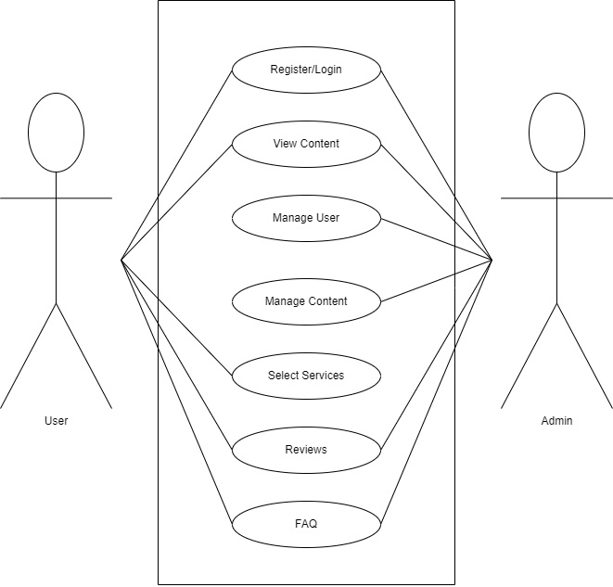

7

**3.2.2. Flow Chart**

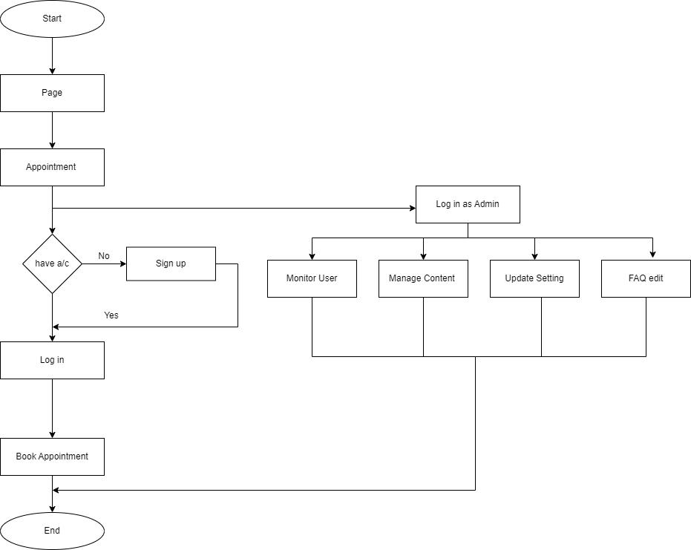

8

**3.2.3 Gantt Chart**

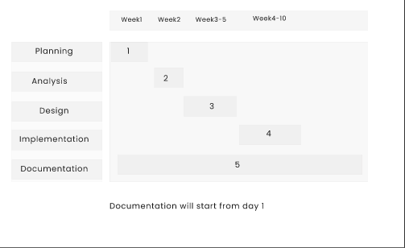

9

**Chapter 4: Expected Outcomes and References**

**4.1 Expected Outcome**

1. Online platform for appointment booking and getting the services efficient.
2. A wider range of makeover services available to customers, meeting the needs of diverse customer groups.
3. Increased booking and help in higher revenue of business.

**4.2 Appendices**

**4.2.1 Screenshots**

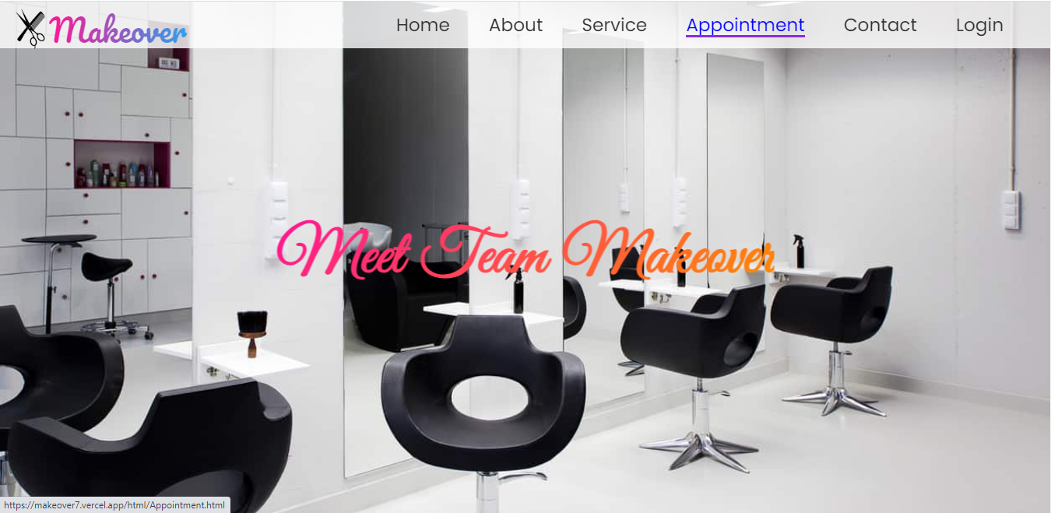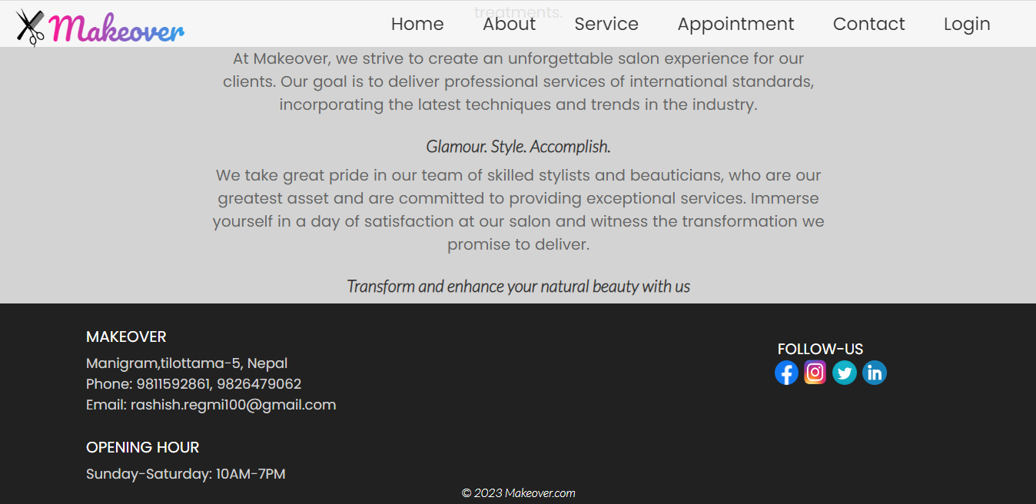 10

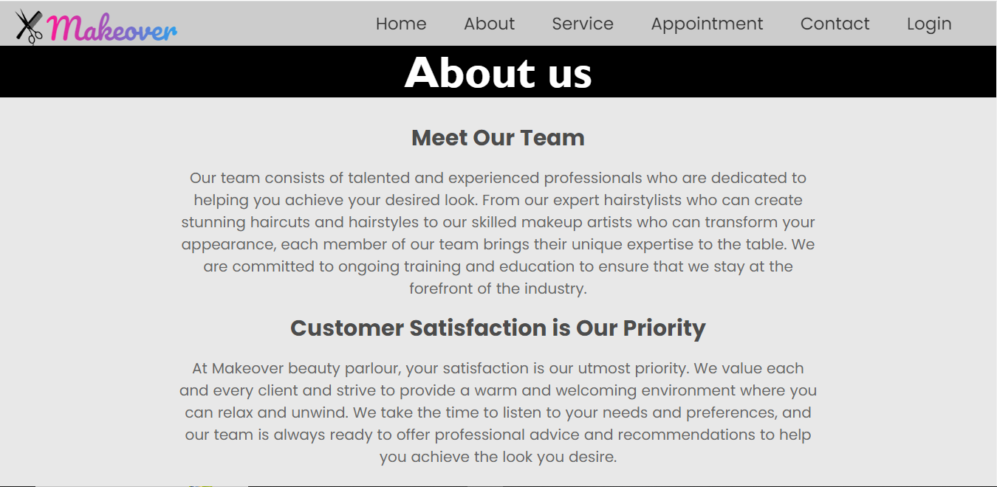

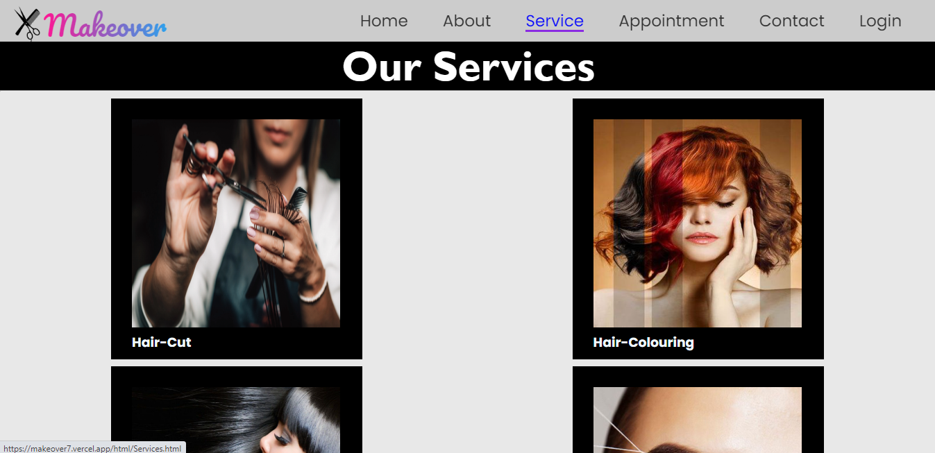

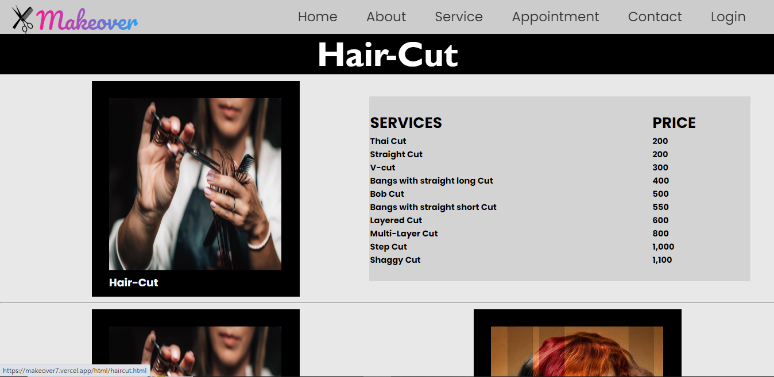

11

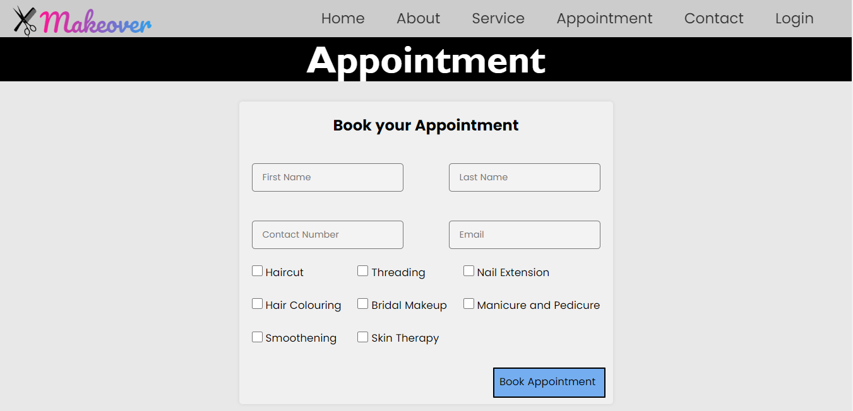

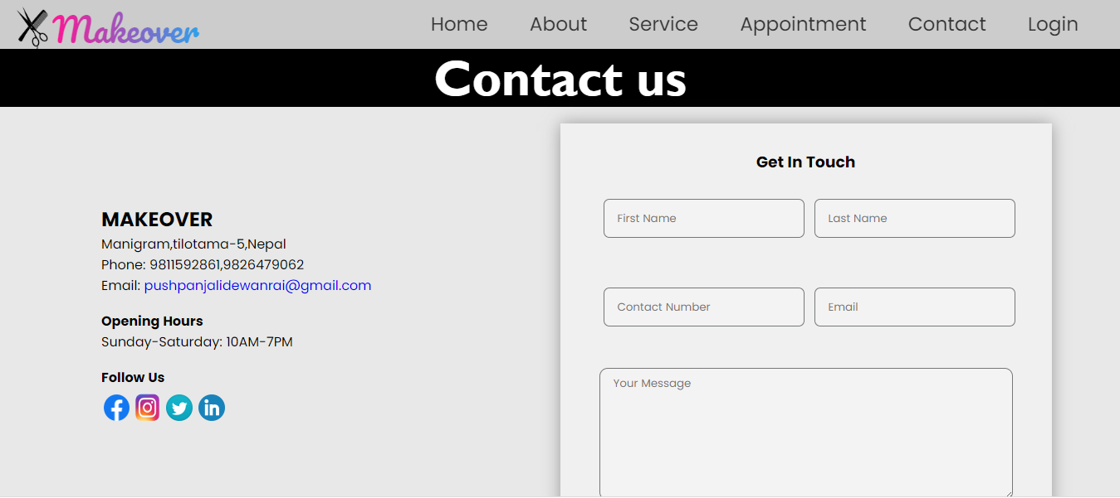

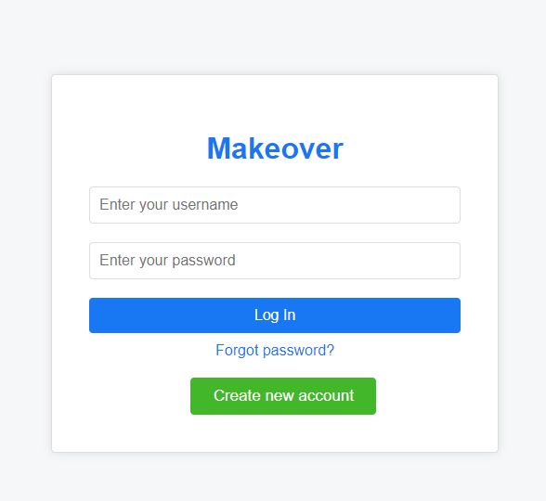

12

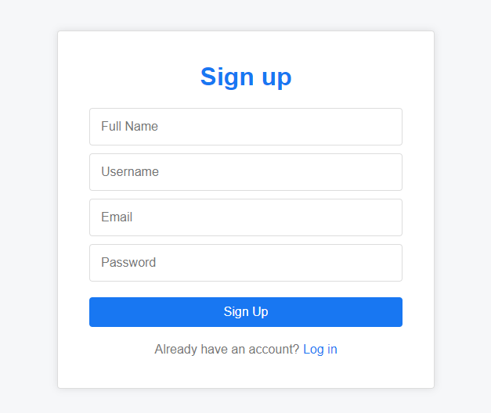

**4.3 References**

“Style Lounge &amp; Makeover Concepts,” LAVISH. [Online]. Available:https://lavishsalon.com.np/. [Accessed: 02-Apr-2023].

“Home,” The Beauty Parlour, 12-Dec-2019. [Online]. Available:http://www.organicbeautyparlour.com/. [Accessed: 02-Apr-2023].

13