

**Tribhuvan University**

**Faculty of Humanities and Social Science**

**“E KHAJA”**

**A PROJECT REPORT**

**Submitted to**

**Department of Computer Application**

**Lumbini City College**

***In Partial Fulfillment of the Requirements for the Bachelors in Computer Application***

Submitted by:

Suman Khatri (T.U.Reg.No:-6-2-1134-60-2020)

Chitra Bahadur Thapa (T.U.Reg.No:-6-2-1134-42-2020)

(Aug, 2023)

Under the Supervision of

**Mr. Suraj Khattri**



**Tribhuvan University**

**Faculty of Humanities and Social Science**

**Lumbini City College**

# Supervisor’s Recommendation

I hereby recommend that this project prepared under my supervision by SUMAN KHATRI and CHITRA BAHADUR THAPA entitled “ E KHAJA” in partial fulfillment of the requirements for the degree of Bachelor of Computer Application is recommended for the final evaluation.

**……………………**

**SIGNATURE**

Suraj Khattri

**SUPERVISOR**

Faculty of Humanities and Social Sciences

Lumbini City College

Tilottama-4, Drivertole

# Letter of Approval

This is to certify that this project prepared by Suman Khatri and Chitra Bahadur Thapaentitled **“ E KHAJA”** in partial fulfillment of the requirements for the degree of bachelor in computer application has been evaluated. In our opinion it is satisfactory in the scope and quality as a project for the required degree.

|  |  |
| --- | --- |
| **……………….**  **Suraj Khattri**  **Supervisor**  **Lumbini City College** | **…………………….**  **Bishal Kandel**  **Program coordinator**  **Lumbini City College** |
| **…………………….**  **Internal Examiner**  **Lumbini City College** | **…………………….**  **External Examiner**  **FOHSS, Tribhuvan University** |

Abstract

This project involves the development of a comprehensive framework tailored for the seamless operation of intricate applications, specifically centered around the "E KHAJA" online platform. "E KHAJA" revolutionizes the food industry by offering a virtual hub for culinary delights, connecting a diverse array of eateries with discerning customers seeking a convenient and delightful dining experience.

At its core, "E KHAJA" is an innovative solution for food enthusiasts, providing a digital marketplace where an eclectic range of gastronomic offerings converge. This platform boasts a diverse selection of culinary options, ensuring that customers can explore and savor an extensive array of dishes from various cuisines, all from the comfort of their homes.

Aiming to encapsulate convenience, quality, and choice, "E KHAJA" facilitates the easy ordering of meals from an assortment of restaurants, cafes, and eateries. The platform's commitment to excellence is evident not only in its culinary offerings but also in its dedication to prompt and efficient delivery services, ensuring that customers' appetites are satisfied in a timely manner.

"E KHAJA" embraces a user-centric approach, tailoring its interface to provide an intuitive and user-friendly experience. Customers can effortlessly navigate through a rich array of menus, make selections according to their preferences, and place orders with ease. The platform's mission is to redefine the dining experience by delivering not just food, but also an impeccable level of service that enhances every aspect of the journey.

Overall, "E KHAJA" embodies the modern era's culinary ethos, bringing together culinary excellence, convenience, and innovation under one digital roof. With a commitment to satisfying diverse palates, fostering a vibrant dining community, and elevating the food delivery landscape, "E KHAJA" is set to become the preferred destination for those seeking exceptional meals that celebrate flavor, variety, and the joy of culinary exploration.

# Acknowledgement

We are immensely grateful as we reflect upon our journey at Lumbini City College, where our passions and curiosities in the realm of software development were nurtured and brought to fruition through this remarkable project. Our sincere appreciation is extended to Mr. Bishal Kandel, whose role as the Academic Coordinator proved indispensable; his astute guidance not only led us to the perfect project topic but also provided us with an array of invaluable resources, setting us on the right path.

A special mention of gratitude must also be reserved for our dedicated supervisor, Mr. Suraj Khattri, whose unwavering support and supervision played an integral role in shaping the project's trajectory. His profound insights not only enriched our understanding but also inspired us to surpass our own expectations.

Moreover, we cannot overlook the collective efforts of our friends, classmates, and all those who selflessly offered their guidance and assistance throughout this journey. Their contributions, both big and small, collectively propelled us towards the triumphant culmination of this endeavor. As we stand at the completion of this project, we carry forward not only a sense of accomplishment but also a deep appreciation for the collaborative spirit that embodies the ethos of Lumbini City College.

Table of Contents

Supervisor’s Recommendation i

Letter of Approval ii

Abstract iv

Acknowledgement iii

List of Figures vii

List of Tables viii

Abbreviations ix

Chapter 1: Introduction 1

1.1 Introduction 1

1.2 Problem Statement 1

1.3 Objectives Statement 2

1.4 Scope and Limitation 2

1.5 Report organization 1

Chapter 2: Background Study and Literature Review 3

2.1 Background Study 3

2.2 Literature Review 3

Chapter 3: System Analysis and Design 4

3.1 Research Methodology **Error! Bookmark not defined.**

3.2 System Analysis 4

3.2.1 Requirement Analysis 4

3.2.2 Feasibility Study 5

3.3 System Modelling 6

3.3.1 Data Modelling: ER-Diagram 6

3.3.2 Use–Case Diagram 7

3.3.3 Process Modelling: Data Flow Diagram (DFD) 8

3.3.4 Gantt Chart 10

3.4 System Design 10

3.4.1 Database Schema Design 11

3.4.2 Interface Design (UI/UX) 12

3.4.3 Flowchart 12

Chapter 4: Implementation and Testing 16

4.1 Implementation 16

4.1.1 Tools Used (CASE tools, Programming languages, Database platforms) 16

4.1.2 Implementation Details of Modules (Description of procedures/functions) 17

4.2 Testing 18

4.2.1 Test Cases for System Testing 18

4.2.2 Test Cases for Unit Testing 18

4.2.3 Integration Testing 20

Chapter 5: Conclusion and Future Recommendations 21

5.1 Conclusion 21

5.2 Future Recommendations 21

References 23

# List of Figures

Figure 3.1.: E-R Diagram....................................................................................................9

Figure 3.3.2: Use Case Diagram….….…………………………………………………..10

Figure 3.3.1: Level 0 DFD…............................................................................................10

Figure 3.3.2: Level 1 DFD………………………….……...............................................11

Figure 3.3.3: Gantt Chart ……………..….……………………………………………...12

Figure 3.4.1: Database Schema Design………………………………….………………13

Figure 3.4.2: Interface Design……………………………………………….…………..16

Figure 3.4.3: Flowchart ………………………………………………..….......................16

# List of Tables

Table 4.2.1: Test case for integration testing……………………………….…………....21

Table 4.2.2: Test cases for unit testing…………………………………………………...22

# Abbreviations

CASE : Computer Aided Software Engineering

DFD : Data Flow Diagram

ER : Entity Relationship

SRS : Software Requirement Specification

UI : User Interface

UX : User Experience

# Chapter 1: Introduction

## 1.1 Introduction

This project has been submitted in the fulfilment of the requirements for the Bachelor of Computer Application. We the team members of this project, take pleasure in presenting the detail project report that reflects our efforts in this semester.

Our project name is Food Ordering System. This system aims to provide an easy and convenient way for customers to order food online from different restaurants. With the increasing trend of online food ordering, this system is a useful tool for customers to order food in a hassle-free way. The system will provide a user-friendly interface that will enable customers to place their orders quickly and easily.

The Food Ordering System will consist of a user-friendly interface that allows customers to browse menus, select items, and place their order with just a few clicks. The system will also allow restaurant owners to manage their menu from a centralized platform.

With the increasing trend of online food ordering, there is a need for a system that provides customers with an easy and convenient way to order food online. The Food Ordering System aims to fulfil this need by providing a platform for customers to order food online.

## 1.2 Problem Statement

The traditional method of ordering food in person or over the phone has become increasingly inconvenient and time-consuming for customers. Additionally, restaurant owners are struggling to manage orders and ensure efficient delivery of food items. These issues have led to a need for a more streamlined food ordering system that can simplify the process of ordering food for both customers and restaurant owners. The current systems often lack a user-friendly interface, efficient order management, and accurate order tracking, resulting in delays, errors, and dissatisfied customers. Therefore, there is a need for a reliable and efficient food ordering system that can improve the customer experience and enhance the overall efficiency of the food ordering process.

## 1.3 Objectives Statement

We have made the Food Ordering System to simplify the process of ordering food online. Some of the specific objectives of this system are listed below:

1. To provide customers with a fast and convenient method of ordering food.
2. To improve accuracy in the order taking process.
3. To streamline the delivery process.
4. To provide customers with a user-friendly and intuitive ordering interface.
5. To enable restaurant owners to manage orders.

## 1.4 Scope and Limitations

## Scope:

The scope of the food ordering system includes providing customers with a wide range of options, including both vegetarian and non-vegetarian dishes. The system will have a menu and item management module to add, remove, and update traditional Nepali food items on the menu. The ordering process is simplified, and real-time updates is provided on the status of orders. The system is user-friendly and secure, ensuring the privacy and security of customer data. Overall, the food ordering system will provide a seamless and convenient experience for customers, allowing them to easily browse through the menu, select their desired items, and place orders from the comfort of their homes or workplaces.

### Limitations:

The limitations of this project are given below:-

1. Delivery limitations: Online food ordering systems are dependent on third-party delivery services, which may have limitations on delivery range, delivery times, and delivery fees. This can impact the convenience and overall experience of the customer.
2. No Order tracking: It is very complex process to order track so we will not use order tracking.

# Chapter 2: Background Study and Literature Review

## 2.1 Background Study

In a rapidly evolving digital landscape, online food ordering systems have gained significant traction as a convenient and efficient way to satisfy culinary cravings. With the rise of digital platforms, the "E Khaja" project emerges as a response to the growing demand for a streamlined food ordering experience.

## This project is driven by the changing dynamics of dining preferences, where individuals are increasingly seeking the convenience of ordering food online. With the digital age redefining consumer behavior, the goal of "E Khaja" is to provide a user-friendly platform that caters to this trend. The project aims to create an accessible virtual space where users can explore a diverse array of culinary options and place orders effortlessly.

## Unlike the traditional dining experience, "E Khaja" eliminates the need for physical presence, allowing users to browse menus, choose their desired dishes, and place orders from the comfort of their homes. The project aims to bridge the gap between local eateries and hungry consumers, presenting a win-win situation for both parties.

## In the context of modern challenges, such as time constraints and busy schedules, the "E Khaja" platform seeks to offer a seamless solution. By providing a hassle-free way to discover, select, and order food, it caters to individuals who seek convenience without compromising on their culinary preferences.

## The anticipated user base of "E Khaja" encompasses a broad spectrum of individuals, ranging from professionals seeking quick and delicious meals to families desiring diverse dining options. The platform's features may include detailed menus, vibrant food imagery, and a user-friendly interface that simplifies the ordering process.

## Unlike the other Ecommerce project, "E Khaja" does not include an order tracking feature, focusing solely on facilitating the food selection and ordering aspects. This streamlined approach aims to optimize the user experience and cater to individuals looking for a swift and straightforward food ordering solution.

## In essence, the "E Khaja" project is designed to redefine the way individuals interact with their dining choices. By embracing the digital realm, it offers a tantalizing array of culinary options at users' fingertips, transforming the act of ordering food into a seamless, convenient, and delightful experience.

## 2.2 Literature Review

The use of online food ordering systems has become increasingly popular in recent years, with more and more consumers opting for the convenience and ease of ordering food online. According to a report by Statista (2021), the global revenue of the online food ordering industry is projected to reach $151.5 billion by 2024, up from $72.9 billion in 2020. This highlights the significant growth potential of the industry and the increasing demand for online food ordering systems.

Studies have shown that online food ordering systems can improve customer satisfaction and loyalty (Wang & Tsai, 2017). Customers appreciate the convenience of being able to order food from anywhere, at any time, without having to wait in long queues or make phone calls. This is particularly true for younger generations who are accustomed to using technology in their daily lives (Mishra & Sharma, 2017).

Moreover, online food ordering systems can also help restaurants to increase their sales and revenue by offering customers an easy and user-friendly way to place orders (Wang & Tsai, 2017). This is particularly relevant during the COVID-19 pandemic, where many customers are opting for delivery and takeaway options over in-person dining.

However, online food ordering systems also have their limitations. Technical issues, such as software bugs or server downtimes, can impact the overall performance of the system (Batra, 2020). Additionally, the implementation and maintenance costs of an online food ordering system can be relatively high, making it challenging for small businesses to adopt (Mishra & Sharma, 2017).

In conclusion, online food ordering systems offer significant benefits for both customers and restaurants, including convenience, increased sales, and improved customer satisfaction.

# Chapter 3: System Analysis and Design

## System Analysis

### 3.1.1 Requirement Analysis

**A) Functional Requirements**

Functional requirements for a food ordering website might include:

1. User registration and authentication: Users is able to create an account, log in, and manage their profile information.
2. Ordering process: The system should provide a user-friendly interface for customers to browse menu items, add them to their cart, and specify any special instructions or preferences. The system should also handle payments securely.
3. Restaurant management: Restaurants is able to view and manage their orders and update their menu.
4. Customer support: This system provide customer support features such as FAQs, chat support, and other support.

**B) Non-Functional Requirements:**

1. Performance: This system is designed to handle high traffic and load without significant downtime or slowdowns.
2. Security: The system use encryption and other security measures to protect user data, payment information, and other sensitive information.
3. Reliability: The system is reliable and available 24/7, with minimal downtime for maintenance or upgrades.
4. Usability: The system is user-friendly and easy to navigate, with clear instructions and feedback for users.
5. Compatibility: The system is compatible with a variety of devices and platforms, including desktop and mobile devices, various operating systems, and different web browsers.
6. Accessibility: The system should be designed to be accessible to users with disabilities, including support for assistive technologies like screen readers and keyboard navigation.
7. Scalability: The system should be scalable, able to handle increasing amounts of data and traffic as the business grows.
8. Maintainability: The system should be easy to maintain and update, with a modular design and clear documentation for developers.

### 3.2.2 Feasibility Study

**A) Technical Feasibility**

This system is technically feasible to implement. The technical feasibility of the proposed system will be evaluated by considering the hardware and software requirements, internet connectivity, and any technical barriers that could affect the system's performance.

**B) Economic Feasibility**

This system is economically feasible to implement. The economic feasibility of the proposed system will be evaluated by considering the costs involved in implementing and maintaining the system. This will include hardware and software costs, website design and development costs, and ongoing maintenance and support costs.

**C) Operational Feasibility**

The operational feasibility of the proposed system will be evaluated by considering how the system will integrate with the restaurant's existing operations. The system would be available 24/7.

**D) Legal Feasibility**

The website must comply with all relevant laws and regulations related to e-commerce, data protection, and consumer protection. This includes registering the website with relevant authorities, securing proper licenses and permits, and complying with taxation laws.

## 3.3 System Modelling

### 3.3.1 Data Modelling: ER-Diagram

An ER diagram, also known as ER model, is a graphical representation of entities and their relationships to each other. Typically, it's used in computing regarding the organization of data within a database or information system. The basic components of an ER diagram are entities, attributes, and relationships between and among those entities. The ER diagram for the E Khaja is as follows.

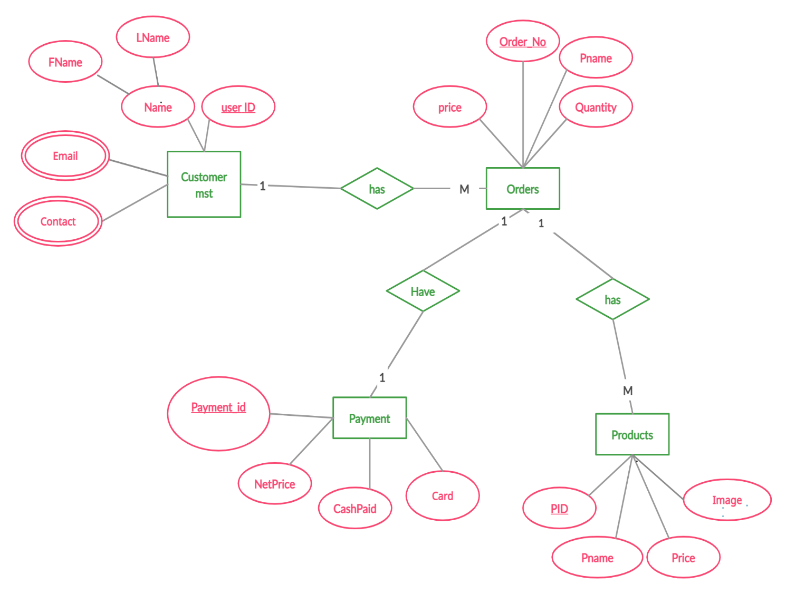

***Fig 3.3.1: ER Diagram***

### 3.3.2 Use–Case Diagram

A use case is a technique used in software development and system design to identify, clarify, and organize the requirements of a system or software application. It defines the interactions between users and the system, as well as the steps and conditions involved in completing a specific task or goal. Use-cases help ensure that a system or software application meets the needs and expectations of its users, and they can also serve as a basis for testing and validation.

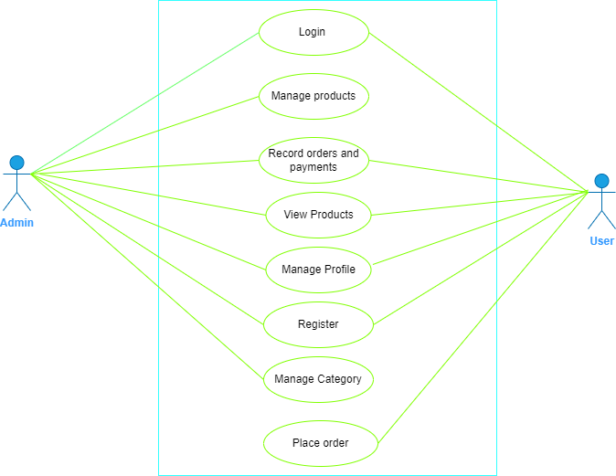

***Fig 3.3.2: Use-Case Diagram***

### 3.3.3 Process Modelling: Data Flow Diagram (DFD)

**A) Zero level DFD (Context Diagram)**

A zero-level Data Flow Diagram (DFD) is the simplest type of DFD, which provides a high-level view of the system, without going into much detail. It shows the overall flow of data within a system and the external entities that interact with it. It typically consists of a single process symbol, which represents the entire system, and the external entities, which represent the sources and destinations of data. The zero-level DFD is often used as a starting point for developing more detailed DFDs and other system documentation.

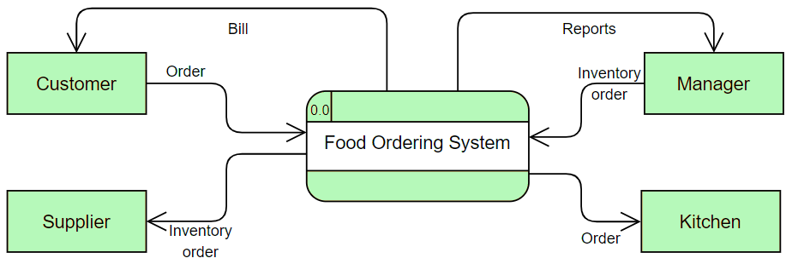

***Fig 3.3.3 Zero level DFD***

**B) Level 1 Data Flow Diagram**

A Level 1 Data Flow Diagram (DFD) is a high-level representation of a system's processes and flows of data between them. It provides an overview of the system and its main processes, without going into the details of how each process works.

At Level 1, the system is typically divided into major processes or functions that represent the system's main capabilities. The data flows between these processes are also identified, showing how data is input, processed, and output by the system. The external entities that interact with the system are also represented, along with the data they input or receive from the system.

Overall, a Level 1 DFD provides a simple and clear overview of the system's main processes and data flows, making it an important tool for system analysts to understand the system's overall architecture and functionality

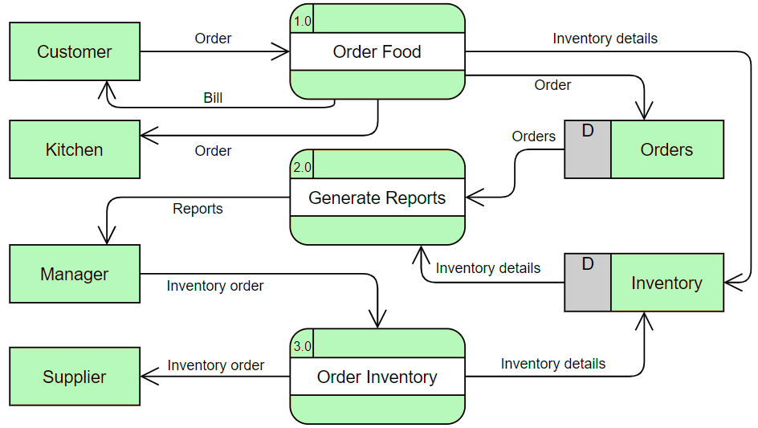

***Fig 3.3.3:2 Level 1 DFD***

### 3.3.4 Gantt Chart

***Fig 3.3.3: Gantt chart of food ordering system.***

## 3.4 System Design

System design is the process of defining the architecture, components, modules, interfaces, and data for a system to satisfy specified requirements. It involves identifying the key functionalities of the system, selecting appropriate technologies and frameworks, and designing a scalable and maintainable solution that meets the desired performance, security, reliability, and usability criteria. A good system design should consider factors such as performance, scalability, reliability, maintainability, security, and usability, and should be flexible enough to accommodate changing requirements and evolving technology trends.

### 3.4.1 Database Schema Design

Database schema design involves creating a blueprint for organizing and structuring data in a database. It includes defining tables, columns, and data types, relationships between tables, and constraints to ensure data integrity. A well-designed schema is crucial for efficient data management and querying. Some key principles of database schema design include normalization, data modeling, and understanding the requirements of the system and its users.

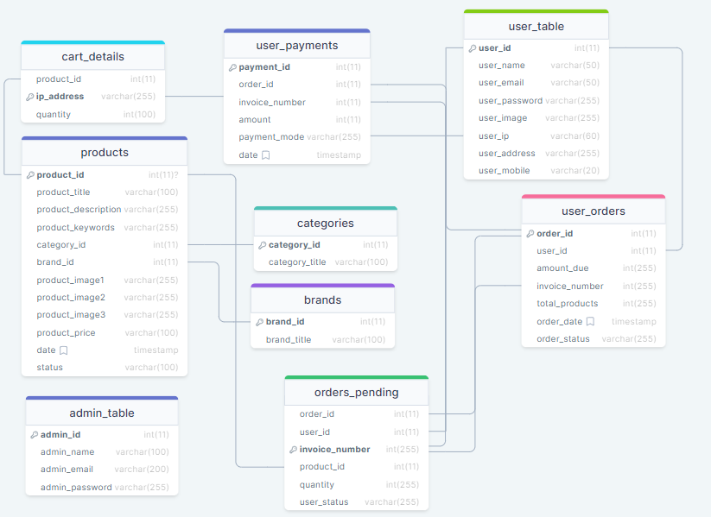

***Fig 3.4.1:*** ***Database Schema of E Khaja***

### 

### 3.4.2 Interface Design (UI/UX):

Interface Design, also known as UI/UX design, is the process of creating user interfaces for digital products such as websites, mobile apps, and software. UI (User Interface) refers to the design of the visual elements that a user interacts with, while UX (User Experience) refers to the overall experience a user has while interacting with a product. The goal of UI/UX design is to create interfaces that are aesthetically pleasing and user-friendly in order to enhance the user's overall experience and satisfaction with the product.

### Home Page

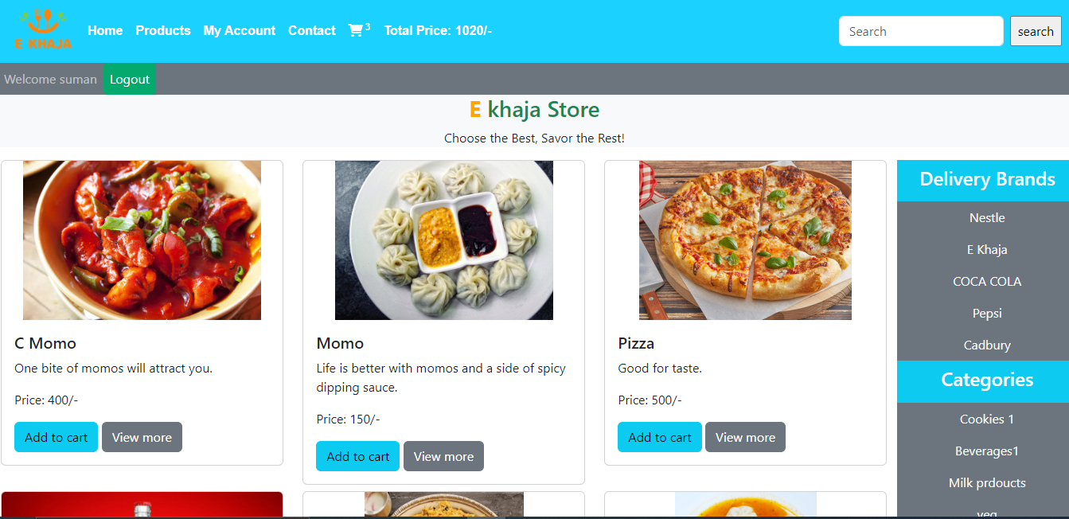

### Login Page

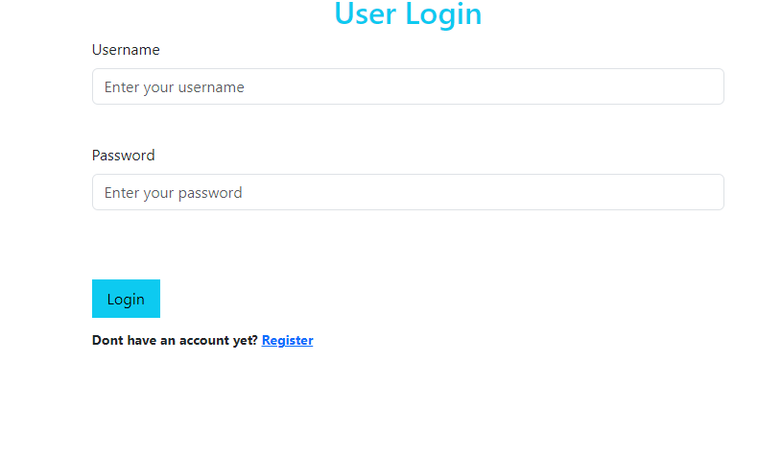

### Cart Page

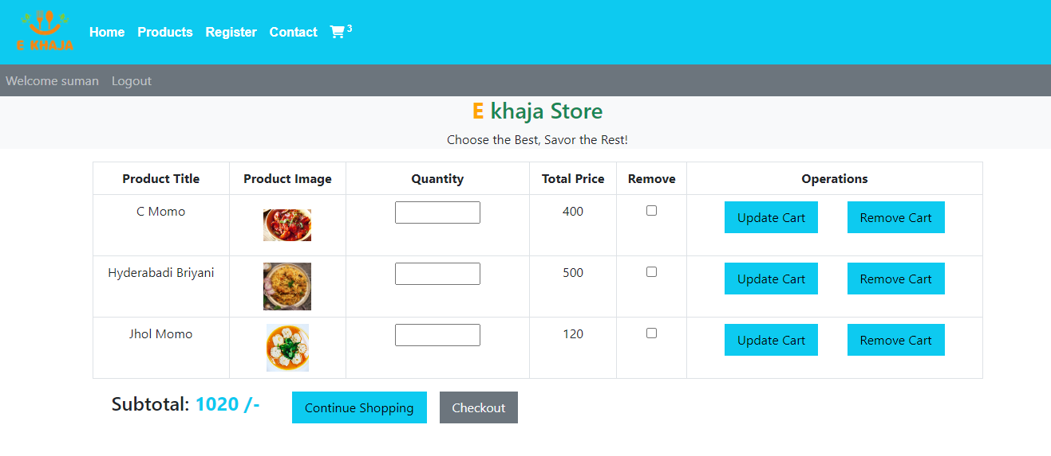

### User Profile and Orders Page

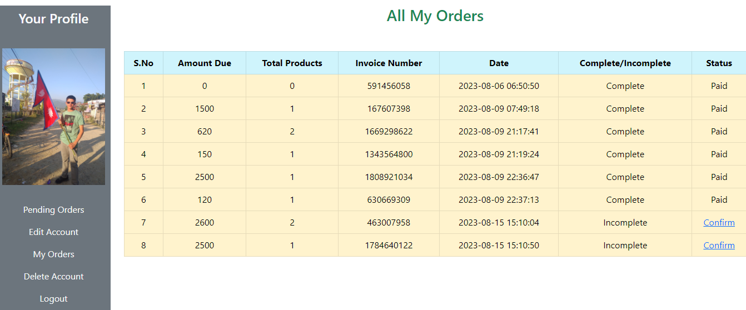

***Fig 3.4.2 Interface Design of E Khaja***

### 3.4.3 Flowchart

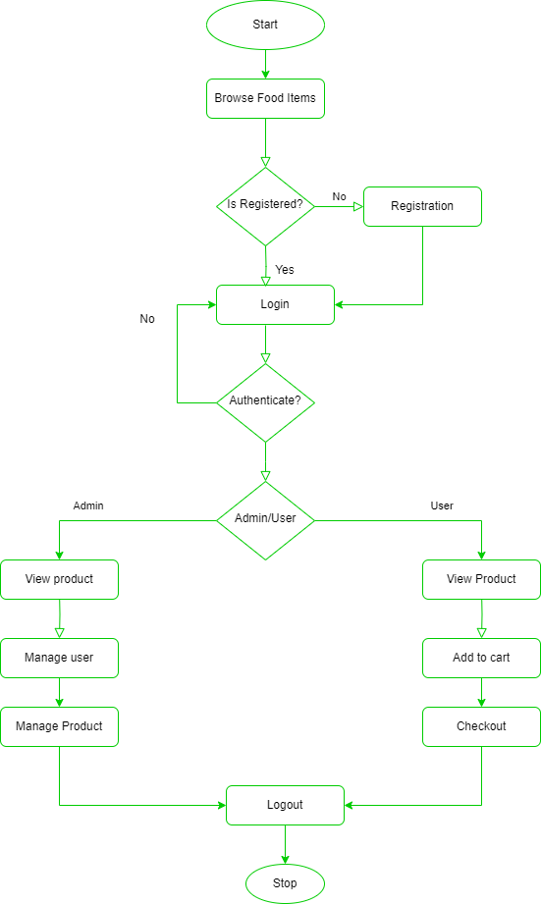

***Fi******g 3.4.3: Flowchart of E Khaja***

# Chapter 4: Implementation and Testing

## 4.1 **Implementation**

### 4.1.1 Tools Used (CASE tools, Programming languages, Database platforms)

**CASE**

Case tools (computer-aided software engineering tools) are software applications designed to support the software development life cycle (SDLC) by automating various tasks such as requirement gathering, analysis, design, testing, and maintenance. Here are some of the most common case tools and their brief descriptions:

* Requirements Gathering Tools: These tools help in capturing, organizing, and managing requirements. They also help in generating test cases from requirements.
* Analysis Tools: These tools help in modeling the requirements using different techniques such as data flow diagrams, use case diagrams, and entity-relationship diagrams.
* Design Tools: These tools help in transforming the analysis models into detailed design specifications. They also help in generating code from the design models.
* Testing Tools: These tools help in testing the software by automating test case generation, test execution, and test reporting.
* Maintenance Tools: These tools help in maintaining the software by analyzing the code and identifying any bugs or defects. They also help in managing changes to the software.

Overall, case tools help in improving the quality and productivity of software development by reducing the time and effort required for various tasks in the SDLC.

**Case tools used in this project are:**

**1) Diagram Tools**

The components of the system, data flow, control flow among the various components of software and the structure of the system can be represented in graphical form using diagram tools. Example: flow chart maker tool.

**2) Process Modeling**

The software process model can be created using process modelling tools for software development. The managers can choose a process model using process modelling tools or make modifications depending upon the software product requirements.

**3) Programming**

The programming environments like integrated development environment, library consisting of in-built modules, simulation is all included in programming tools. The development of software product is aided by these and simulation and testing features are included.

**4.1.1.2 Programming languages**

1. **HTML:**

For the implementation in the front-end HTML was used. It was indeed used for a better looking and make user feel with the display of the contents of the design and the system. Different mark-up tags are used like anchor tag for link bold tag for making the font bold.

1. **CSS:**

For the style implementation CSS is used.CSS made our system more decorative which can make the users feel good looking site. Taking margins, providing sizes, color filling for various pages and contents and other several designs are implemented using the concept of the CSS.

1. **Java Script:**

JavaScript is most used as a client-side scripting language. This means that JavaScript code is written into an HTML page. When a user requests an HTML page with JavaScript in it, the script is sent to the browser and it's up to the browser to do something with it.

1. **MY SQL**

For the database connection MY SQL is used in this project. Various queries are used to interact with the database. Insertion, edit, delete selection of the data are performed through queries. Databases have various tables like registration table, login table, book details table etc. it is always written inside the PHP tag.

1. **PHP**

Hypertext Pre-processor (PHP) is used to validate in the server side. Project was dynamically implemented by using PHP. There is a dynamic page content in our site. User can dynamically access the system and interact with the facilities which they want, to make this success and possible PHP has been used in the system. Admin handle the site dynamically only with the use of different PHP variables, functions, and methods.

### 4.1.2 Implementation Details of Modules (Description of procedures/functions)

1. **User module implementation:**

User module functions include user registration, user login, and user purchase, check order, and modify information.

1. **Administrator module implementation:**

Administrator module functions include login, manage food items, process orders, manage users, and provide feedback.

## 4.2 Testing

Testing is the process of evaluating a product or system to identify any errors, bugs, or defects that need to be corrected before it is released to the public. It involves executing a system or application with the intent of finding errors, defects, or other issues Testing can be done manually or with the help of automated tools, and it involves running a variety of tests to ensure that the product or system functions as intended and meets the required specifications. The goal of testing is to improve the quality and reliability of the product or system, and to minimize the risk of errors or failures that could cause harm to users or damage to property.

### 4.2.1 Test Cases for System Testing

System testing is a type of software testing that evaluates the entire system or software application as a whole, rather than testing individual modules or components. The objective of system testing is to verify that the software meets its specified requirements and performs as expected in its intended environment. To ensure comprehensive testing, it is essential to design and execute a set of effective test cases that cover all possible scenarios and functionalities of the software system.

Overall, effective test cases in system testing should be designed to identify defects, errors, and issues that may arise in the system and ensure that it meets the specified requirements and performs as intended in its real-world environment.

### 4.2.2 Test Cases for Unit Testing

Unit testing is a software testing technique that tests individual units or components of a software application in isolation to ensure that they are functioning as expected. Test cases for unit testing are designed to test the smallest units of code, typically at the function or method level. Unit testing tests a unit of code (module or program) after coding of that unit is tested. Integration testing tests whether the various program that makes up a system, interface with each other as desired, fit together and whether the interface between the programs is correct. System testing ensures that the system meets its stated design specifications. Acceptance testing is testing by the user to ascertain whether the system developed is a correct.

|  |  |  |  |  |  |  |  |  |  |  |
| --- | --- | --- | --- | --- | --- | --- | --- | --- | --- | --- |
| **Test No.** | **Test case** | | **Precondition** | | **Input data**  **test** | | **Expected result** | **Actual result** | | **Result** |
| 1 | Test if user can register | | User should not have this account | | Correct data such as  correct form of Username, password | | User must successfully register. | User is registered successfully. | | pass |
| 2 | | Test if user is not able to register | User should not have this account | Incorrect data as incorrect form of  Username, password | | | User must not be able to register and error message should toast. | User is not registered and gets error message. | pass | |
| 3 | Test if user is not able to register | | User should have registered with this account | | Correct data as correct form of  Username, password | User must not be able to register  and gets error message. | | User is not registered and  gets message  “Already registered, enter new username”. | pass | |
| 4 | Test if user can log in | | User should have registered. | | Correct Username and password. | User must be  successfully logged in. | | User is logged in  successfully and enters profile page. | pass | |
| 5 | Test if user is not able to login | | User should have registered | | Incorrect  Username and password | User must not be able to login. | | User is not able to log in  and get error message “incorrect username or password” | pass | |
| 6 | Test if user is not able to register | | User should not have  registered the account | |  | User must not be able to log in. | | User is not able to log in and gets  message  “incorrect username and password”. | pass | |
| 7 | Test if user can edit information | | User should have those fields already | | New updated information | User information must be updated. | | User’s information is updated | pass | |

***Table 1: Test case for unit testing***

## 4.2.3 Integration Testing

Integration testing is a software testing approach that focuses on examining the interactions and communication between different components or modules within a software system. Its purpose is to ensure that these components collaborate seamlessly as intended, identifying and rectifying any potential issues that might arise when they are integrated. By verifying the correctness of data flow, function calls, and interface compatibility, integration testing contributes to the overall reliability and performance of the software, playing a vital role in delivering a cohesive and functional end product.

|  |  |  |  |  |
| --- | --- | --- | --- | --- |
| Test no. | Test case | Expected result | Actual result | Pass/fail |
| 1 | Test if after registration the user can have login successful | After registering the user must have log in successful. | The user signs up and the login is successful. | Pass |
| 2 | Test if after login the user is in  dashboard page and can search information. | After login the user must get into  dashboard and can search information. | The user login and get into its dashboard  activity and can easily search information. | Pass |
| 3 | Test if after editing the  information the change is  reflected in the database | The change must be reflected in the database. | The new information is saved in the database. | Pass |

***Table 2: Test cases for integration testing***

# Chapter 5: Conclusion and Future Recommendations

## 5.1 Conclusion

## The E Khaja platform has revolutionized the way people order food, offering the convenience of browsing and selecting dishes from the comfort of their own homes. The rise of online food ordering has gained immense popularity in recent years, with E Khaja leading the charge. The anticipated outcome of an online food ordering system like E Khaja is a significant enhancement in the availability and accessibility of a wide variety of cuisines to consumers worldwide.

## E Khaja's online platform offers an extensive range of food options, including diverse cuisines, regional specialties, and the latest culinary trends. This selection empowers consumers to explore high-quality dishes from various restaurants and chefs, often beyond what might be available in their local area. This diversity in offerings not only introduces consumers to new flavors and culinary experiences but also fosters an increased awareness and understanding of different cuisines and ingredients.

## The convenience of online food ordering brings several advantages for consumers. E Khaja's user-friendly interface provides detailed menu descriptions, customer reviews, and ratings, assisting users in making informed choices about their orders. Moreover, the platform frequently offers promotions, discounts, and even free delivery, helping consumers save money and making the dining experience more enjoyable.

## In conclusion, the anticipated outcome of an online food ordering system like E Khaja is a substantial improvement in the accessibility, availability, and convenience of food options for consumers globally. By offering an array of culinary choices, educational insights into different cuisines, and seamless online transactions, platforms like E Khaja are reshaping the way people order food. Ultimately, the expected result of E Khaja and similar platforms is to provide a hassle-free and delightful dining experience while also contributing to the growth of the food industry's online sector.

## 5.2 Future Recommendations

The E Khaja food ordering system is currently focused on providing a seamless platform for ordering a wide range of cuisines. To further enhance the user experience and cater to evolving needs, the following modules are recommended to be included in the platform:

* Centralized Customer Database: Implement a centralized customer database to store and manage customer information, order history, preferences, and payment details.
* Enhanced Database Security: Strengthen the database security measures to ensure the utmost confidentiality and security of customer data.
* Transition to Agile Methodology: As the E Khaja platform grows, consider transitioning from the traditional waterfall model to an agile methodology.
* Mobile Application Development: Plan for the future expansion of E Khaja by developing a dedicated mobile application.
* 24/7 Online Support and Chat Service: Introduce a 24/7 online customer support and chat service to address user queries, provide assistance with orders, and ensure a smooth customer experience. This feature will enhance user engagement and satisfaction, leading to increased customer loyalty.
* Customer Loyalty Programs: Implement customer loyalty programs that reward frequent users with discounts, special offers, and exclusive promotions. By increasing customer loyalty, E Khaja can encourage repeat orders and build long-term relationships with its user base.

# References

[1] Get food or groceries delivered to your doorsteps, https://www.bhojdeals.com/

(accessed jun. 11, 2023).

[2] “Foodmandu: Food Delivery Service in Kathmandu,” Foodmandu Main,

https://foodmandu.com/ (accessed Jul. 1, 2023).

[3] “Khaanpin 24 hour online cloud kitchen - all time, on time - kathmandu & pokhara,” Khaanpin Online Cloud Kitchens - Kathmandu and Pokhara - 24 Hours Food, Liquor and Cakes - All Day All Night Pizza, Breakfast, Snacks and Dinner Delivery, https://khaanpin.com.np/en/ (accessed Jul. 1, 2023).

[4] Best restaurants in India - zomato, https://www.zomato.com/india (accessed jun. 11, 2023).

[5] Swiggy, https://www.swiggy.com/ (accessed jun. 11, 2023).

[6] “Foodpanda: Food and more, delivered,” Home, https://www.foodpanda.com/

(accessed jun. 11, 2023).