**Chapter 1: Introduction**

* 1. **Introduction**

This project has been submitted in the fulfilment of the requirements for the Bachelor of Computer Application. We the team members of this project, take pleasure in presenting the detail project report that reflects our efforts in this semester.

Our project name is Food Ordering System. This system aims to provide an easy and convenient way for customers to order food online from different restaurants. With the increasing trend of online food ordering, this system is a useful tool for customers to order food in a hassle-free way. The system will provide a user-friendly interface that will enable customers to place their orders quickly and easily.

The Food Ordering System will consist of a user-friendly interface that allows customers to browse menus, select items, and place their order with just a few clicks. The system will also allow restaurant owners to manage their menu from a centralized platform.

With the increasing trend of online food ordering, there is a need for a system that provides customers with an easy and convenient way to order food online. The Food Ordering System aims to fulfil this need by providing a platform for customers to order food online.

* 1. **Problem Statement**

1. Traditional ordering (in-person, phone) inconvenient and time-consuming for customers.
2. Restaurant owners struggle with order management and efficient food delivery.
3. Requirement for streamlined food ordering system for customers and restaurant owners.
4. Current systems lack user-friendly interface and efficient order management.
5. Resulting issues: delays, errors, dissatisfied customers.
6. Need for reliable and efficient food ordering system to enhance customer experience and overall efficiency.
   1. **Objective**

We have made the Food Ordering System to simplify the process of ordering food online. Some of the specific objectives of this system are listed below:

1. To provide customers with a fast and convenient method of ordering food.

2. To improve accuracy in the order taking process.

3. To streamline the delivery process.

4. To provide customers with a user-friendly and intuitive ordering interface.

5. To enable restaurant owners to manage orders.

* 1. **Scope and Limitation**

## Scope:

The scope of the food ordering system includes providing customers with a wide range of options, including both vegetarian and non-vegetarian dishes. The system will have a menu and item management module to add, remove, and update traditional Nepali food items on the menu. The ordering process is simplified, and real-time updates is provided on the status of orders. The system is user-friendly and secure, ensuring the privacy and security of customer data. Overall, the food ordering system will provide a seamless and convenient experience for customers, allowing them to easily browse through the menu, select their desired items, and place orders from the comfort of their homes or workplaces.

### Limitations:

The limitations of this project are given below:-

1. Delivery limitations: Online food ordering systems are dependent on third-party delivery services, which may have limitations on delivery range, delivery times, and delivery fees. This can impact the convenience and overall experience of the customer.
2. No Order tracking: It is very complex process to order track so we will not use order tracking.

**Chapter 2: Background Study and Literature Review**

**2.1 Background Study**

In a rapidly evolving digital landscape, online food ordering systems have gained significant traction as a convenient and efficient way to satisfy culinary cravings. With the rise of digital platforms, the "E Khaja" project emerges as a response to the growing demand for a streamlined food ordering experience.

This project is driven by the changing dynamics of dining preferences, where individuals are increasingly seeking the convenience of ordering food online. With the digital age redefining consumer behavior, the goal of "E Khaja" is to provide a user-friendly platform that caters to this trend. The project aims to create an accessible virtual space where users can explore a diverse array of culinary options and place orders effortlessly.

Unlike the traditional dining experience, "E Khaja" eliminates the need for physical presence, allowing users to browse menus, choose their desired dishes, and place orders from the comfort of their homes. The project aims to bridge the gap between local eateries and hungry consumers, presenting a win-win situation for both parties.

In the context of modern challenges, such as time constraints and busy schedules, the "E Khaja" platform seeks to offer a seamless solution. By providing a hassle-free way to discover, select, and order food, it caters to individuals who seek convenience without compromising on their culinary preferences.

In essence, the "E Khaja" project is designed to redefine the way individuals interact with their dining choices. By embracing the digital realm, it offers a tantalizing array of culinary options at users' fingertips, transforming the act of ordering food into a seamless, convenient, and delightful experience.

**2.2 Literature Review**

The use of online food ordering systems has become increasingly popular in recent years, with more and more consumers opting for the convenience and ease of ordering food online. According to a report by Statista (2021), the global revenue of the online food ordering industry is projected to reach $151.5 billion by 2024, up from $72.9 billion in 2020. This highlights the significant growth potential of the industry and the increasing demand for online food ordering systems.

Studies have shown that online food ordering systems can improve customer satisfaction and loyalty (Wang & Tsai, 2017). Customers appreciate the convenience of being able to order food from anywhere, at any time, without having to wait in long queues or make phone calls. This is particularly true for younger generations who are accustomed to using technology in their daily lives (Mishra & Sharma, 2017).

Moreover, online food ordering systems can also help restaurants to increase their sales and revenue by offering customers an easy and user-friendly way to place orders (Wang & Tsai, 2017). This is particularly relevant during the COVID-19 pandemic, where many customers are opting for delivery and takeaway options over in-person dining.

However, online food ordering systems also have their limitations. Technical issues, such as software bugs or server downtimes, can impact the overall performance of the system (Batra, 2020). Additionally, the implementation and maintenance costs of an online food ordering system can be relatively high, making it challenging for small businesses to adopt (Mishra & Sharma, 2017).

In conclusion, online food ordering systems offer significant benefits for both customers and restaurants, including convenience, increased sales, and improved customer satisfaction.

**Chapter 3: System Analysis and Design**

* 1. **System Analysis**
     1. **Requirement Analysis**

1. **Functional Requirement**

Functional requirements for a food ordering website might include:

* User registration and authentication: Users is able to create an account, log in, and manage their profile information.
* Ordering process: The system should provide a user-friendly interface for customers to browse menu items, add them to their cart, and specify any special instructions or preferences. The system should also handle payments securely.
* Restaurant management: Restaurants is able to view and manage their orders and update their menu.
* Customer support: This system provide customer support features such as FAQs and other support.

Functional Requirement can be expressed in Use Case as

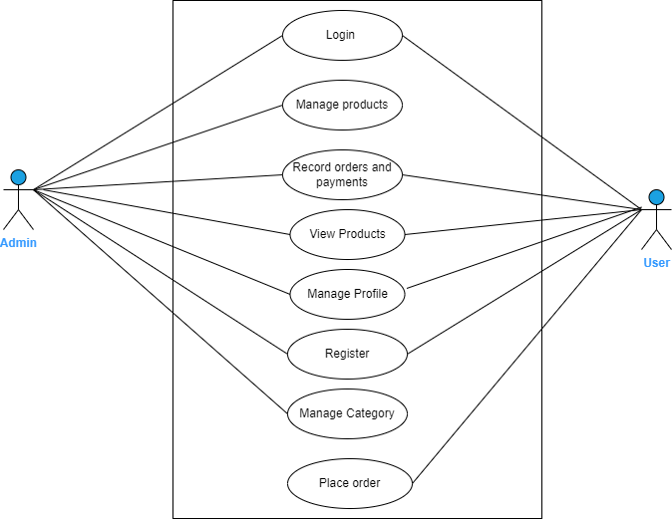

Fig-3.1: Use Case Diagram

1. **Non – Functional Requirement**

* Performance: This system is designed to handle high traffic and load without significant downtime or slowdowns.
* Security: The system use encryption and other security measures to protect user data, payment information, and other sensitive information.
* Reliability: The system is reliable and available 24/7, with minimal downtime for maintenance or upgrades.
* Usability: The system is user-friendly and easy to navigate, with clear instructions and feedback for users.
* Compatibility: The system is compatible with a variety of devices and platforms, including desktop and mobile devices, various operating systems, and different web browsers.
* Accessibility: The system should be designed to be accessible to users with disabilities, including support for assistive technologies like screen readers and keyboard navigation.
* Scalability: The system should be scalable, able to handle increasing amounts of data and traffic as the business grows.
* Maintainability: The system should be easy to maintain and update, with a modular design and clear documentation for developers.
  1. **Feasibility Analysis**

1. **Technical Feasibility:** This system is technically feasible to implement. The technical feasibility of the proposed system will be evaluated by considering the hardware and software requirements, internet connectivity, and any technical barriers that could affect the system's performance.
2. **Operational Feasibility:** The operational feasibility of the proposed system will be evaluated by considering how the system will integrate with the restaurant's existing operations. The system would be available 24/7.
3. **Economic Feasibility:** This system is economically feasible to implement. The economic feasibility of the proposed system will be evaluated by considering the costs involved in implementing and maintaining the system. This will include hardware and software costs, website design and development costs, and ongoing maintenance and support costs.
4. **Schedule Feasibility:** This includes the project schedule and all time allocated for their completion. The Gantt chart is as follow:

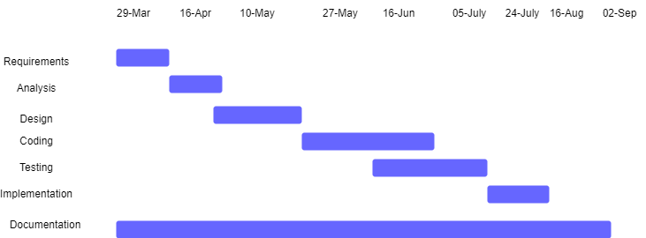

Fig-3.2: Ganttchart

* 1. **Data Modelling (ER-Diagram)**

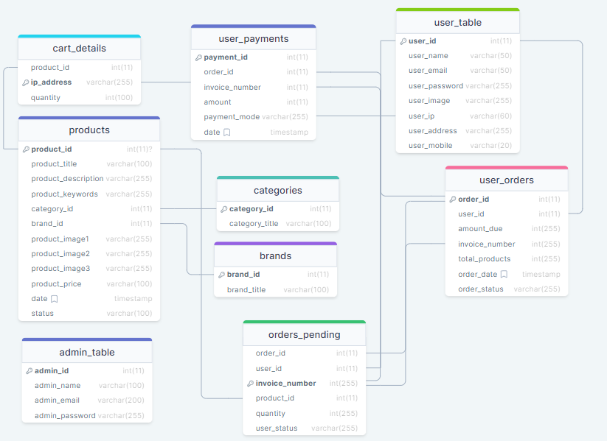

Fig-3.3: ER- Diagram

* + 1. **Process Modelling (DFD)**

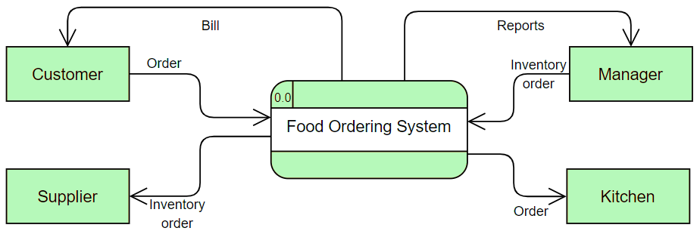

Fig-3.4.1 Zero Level DFD

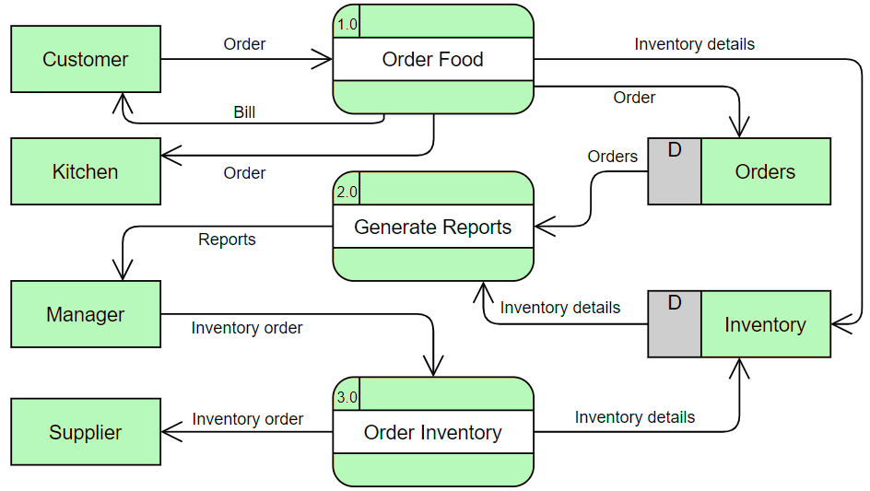

Fig-3.4.2 Level 1 DFD

* 1. **System Design**
     1. **Flowchart**

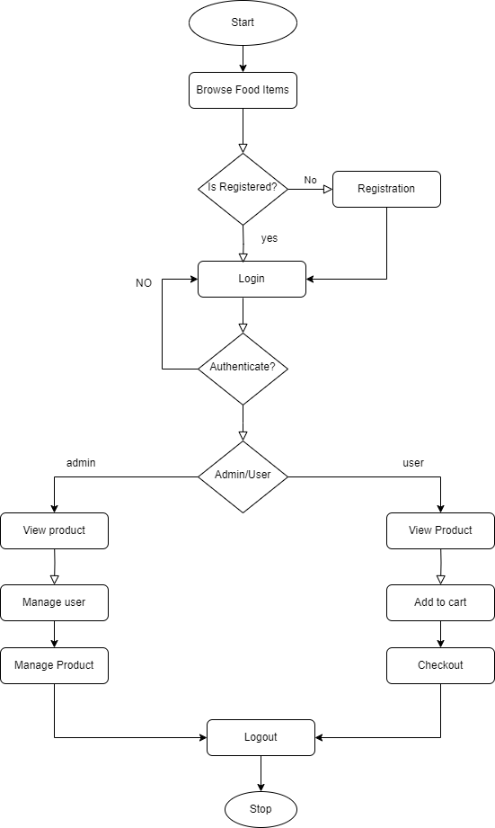

Fig-3.5: Flowchart

* + 1. **Database Schema Design**

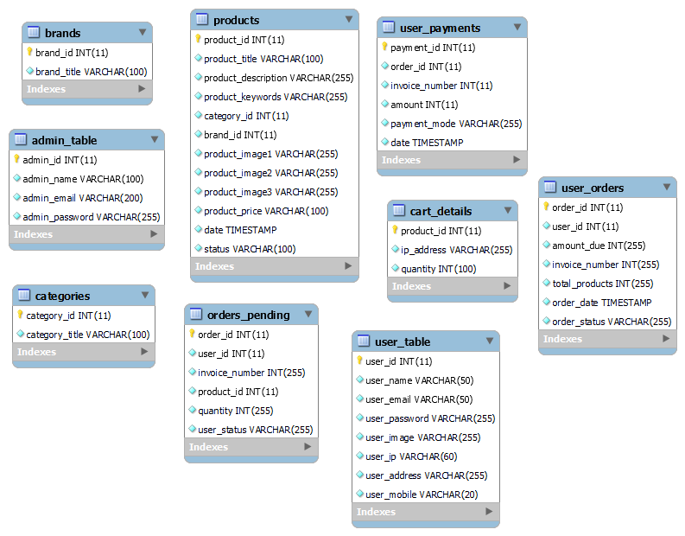

Fig-3.6: Database Schema Design

**Chapter 4: Implementation and Testing**

* 1. **Implementation**
     1. **Tools Used**
* IDE: Visual Studio Code (VSCode) – A user-friendly integrated development environment (IDM) used for coding and developments tasks.
* Documentation: MS Office – Tools for creating and editing project-related documents and presentation.
* Font-end: HTML, CSS, JavaScript – A languages to development of the graphical user interface of a website.
* Back-end: PHP – A program supports font-end user services, and interface with any required resource.
* Database Management: MYSQL – An oracle-backed open source relational database management system (RDBMS) based on Structured Query Language (SQL).
* Localhost: Xampp – A free and open-source cross-platform web server solution stack package developed by Apache Friends.
* Diagramming: Draw.io – An online diagramming tool for creating visual representation such as system architecture diagrams and flowcharts.
  + 1. **Implementation Details of Modules**

The modules include:

* User Registration: The user module allows users to register, log in, and log out. Users benefit from being able to sign on because this associates content they create with their account and allows various permissions to be set for their roles.
* Checkout: A checkout module is a special container that hosts all modules that are required to create an order. It presents a step-by-step flow that a customer uses to enter all the relevant information to make a purchase. It captures the address, and billing information.
* Profile Creation: Users can create and manage their profiles.
  1. **Testing**
     1. **Unit Testing**

|  |  |  |  |  |  |
| --- | --- | --- | --- | --- | --- |
| Test Case No | Module | Test Description | Steps | Expected Result | Result |
| TC_01 | User Registration | Verify user registration functionality | Input valid user details and register | User is registered successfully | Pass |
| TC_02 | Admin Registration | Verify Admin registration functionality | Input valid Admin details and register | Admin is registered successfully | Pass |
| TC_03 | Add Product | Add product in website | Post with details and submits | Added product successfully | Pass |
| TC_04 | Profile Update | Update Admin & User profile | Fill in relevant details and  Save profile | Profile is updated | Pass |

Table-4.1 Test Cases for Unit Testing

* + 1. **System Testing**

Table-4.2 Test Cases for System Testing

|  |  |  |  |  |  |
| --- | --- | --- | --- | --- | --- |
| Test Case No | Module | Test Description | Steps | Expected Result | Result |
| TC_05 | My Account | User manages his/her profile. | Edit username and passwords. | Profile edited successfully | Pass |
| TC_06 | Search | User see searched items in website | Search typed items. | Searched item  successfully | Pass |
| TC_07 | Checkout | Process of checkout | Click to checkout button | Successfully  order products items | Pass |

**Chapter 5: Conclusion and Future Recommendations**

* 1. **Lesson Learnt / Outcome**

Throughout the development of the food ordering system, a wide range of lessons were learned, and significant outcomes were achieved, contributing to both personal and professional growth. The key lessons and outcomes are as follows:

* Customers' Preferences Evolve: Just like in any business, customers' tastes and preferences in the food industry also change over time. It's crucial to stay in touch with your customers, gather feedback, and adapt your menu offerings accordingly to meet their evolving needs.
* Streamlined Checkout Process is Vital: The checkout process in a food ordering system should be quick and efficient. Customers don't want to spend a lot of time navigating through numerous pages. Minimize the number of steps and make sure the ordering process is smooth.
* Embrace Localized Strategies: While dealing with food orders, it's essential to consider local factors. You can offer region-specific dishes, collaborate with local suppliers for fresh ingredients, and even implement delivery strategies that cater to the specific needs of your local customers.
* Data-Driven Insights Drive Success: Rather than relying solely on opinions or assumptions, data is invaluable. Analyzing order patterns, popular dishes, peak ordering times, and customer feedback can provide you with accurate insights that guide your decisions and strategies.
  1. **Conclusion**

The E Khaja platform has revolutionized the way people order food, offering the convenience of browsing and selecting dishes from the comfort of their own homes. The rise of online food ordering has gained immense popularity in recent years, with E Khaja leading the charge. The anticipated outcome of an online food ordering system like E Khaja is a significant enhancement in the availability and accessibility of a wide variety of cuisines to consumers worldwide.

In conclusion, the anticipated outcome of an online food ordering system like E Khaja is a substantial improvement in the accessibility, availability, and convenience of food options for consumers globally.

* 1. **Future Recommendations**

The E Khaja food ordering system is currently focused on providing a seamless platform for ordering a wide range of cuisines. To further enhance the user experience and cater to evolving needs, the following modules are recommended to be included in the platform:

* Centralized Customer Database: Implement a centralized customer database to store and manage customer information, order history, preferences, and payment details.
* Enhanced Database Security: Strengthen the database security measures to ensure the utmost confidentiality and security of customer data.
* Transition to Agile Methodology: As the E Khaja platform grows, consider transitioning from the traditional waterfall model to an agile methodology.
* Mobile Application Development: Plan for the future expansion of E Khaja by developing a dedicated mobile application.
* 24/7 Online Support and Chat Service: Introduce a 24/7 online customer support and chat service to address user queries, provide assistance with orders, and ensure a smooth customer experience. This feature will enhance user engagement and satisfaction, leading to increased customer loyalty.
* Customer Loyalty Programs: Implement customer loyalty programs that reward frequent users with discounts, special offers, and exclusive promotions. By increasing customer loyalty, E Khaja can encourage repeat orders and build long-term relationships with its user base.

**Appendices**

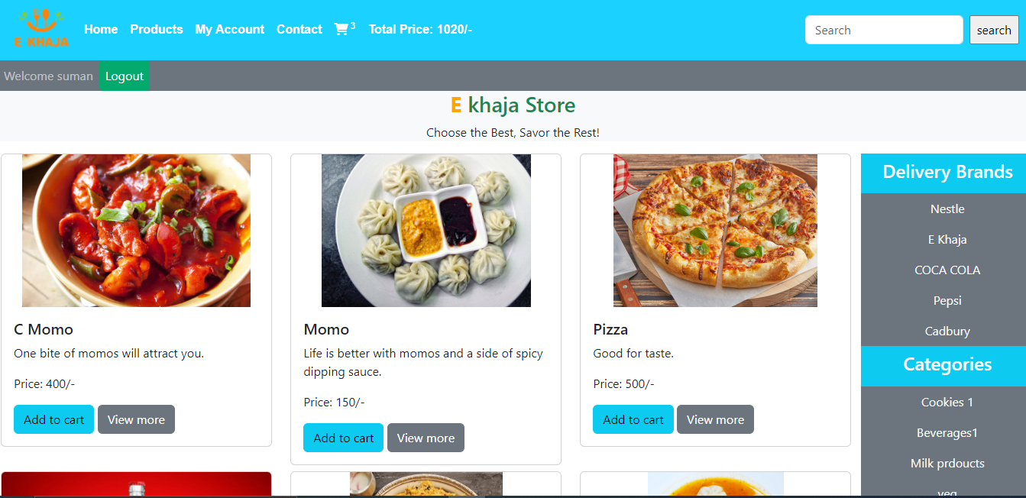**Appendix: Project Screenshots**

Fig-4 Home Page

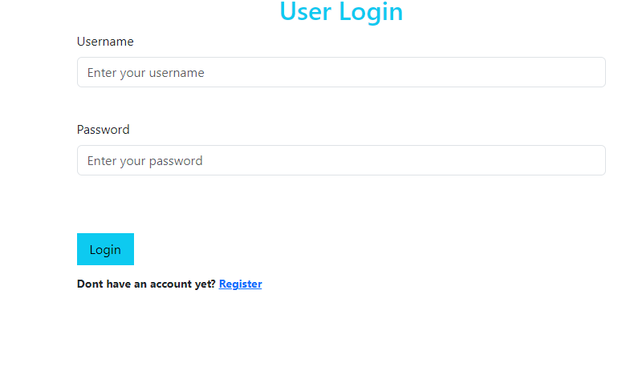

Fig-5 Login / Register page

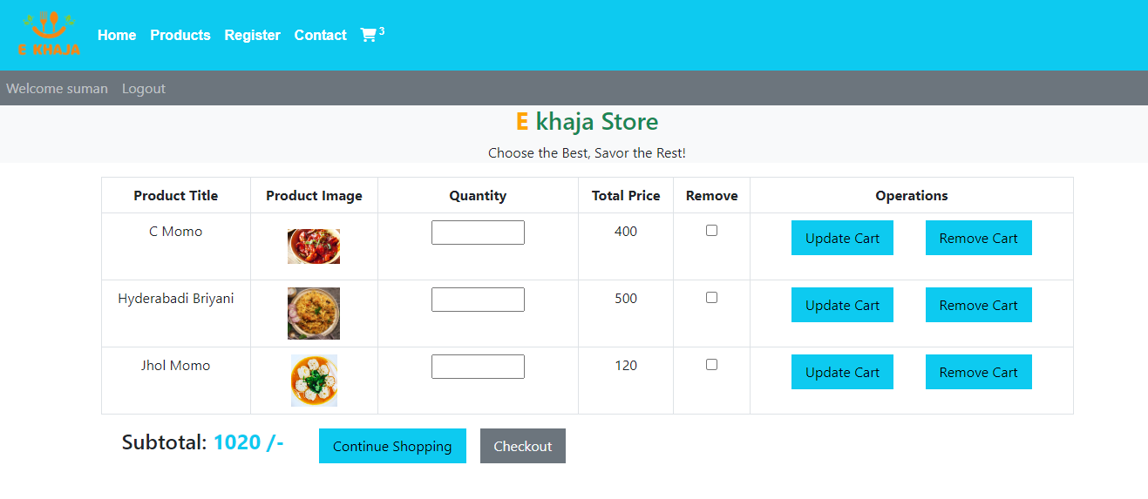

Fig-6 Shopping Cart

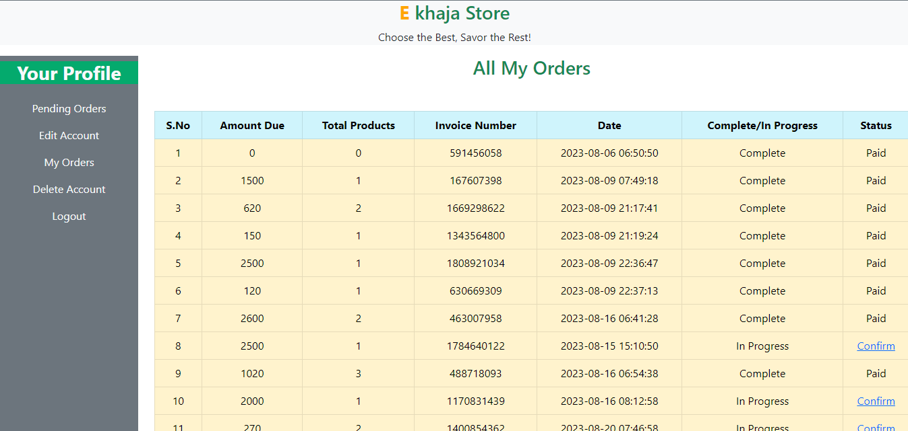

Fig-7 User Orders

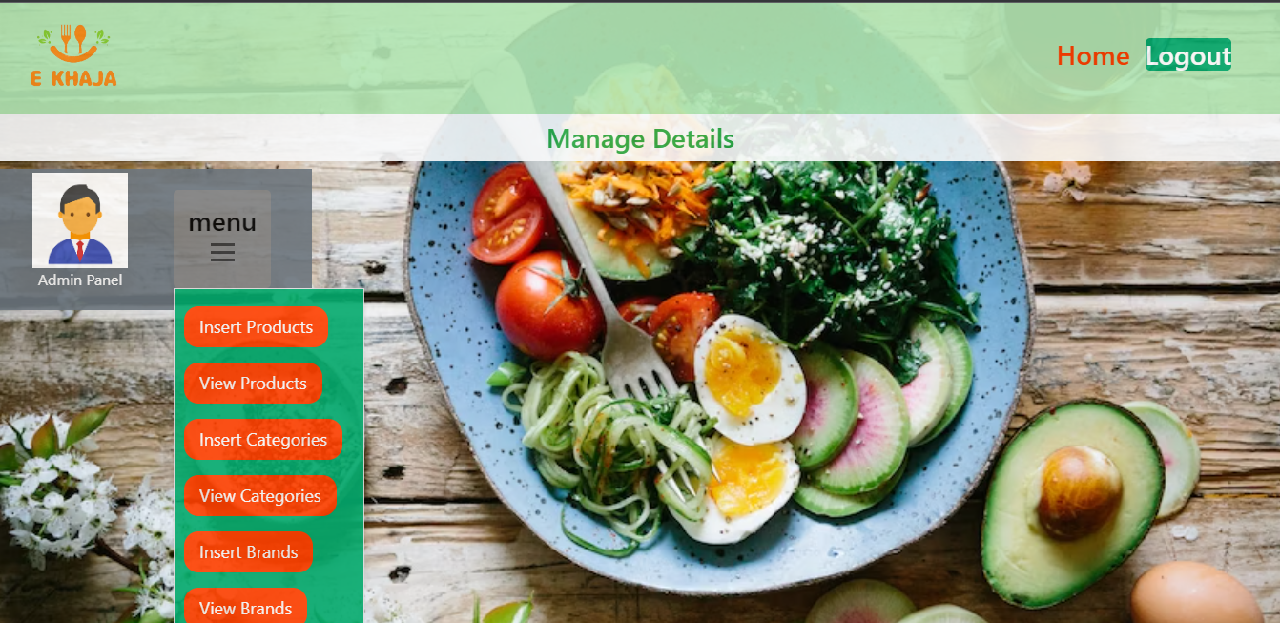

Fig-8 Admin Panel

# Supervisor Log Sheet

# References

|  |  |
| --- | --- |
| [1] | Get food or groceries delivered to your doorsteps, https://www.bhojdeals.com/  (accessed jun. 11, 2023). |
| [2] | “Foodmandu: Food Delivery Service in Kathmandu,” Foodmandu Main, https://foodmandu.com/ (accessed Jul. 1, 2023). |
| [3] | “Khaanpin 24 hour online cloud kitchen - all time, on time - kathmandu & pokhara,” Khaanpin Online Cloud Kitchens - Kathmandu and Pokhara - 24 Hours Food, Liquor and Cakes - All Day All Night Pizza, Breakfast, Snacks and Dinner Delivery, https://khaanpin.com.np/en/ (accessed Jul. 1, 2023). |
| [4] | Best restaurants in India - zomato, https://www.zomato.com/india (accessed jun. 11, 2023). |
| [5] | Swiggy, https://www.swiggy.com/ (accessed jun. 11, 2023). |