Required Tools:

- Docker version 27.1.1
- docker-compose version 1.29.2
- Python 3.10.12

Setup The Django Env:
- unzip the chaotix.zip
- go to project root dir: Chaotix.ai/chaotix
- Run the docker compose command
- docker compose -f docker-compose.yml up --build --force-recreate –remove-orphans

it will take some time to setup django, redis, and celery. After completiotion of setup

Run The API:
API URL: http://127.0.0.1:8000/text-to-image/
Request Body:
{
"text": "A footballer kid",
"no_of_image": 3
}
API Output:
{
task_ids": [
"4782f50b-d971-4f8b-8c5d-cd7264864950",
"76ba8aed-ca5c-4378-850f-3c75aa6dcc4e",
"83519e52-e576-484c-9bfe-d28b9c2f7feb"
],
"message": "3 tasks is running parallel into background"
}

after runing api, what ever no_of_image will pass, that no of task will run parallel and image will be created, image_file path and title will be stored into database

Django Admin Creds:
URL: http://localhost:8000/admin/
Username: admin
password: admin

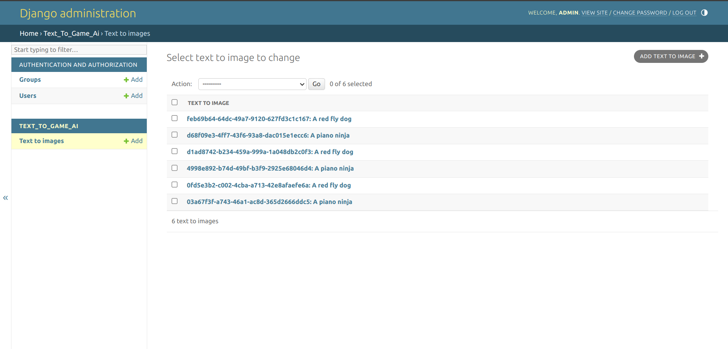

and images will be stored into Chaotix.ai/generate_images/<text>/

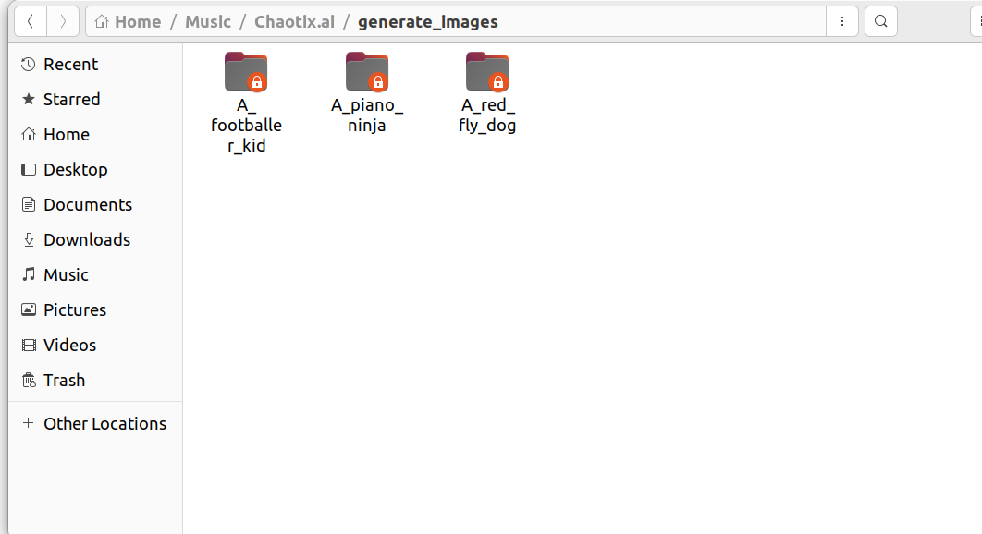
And text(title) folder will contains generated images

