420-541-VA Game Programming 2

Week 12 lab 2: Playtest and bug reports (1%)

Today we will be looking into testing our game.

In order to download the project, you will have to clone this git repository:

https://github.com/amcnabbbaltar/420-541-Week12_Lab2

Then:

Task 1) Open the game project and build the project.

Task 2) The game is buggy. Currently the pickups don’t do anything. The expected result is that they boost the player speed for 2 seconds.

Task 3) Uncomment the commented code in PickupComponent

Task 4) Rebuild the game

Task 5) Write a small questionnaire of 4 questions to ask during the playtest of the kart game on page 3.

How to submit your project.

1. Send a link to either your GitHub or a One Drive link via the Assignment Delivery option in LEA.
2. Add me to your repo if it’s private so I can see your work.

Bug report:

**The game wasn’t able to load because of the this error at the OnActionReceived() function.**

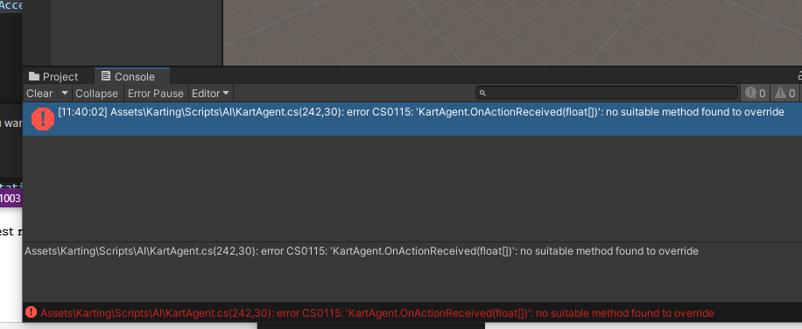

Bug Description:

**Changed the function from**

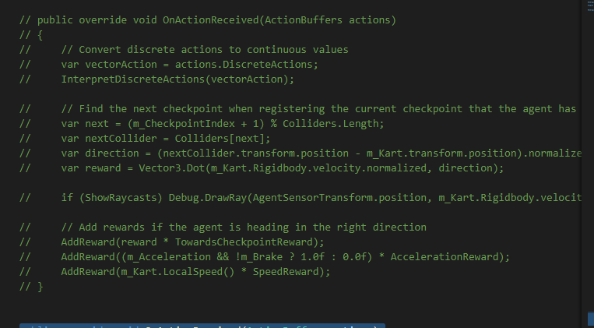

**To the new function that will be able to change the int value into float by**

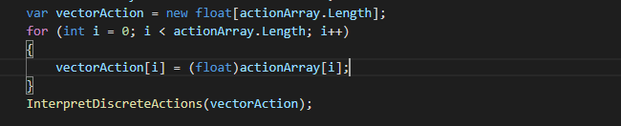

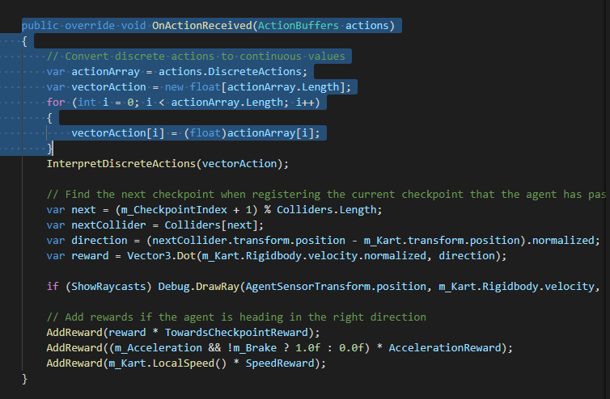

Reproduction Step:

**I changed the function in the KartAgent because the game was buggy. Now the pick-ups allow the player to move faster for the span of 2 seconds. I started uncommenting the Pickup Component**

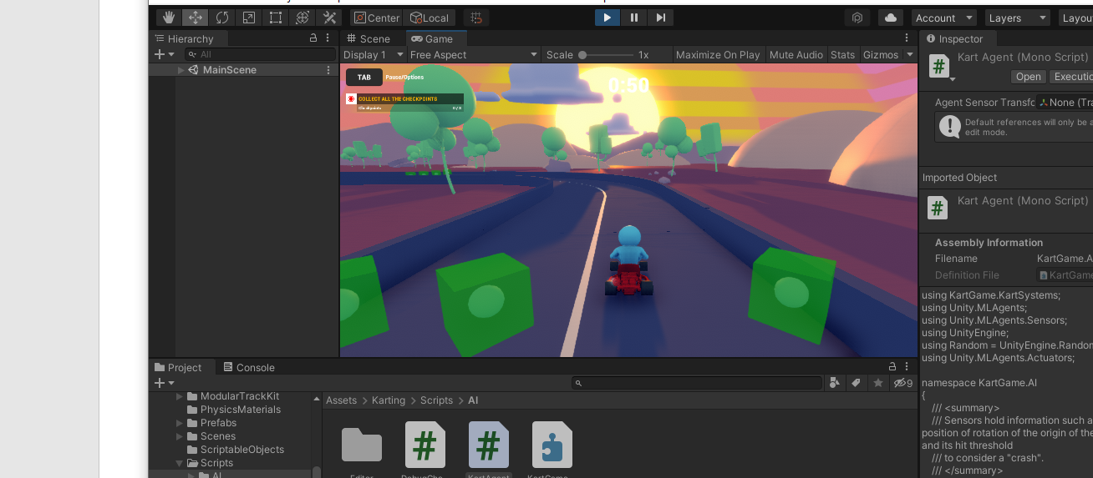

**The green box disappears every time they player gets in contact and this helps the player move faster.**

Expected Result:

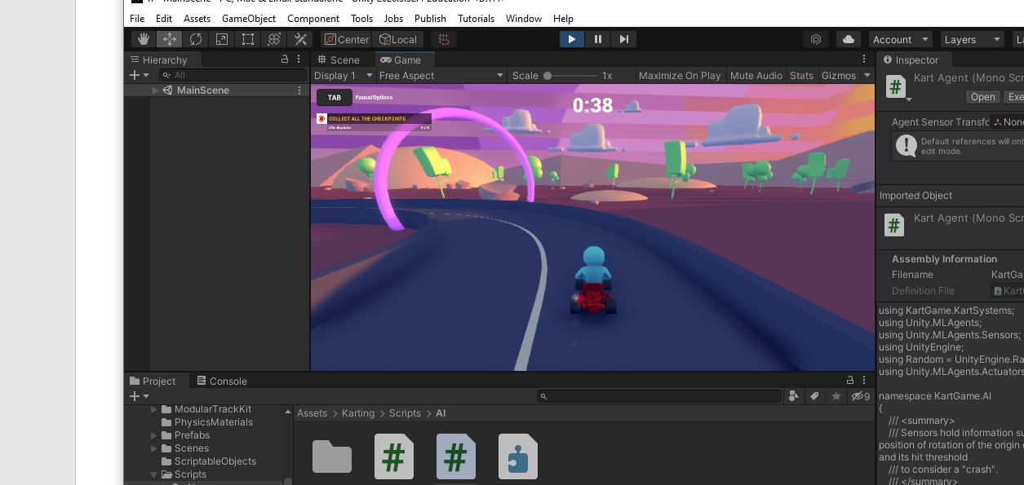

**The player is able to move faster when he gets in contact with the green box.**

Actual Result:

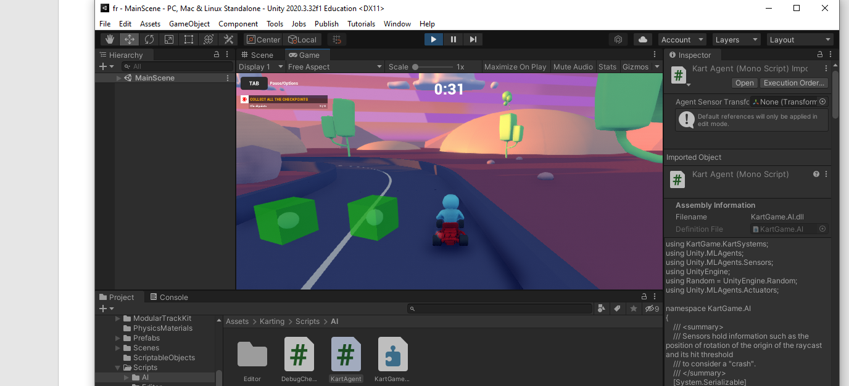

**The actual result we getting is the that the player is able to run faster when he hits the box.**

Screenshot and Another document:

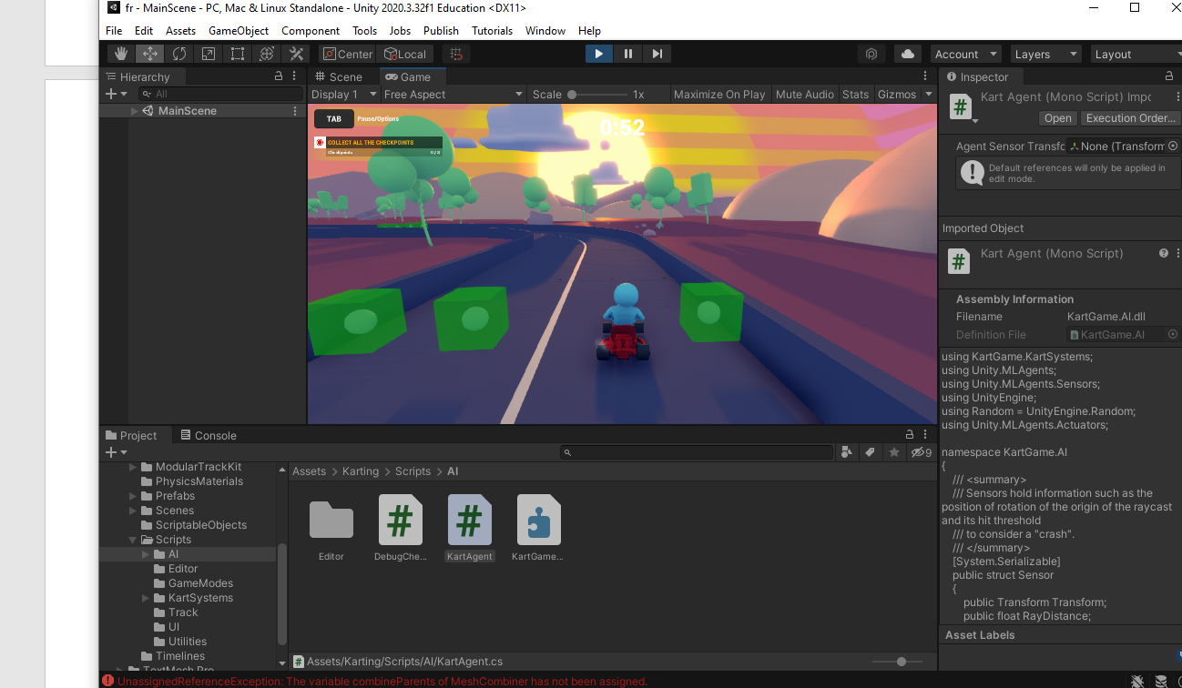

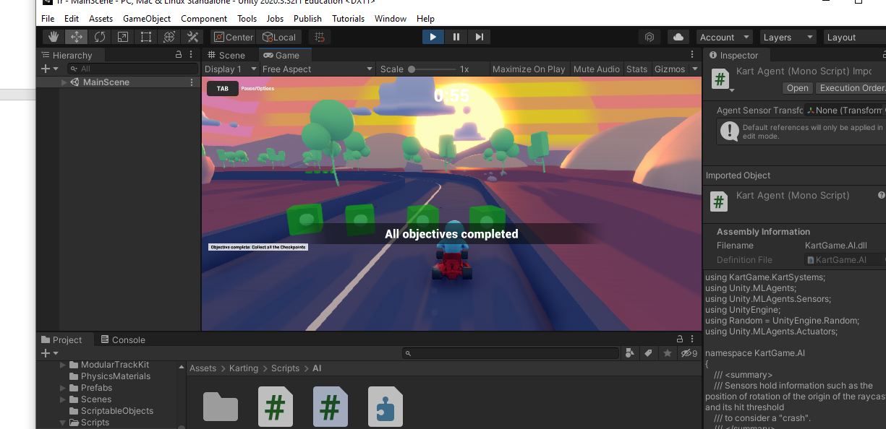

**The player is able to complete the whole game with zero bugs**

Playtest report:

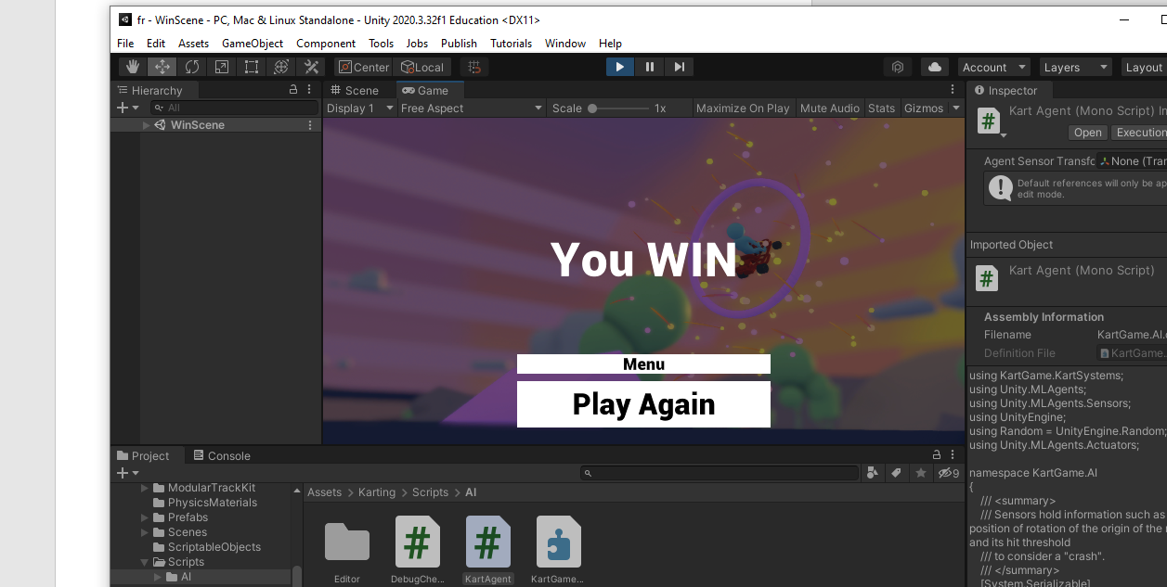

**The player is able to complete the game faster and with the fast pace.**

