**FINAL YEAR PROJECT**

**PROJECT REPORT**



**[UE2]**

**Developer - Winston (212668S)**

**Developer - Jiaxu (210681N)**

**Developer - Yokawa**

**Artist - XinYing (212035K)**

**Artist - Kerrin (213155U)**

**Artist - John (Admin No)**

**TABLE OF CONTENTS**

**1.0. Project Overview 3**

1.1. Introduction 3

1.2. Scope/Objectives 3

**2.0. Development Plan 3**

2.1. Project Management Methodologies 3

3.0. Milestone Chart 3

3.1. Member Role 4

3.2. Product Schedule 4

**4.0. Member Feedbacks 4**

4.1. Winston Chiu 4

4.2. Wang Jiaxu 5

4.3. Goh Xin Ying 6

4.4. Yokawa Kazuya - Trident College 6

4.5. John Tan Ern Yong 6

**5.0. Problems and Solutions 6**

## Project Overview

## Introduction

Over the period of 12 weeks, we have developed a stealth infiltration game with vampires and post war aesthetics. The game is played in isometric orbit and third person interchangeably. The main character is a half-vampire with abilities to aid her, as such, is tasked to infiltrate various locations to accomplish objectives for the government.

The game is heavily inspired by other stealth games and franchises such Hitman, Splinter Cell and Batman.

## Scope/Objectives

The team has brought together many great ideas as to the design and development of the game. Above all, we have decided to limit the scope to a playable demo of the first level, as well as any scene transitions needed for the menus.

The game should also have light abilities, interactions and combat built into the framework in preparation for further enemies, objectives and items to interact with.

## Development Plan

## Project Management Methodologies

A combination of SCRUM and waterfall, led by Winston Chiu(Project Lead and Tech Lead), has split the development of the game into 4 stages: design(2 weeks), sprint 1(4 weeks), sprint 2(4 weeks) and polishing(2 weeks).

This is due to a relatively short development time for a game made from scratch, as all assets and framework code has to be completed before substantial content can be added. As such, the design phase has been lengthened in order to completely align the art team and the development team’s visualization of the project, ensuring no miscommunication and time shortages due to unneeded design choices. The first sprint consists of all framework code for the gameplay as well as enough player specific code such that the player can interact with the world. The second sprint consists of content code for items, entities and interactions, as well as AI. Lastly, the polishing phase is 2 weeks, consisting of playtesting, analysis of results and the subsequent polishing and bug fixing of the game, as well as documentation and admin work.

## Milestone Chart

Following the above guidelines set by the team as well as the supervisors, the agreed upon milestones are as stated:

**Presentation Milestone**

1. [18th September] Proposal Pitch
2. [9th October] Proof of Concept
3. [17th November] Final Presentation

## Member Role

* Winston Chiu: Tech Lead, Backend Developer, AI developer and Interaction developer
* Wang Jiaxu: Tech Artist, VFX and SFX developer
* Yokawa Kazuya: UI and Scene Management
* Goh Xin Ying: Art Lead, Concept Artist, Environment Artist, Prop/Weapon Artist, Level Designer
* Kerrin Khoo: Character Artist, Animator, Prop Artist
* John Tan: Concept Artist, UI Artist, Prop Artist, Video Editor

## Product Schedule

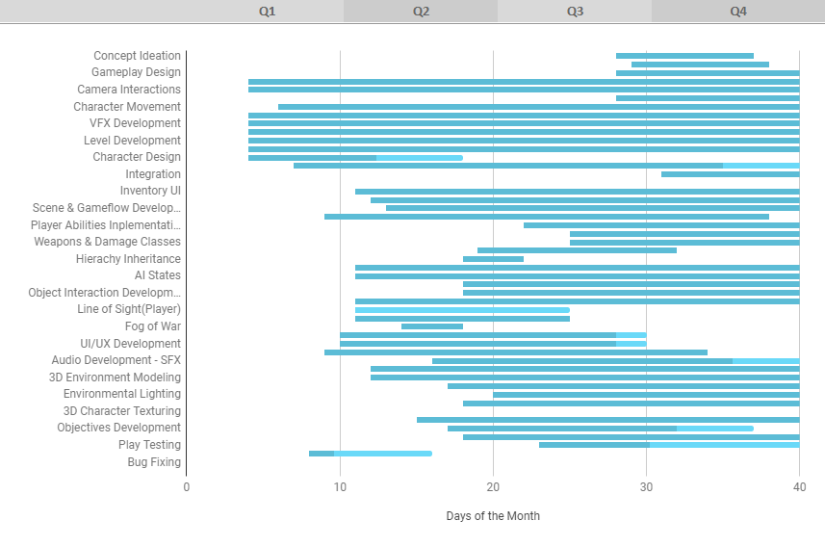

## Member Feedbacks

## Winston Chiu

* **Coding Practices and Programming based learning points**
  + Learned how to work with Unreal and blueprints
  + Converted line based code into Unreal specific blueprint nodes
  + Furthered knowledge of **abstract coding practices** to create **designer friendly interfaces**
  + Learnt about the inheritance hierarchy of Unreal Engine
    - Worked around the **limitations of Unreal’s 1 unique parent code** by **implementing interfaces**
  + Improved performance by learning the **pipeline** of Unreal Engine
    - Improved coding efficiency and attempted to make multiplayer compatible code
  + Facilitated **data standardization** with namespaces and naming conventions
  + Facilitated easier balancing of entities and interactions via **Data Tables**
  + Learnt more about **AI**
    - **Behavior tree** & **State machine** hybrid code, Called **State Tree**
    - Recreation of **Environment Query System**
  + Unreal Crashing, the crash logs created by the frequent failure of the engine is larger than the actual project. Frequent crashing disrupts development and loss of work leads to unstable and unversioned codes.
* **Visual Effects and design based learning points**
  + Learned how to create materials and post process materials
    - Applied knowledge to creating **NANITE** compatible materials
    - Applied knowledge to creating **SUBSTRATE** compatible materials
  + Transitioned particle effects from **LEGACY CASCADE** to **NIAGARA**
* **Team based cooperation and leadership roles**
  + Participated in group discussions, leading design roles and technical roles to facilitate communication
  + Took up role of team leader after an unfortunate team issue, resulting in the tragic loss of a member
  + Brought production forward as the Scrum Master as well as kept on track as the Product Manager
  + Brought the Dev side together and helped communicate with the Japanese Guest Developer from Trident.
  + managed the Server as well as Github repository to ensure that all code and assets have a corresponding naming convention
  + managed the merging of code to ensure that overwriting of code does not occur, applied version control practices to merge code

## Wang Jiaxu

* Learned how to work with Unreal and blueprint
* Learned how to create materials and post process materials
* Learned how to make use of the niagara system
* Learned how to create visual effects
* First-time experience with working with uncooperative and problematic members

## Goh Xin Ying

* Learned how to use Substance Painter
* Learned about materials and lighting in Unreal
* Learned cloth simulation in Maya
* Gained more experience modeling and unwrapping in Maya, especially how to effectively model and unwrap small details by reusing small pieces and transferring attributes
* Gained more experience with functional lighting
* Gained more experience "decorating" levels when designing levels/environments
* As art lead, learned the importance of coordinating between team members, regular updates, and ensuring every team member is on the same page

## John Tan Ern Yong

* Learned how to use Substance Painter at a very basic level.
* Learned how to use Github at a very basic level.
* Gained more experience drawing concept art.
* Gained more experience with modeling efficiently in Maya in tandem with the UV unwrapping process. Understanding when to leverage height maps and textures to save on poly count.

## Kerrin Khoo

* Learned blendspaces and how they work in UE5
* Learned how to code the animation blueprints to implement the animations into the game
* Learned how to use Github
* Learned how to use the Lattice tool in Maya to model different body shapes
* Learned how to better use Substance Painter compared to the previous projects
* Gained experience in sculpting different body types and anatomy plus different type of materials in Zbrush

## Yokawa Kazuya

シンガポールの人たち、もとい外人とのチーム制作はやはり難しく翻訳アプリを使ってなんとかコミュニケーションが取れたように感じます。しかし、シンガポール生活終盤では翻訳アプリを使いながらでも意思の疎通がある程度取れていたように感じるので慣れが大切なのかなと感じました。 UE5は今回初めて使ってゲーム制作を行いましたが、基本的な操作や使い方、UE4との違いは分かりました。 まだまだ少ないように感じるチーム制作でこのメンバーで作業ができたことはとても良い刺激や経験になったと思います。ありがとうございました。

It was difficult to create a team with Singaporeans, or even foreigners, so I feel like we managed to communicate using a translation app. However, towards the end of my time in Singapore, I felt like I was able to communicate to some extent even though I was using a translation app, so I realized that getting used to it is important.

This was my first time using UE5 to create a game, but I was able to understand the basic operations, how to use it, and the differences from UE4.

I think it was a very good stimulus and experience to be able to work with these members in a team production, which I feel is still rare. Thank you very much.

## Problems and Solutions

Tight time schedule - lead a sprint and worked overtime to accommodate milestone requirements, reduced scope by removing combat with the boss

Unreal Engine 5.2.1 has been unreliable with frequent crashes and unstable codes. We have lost around 1.5 weeks in restoring and merging versions solely due to crashing, leading to slower development times.