# ShoreFor GUI User Manual

# *Version 1.00*

# September 15, 2014

# *Tomas Beuzen*

Contents

1. Preface 2

1.1. Disclaimer 2

1.2. Program Requirements 2

1.3. Data Required 2

2. GUI Walkthrough 2

2.1. Starting up 2

2.2. Choosing raw or formatted data 3

2.3. Inputting data 3

2.3.1. Selecting files 3

2.3.2. Inputting variables 4

2.4. Calibration Method 5

2.4.1. Full Data 5

2.4.2. Partial Data 5

2.4.3. Different Data 5

2.4.4. Parameterize 6

2.5. Filter cut off 6

2.6. Running Model and Selecting Results 7

2.7. Aborting Model 7

2.8. Saving Results 7

3. Troubleshooting 8

4. Help 8

# Preface

The ShoreFor GUI v1 (the GUI) is a tool allowing users to interact with the ShoreFor model developed by Davidson, Splinter & Turner 2013 (“A Simple equilibrium model for predicting shoreline change”, Coastal Engineering, 73, 191-202).

## Disclaimer

WRL 2014. All Rights Reserved. No part of this document or application may be reproduced without WRL's express consent. This product is meant for educational purposes only. This is work in progress and subject to change.

## Program Requirements

To run the GUI users should have the following;

* MATLAB v10 or higher
* Or, MATLAB COMPILER RUNTIME 8.1

## Data Required

The GUI requires input data to be in a *.mat* file format containing the following data;

* Wave height data;
* Wave period data;
* Wave dates data;
* Shoreline data;
* Shoreline elevation;
* Shoreline dates; and
* Shoreline measurement standard deviation (optional).

This data may be included in a single *.mat* file, or may be two separate *.mat* files, one containing wave data, the other containing shoreline data.

File and variable names are irrelevant to the GUI.

# GUI Walkthrough

## Starting up

To initiate the GUI simply double click on the ShoreFor_GUI application.

The GUI start window will then appear, as shown below.

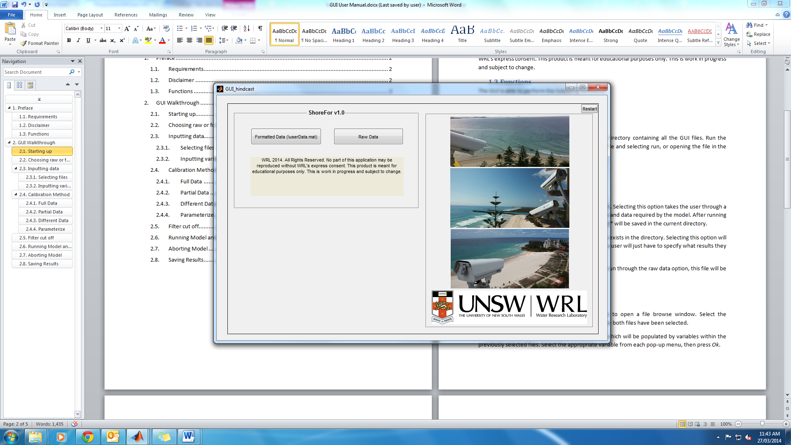

Figure 1 GUI start-up menu.

## Choosing raw or formatted data

FORMATTED DATA: Select formatted data if a *userData.mat* file already exists in the directory. Selecting this option will take the user straight to the end of the GUI, where a user will just have to specify what results they want before the model will run. Skip to section 2.6.

RAW DATA: Select raw data if it is the first time running the GUI. Selecting this option takes the user through a series of steps to verify a number of input variables and data required by the model. After running the GUI by using raw data, a file called *userData.mat\** will be saved in the current directory. *NOTE: If a userData.mat file already exists and the GUI is run through the raw data option, this file will be overwritten by a new file of the same name.

## Inputting data from the Raw Data option

### Selecting files

Here is where you will chose where your input files are for the model. Click the *Select Wave/Shoreline data file* buttons to open a file browse window, as shown in figure 2. Select the appropriate *.mat* files for both criteria (as outline in section 1.3.). If all your data is in the same .mat file, you need to select it for both options. Press *Ok* once both files have been selected.

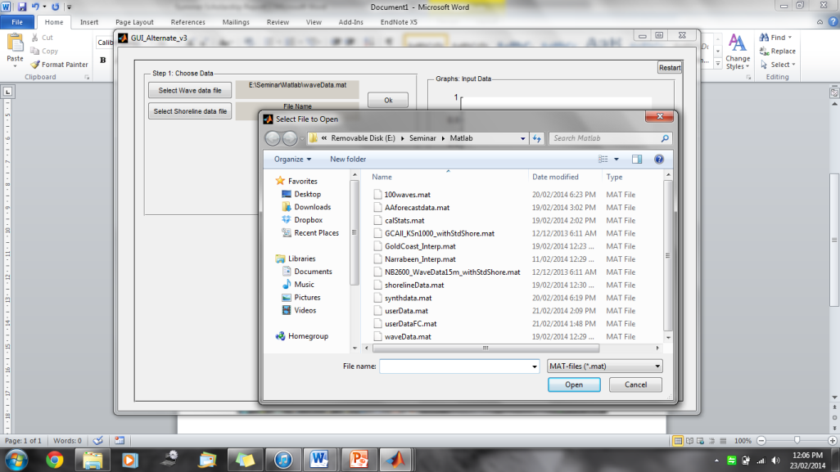

Figure 2 Browsing for an input file.

The next step is to assign variables in the model to the appropriate data you’ve just loaded in. Clicking *Ok* will make visible a number of pop-up menus which will be populated by variables within the previously selected files. Select the appropriate variable from each pop-up menu you want to assign to the model variables, then press *Ok*. In the example below, ‘Shoreline Data’ is assigned to the variable ‘datan1000’ from our input *.mat* file.

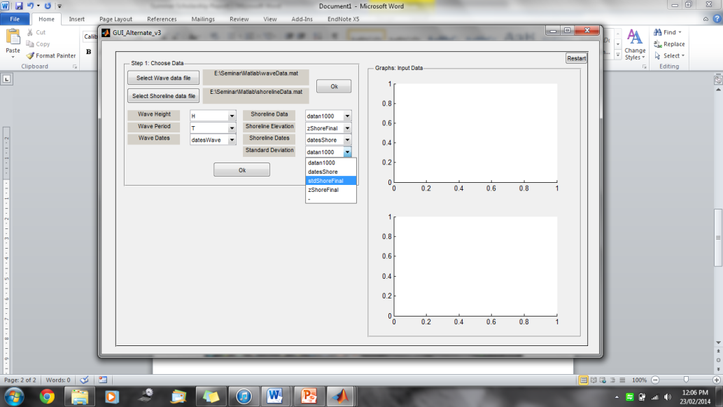

Figure 3 Selecting a variable from a pop-up menu.

The GUI will then plot the data that has been selected, as shown in figure 4 below. If there is an error, the GUI will show an error dialogue and the user should either select the correct data from the pop-up menus, or choose a different file, re-populate the pop-up menus by pressing *Ok*, and selecting the correct data from the pop-up menus.

If the GUI plots the results but the user sees the data is wrong, the *Clear Graph* button will clear the plots and allow the user to re-select their data following the previous steps.

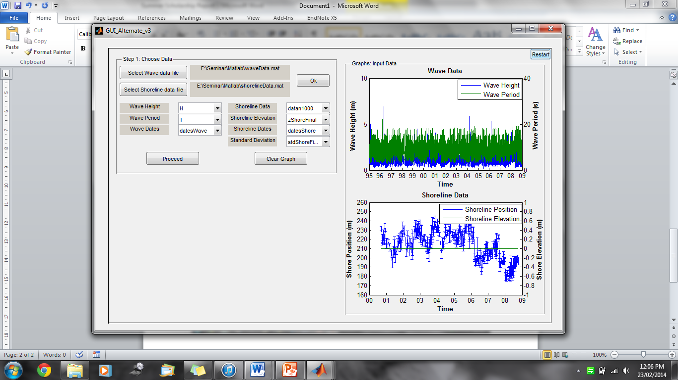

Figure 4 GUI screen after data has been correctly plotted.

Click *Proceed* to move on to the next step.

### Inputting variables

Click in each box of the *Identify Parameters* panel to type in the variable. The *Site Name* may be anything the user chooses but each of the other variables must be numeric.

*Shoreline Measurement Error*: the error in the shoreline measurements data.

*Water Depth*: the depth of water at which wave data was taken.

*d50*: the d50 sand grain size of the site.

Click *Proceed* to move on to the next step.

## Calibration Method

The calibration method defines what data you want to calibrate the model on. This does not have to be the same data you hindcast the model on. Select the appropriate option in *Calibration Method* panel and click proceed to continue with the model. The details of each option are listed below.

### Full Data (Default option)

This selection causes the model to calibrate to the full inputted data set.

Selecting this option and clicking proceed will take the user to the *Filter cut-off* panel. Skip to section 2.5.

### Partial Data

This selection causes the model to calibrate to a user-specified section of the full inputted data set.

Selecting this option and clicking *Proceed* will take the user to the *Option 2 – Partial Data* panel. In this panel are two buttons labelled *Click to select Start Date* and *Click to select End Date*. This panel is asking the user to specify the range of data they wish the model to calibrate to. Clicking on either button will bring up an interactive calendar, shown in figure 5, in which a user can choose the start and end date of the range of data they want the model to calibrate to.

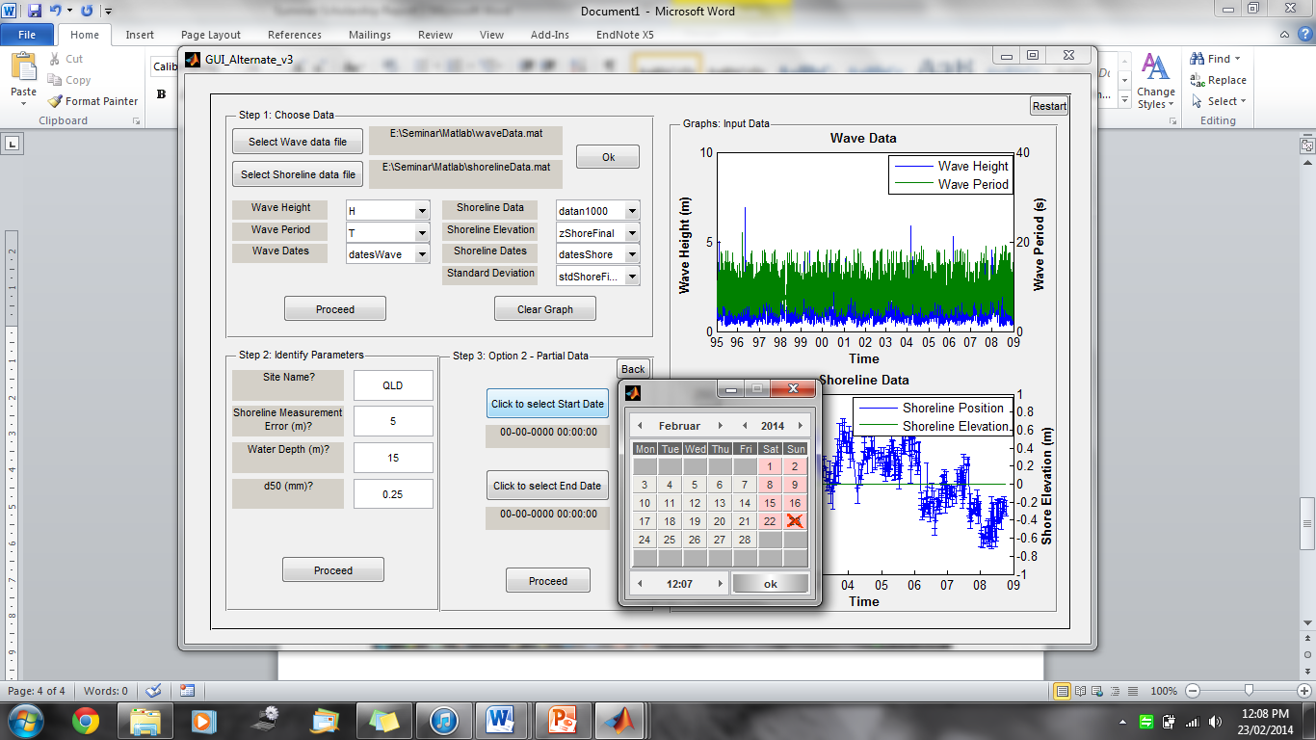

Figure 5 Interactive calendar pop-up, used for calibrating to a partial data set.

Ensure that both a start date and end date have been selected before clicking *Proceed*. This will take the user to the *Filter cut-off* panel. Skip to section 2.5.

### Different Data

This selection causes the model to calibrate to a different data set.

Selecting this option and clicking *Proceed* will take the user to the *Option 3 – Different Data(i)* . The user should proceed through the following steps similarly to the approach outlined in section 2.3.1, except the user should now select files containing the different data they wish the model to calibrate to.

There is a separate panel for the wave and shoreline data files. Clicking *Proceed* from the wave data panel will take the user to shoreline data panel. Clicking *Back* on the shoreline data panel will take the user back to the wave data panel.

After selecting files and the appropriate variables from the pop-up menus in both the *Option 3 – Different Data(i)* and *Option 3 – Different Data(ii)* panels. Click *Ok* to plot the selected data. Note that if data is incompatible, an error dialogue will be displayed and the user will have to go back and reselect the appropriate data.

After the GUI plots the different data set, toggles button will appear above the graphs, labelled *Input Data* and *Calibration Data*. Clicking on these buttons will toggle the graphs between the two different data sets.

Figure 6 shows what the GUI should look like after plotting calibration data.

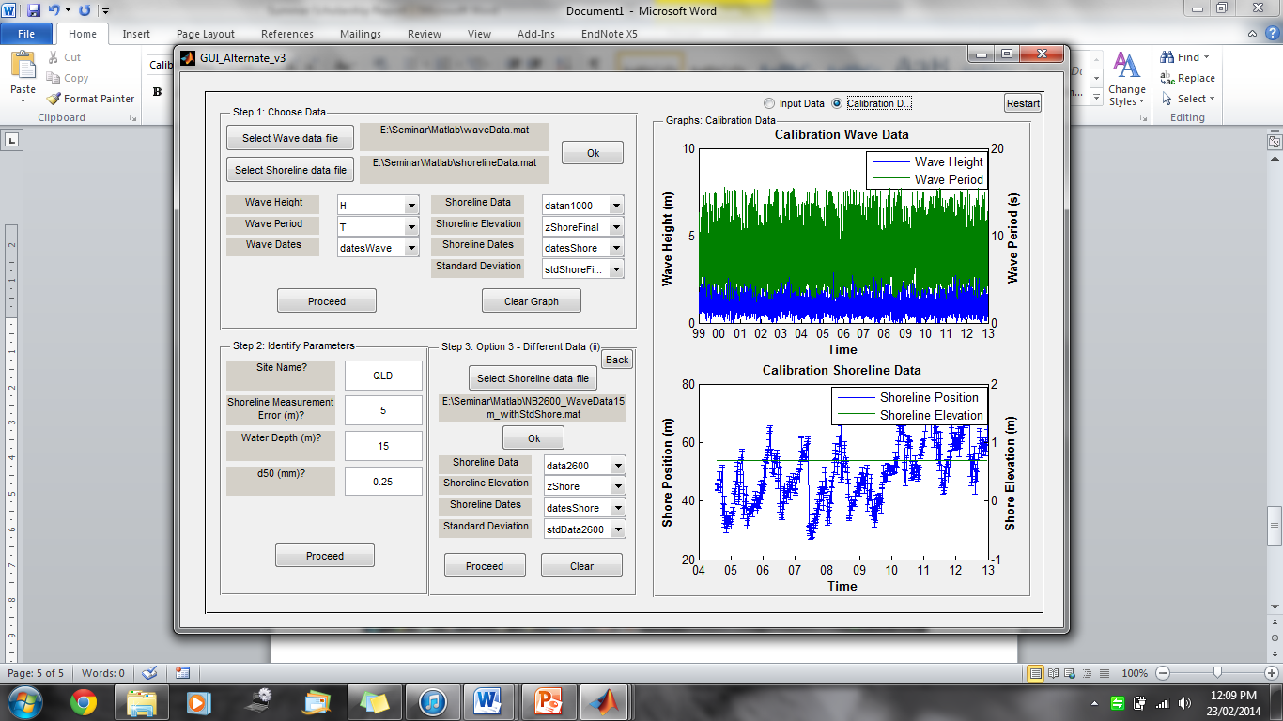

Figure 6 GUI after plotting calibration data. Toggle buttons are visible above plots. The center bottom panel was used to select shoreline data in this snapshot, an identical panel would previously have been used to select wave data.

Click *Proceed* at the bottom of the *Option 3 – Different Data(ii)* panel to continue. This will take the user to the *Option 3 – Different Data(iii)* panel in which they should input the appropriate variables for the different data set, similarly to the approach outlined in section 2.3.2.

Click *Proceed*  to continue. This will take the user to the *Filter cut-off* panel. Skip to section 2.5.

### Parameterize

Selecting this option and clicking *Proceed* will take the user to the *Option 4 – Parameterization* panel.

This option causes the model to utilize parameters calculated internally, with no calibration required. Parameterizations for the response factor (Φ) and the rate parameter ( c ) are based on the work presented in Splinter et al. (in review). Journal of Geophysical Research – Earth Surface.

Click *Proceed*  to continue. This will take the user to the *Run Model* panel. Skip to section 2.6.

## Filter cut off

The *Filter cut-off* panel asks the user about the filter cut-off value in the model.

Select *Optimise* (default option) to let the model optimise the result. Alternatively, you can select *Hardwire* to manually input a filter cut-off value.

Click *Proceed* to move on to the next step.

## Running Model and Selecting Results

The *Run model* panel is the final GUI panel, shown in figure 7. It allows users to choose what results they would like to be displayed, and allows them to run the model.

The user should select which results they want to be displayed. They can choose any number of, or no options, depending on preference.

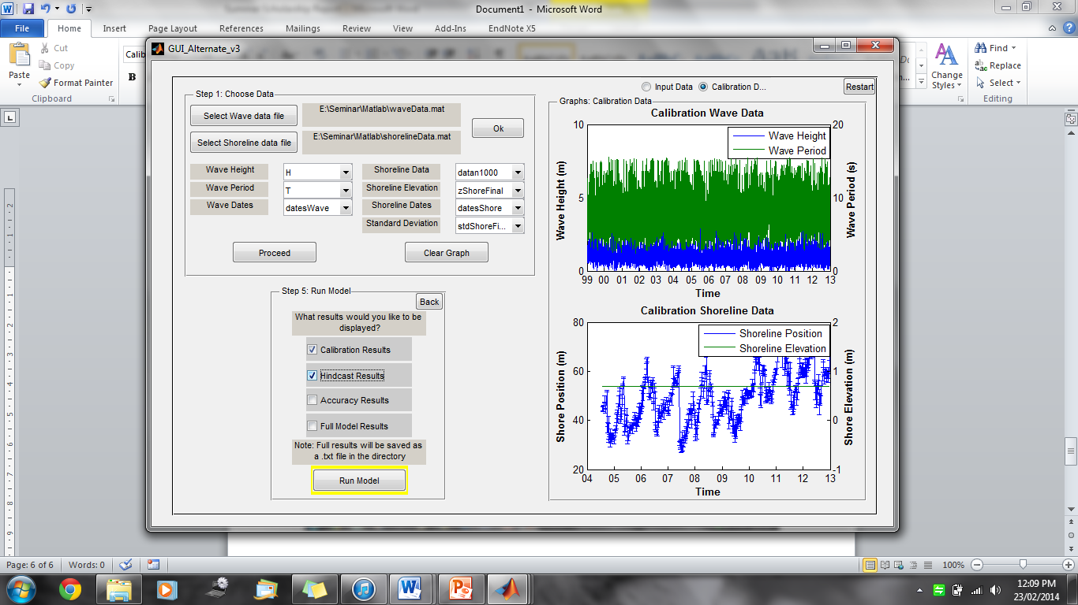

Figure 7 The final GUI layout before the model is run.

*Calibration, Hindcast,* and *Accuracy* results all display plots of the respective results if selected.

*Full model results* displays the textual output in the MATLAB editor.

After selecting which results to be displayed, click *Run Model* to begin the model.

After clicking *Run Model* and beginning the model. A window will pop up showing the user where the model is at in terms of calibrating.

No user input is required from this point on except when prompted to save data. Once the model is finished, the appropriate results will be displayed.

## Aborting Model

If the user wishes to abort the model they must type *Ctrl+C* in the MATLAB main window, closing windows will not stop the model from functioning.

## Saving Results

During the running of the model, the user will be prompted for the name and location for saving data sets and full model results.

If a user wishes to save the outputted figures they should click on the desired figure window, click file in the top left hand corner and select save.

# Troubleshooting

# Help

For further help in using this GUI, contact [k.splinter@unsw.edu.au](mailto:k.splinter@unsw.edu.au) or t.beuzen@wrl.unsw.edu.au