Assignment 5

### Creating figures

The assignment is about creating an expository figure from an initial exploratory figure. The data used came from FSAdata package.

library(tidyverse)

## -- Attaching packages --------------------------------------- tidyverse 1.3.0 --

## v ggplot2 3.3.2 v purrr 0.3.4  
## v tibble 3.0.4 v dplyr 1.0.2  
## v tidyr 1.1.2 v stringr 1.4.0  
## v readr 1.4.0 v forcats 0.5.0

## -- Conflicts ------------------------------------------ tidyverse_conflicts() --  
## x dplyr::filter() masks stats::filter()  
## x dplyr::lag() masks stats::lag()

library(ggplot2)  
library(viridis)

## Loading required package: viridisLite

library(FSAdata)

## ## FSAdata v0.3.8. See ?FSAdata to find data for specific fisheries analyses.

### FSAdata

head(SiscowetMI2004)

## locID pnldep mesh fishID sex age len wgt  
## 1 Deer Park 36.74 2.5 19108 <NA> NA 316 400  
## 2 Deer Park 40.09 3.0 19109 <NA> NA 396 700  
## 3 Deer Park 41.46 5.0 19110 M NA 590 1800  
## 4 Deer Park 41.46 5.0 19111 M NA 516 1500  
## 5 Deer Park 43.45 5.5 19112 <NA> NA 414 800  
## 6 Deer Park 45.58 4.0 19113 M NA 481 1000

### Exploratory Plots

We will explore the data by plotting lengths and weights

SiscowetMI2004 %>%  
 ggplot(aes(x=len,  
 y=wgt)) +  
 geom_point()

## Warning: Removed 1 rows containing missing values (geom_point).

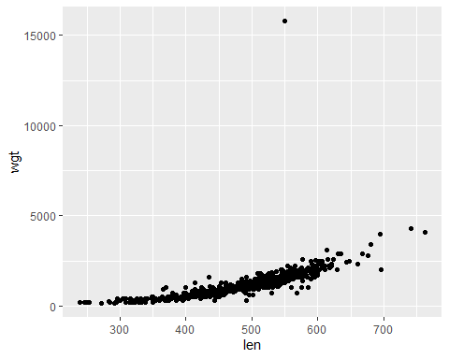

### Expository Plots

We will now create an expository figure. Here, we will also examine the locations with the fishes length and weight.

SiscowetMI2004 %>%  
 ggplot(aes(x=len,  
 y=wgt,  
 color=locID)) +  
 geom_point() +  
 xlab("Total length (mm)") +  
 ylab("Weight (g)") +  
 labs(title = "Lengths and weights for male and female \n Siscowet Lake Trout captured at four locations \n in Michigan waters of Lake Superior",  
 color= "Locations") +  
 scale_color_viridis_d() +  
 theme_minimal() +  
 theme(plot.title.position = "panel",  
 axis.title.y = element_text(angle = 90, vjust = .8,size=12),  
 axis.text = element_text(size=12),  
 legend.position = c(.85, .8)) +  
 geom_smooth(method = "lm", se = FALSE)

## `geom_smooth()` using formula 'y ~ x'

## Warning: Removed 1 rows containing non-finite values (stat_smooth).

## Warning: Removed 1 rows containing missing values (geom_point).

