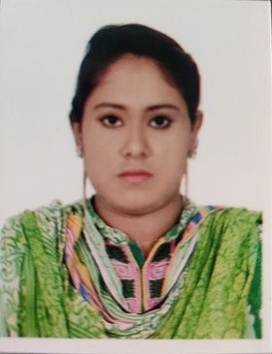

**JHARNA Akter**

Address: 121, East Raza Bazar

Farmgate, Dhaka-1215

Mob : +8801682031712

Email : shorna662@gmail.com

* **Career Objective**

Prepared to take challenges and work hard, while having an excellent interpersonal communication skill, which informs my managerial ability. Seeking an opportunity to prove myself.

* **What makes me different**

I am self-motivated, diligent and ready to go the extra leg to achieve the goal. I have set for myself. I am a natural team player and I can lead and be led, as the situation requires. I am self-starter with strong organizational and interpersonal skill having a thirst to face new challenges.

* **Educational Qualification**
* **Bachelor of Science (B.Sc):**
* University   : University of Asia Pacific
* Department : Computer Science & Engineering
* Year : 3year ( Running )

**Higher Secondary Certificate (H.S.C.):**

* + Board : Dhaka
  + Institution : Adamjee Cantonment College
  + Group : Science
  + Year : 2017
  + Result : GPA : 5
* **Secondary School Certificate (S.S.C):** 
  + Board : Dhaka
  + Institution : Tejgaon Govt. Girl’s High School
  + Group : Science
  + Year : 2015
  + Result : GPA : 5
  + **Language Proficiency**
* **Bengali:** Mother language.
* **English:** Good in both writing and speaking.
* **Personal Competencies**
* Honest, Loyal, Self-confident & Hard Working.
* Co-operative, Optimistic, Quick Learner, Ready to accept.
* Always ready to cope up with new challenging environment.
* Able to work any under pressure.
* Having positive attitude.
* Capability of communicating with people effectively.
* Having good analytical & judgment skills.
* **Personal Information**

**Name :** Jharna Akter Sharna

**Father’s Name : Late** Md. Khokon

**Mother’s Name :** Salma Begum

**Date of Birth :** 19/10/2000

**Permanent Address : Vill.:** West Gongranpur, **P. O.:** Gohala**,**

**P. S.:** Moksadpur**,** **Dist.:** Gopalgonj.

**Nationality :** Bangladeshi (By birth)

**Hight :** 5 ft. 2 inch

**Sex :** Female

**Religion :** Islam

**Marital Status :** Unmarried

**Blood Group :** B(+ve)

* **Hobby**
  + Reading Book and Writing Poem.
  + **R**esearching and exploring on the Internet; computer games.
  + **W**atching intelligent drama, sports and documentaries.
  + Leading any kind of Group work.
* **Declaration**

I, the undersigned, hereby assure that, according to my knowledge and belief, this CV correctly describes my qualification. I also assure that I can be an asset to your company. So please give an opportunity to have an interview to prove myself.

**Signature**

**Jharna Akter Sharna**