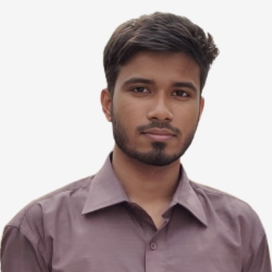**Monjurul Islam Shoron**   
**Diploma Holder in Computer Technology**

Present Address: Road #08, Mohammadpur Housing, Dhaka, Bangladesh  
Contact: 01771-224762 | Email: monjurulislamshoron2005@gmail.com  
LinkedIn: linkedin.com/in/monjurul-islam-shoron-a3a359352

*GitHub:* [*gist.github.com/Shoronislam639*](gist.github.com/Shoronislam639)

**Profile Summary**

Motivated and detail-oriented Computer Technology graduate from Daffodil Polytechnic Institute with a strong foundation in Python programming and backend development. Proficient in building scalable web applications using Django, with hands-on experience in database management using MySQL and SQLite. Possessing a solid grasp of core Python concepts, RESTful API integration, and backend logic. Eager to apply technical skills and contribute to real-world projects in a collaborative, innovative environment. Committed to continuous learning and professional growth as a Python Backend Developer.

**Working Experience:**

Although I do not have formal work experience, I have actively practiced and built a strong foundation in Backend web development. My learning journey and practical coding are showcased in my GitHub repository, including:

* *Practice projects using* ***Python*** *and* ***Django*** *to implement backend logic and CRUD operations.*
* *Frontend exercises with* ***HTML****,* ***CSS****,* ***Bootstrap****, and* ***JavaScript*** *for responsive UI development.*
* *Basic applications developed with* ***PHP*** *and* ***Laravel*** *to understand MVC architecture and routing.*
* *Database integration using* ***MySQL*** *and* ***SQLite****.*

**Education**

**Diploma in Computer Technology**  
Daffodil Polytechnic Institute  
Computer Science & Technology   
Total Credit Complete: 142 (Out of 154)

**Secondary School Certificate (SSC)**  
Authentic Ideal School  
CGPA: 4.14 (Out of 5.00)  
Year of Passing: 2021

**Key Skills**

**Technical Skills:**

* **Programming Languages:** C, Java, Python Django (Framework)
* **Database Management:** SQL Lite, MySQL
* **Operating Systems:** Windows
* **Web Technologies:** HTML, CSS, JavaScript, Bootstrap, Django, Laravel
* **Digital Marketing** (Professional)
* **Video Editing & Motion Animation** (Intermediate)
* **WordPress With Elementor (Expert)**

**Trainings & Certifications**

* **Web Development** – Academic
* **Digital Marketing** – Skill Upper
* **Video Editing & Animation** – UY Lab
* **Graphics Design:** Academic
* **Excel for Beginners to Advanced** – Academic

**Co-Curricular Activities**

* Member of the **Daffodil Tech Club**, actively participating in workshops and hackathons.
* Volunteered in organizing the **Annual Tech Fest 2023**, Daffodil Polytechnic Institute.

**Language Proficiency**

* **Bangla:** Native – Excellent in reading, writing, and speaking.
* **English:** Proficient – Strong communication and writing skills.

**References**

|  |  |
| --- | --- |
| Mrs. Soma Rani Das  Head of Computer Department  **Daffodil Polytechnic Institute**  Contact: 01833-102815  Email: head.computer@bsdi-bd.org | Mr. Rasel Uddin SYSTEM AND NETWORK ENGINEER  **Bangladesh Satellite Company Limited**  Contact: 01616-029699  Email: raseluddin8@gmail.com |

**Signature:**  
