# MOM

## ABOUT

The strength of motherhood is greater than natural laws . It is all this time that she need

both emotional & physical care and support during pregnancy .we will provide her and will full care and advise her .

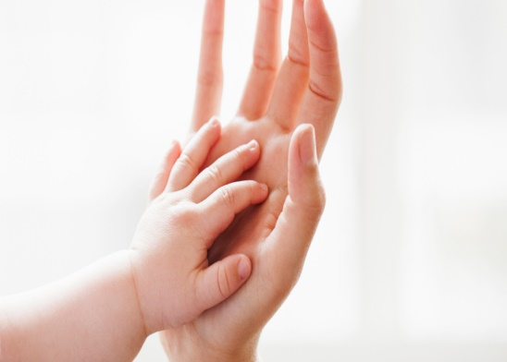 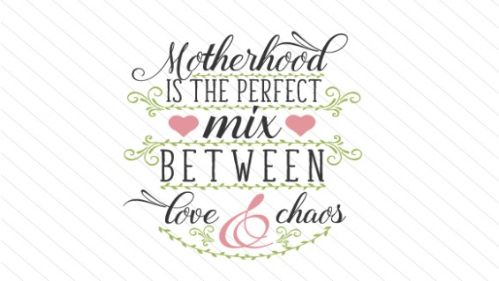

## DESCRIPTION

Mom is a website take care of the mother from the first minute in her pregnancy & her food and her body after giving birth in every step and can discuss with doctors to ask them any question and how can child rearing and take care about him . Mom also takes care about women’s psychological issues in those periods. Mom can send notifications to mommies to remind them with the most common problems and psychological emotions at this period and how to overcome that, also remind them of vaccination dates of their children.