1. Using vi write your CV in the file mycv. Your CV should include your name, age, school, college, experience,..

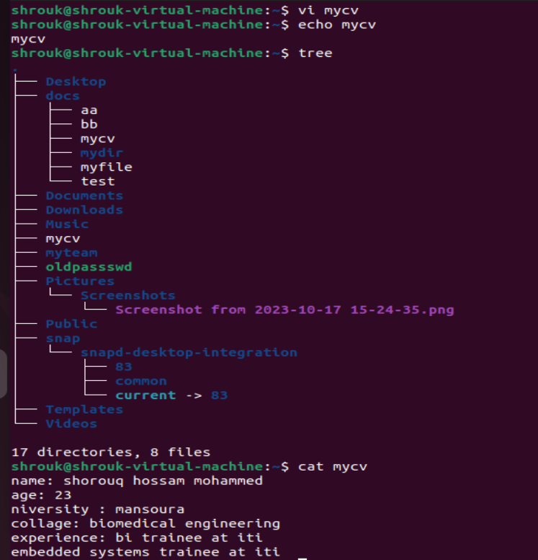

2.Openmycv file using vi command then: Without using arrows state how to:

a. Move the cursor down one line at time. 🡪**j**

b. Move the cursor up one line at time. 🡪 **k**

c. Search for word age

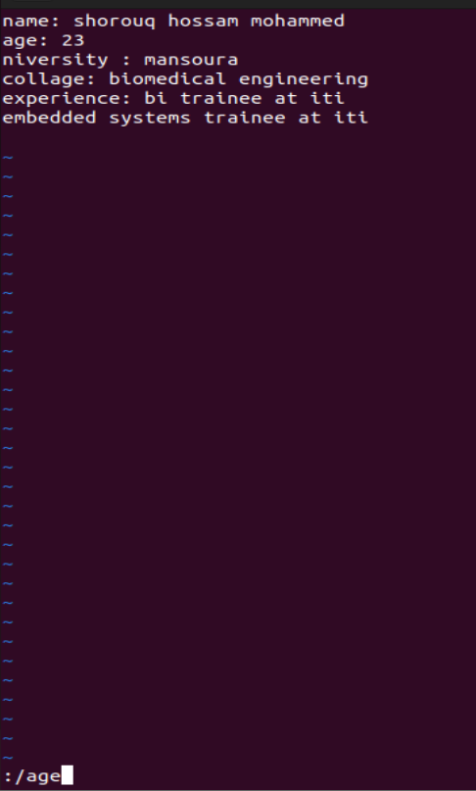

d. Step to line 5 (assuming that you are in line 1 and file is more than 5 lines).

**Using 5G or :5 with dd**

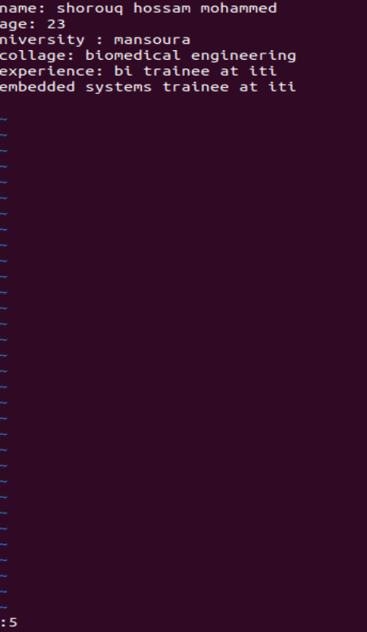

e. Delete the line you are on and line 5.

**To delete a line I am on I use: dd**

**To delete a line 5 I use: :5 with dd**

f. How to step to the end of line and change to writing mode in one-step.

**Using: A**

3. List the available shells in your system

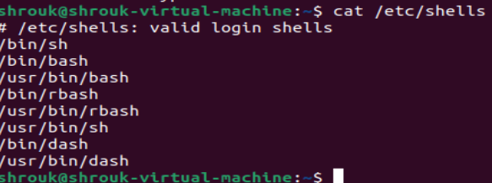

4. List the environment variables in your current shel

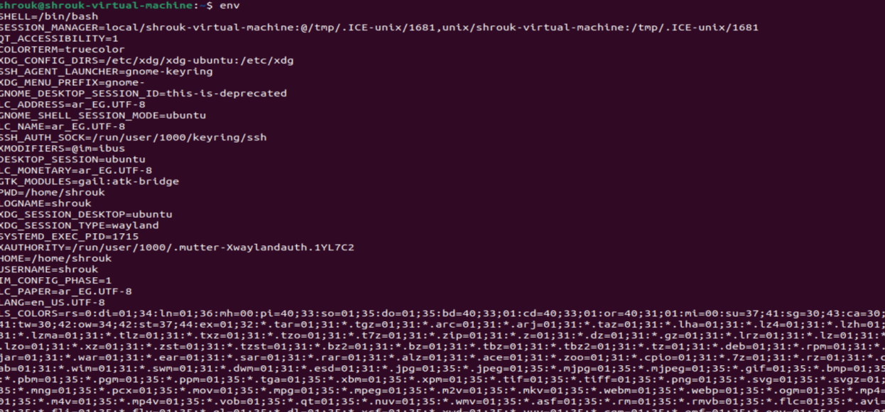

5. List all of the environment variables for the bash shell



11.Create a Bash shell alias named ls for the “ls –l” command

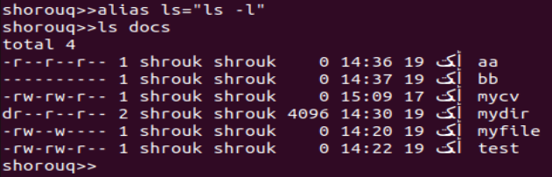

10.Execute the following command : echo \

then press enter What is the purpose of \ ? **it opens a second prompt, tells the shell that the command ia not completed**

Notice the prompt ”>” what is that? and how can you change it from “>” to “:”



9. Edit in your profile to display date at login and change your prompt permanently.

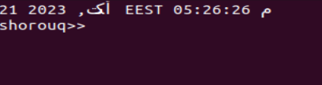

7. Display your current shell name.



6. What are the commands that list the value of a specific variable





