1. **The difference between cat and more:**

both cat and more are command-line utilities for viewing the content of text files, but they have different functionalities.

-cat (short for concatenate):

cat is used to display the entire content of one or more text files directly in the terminal.

-more: is used to display the content of a text file one screen at a time, allowing you to scroll through the file page by page.

**2) the difference between rm and rmdir using man:**

* The rm command in Linux, by default, does not delete directories, whether they are empty or contain files. Its primary purpose is to remove files, not directories. However, if you use the -r (or -R) option with rm, it will recursively remove directories and their contents.
* to delete an empty directory specifically, you can use the rmdir

3)

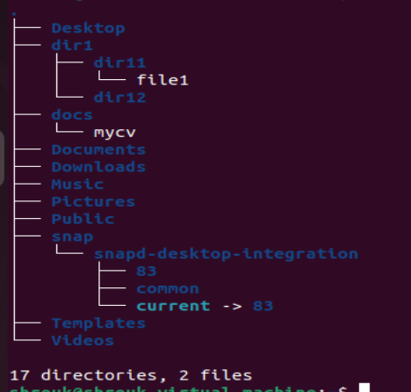

3) a)

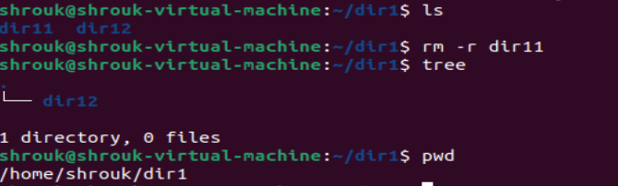

when i tried to delete the directory using rmdir i couldn't remove the directory in one step because it contained a file so i used rm -r to remove it with its content

3)b)

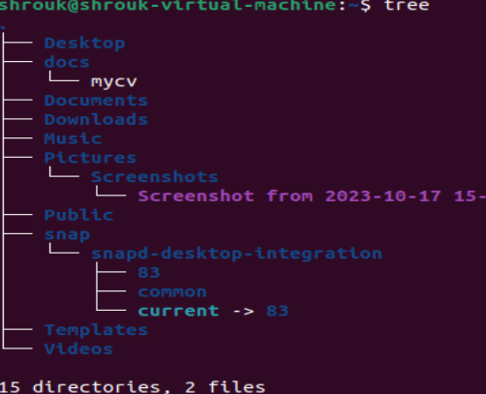

When rmdir –p used the the last directory interd in the path and its parent were removed.

3)c)

* absolute:



* relative:



4)

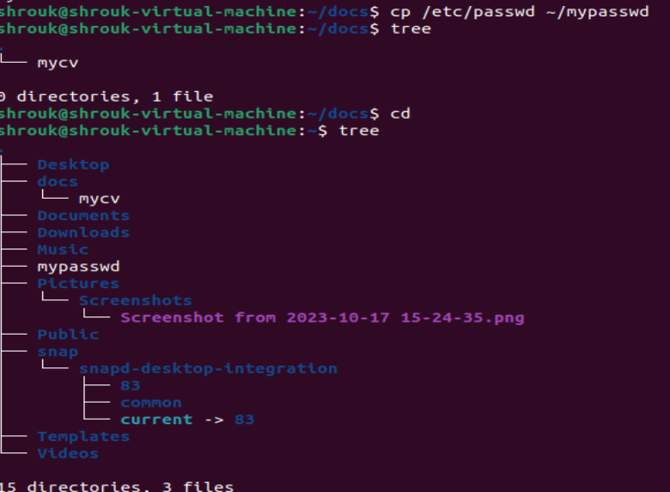

5)

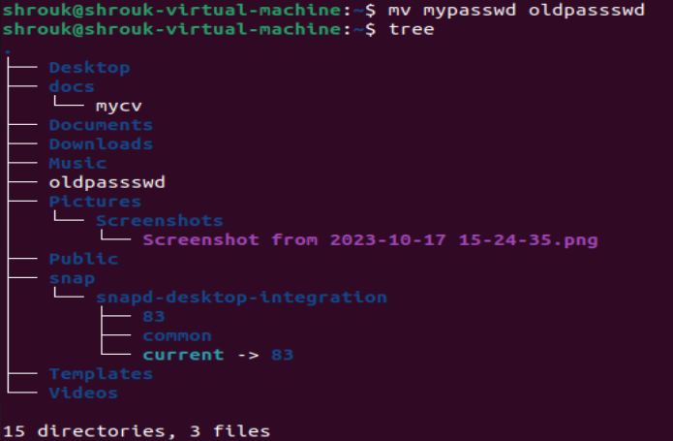

6)

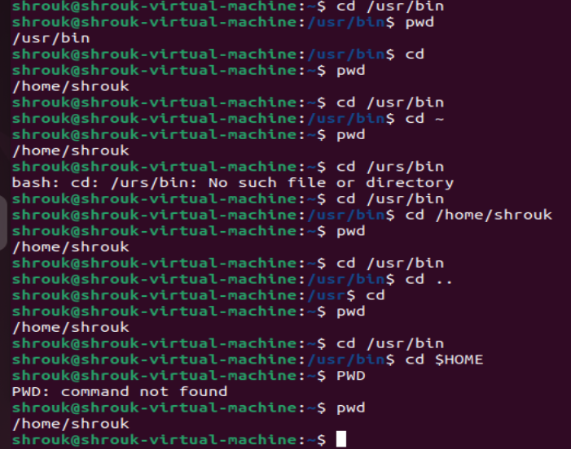

7)



8)

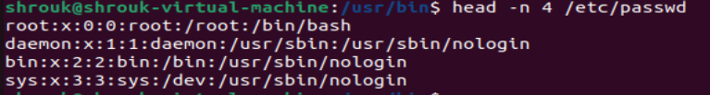

9)

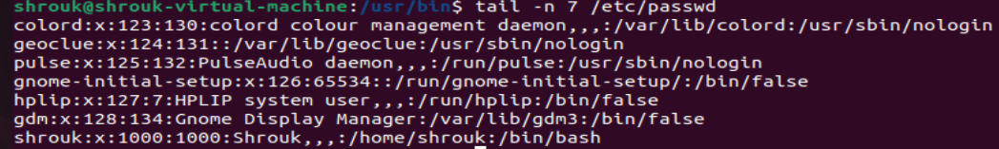

10)

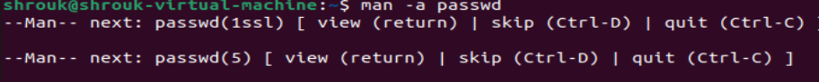

11)



12)

