13. Create a folder called myteam in your home directory and change its permissions to read only for the owner.

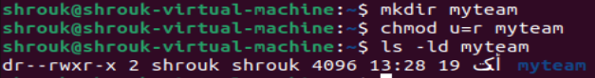

14. Log out and log in by another user

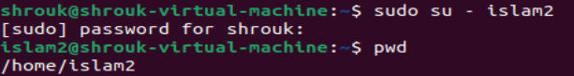

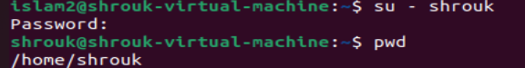

15. Try to access (by cd command) the folder (myteam)



16. Using the command Line

Change the permissions of oldpasswd file to give owner read and write

permissions and for group write and execute and execute only for the others

(using chmod in 2 different ways)

Change your default permissions to be as above.

What is the maximum permission a file can have, by default when it is just

created? And what is that for directory.

Change your default permissions to be no permission to everyone then create a

directory and a file to verify.



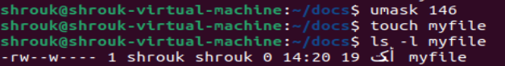



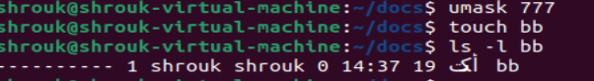



17. What are the minimum permission needed for:

Copy a directory (permission for source directory and permissions for target

parent directory)

source directory: read and execute

target parent: write and execut

Copy a file (permission for source file and and permission for target parent

directory)

source directory: read

target parent: write

Delete a file

No permission

Change to a directory

execute

List a directory content (ls command)

read

View a file content (more/cat command)

read

Modify a file content

Write

18. Create a file with permission 444. Try to edit in it and to remove it? Note what happened

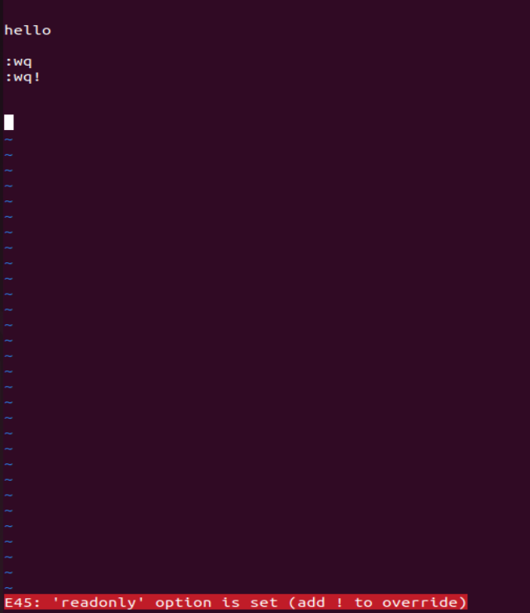



19. What is the difference between the “x” permission for a file and for a directory?

Execute permission on files means the right to execute them, if they are programs. (Files that are not programs should not be given the execute permission.) For directories, execute permission allows you to enter the directory (i.e., cd into it), and to access any of its files