1)

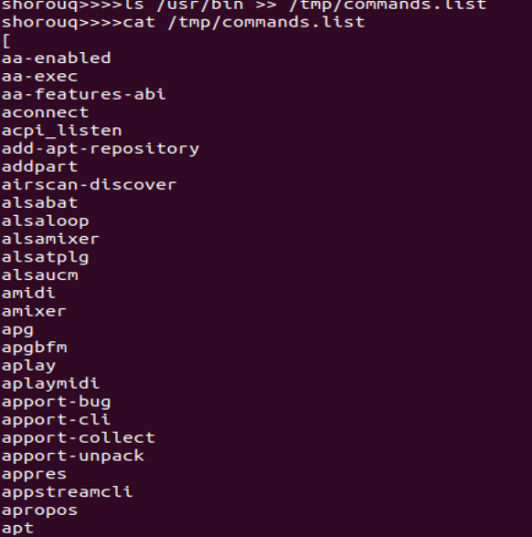

2)



3)

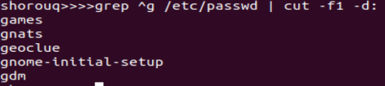

Or

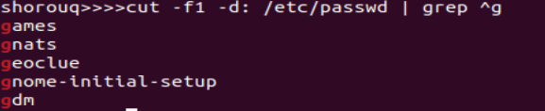

4)

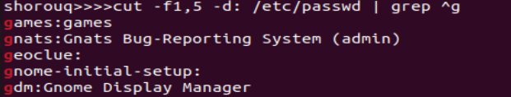

5)

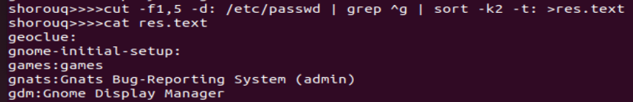

6)



No result found and errors contain permission denied

7)



8)

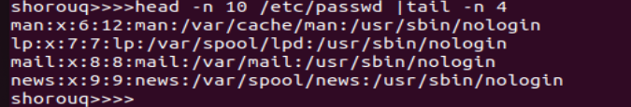

9)

a)



b)



rm🡪 receives one file or directory.

c)



l will not work as intended because /etc/passwd is a file, not a directory. The ls command is typically used to list the contents of directories

10) 🡪 15)

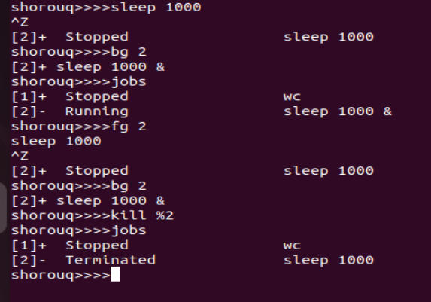

16)

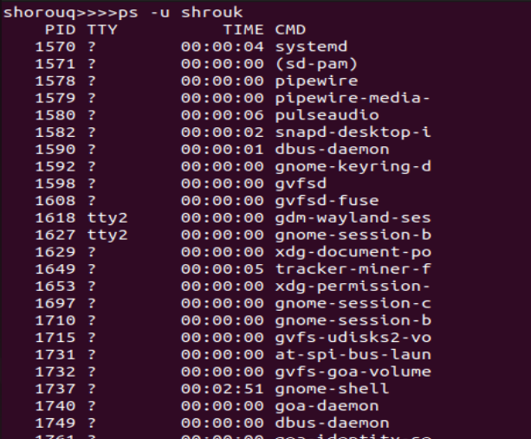

17)

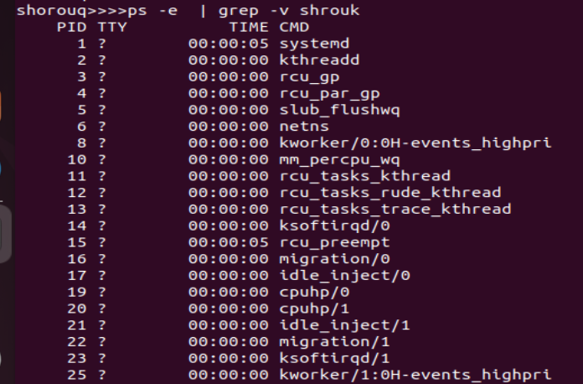

18)

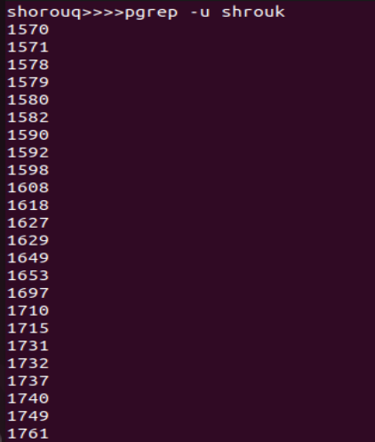

19)

