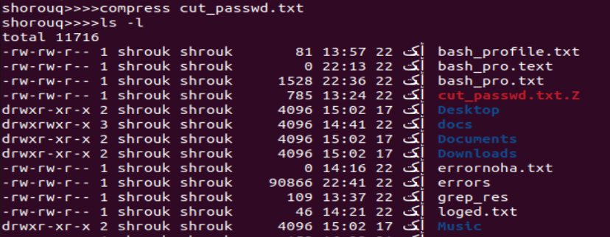

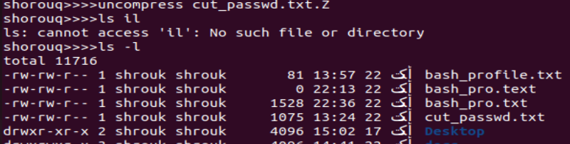

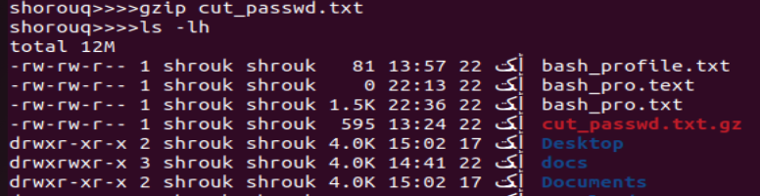

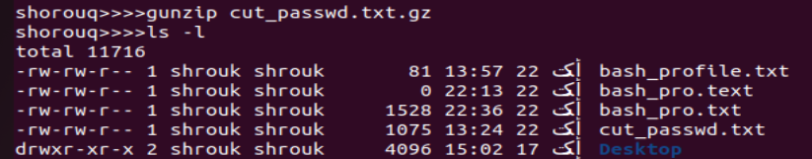

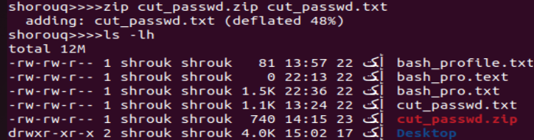

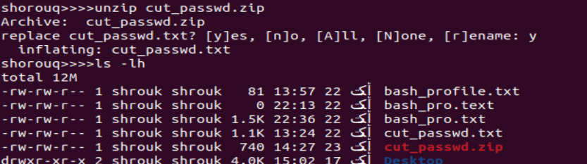

compress and gzip are primarily used for single-file compression, while zip is more versatile, allowing you to create archives containing multiple files and directories in addition to compression.

2)

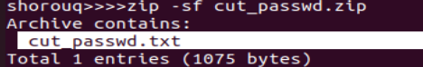

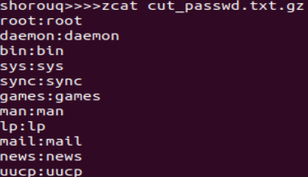

3)

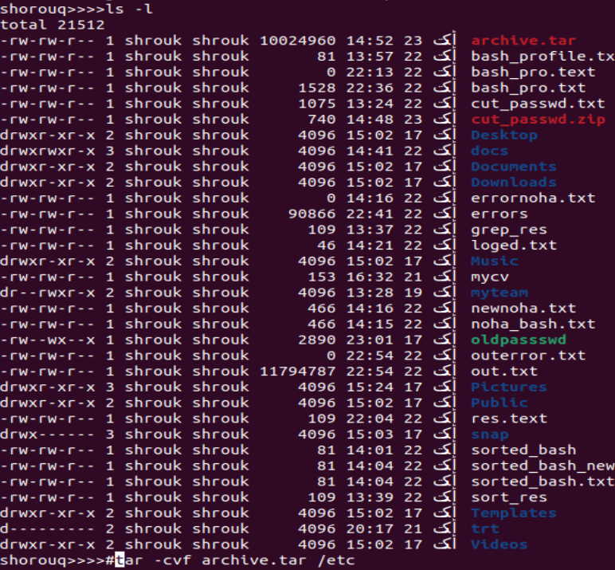

4)

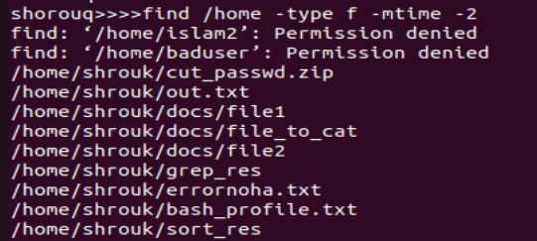

5)

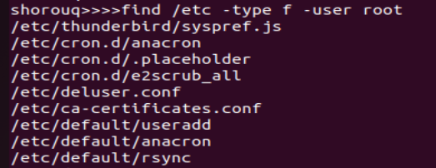

6)

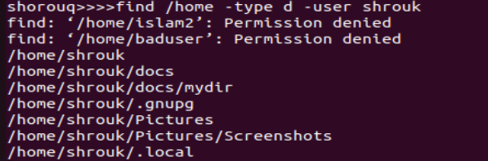

7)

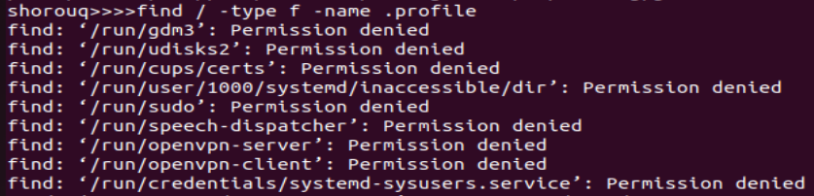

8)

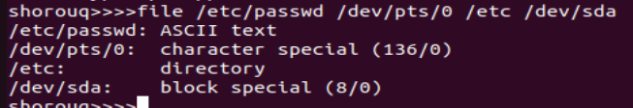

9)

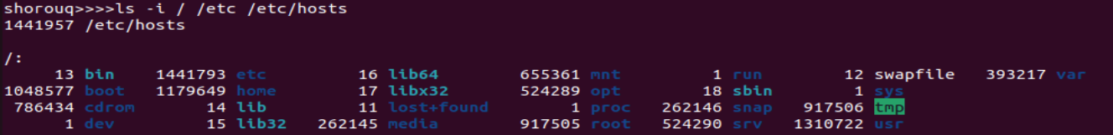

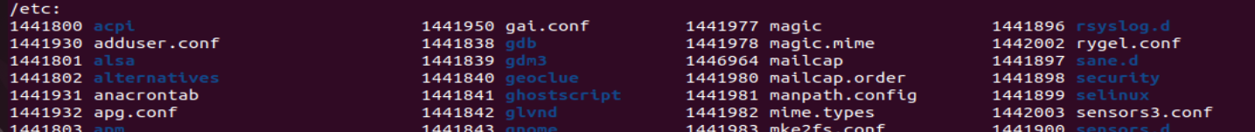

10)



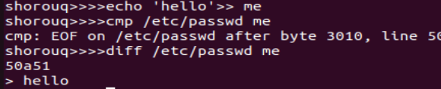

11)

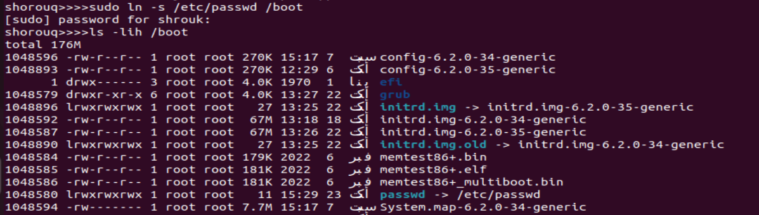

12)



In Linux, hard links can only be created within the same filesystem. /etc and /boot are often on separate filesystems.