Table of Contents

Key 2

Departments 2

Team 2

Concept 🧰 2

Genre 2

Comparable Games 2

Pillars 2

Player Controller 🧪🎨 3

Actions/Controls 3

Rules 3

Story 🍂 3

Level Design 🌃 4

Flow 4

Obstacles / Environment Pieces 🌃🧰🧪🎨 4

Brainstorm 4

Sound Design 🎼 4

Art 🎨 4

Character Design 🎨🍂 4

Environment Art 4

Environments 4

Schedule 👾 5

Stretch Goals 🧰👾 5

# Key

### Departments

|  |  |  |  |
| --- | --- | --- | --- |
| 🧰 Game Design | 🍂 Story | 🎨 Art | 🧪 Programming |
| 🎼 Audio | 🌃 Level Design | 👾 Producer | 🌸 Juice |

# Team

*All members possess strong game design skills

|  |  |  |
| --- | --- | --- |
| Team Member | Assigned as | Also Comfortable with |
| Eric VH | Co-Producer, Programmer, Docs | Juice, Concept Artist |
| Nick S | Co-Producer, Programmer |  |
| Graham L | Programmer |  |
| Chris H | Level Designer | Concept Artist, Programmer |
| Matthew B | Level Designer, Docs | Audio |
| Kaicheng (KC) L | 3D Artist, 3D Animator | Juice |

# Concept 🧰

## Genre

Puzzle/Platformer/Action

## Comparable Games

*Celeste –* Platformer where precision and timing skills are rewarded, but also puzzle-like problem solving, contained levels

*Super Meat Boy –* Platformer where precision and timing skills are rewarded, contained levels

She Remembers Caterpillars –Puzzle game with bug theme

## Pillars

(unconfirmed)

|  |  |
| --- | --- |
| Fun Physics | Mastery |
| Puzzle Problem Solving | Planning/Execution |

# Player Controller 🧪🎨

## Actions/Controls

|  |  |  |
| --- | --- | --- |
| Walking Mode | Description | Control |
| Move Side to Side |  | AD |
|  |  |  |
| Both Modes |  |  |
| Jump | Jump off of the “normal” supporting it | Z |
| Toggle Mode | Change between Walking and Ball Mode | X |
| Dash | Charge forward | C |
|  |  |  |
| Ball Mode |  |  |
| Alter Couse Mid-Air | Accelerate in the selected direction while mid-air | WASD |
|  |  |  |

## Rules

Walking Mode

Falls when unsupported by a platform

Ball Mode

On slopes, the character rolls

Gravity? We’re not sure yet

When on flat ground, the character decelerates

With every bounce off a surface or enemy, the character gains speed

When hitting a surface, the character bounces off the normal

# Story 🍂

Hero: Roly-Poly Character

Objective: Reach candy?

Enemies: Other Bugs

# Level Design 🌃

## Flow

# Obstacles / Environment Pieces 🌃🧰🧪🎨

## Brainstorm

Gates where you need a specific speed to be able to pass (Puzzle)

Trampoline

Spikes

Directional Gates (like valves)

Direction Router (no matter what direction you are now, your new direction is set)

Rising Lava

# Sound Design 🎼

# Art 🎨

## Character Design 🎨🍂

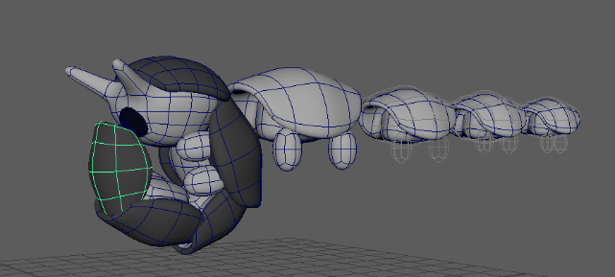Basic structure of body part

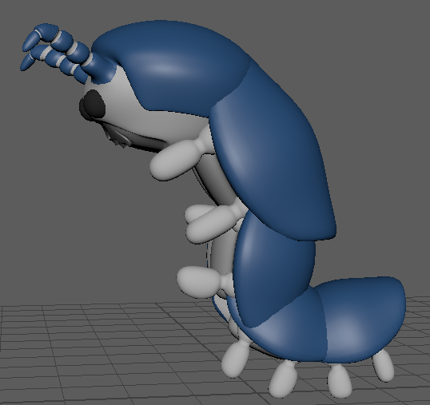 Basic form (Stand)

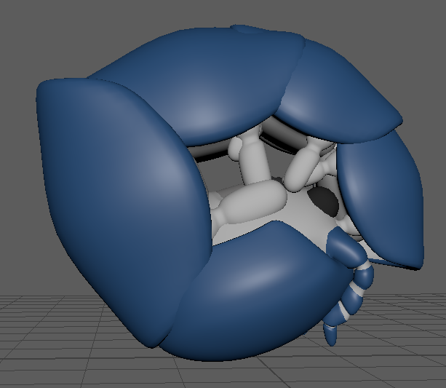Ball form (Rolling)

## Environment Art

### Environment Ideas Open

Garden

### Environment Ideas Contained

Woodwork Bug City

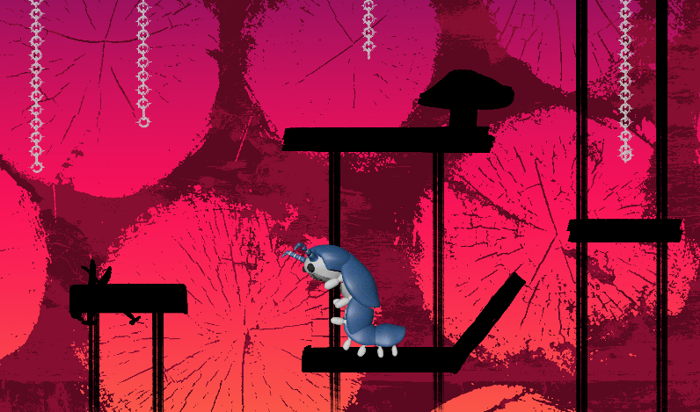

Candy Dealer

# Schedule 👾

End Date:

# Stretch Goals 🧰👾