Advanced SQL Semester Project - Restaurant database
Mason Romdenne, Nathan Krouth, Nicholas Fearing
Prepared by Mason Romdenne
Week 4 Deliverables - Item 1 - Stored Procedures
21 September 2026

Week 4 Item 1 - Stored Procedures - Testing Documentation
All of the code for this item is in one file, Week4_Item1_StoredProcedures.sql, which was run as a whole against the Restaurant database in SQL Server Management Studio on the class VM (instance ADVSQL). Each object below shows who wrote it, the code, the test that was run, and a screenshot of the result. The TESTING section at the bottom of the .sql file is the testing code.
Every group member's work went in through a pull request on the group's GitHub repo (PRs #22, #23 and #24) and was reviewed and merged into this file.
Money columns use FORMAT(value, 'C', 'en-IE'), which lets SQL Server supply the euro sign for the Irish locale rather than it being hardcoded.

Item 1 - Stored procedures
Requirement: five stored procedures, a through e. The project document names both b and c spN_RecipeDetails, so c is spN_DishDetails here.

1a - spN_ChefDetails (Mason)
"Return the chef(s) that have a preferred vendor and what item(s) these chefs prefer from these vendors. Also include the price for these items. Ensure the item price is in Irish Pounds and do NOT hardcode the euro dollar sign."
Our Week 2 schema had no link between a supplier and the items it sells, so this needed a new table first. SupplierIngredients is each vendor's catalogue with a price per item; the project document allows tables to be added as the project goes on. It is filled with 4 items per supplier (400 rows).

New table - SupplierIngredients
CREATE TABLE SupplierIngredients (
SupplierIngredientID INT IDENTITY(1,1) NOT NULL,
SupplierID INT NOT NULL,
IngredientID INT NOT NULL,
SupplierPrice DECIMAL(10,2) NOT NULL,
IsActive BIT NOT NULL DEFAULT 1,
CreationDate DATETIME2 NOT NULL DEFAULT SYSDATETIME(),

CONSTRAINT PK_SupplierIngredients PRIMARY KEY (SupplierIngredientID),
CONSTRAINT UQ_SupplierIngredients_SupplierIngredient
UNIQUE (SupplierID, IngredientID),
CONSTRAINT FK_SupplierIngredients_Suppliers FOREIGN KEY (SupplierID)
REFERENCES Suppliers (SupplierID),
CONSTRAINT FK_SupplierIngredients_Ingredients FOREIGN KEY (IngredientID)
REFERENCES Ingredients (IngredientID),
CONSTRAINT CK_SupplierIngredients_Price_Positive CHECK (SupplierPrice >= 0)
);

Procedure
CREATE PROCEDURE spN_ChefDetails
AS
BEGIN
SET NOCOUNT ON;

SELECT c.ChefID,
CONCAT(e.FirstName, ' ', e.LastName) AS 'Chef Name',
c.ChefType AS 'Chef Type',
s.SupplierName AS 'Preferred Vendor',
i.IngredientName AS 'Item',
FORMAT(si.SupplierPrice, 'C', 'en-IE') AS 'Item Price'
FROM Chefs c
INNER JOIN Employees e ON c.EmployeeID = e.EmployeeID
INNER JOIN Suppliers s ON c.PreferredSupplierID = s.SupplierID
INNER JOIN SupplierIngredients si ON s.SupplierID = si.SupplierID
INNER JOIN Ingredients i ON si.IngredientID = i.IngredientID
WHERE si.IsActive = 1
ORDER BY e.LastName, e.FirstName, i.IngredientName;
END;

Test
EXEC spN_ChefDetails;
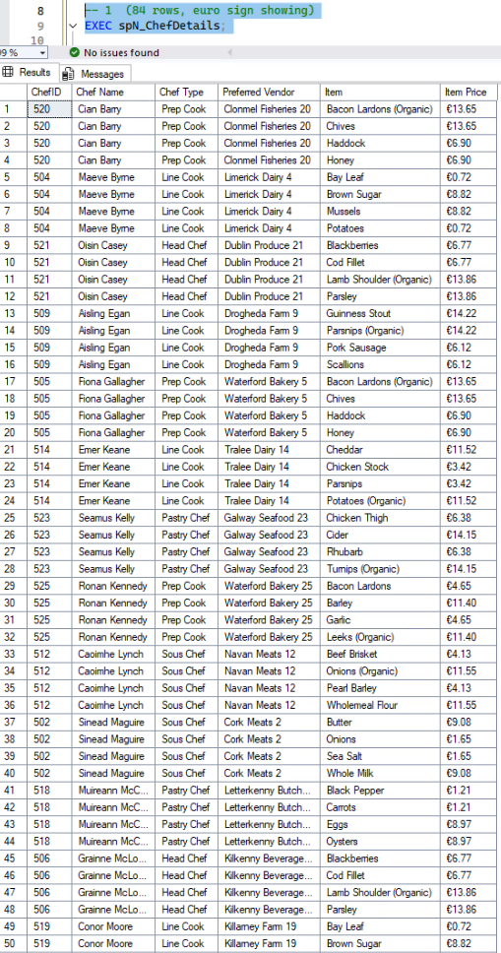
Figure 1: 84 rows, one per chef and item. 21 of the 25 chefs have a preferred vendor and each vendor carries 4 items. The euro sign in Item Price comes from FORMAT with the en-IE locale.

1b - spN_RecipeDetails (Nathan)
"Return the sum of the ingredients by recipe. Also included with this will be the recipe items. Ensure the totaldue is in Irish Pounds and do NOT hardcode the euro dollar sign."
Selects every ingredient line for each dish and tallies the cost. GROUP BY ROLLUP adds a subtotal row per dish (IngredientName is NULL) and one grand total row (both NULL), so the recipe items and the sum come back together in one result.
CREATE PROC spN_RecipeDetails

AS

SELECT DishID, IngredientName, FORMAT(SUM(IngredientCost * QuantityUsed), 'C', 'en-IE') AS RecipeCost
FROM Recipes r
JOIN Ingredients i
ON r.IngredientID = i.IngredientID
GROUP BY ROLLUP(DishID, IngredientName)
ORDER BY DishID

Test
EXEC spN_RecipeDetails;
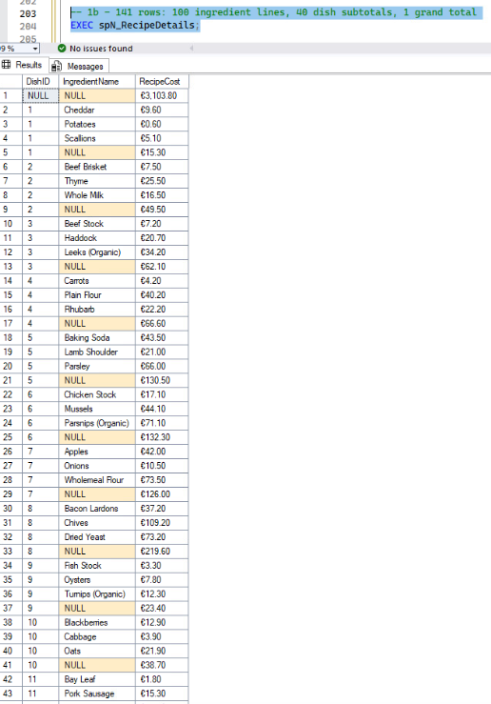
Figure 2: 141 rows: 100 ingredient lines, a subtotal for each of the 40 dishes, and the grand total at the top. Dish 1 (Irish Stew) costs 15.30 to make.

1c - spN_DishDetails (Nathan)
"Show me the ingredients used in each recipe and the prices listed for those dishes that use the ingredients."
Each dish, each ingredient in its recipe, and the menu price of the dish itself.
CREATE PROC spN_DishDetails

AS

SELECT r.DishID, d.DishName, r.IngredientID, IngredientName, FORMAT(Price, 'C', 'en-IE') AS DishCost
FROM Dishes d
JOIN Recipes r
ON d.DishID = r.DishID
JOIN Ingredients i
ON i.IngredientID = r.IngredientID
GROUP BY r.DishID, d.DishName, r.IngredientID, IngredientName, Price

Test
EXEC spN_DishDetails;
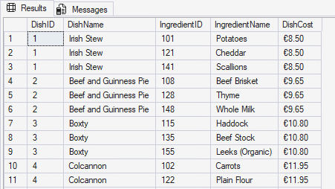
Figure 3: 100 rows, one per recipe line. Irish Stew uses potatoes, cheddar and scallions and sells for 8.50.

1d - spN_KitchenDetails (Nicholas)
"Show me the kitchen details. These details can either be all records or by individual chef."
Returns every column of KitchenDetails. The @LeadChef parameter is optional; with nothing passed it returns every kitchen, with a chef ID it returns only the kitchen that chef leads.
CREATE PROCEDURE spN_KitchenDetails
@LeadChef int = NULL
AS
BEGIN
BEGIN TRY
SELECT *
FROM KitchenDetails
WHERE @LeadChef IS NULL OR @LeadChef = LeadChef
END TRY
BEGIN CATCH
PRINT 'An error occured while searching for Chef #' +
CONVERT(varchar, @LeadChef, 1) + '.'
END CATCH
END;

Test - all kitchens
EXEC spN_KitchenDetails;
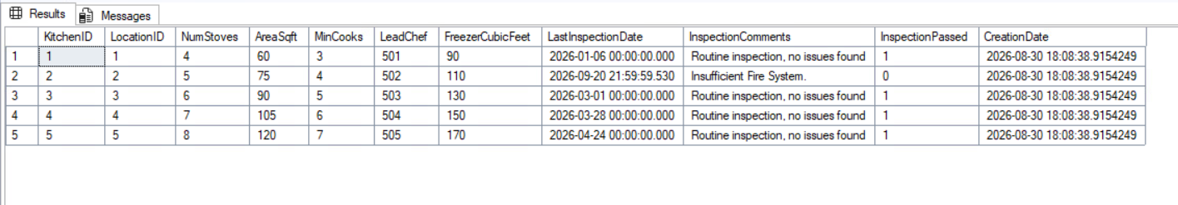
Figure 4: All 5 kitchens.

Test - by chef
EXEC spN_KitchenDetails @LeadChef = 503;
Figure 5: Only kitchen 3, the one led by chef 503.

1e - spN_CustomerDetails (Nathan)
"Return information on the customers that dine at the restaurant. This stored procedure should be able to run and return individual customer information."
Returns the customers with a formatted name to make it a bit more neat. The @CustomerID parameter is optional; with nothing passed it lists all 100 customers, with an ID it returns that one customer.
CREATE PROC spN_CustomerDetails
@CustomerID INT = NULL
AS

SELECT FirstName + ' ' + LastName AS CustName, Email, PhoneNumber,
PreferredTable, PreferredServer, PreferredRes, PreferredOrder,
Birthday
FROM Customers
WHERE @CustomerID IS NULL OR CustomerID = @CustomerID
ORDER BY CustName ASC

Test - all customers, then one customer
EXEC spN_CustomerDetails;
EXEC spN_CustomerDetails @CustomerID = 1;
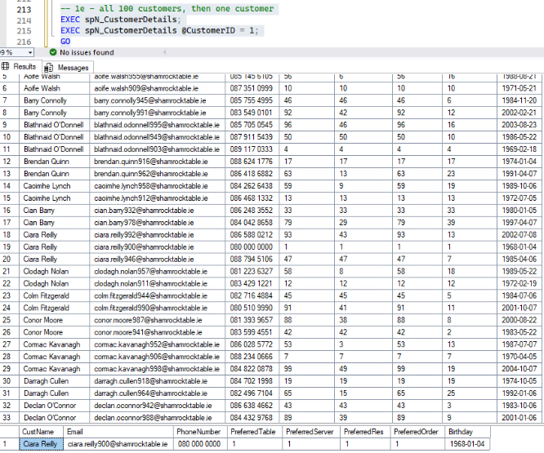
Figure 6: Top grid: all 100 customers, sorted by name. Bottom grid: only Ciara Reilly comes back when @CustomerID = 1 is passed.

