Advanced SQL Semester Project - Restaurant database
Mason Romdenne, Nathan Krouth, Nicholas Fearing
Prepared by Mason Romdenne
Week 4 Deliverables - Item 2 - Indexes
21 September 2026

Week 4 Item 2 - Indexes - Testing Documentation
All of the code for this item is in one file, Week4_Item2_Indexes.sql, which was run as a whole against the Restaurant database in SQL Server Management Studio on the class VM (instance ADVSQL). Each object below shows who wrote it, the code, the test that was run, and a screenshot of the result. The TESTING section at the bottom of the .sql file is the testing code.
Every group member's work went in through a pull request on the group's GitHub repo (PRs #22, #23 and #24) and was reviewed and merged into this file.

Item 2 - Indexes
Requirement: an index on each of five Week 2 tables (items d, e, i, l and p), with the reason for the field chosen. Those are Charities, Dishes, Recipes, Transactions and Reservations. TransactionDetails is indexed as well since item l's order total is built from that table.
All are nonclustered because each table's primary key already created the one clustered index a table gets. INCLUDE adds columns to the index so a query can be answered without going back to the table.

d - Charities.DonatingLocationID (Mason)
DonatingLocationID is the foreign key to Demographic, so it is what the join and any "charities for this branch" filter run on, and SQL Server does not index foreign keys on its own. CharityID is already the primary key and CharityName already has a unique constraint. CharityName and TotalDonatedValue are included so the donation report is answered from the index.
CREATE NONCLUSTERED INDEX IX_Charities_DonatingLocationID
ON Charities (DonatingLocationID)
INCLUDE (CharityName, TotalDonatedValue);

e - Dishes.DishName, Price (Nicholas)
Nicholas chose Dishname and Price to make a covering index for fnMenuPrices() from Week 3, which reads exactly those two columns.
CREATE INDEX IX_Dishname_Price
ON Dishes (Dishname, Price);

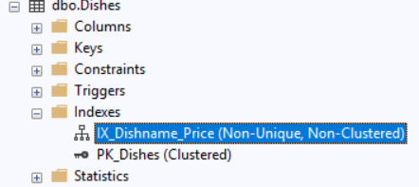
Figure 1: IX_Dishname_Price under Dishes in Object Explorer, next to the clustered primary key.

i - Recipes.DishID (Nathan)
The key already takes up the clustered index so this one is nonclustered. DishID is mandatory when looking into this table to find all the ingredients belonging to a specific dish. IngredientID and QuantityUsed are included so it may work as a recipe book as well.
CREATE NONCLUSTERED INDEX IX_Recipes_DishID
ON Recipes (DishID)
INCLUDE (IngredientID, QuantityUsed);

l - Transactions.OrderDateTime (Mason)
The restaurant keeps three years of orders and nearly every question is a date range, which scans the whole table without an index on OrderDateTime. TransactionID and BillingNumber are already indexed by their constraints, and OrderChannel and PaymentMethod only have a few distinct values so an index on them would not narrow much. OrderTotal and OrderChannel are included since date queries sum and group by them.
CREATE NONCLUSTERED INDEX IX_Transactions_OrderDateTime
ON Transactions (OrderDateTime)
INCLUDE (OrderTotal, OrderChannel);

TransactionDetails.TransactionID as well: TransactionID is the foreign key back to the order, and "the lines on this bill" is the only way the table is read, but the primary key is TransactionDetailID so that lookup had no index. DishID, Quantity and UnitPrice are included so printing a bill only touches the index.
CREATE NONCLUSTERED INDEX IX_TransactionDetails_TransactionID
ON TransactionDetails (TransactionID)
INCLUDE (DishID, Quantity, UnitPrice);

p - Reservations.CustomerID (Nicholas)
CustomerID because it is both a foreign key and it is used in a join by fnReservationFavoriteTable() from Week 3.
CREATE INDEX IX_CustomerID
ON Reservations (CustomerID);

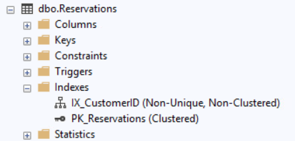
Figure 2: IX_CustomerID under Reservations in Object Explorer.

Test - sys.indexes
SELECT OBJECT_NAME(object_id) AS 'Table', name AS 'Index' FROM sys.indexes WHERE name LIKE 'IX[_]%' ORDER BY 1;
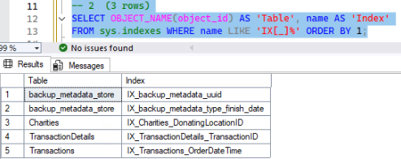
Figure 3: The three indexes on Charities, Transactions and TransactionDetails. The full run of Week4_Item2_Indexes.sql creates all six; the two backup_metadata_store rows are SQL Server's own.

