Advanced SQL Semester Project - Restaurant database
Mason Romdenne, Nathan Krouth, Nicholas Fearing
Prepared by Mason Romdenne
Week 4 Deliverables - Item 3 - CRUD Stored Procedures
21 September 2026

Week 4 Item 3 - CRUD Stored Procedures - Testing Documentation
All of the code for this item is in one file, Week4_Item3_CRUD.sql, which was run as a whole against the Restaurant database in SQL Server Management Studio on the class VM (instance ADVSQL). Each object below shows who wrote it, the code, the test that was run, and a screenshot of the result. The TESTING section at the bottom of the .sql file is the testing code.
Every group member's work went in through a pull request on the group's GitHub repo (PRs #22, #23 and #24) and was reviewed and merged into this file.
The project says each procedure "should not generate any exceptions and all should return data."

Item 3 - CRUD stored procedures
Requirement: CRUD procedures on two tables, one procedure per action, named spN_Get/Insert/Update/Delete + table. The tables are Charities and KitchenDetails, chosen because nothing else has a foreign key pointing at them, so the DELETE procedures can run without breaking a relationship. The group split the work by action: Mason wrote SELECT and INSERT, Nicholas UPDATE, Nathan DELETE.
The project says each procedure "should not generate any exceptions and all should return data." Both tables have constraints a bad insert would trip (a unique name on Charities and foreign keys on both), so the INSERT procedures check for those first and return a Rejected message instead of letting SQL Server throw. Every procedure returns a result set: the row it worked on, or for a delete the number of rows deleted.
The tests below run a full cycle: insert a test charity and a test kitchen, update them, then delete them, so the tables finish exactly as they started (15 charities, 5 kitchens).

SELECT - spN_GetCharities and spN_GetKitchenDetails (Mason)
Each takes the primary key as an optional parameter. With no argument it returns every row, with an ID it returns that one row. Both join in the branch name, and the kitchen one also joins through Chefs to Employees for the lead chef's name.
CREATE PROCEDURE spN_GetCharities
@CharityID INT = NULL
AS
BEGIN
SET NOCOUNT ON;

SELECT c.CharityID,
c.CharityName AS 'Charity',
c.CharityType AS 'Type',
c.ContactName AS 'Contact',
c.PhoneNumber AS 'Phone',
c.City,
d.LocationName AS 'Donating Branch',
FORMAT(c.TotalDonatedValue, 'C', 'en-IE') AS 'Total Donated',
CASE WHEN c.IsActive = 1 THEN 'Yes' ELSE 'No' END AS 'Active',
c.CreationDate AS 'Created'
FROM Charities c
LEFT JOIN Demographic d ON c.DonatingLocationID = d.LocationID
WHERE (@CharityID IS NULL OR c.CharityID = @CharityID)
ORDER BY c.CharityName;
END;

Test
EXEC spN_GetCharities @CharityID = 9001;
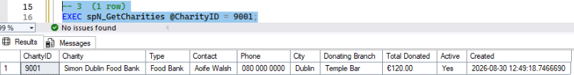
Figure 1: One charity returned when an ID is passed; with no argument all 15 come back.
CREATE PROCEDURE spN_GetKitchenDetails
@KitchenID INT = NULL
AS
BEGIN
SET NOCOUNT ON;

SELECT k.KitchenID,
d.LocationName AS 'Branch',
k.NumStoves AS 'Stoves',
k.AreaSqft AS 'Area (sq ft)',
k.MinCooks AS 'Min Cooks',
CONCAT(e.FirstName, ' ', e.LastName) AS 'Lead Chef',
c.ChefType AS 'Lead Chef Type',
k.FreezerCubicFeet AS 'Freezer (cu ft)',
k.LastInspectionDate AS 'Last Inspection',
CASE k.InspectionPassed
WHEN 1 THEN 'Passed'
WHEN 0 THEN 'Failed'
ELSE 'Not yet inspected'
END AS 'Inspection Result',
k.InspectionComments AS 'Inspection Comments',
k.CreationDate AS 'Created'
FROM KitchenDetails k
INNER JOIN Demographic d ON k.LocationID = d.LocationID
INNER JOIN Chefs c ON k.LeadChef = c.ChefID
INNER JOIN Employees e ON c.EmployeeID = e.EmployeeID
WHERE (@KitchenID IS NULL OR k.KitchenID = @KitchenID)
ORDER BY k.KitchenID;
END;

Test
EXEC spN_GetKitchenDetails @KitchenID = 3;
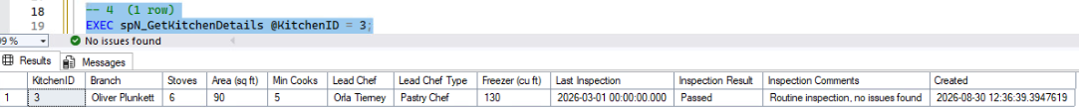
Figure 2: One kitchen returned, with the branch name and the lead chef's name joined in.

INSERT - spN_InsertCharities and spN_InsertKitchenDetails (Mason)
Every column a user can fill in is a parameter. CreationDate is not a parameter so its default fills in the insert time. Each checks the things that would break a constraint and returns the new row on success.
CREATE PROCEDURE spN_InsertCharities
@CharityName NVARCHAR(100),
@CharityType NVARCHAR(50) = NULL,
@ContactName NVARCHAR(100) = NULL,
@PhoneNumber NVARCHAR(20) = NULL,
@City NVARCHAR(50) = NULL,
@DonatingLocationID INT = NULL,
@TotalDonatedValue DECIMAL(10,2) = NULL,
@IsActive BIT = 1
AS
BEGIN
SET NOCOUNT ON;

IF @CharityName IS NULL OR LTRIM(RTRIM(@CharityName)) = ''
BEGIN
SELECT 'Rejected - a charity name is required.' AS 'Result';
RETURN 1;
END;

IF EXISTS (SELECT 1 FROM Charities WHERE CharityName = @CharityName)
BEGIN
SELECT CONCAT('Rejected - ', @CharityName, ' already exists.') AS 'Result';
RETURN 1;
END;

IF @DonatingLocationID IS NOT NULL
AND NOT EXISTS (SELECT 1 FROM Demographic WHERE LocationID = @DonatingLocationID)
BEGIN
SELECT CONCAT('Rejected - no location with ID ', @DonatingLocationID, '.') AS 'Result';
RETURN 1;
END;

IF @TotalDonatedValue < 0
BEGIN
SELECT 'Rejected - the donated total cannot be negative.' AS 'Result';
RETURN 1;
END;

INSERT INTO Charities
(CharityName, CharityType, ContactName, PhoneNumber, City,
DonatingLocationID, TotalDonatedValue, IsActive)
VALUES
(@CharityName, @CharityType, @ContactName, @PhoneNumber, @City,
@DonatingLocationID, @TotalDonatedValue, @IsActive);

-- return the new row so the ID and CreationDate show up
SELECT * FROM Charities WHERE CharityID = SCOPE_IDENTITY();
RETURN 0;
END;

CREATE PROCEDURE spN_InsertKitchenDetails
@LocationID INT,
@NumStoves INT,
@AreaSqft INT,
@MinCooks INT,
@LeadChef INT,
@FreezerCubicFeet INT,
@LastInspectionDate DATETIME = NULL,
@InspectionComments NVARCHAR(500) = NULL,
@InspectionPassed BIT = NULL
AS
BEGIN
SET NOCOUNT ON;

IF NOT EXISTS (SELECT 1 FROM Demographic WHERE LocationID = @LocationID)
BEGIN
SELECT CONCAT('Rejected - no location with ID ', ISNULL(@LocationID, 0), '.') AS 'Result';
RETURN 1;
END;

IF NOT EXISTS (SELECT 1 FROM Chefs WHERE ChefID = @LeadChef)
BEGIN
SELECT CONCAT('Rejected - no chef with ID ', ISNULL(@LeadChef, 0), '.') AS 'Result';
RETURN 1;
END;

IF ISNULL(@NumStoves, 0) <= 0 OR ISNULL(@AreaSqft, 0) <= 0
OR ISNULL(@MinCooks, 0) <= 0 OR ISNULL(@FreezerCubicFeet, 0) <= 0
BEGIN
SELECT 'Rejected - stoves, area, min cooks and freezer size must be above zero.' AS 'Result';
RETURN 1;
END;

INSERT INTO KitchenDetails
(LocationID, NumStoves, AreaSqft, MinCooks, LeadChef, FreezerCubicFeet,
LastInspectionDate, InspectionComments, InspectionPassed)
VALUES
(@LocationID, @NumStoves, @AreaSqft, @MinCooks, @LeadChef, @FreezerCubicFeet,
@LastInspectionDate, @InspectionComments, @InspectionPassed);

SELECT * FROM KitchenDetails WHERE KitchenID = SCOPE_IDENTITY();
RETURN 0;
END;

Test - a good call then bad calls for each
EXEC spN_InsertCharities @CharityName = 'Week 4 Test Charity', @CharityType = 'Food Bank', @City = 'Galway', @DonatingLocationID = 1, @TotalDonatedValue = 250.00;
EXEC spN_InsertCharities @CharityName = 'Week 4 Test Charity';
EXEC spN_InsertCharities @CharityName = 'Bad Branch', @DonatingLocationID = 9999;
EXEC spN_InsertKitchenDetails @LocationID = 1, @NumStoves = 5, @AreaSqft = 80, @MinCooks = 4, @LeadChef = 501, @FreezerCubicFeet = 100, @InspectionComments = 'Week 4 test row';
EXEC spN_InsertKitchenDetails @LocationID = 1, @NumStoves = 5, @AreaSqft = 80, @MinCooks = 4, @LeadChef = 9999, @FreezerCubicFeet = 100;
EXEC spN_InsertKitchenDetails @LocationID = 1, @NumStoves = 0, @AreaSqft = 80, @MinCooks = 4, @LeadChef = 501, @FreezerCubicFeet = 100;
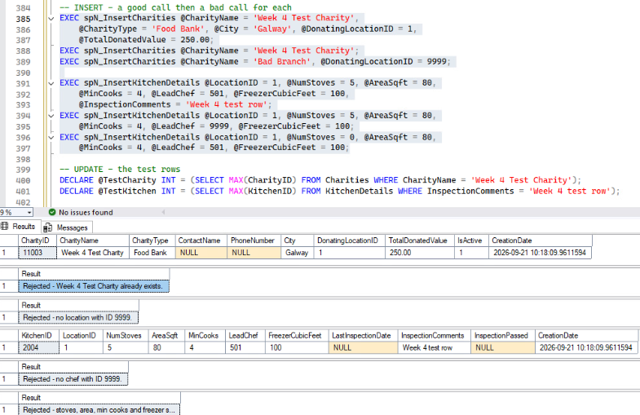
Figure 3: Six results, one per call. The good calls return the new charity (11003) and kitchen (2004) with their IDs and CreationDate filled in by the database. The duplicate name, the bad location ID, the bad chef ID and the zero stoves each come back as a Rejected message - the status bar shows no error, so no exception was raised.

UPDATE - spN_UpdateCharities and spN_UpdateKitchenDetails (Nicholas)
Both update at least three fields inside a transaction with TRY/CATCH. spN_UpdateCharities takes the ID and IsActive, then four optional fields that default to the row's existing value when left off, ordered from most likely to change to least. spN_UpdateKitchenDetails records an inspection: the comments, pass/fail, and a date that defaults to the day and time of the update. Both return the updated row.
CREATE PROC spN_UpdateKitchenDetails
@KitchenID int,
@Comments nvarchar(500),
@InspectionPassed bit,
@InspectionDate datetime = NULL
AS
BEGIN TRY
IF @InspectionDate IS NULL
SELECT @InspectionDate = SYSDATETIME();

BEGIN TRAN;
UPDATE KitchenDetails
SET InspectionComments = @Comments,
InspectionPassed = @InspectionPassed,
LastInspectionDate = @InspectionDate
WHERE KitchenID = @KitchenID
COMMIT TRAN;

SELECT * FROM KitchenDetails WHERE KitchenID = @KitchenID;
END TRY
BEGIN CATCH
ROLLBACK TRAN;
END CATCH;

CREATE PROC spN_UpdateCharities
@CharityID int,
@IsActive bit,
@ContactName nvarchar(100) = NULL,
@PhoneNumber nvarchar(20) = NULL,
@CharityName nvarchar(100) = NULL,
@CharityType nvarchar(50) = NULL
AS
BEGIN TRY
IF @ContactName IS NULL
SELECT @ContactName = ContactName FROM Charities WHERE CharityID = @CharityID;

IF @PhoneNumber IS NULL
SELECT @PhoneNumber = PhoneNumber FROM Charities WHERE CharityID = @CharityID;

IF @CharityName IS NULL
SELECT @CharityName = CharityName FROM Charities WHERE CharityID = @CharityID;

IF @CharityType IS NULL
SELECT @CharityType = CharityType FROM Charities WHERE CharityID = @CharityID;

BEGIN TRAN;
UPDATE Charities
SET IsActive = @IsActive,
ContactName = @ContactName,
PhoneNumber = @PhoneNumber,
CharityName = @CharityName,
CharityType = @CharityType
WHERE CharityID = @CharityID;
COMMIT TRAN;

SELECT * FROM Charities WHERE CharityID = @CharityID;
END TRY
BEGIN CATCH
ROLLBACK TRAN;
END CATCH;

Test - update the two test rows
@TestCharity and @TestKitchen are the IDs of the rows the INSERT tests just created, looked up by name so the script never touches real data.
EXEC spN_UpdateCharities @CharityID = @TestCharity, @IsActive = 1, @ContactName = 'James Joyce', @PhoneNumber = '353 1 878 8547', @CharityName = 'Joyce Dublin Clinic', @CharityType = 'Free Clinic';
EXEC spN_UpdateKitchenDetails @KitchenID = @TestKitchen, @Comments = 'Insufficient fire suppression system.', @InspectionPassed = 0;
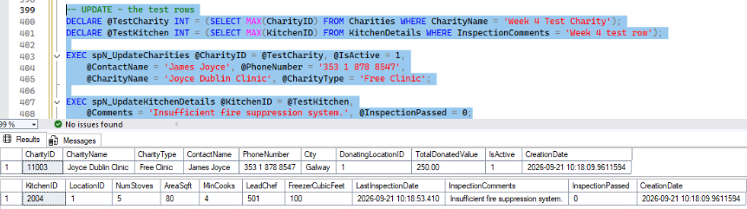
Figure 4: Each procedure returns its updated row. Charity 11003 now has all four fields changed (name, type, contact, phone); kitchen 2004 shows the new comment, InspectionPassed = 0 and an inspection date that defaulted to the time of the update.

DELETE - spN_DeleteCharities and spN_DeleteKitchenDetails (Nathan)
spN_DeleteCharities deletes one charity by CharityID - simple since no other table has a foreign key to Charities. spN_DeleteKitchenDetails takes the KitchenID and its LocationID; nothing has a foreign key to KitchenDetails either (chefs are tied to a branch through Demographic, not through the kitchen), so the row is removed without touching any other table. Both return the number of rows deleted.
CREATE PROC spN_DeleteCharities

@CharityID INT

AS

DELETE FROM Charities
WHERE CharityID = @CharityID;

SELECT @@ROWCOUNT AS RowsDeleted;

CREATE PROC spN_DeleteKitchenDetails

@KitchenID INT,
@LocationID INT

AS

DELETE FROM KitchenDetails
WHERE LocationID = @LocationID AND KitchenID = @KitchenID;

SELECT @@ROWCOUNT AS RowsDeleted;

Test - delete the two test rows
EXEC spN_DeleteCharities @CharityID = @TestCharity;
EXEC spN_DeleteKitchenDetails @KitchenID = @TestKitchen, @LocationID = 1;
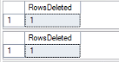
Figure 5: Each procedure returns RowsDeleted = 1 - the test charity and test kitchen are gone.

Test - the tables are back where they started
SELECT (SELECT COUNT(*) FROM Charities) AS 'Charities', (SELECT COUNT(*) FROM KitchenDetails) AS 'Kitchens';
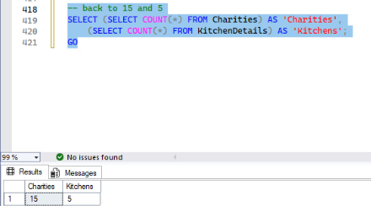
Figure 6: After the full insert, update, delete cycle Charities and KitchenDetails are back at 15 and 5 rows, exactly as they started.

