SQL Advanced Programming
Group Project – Week 3: Functions

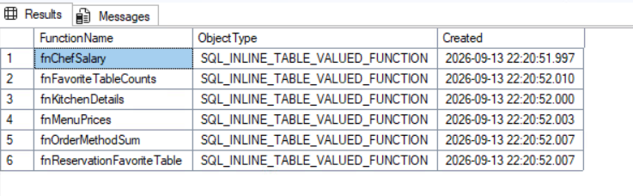
-- Test 0. All six functions are deployed to the Restaurant database.
SELECT name AS FunctionName, type_desc AS ObjectType, create_date AS Created
FROM sys.objects
WHERE type IN ('FN', 'IF', 'TF')
AND name IN ('fnChefSalary', 'fnKitchenDetails', 'fnMenuPrices',
'fnOrderMethodSum', 'fnReservationFavoriteTable', 'fnFavoriteTableCounts')
ORDER BY name;
GO
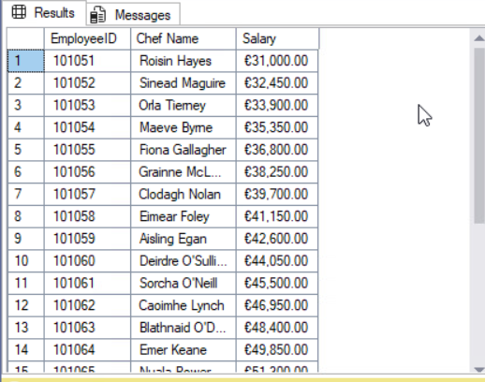
-- Test 1. Function 1 - the salary of each chef, in euro. 25 rows.
SELECT * FROM dbo.fnChefSalary();
GO

-- Test 2. Function 2 - the kitchen details by kitchen. 5 rows.
SELECT * FROM dbo.fnKitchenDetails();
GO
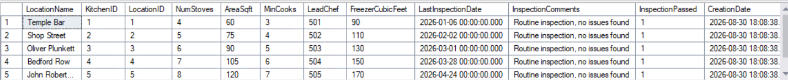

-- Test 3. Function 3 - the unique menu items and their prices, in euro. 40 rows.
SELECT * FROM dbo.fnMenuPrices();
GO
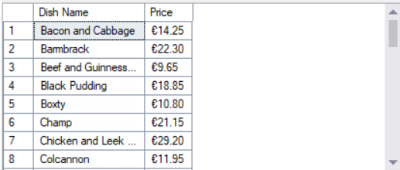

-- Test 4. Function 4 - how orders are placed, with the overall total. 4 rows.
SELECT * FROM dbo.fnOrderMethodSum();
GO
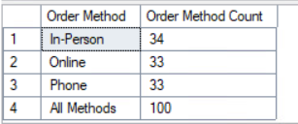

-- Test 5. Function 5 - every reservation and whether the patron got their
-- favorite table. 100 rows.
SELECT * FROM dbo.fnReservationFavoriteTable();
GO

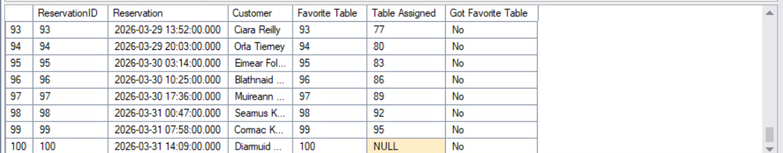

-- Test 6. Function 6 - how many patrons got their favorite table and how
-- many did not, with the overall total. 3 rows.
SELECT * FROM dbo.fnFavoriteTableCounts();
GO

