Compiled by
Griffin DesBles
Matthew Scott
Andrew Levans
Angel Rivera-Velez

Running from Life

Last updated: April 30, 2020

Overview - Executive summary

Story/Background
The story focuses on Prog, a teen who growing up has had to deal with the mental health effects that depression has had on his life. This has caused him to run from situations in his life only to relive them in his dreams. Each level shows different scenarios like troubled parents, bullying in school, not living up to societal expectations, etc. Prog works through each of the trials to try to change the outcome that life has dealt him in order to keep living with a purpose.

Elevator Pitch / High Concept
“Running from Life” is a first-person perspective runner where the player takes the role of a man struggling with depression. As they progress through the game they dive deeper into the mind of the character and experience life through his perspective. The rich story driven and detail-oriented environment create a serious tone that keeps the player engaged as they run through procedurally generated levels representing the characters life to complete tasks and earn upgrades.

Genre
Runner

Key/Exotic Features
- Tasks/Goals
The game features a list of tasks for the player to complete. Each task can be completed independently of the others and in any order. Upon completion of each task, the player is rewarded with unique upgrades or abilities permanently available for the player.
Players can see all the tasks as well as their progress towards completing them in the upgrade and pause menus.
- Unique Story
The game has a very thematic story line with a more serious tone intended to get the player to understand how real-world problems can affect someone. Through each stage the player gains more insight into the mind of the runner and their perspective on life. As they progress, the player gets to see how a person with depression can view the world.

Target Audience
Primary: Teens
Teens usually have a dramatic outlook on like and tend to react to difficult situations in an overly exaggerated way. Our theme appeals to this by exaggerating the hardships of life.
Secondary: Young Adults
Young Adults tend to be more mature than teens but are still familiar with the struggles of life. We appeal to this with our theme by focusing on not only the struggles that life presents us with but how we overcome them.

Play Action and Cadence
The game relies heavily on easy to use and intuitive controls. Movement will be fast-paced and fluid. Moment to moment gameplay will feel rapid and high staked. Gameplay while upgrading between run attempts will feel more relaxed with more focus on choosing which stats to upgrade to better accomplish tasks.

Win Condition / Player Goal
The game is won when the player reaches the end of the level by avoiding obstacles & hazards. The player’s goal is to complete all the given tasks to unlock all the permanent upgrades and allow for completion of the level. The primary goal the player is trying to achieve is completion of the story through completion of the levels.
Thematically, the game is representative of the hardships of life. The player is running away from his struggles while avoiding new hardships. There is an emotional investment at this point that when the player finally beats every level, he (the player), is grateful to see this character in a better place. They’ve seen him at his worst and gotten him through it, now they can finally rejoice at the fact he is happy.

Loss Condition / Continuation
The level is lost, and an attempt is failed, when the player is no longer able to progress forward (i.e. hitting an obstacle, missing a turn, etc.). Upon failure of an attempt the player is presented with a upgrade screen where players can use the currency they earned from previous runs to purchase temporary upgrades to improve their next attempt.

Comparable products

Silent Hill: Shattered Memories
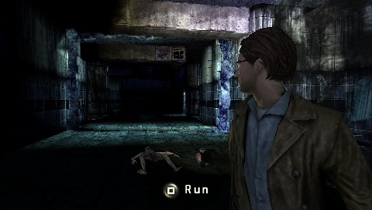
Our game would have a close art style with some gloomification.

Resident Evil 7
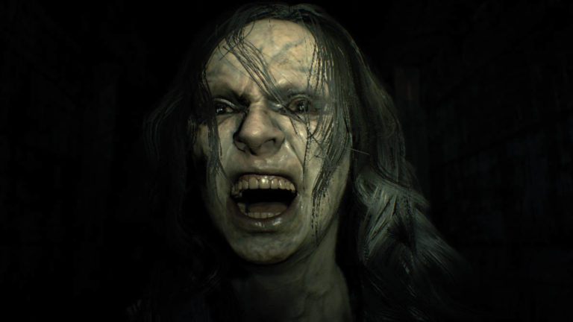
Our game will incorporate well timed events (Sound and animations) relative to the story and our goal, which is emotional investment. Resident Evil 7 makes great use of its jump scares to reach its goal the same way.

Temple Run Series
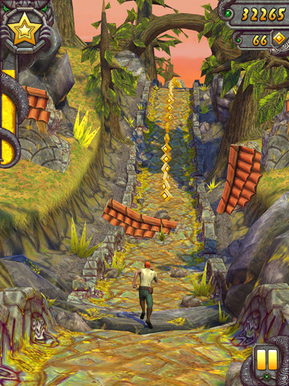
Temple Run is an endless runner designed to engulf the user in endless twists and turns. Our game will use the same runner style but without the endless functionality. Ours will be level based to show progression in the story.

Mirrors Edge Series
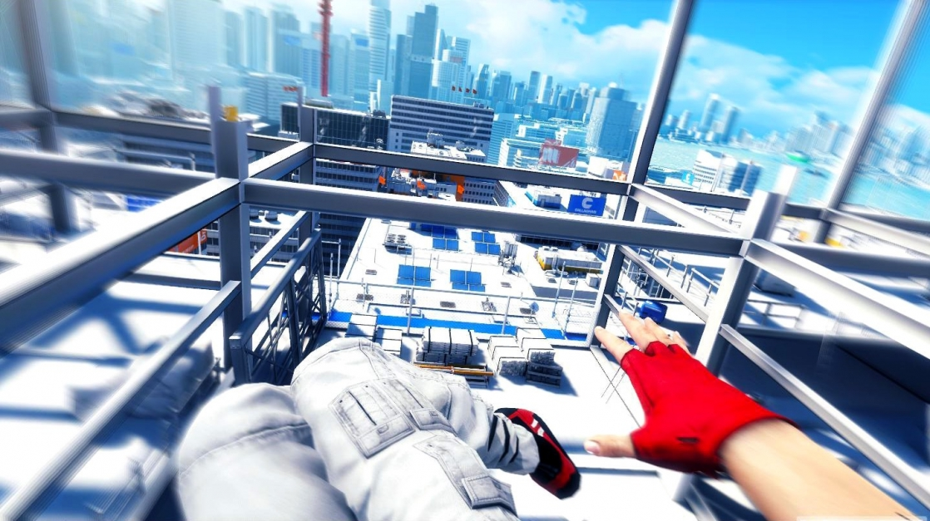
Mirrors Edge is a free running game set in the first person, we would like to harness the first person aspect and ditch the “free”-running aspect for a more controlled run that is more feet on ground and not on the wall.

marvel: contest of champions
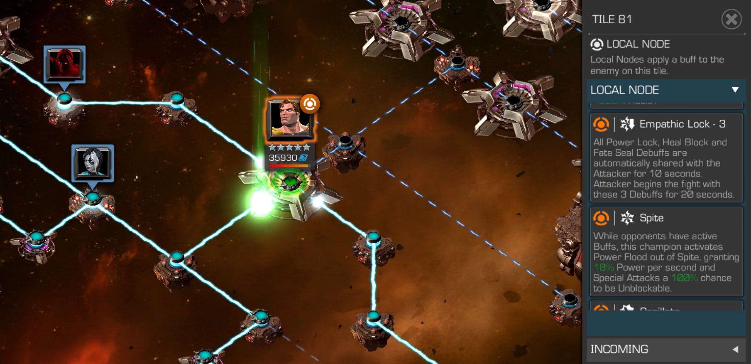
Node based level select screen that we would like to imitate.

Art and Production Design

Colors
Dark and Gloomy
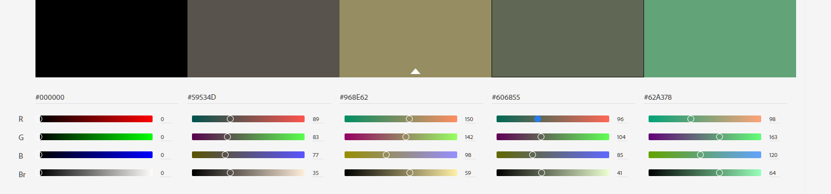

Art / visual Style
A gloomy cartoonish reminiscent of Silent Hill: Shattered Memories

Music Style
Dark, ambient music, volume decreases to bring out the SFX
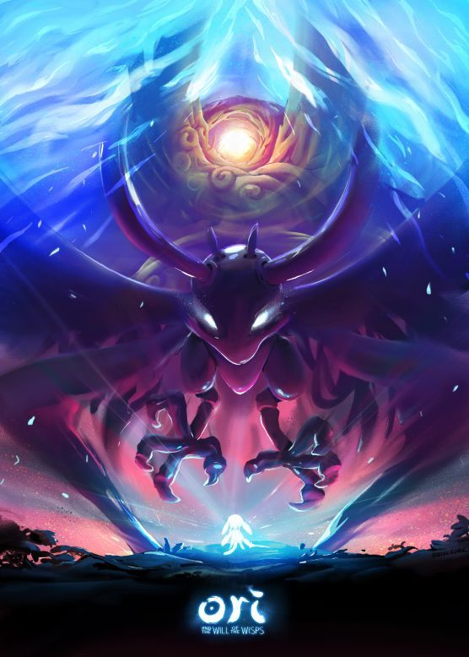

SFX Style
Directional and Distance based, very ominous and well timed

Interactivity

Camera Logic
The camera is locked in 1st person perspective facing the direction the player is currently travelling. Camera controls are minimal if at all

The players camera will take up the entirety of the screen with UI overlaid on top giving them full view of what is in front of them.
Camera rotation will be smooth yet rapid upon turning a corner to maintain a clear image without confusing the player but still allow for quick responses if needed.

Controls

PC Controls

- Movement: A D
- Jump: SPACEBAR
- Double Jump: SPACEBAR (while in air)
- Slide: CTRL
- Boost: SHIFT (once unlocked)
- Menu Interaction: MOUSE

WebPlayer Controls

- Movement: A D
- Jump: SPACEBAR
- Double Jump: SPACEBAR (while in air)
- Slide: CTRL
- Boost: SHIFT (once unlocked)
- Menu Interaction: MOUSE

Scope

Game Progress – Player Milestones
- Travel a certain distance (Boost)
- Avoid a certain number of obstacles (Double Jump)
- Reach a certain speed (Max Speed increase)
- Collect a certain number of “coins” (Magnet)
- Use a certain number of speed boosts (Acceleration increase)
- Reach the end of the level

Worlds/Levels
Tutorial + level (est. 5 attempts minimum) + upgrade screen
Tutorial: 2 min
Level: 4-6 min per attempt (est. 18-10 min completion)
Upgrade Screen: 1-2 min per attempt
Estimated 25-30 min total play time

Mechanics

Movement
The game relieves heavily on a fluid and responsive movement system. The fluidity of the movement allows for traversal of the level without disorientation while the responsiveness allows for easy and rapid reactions to avoid obstacles.
The character will automatically travel forward at an increasing speed until reaching a cap. Players will have limited direction control as well as some evasive abilities. These controls include left & right directional control, jumping, double jumping, sliding, & boosting.

Upgrades/Abilities
The game features an upgrade system for players to enhance their stats. Players will be given the opportunity to upgrade stats between each run.
As the player progresses through the level, they will collect coins. Upon ending a level, the player is presented with a screen where they can upgrade specific stats if they so choose. Upgrades are purchased with the coins earned during gameplay and the number of upgrades that can be purchased is limited.
Upgrades purchased take affect at the start of the following attempt and only stay in affect for the duration of that attempt. Upgrades are temporary and are reset to their initial value between each run.

Tasks/Objectives
The players main objectives are given to them in a list as tasks each with their own unique reward. Players are presented with an array of objectives, as well as their progress towards completing them, that is visible while upgrading and in the pause menu.
Each task has specific criteria that needs to be met in order to complete them (i.e. travel a certain distance, collect a certain number of coins, avoid a certain number of obstacles, etc.). Upon completion of a task the player will be granted the corresponding reward.
Each of the tasks reward empower the player by either granting them access to a new ability (i.e. double jump or boosting) or permanently upgrading a stat (i.e. max speed or acceleration). The rewards granted from completing tasks are permanent and will not reset with the purchased upgrades.

Currency
Through out the level there are coins that can be collected. Players collect these coins by running through them. These coins are the currency used to purchase upgrades.

Obstacles/Hazards
The game features a variety of obstacles and hazards that appear through the level. The players job is to avoid the obstacles.
Each obstacle is avoided in a different way (i.e. jumping over, sliding under, dodging, etc.). Failure to avoid an obstacle causes the player to halt forward progression resulting in failure of the level.
In addition to hazardous obstacles, there are also beneficial obstacles that the player can choose to interact with along the way. These obstacles include speed boosts, double value coins, coin multipliers, and distance multipliers

Procedurally generated levels
The game features a variety of levels as well as an endless mode. Each of these are procedurally generated
Each level will have a set amount of “rooms” that will be randomly ordered and placed along a predetermined path to create a new experience each for each attempt.
In addition to the randomly ordered levels, there is also an endless mode that procedurally generates a level. The levels will be generated by means of the “rooms” used in the levels. A path is calculated real time to prevent the level from looping or becoming unplayable. By using a generated path the level can be endless and still allow for diversity in directions to avoid a straight continuing hallway.
Rooms are created and removed along the path to create the feeling that the level is never ending while only having to have the room the player in currently in, one room behind them, and 2 rooms in front of them.

.

