# CGT/CGAD Semester 2 Feedback Week Task

This semester's mid-term task is focussed on pulling together what you have learned about games programming so far and collaborating on a single project.

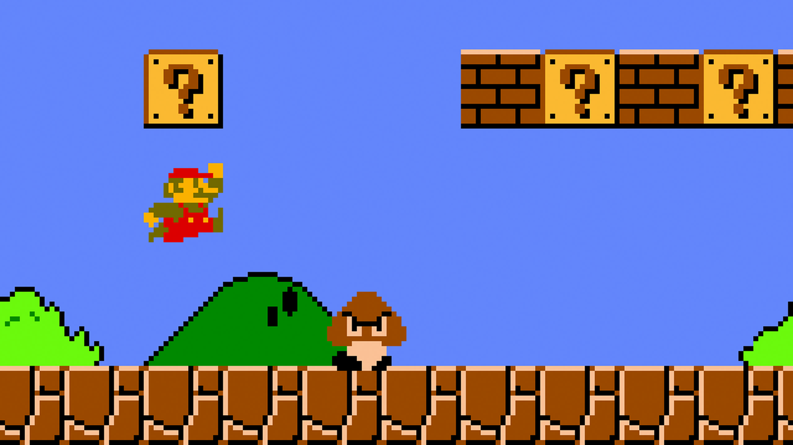

Watch the following video of the first level of Super Mario:

<https://www.youtube.com/watch?v=Aw3AwK74wWQ>

The task is to try and duplicate some of the gameplay that goes beyond the functionality implemented in the starter application provided.

An important aspect of the task is to collaborate on a single project using version control.

The starter application for the task is in the github repository:

<https://github.com/grantclarke-abertay/mario_starter.git>

This repo contains a Unity project that has some very basic functionality to start with. We understand some of you may never have come across Unity so part of the task is to get to grips with this in a similar way you got to grips with Python in 1st semester.

There are plenty of tutorials out there if you’re not sure where to start with this and the online community is very active with a lot of common questions being answered in online forums.

The teams are larger in comparison to last semester. The idea is that you take a single game feature each, develop it and integrate it with the rest the application. You can do more if you wish.

In order to collaborate on an online repository, consider the following steps:

You’ll need to create a copy of the repo you can all work from.

1. ONE person in the team should fork the mario_starter repository.
2. All other team members should then fork that copy of the repo. Not the original repo.

This is so when you try to combine your work you are not trying to update the original repository, but the copy that was made by the first team member.

To fork a repository, look at the following resource:

<http://www.pontikis.net/blog/how-to-collaborate-on-github-open-source-projects>

Version control software is very good at merging changes in text files when they have been changed by multiple users, but it can’t do the same way with binary files. Unity scene files are binary files so one the things your team will have to manage is changes to the scene file so you never need to merge changes to it from multiple sources.

You don’t have to use git from the command line. Feel free to use any git client software you wish.

[e.g. I use the portable version of SmartGit on a USB stick. (Grant)]

When meeting with the member of staff on Thursday be ready to discuss the following:

* How did you approach the problem?
* Who did what?
* How did you communicate with one another throughout the week?
* Were there any difficulties using version control?
* What are the important lessons to take away from this regarding working in a team?

The feedback session with staff is an informal discussion with the whole group. You may wish to create a short PowerPoint presentation for this.