CHAPTER IV
RESULTS AND DISCUSSION

This chapter presents the results of the system development process, including its interface design, core functionalities, and evaluation outcomes. It also discusses user feedback and supporting studies aligned with the ISO/IEC 25010 software quality model, which served as the benchmark for assessing the system’s quality attributes such as functionality, usability, reliability, and security.

System Design and Interfaces
The developed system, RISKWISE, was designed to provide a streamlined and user-friendly platform for hazard reporting and campus safety management. Below are the major components and their corresponding descriptions:

Figure 9-12.
Front Page
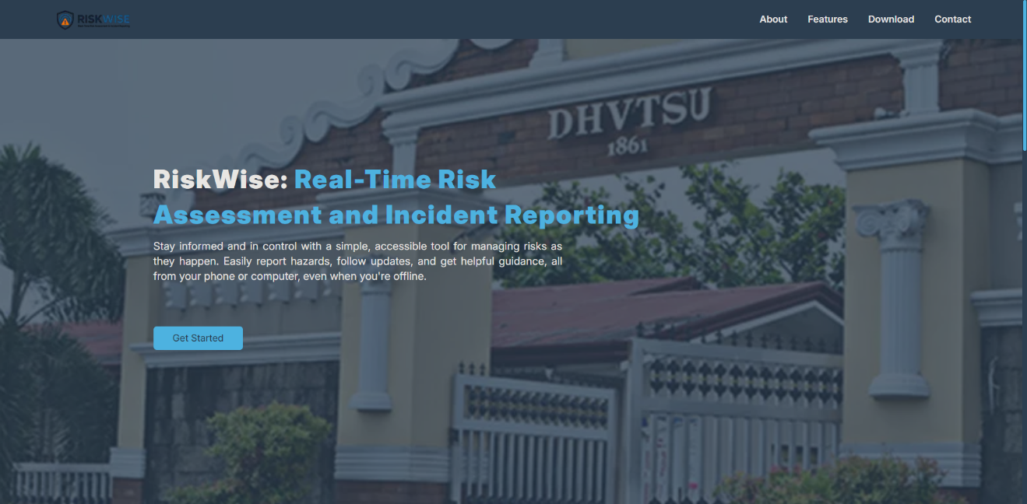
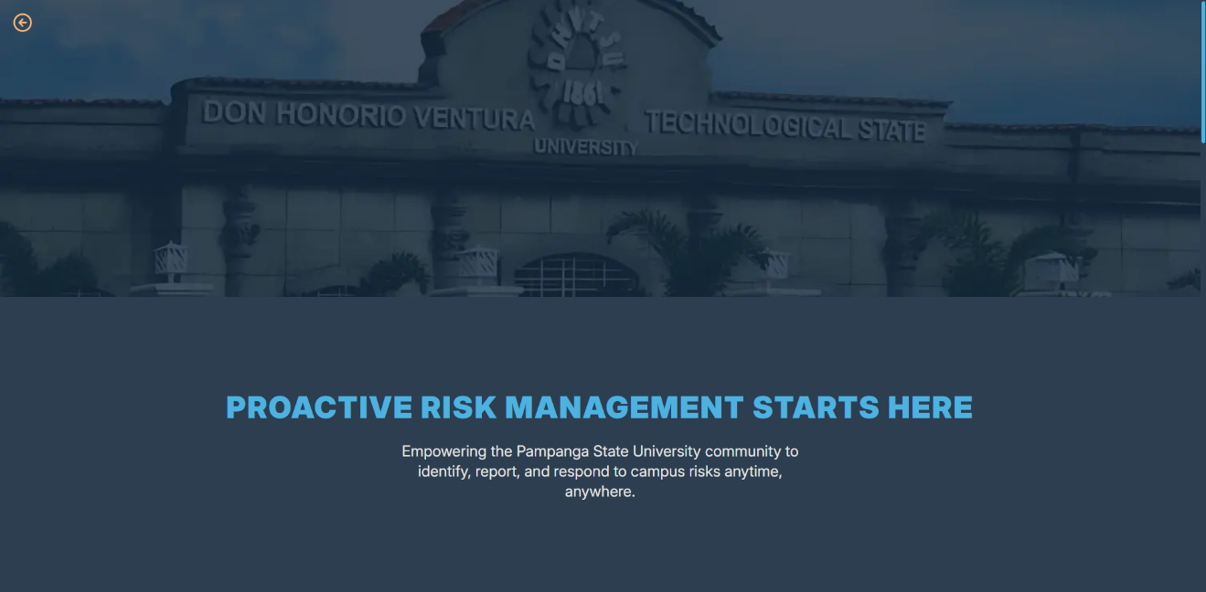
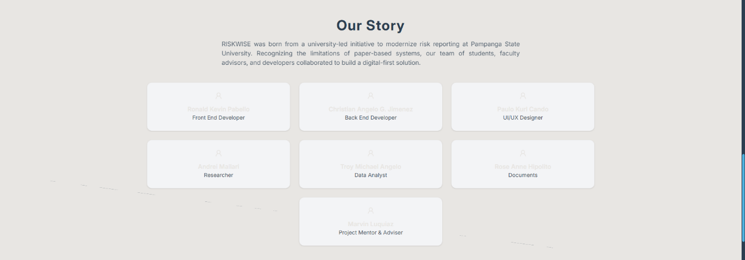

The front page serves as the system’s entry point and is designed to be visually appealing and informative. It features a background image of the university, creating a sense of institutional identity. At the center, the system name “RISKWISE” is prominently displayed along with a short sentence A “Get Started” button is positioned below the sentence, guiding users toward the login or sign-up process. The top navigation menu includes links to About, Features, Download, and Contact, ensuring easy access to essential information.

Figure 1A(3)nd 14.
Login and Sign-Up Page


The login interface is designed for simplicity and security. Users can enter their email and password, with an option to show or hide the password for convenience. Below the login fields, an alternative Google Sign-In option is provided to streamline authentication. A “Forgot Password” button allows users to recover their accounts. For every sign-up and password reset request, the system sends a confirmation email to validate the user’s identity before granting access.

Figure 15.
Admin Dashboard
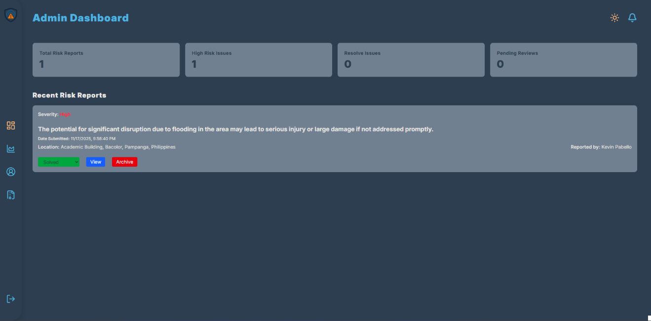

The admin dashboard displays a list of recent reports, each tagged with a severity level indicator. Reports with higher severity are automatically prioritized and appear at the top of the list, enabling administrators to address urgent issues promptly. The dashboard also provides quick access to report details, including location, timestamp, and attached photos.
Figure 16.
Analytics Page
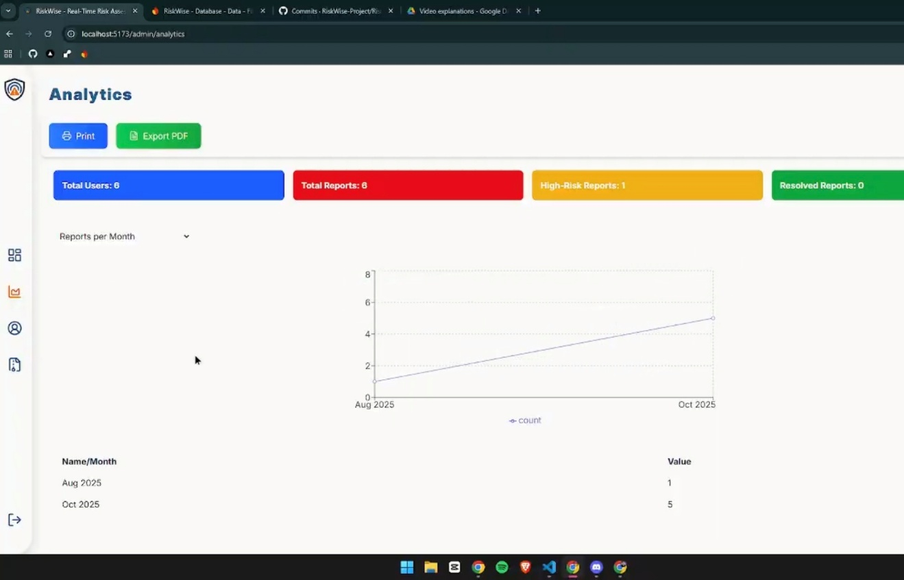

The analytics interface offers administrators a visual representation of incident data through charts and graphs. These analytics summarize trends such as the frequency of hazards, their categories, and locations within the campus. By analyzing these patterns, administrators can make data-driven decisions to implement preventive measures and allocate resources effectively.
Figure 17.
User Report Submission Page
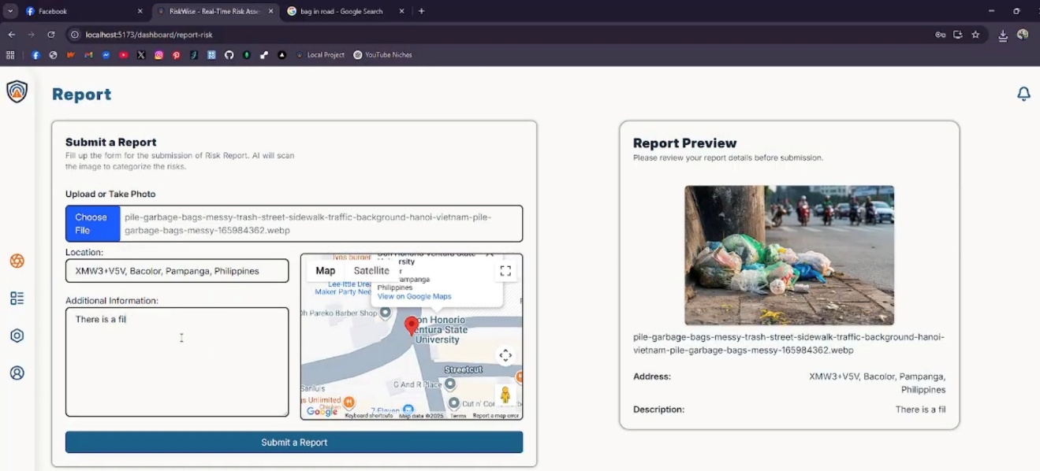

The report submission page allows users to describe the hazard, attach photos, and pin the exact location of the incident on a map. This geolocation feature ensures precise reporting, while the photo attachment provides visual evidence for verification. The interface also includes an auto-timestamp to maintain accurate records.

Figure 18.
Profile View
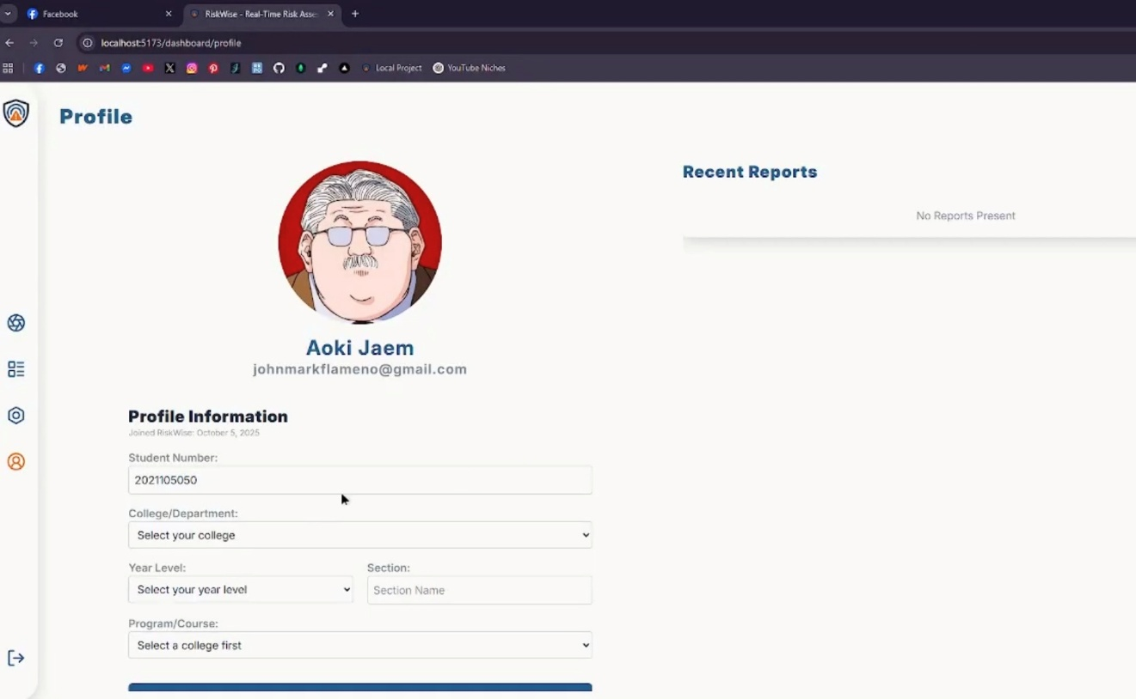

The profile view enables users to manage their personal information and account settings. Users can update their password with email validation, upload a profile picture, and view their recent reports, ensuring transparency and personalization.

Figure 19.
Notification Panel
The notification panel keeps users informed about the status and actions taken on their submitted reports. Notifications include updates such as report acknowledgment, status changes, and administrative remarks, ensuring transparency and engagement.
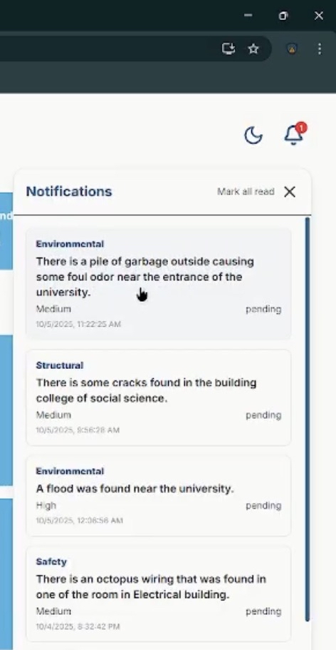

System Architecture
The system architecture consists of three primary components:
- React Frontend – Ensures a responsive and interactive user interface.
- Flask/Node Backend – Handles API requests and business logic.
- Firestore Cloud Database – Provides scalable and secure data storage.

Traditional vs. Digital Reporting
The transition from manual hazard reporting to a digital platform addresses several limitations of traditional methods, such as delayed communication, lack of data visibility, and inefficient record-keeping. Digital reporting enables real-time submission, automated data processing, and centralized monitoring, which collectively enhance institutional responsiveness.

Thematic Analysis of Feedback
User feedback revealed three major themes:
- Usability – Users found the system intuitive and easy to navigate.
- Data Visibility – Instant feedback upon submission improved user confidence.
- Faster Response – Administrators noted significant improvements in decision-making and hazard resolution times.
ISO/IEC 25010 Evaluation
The system was evaluated based on ISO/IEC 25010 quality characteristics, including functionality, reliability, usability, and security. Results indicate that RISKWISE achieved high ratings across these dimensions, validating its effectiveness as a campus safety solution.
Table 1.1
Functional Suitability
Functional Suitability | SD (1) | D (2) | A (3) | SA (4) | WM
The system provides all features required for hazard reporting
The information submitted is accurately processed and displayed
The system meets the safety reporting needs of the campus

Table 1.2
Performance efficiency
Performance Efficiency | SD(1) | D(2) | A(3) | SA(4) | WM
The system loads pages quickly.
The system responds efficiently to user actions
The system performs well when many users are active

Table 1.3
Compatibility
Compatibility | SD (1) | D(2) | A(3) | SA(4) | WM
The system works well on different browsers (Chrome, Firefox, Edge).
The system does not conflict with device configurations

Table 1.4
Usability
Usability | SD(1) | D(2) | A(3) | SA(4) | WM
The system is easy to learn for first-time users.
The interface is clear and understandable.
Icons , buttons and labels are clear and meaningful

Table 1.5
Reliability
Reliability | SD(1) | D(2) | A(3) | SA(4) | WM
The system runs without crashes or errors
Submitted reports are saved accurately and securely
The system consistently performs as expected

Table 1.6
Security
Security | SD(1) | D(2) | A(3) | SA(4) | WM
User data is protected from unauthorized access.

The login and authentication processes are secure

Table 1.7
Maintainability
Maintainability (for IT experts Only) | SD(1) | D(2) | A(3) | SA(4) | WM
The system can be updated or modified easily when requirements change.

The code structure supports efficient debugging

Table 1.8
Portability
Portability | SD(1) | D(2) | A(3) | SA(4) | WM
The system works properly when accessed on different computers.
The system can be deployed in other campuses with minimal changes

Summary of Findings
The implementation of RISKWISE successfully addressed the limitations of traditional reporting systems by providing:
- Real-time hazard reporting
- Geolocation tagging
- Photo documentation
- Push notifications
- Severity scoring
- Comprehensive admin dashboard
Supporting literature confirms that digital safety systems reduce risks and improve institutional responsiveness.

Conclusions
- RISKWISE is an effective and appropriate solution for campus hazard reporting.
- The system meets ISO/IEC 25010 quality standards.
- Users expressed high satisfaction due to its intuitive design and real-time capabilities.
- Real-time reporting enhanced reliability and administrative response time.
- Digital platforms like RISKWISE significantly improve safety communication and management.

Recommendations
System Enhancements
- Integrate advanced analytics and heat maps for hazard trend visualization.
- Implement AI-driven hazard prediction for proactive safety measures.
- Explore IoT or sensor integration for automated hazard detection.
Security Enhancements
- Introduce multi-factor authentication for added security.
- Conduct periodic vulnerability scans to maintain system integrity.
User Interface Improvements
- Enhance mobile responsiveness for better accessibility.
Research Recommendations
- Expand system deployment across multiple campuses.
- Conduct long-term studies to measure the impact on institutional safety.

CHAPTER V
SUMMARY, CONCLUSION AND RECOMMENDATIONS
Summary of the Study
This research focused on the design, development, and evaluation of RISKWISE, a web-based hazard reporting system intended to improve campus safety and streamline communication between students, staff, and administrators. The system was developed using modern web technologies, including React for the frontend, Flask/Node.js for backend services, and Firestore for real-time cloud data storage.
The primary objectives of the study were:
- To create a platform that enables real-time hazard reporting with geolocation tagging and photo documentation.
- To provide administrators with a centralized dashboard for monitoring reports, prioritizing hazards based on severity, and generating analytics for decision-making.
- To evaluate the system using the ISO/IEC 25010 software quality model, focusing on functionality, usability, reliability, and security.
The system was tested and validated through user feedback and expert evaluation. Results indicated that RISKWISE successfully addressed the limitations of traditional hazard reporting methods, such as delayed communication, lack of transparency, and inefficient record-keeping.
Detailed Findings
The study revealed several key findings:
- Enhanced Communication: The system facilitated instant hazard reporting and provided real-time notifications, improving the speed and clarity of communication between users and administrators.
- Improved Data Visibility: Users appreciated the ability to track the status of their reports and receive timely updates, which increased trust and engagement.
- Administrative Efficiency: The dashboard and analytics tools enabled administrators to prioritize hazards, allocate resources effectively, and identify recurring issues through trend analysis.
- High Usability: Based on user feedback, the interface was rated as intuitive and easy to navigate, reducing the learning curve for first-time users.
- Compliance with Quality Standards: Evaluation using ISO/IEC 25010 confirmed that the system met essential quality attributes, including functionality, reliability, and security.

Conclusions
From the findings, the following conclusions were drawn:
- Effectiveness of Digital Reporting: The transition from manual to digital hazard reporting significantly improved response times and institutional accountability.
- System Reliability and Security: The use of Firebase Authentication and email validation ensured secure access, while real-time data handling enhanced reliability.
- User Satisfaction: Positive feedback from users demonstrated that the system’s design and features aligned with their expectations and needs.
- Data-Driven Decision Making: The analytics module provided actionable insights, enabling administrators to implement preventive measures and improve campus safety strategies.
- Scalability and Adaptability: The system architecture supports future enhancements, making it suitable for deployment across multiple campuses or institutions.

Recommendations
A. Technical Enhancements
- Advanced Analytics: Incorporate heatmaps and predictive modeling to identify high-risk areas and forecast potential hazards.
- AI Integration: Implement machine learning algorithms for automated hazard classification and severity prediction.
- IoT Connectivity: Explore integration with sensors for real-time detection of environmental hazards such as gas leaks or fire risks.
B. Security Improvements
- Multi-Factor Authentication: Add an extra layer of security to prevent unauthorized access.
- Regular Vulnerability Assessments: Conduct periodic penetration testing and security audits to maintain system integrity.
C. User Interface and Experience
- Mobile Optimization: Enhance responsiveness and usability on mobile devices to cater to on-the-go reporting.
- Accessibility Features: Include options for visually impaired users and multilingual support for diverse campus populations.
D. Institutional and Research Recommendations
- Multi-Campus Deployment: Expand the system to other campuses or institutions to validate scalability and adaptability.
- Longitudinal Studies: Conduct extended research to measure the long-term impact of digital hazard reporting on campus safety.
- Policy Integration: Collaborate with campus safety committees to integrate the system into official safety protocols and emergency response plans.

Implications of the Study
The successful implementation of RISKWISE demonstrates the potential of digital platforms in transforming safety management practices. By leveraging real-time data, analytics, and user-friendly interfaces, institutions can foster a proactive safety culture and minimize risks. Furthermore, the study highlights the importance of aligning technological solutions with international quality standards to ensure reliability and user trust.

Future Directions
Future research should explore the integration of predictive analytics, IoT-based hazard detection, and AI-driven decision support systems. Additionally, expanding the system’s scope to include incident resolution tracking, resource allocation modules, and emergency communication features could further enhance its effectiveness.

