TITLE OF THE STUDY TITLE OF THE STUDY
TITLE OF THE STUDY

A Capstone
Presented to the Faculty of College of
Computing Studies
Pampanga State University

In Partial Fulfillment
of the Requirements for the Degree
Bachelor of Science in Information Technology

by:
Dela Cruz, Juan D.
Dela Cruz, Juan D.
Dela Cruz, Juan D.
Dela Cruz, Juan D.
Dela Cruz, Juan D.

December 2025

Chapter I
The Problem and its Background
Introduction
The Safety on campuses continues to be a major issue in the world of higher education. Studies have recently shown that there are thousands of accidents taking place in schools each year and that these accidents are usually caused by the neglect of hazards like improper installation of electrical wires, walking paths that are too slippery and fire places that are too close to flammable materials. Accidents like these pose a danger to students and staff, but they also interrupt the academic process, and thereby, cause a depletion of the institution's resources. Pampanga State University (formerly Don Honorio Ventura State University) is a place where every day, thousands of students, faculty, and non-teaching staff share the same space, and therefore the ever-present danger of both natural and artificial disasters cannot be completely avoided. Still, there are safety rules in place, but in fact many accidents and risks are not officially recognized or resolved. One of the causes for that is the old-fashioned reporting system, which mainly involves paper forms, manual submissions, or communication that is too slow. Such a system often ends up in delayed response times, reduced accountability, and accidents that could have been avoided. However, digital fixes such as Progressive Web Applications (PWAs) have the potential to revolutionize the whole idea of risk reporting and hazard management thanks to the rapid technological advancements. PWAs are associated with their fast loading time, the ability to work on different platforms, and synchronization of real-time data, all of which attributes make them suitable for emergency communication and monitoring of safety. Accordingly, the present research presents RISKWISE—a Progressive Web Application that is intended for Pampanga State University. The application permits the users to report risks through geotagging, incident narratives, and photographs. Submission of reports is possible even when there is no internet connection and such reports are automatically synced when the user is back online. An interactive dashboard is made accessible for the administrators and safety officers to categorize hazards, scale their seriousness, and take preventive actions.

Objective of the Study
To design and implement a Progressive Web Application that improves real-time risk assessment and hazard reporting within Pampanga State University.
objectives:
- To design a user-friendly reporting interface for submitting incidents with descriptions, geotagging, and photographic evidence.
- To implement a barcode scanning feature for easy product tracking.
- To develop an administrator dashboard for monitoring, classifying, and resolving reported hazards.
- To integrate real-time push notifications for safety updates and critical alerts.
- To evaluate the system’s performance and user satisfaction using the ISO/IEC 25010 software quality model, focusing on functionality, usability, reliability, and performance efficiency.

Significance of the Study
This study will benefit the following stakeholders:
University Administration & Safety Officers: Provides a streamlined monitoring tool for faster decision-making and accurate documentation.
Students, Faculty, and Staff: Empowers users to actively participate in campus safety by reporting risks conveniently.
Developers and IT Professionals: Serves as a practical case study for applying PWAs to institutional problem-solving.
Future Researchers: Offers a foundation for exploring AI-driven hazard detection, automated emergency response, or SMS-based safety alerts.
Academic Community: Demonstrates how digital platforms can be adapted to strengthen safety protocols across educational institutions.

Scope and Limitation
Scope
This study focuses on the design, development, and evaluation of RISKWISE within Pampanga State University. The system includes: Web-based submission of risk reports with geolocation and image attachments. Administrator dashboard for classifying and responding to incidents. Real-time functionalities using modern web technologies. Evaluation using ISO/IEC 25010 standards for quality assurance.

Limitation
The system will not include native mobile applications (Android/iOS). Real-time dashboard updates still require internet connectivity. Automated emergency response (e.g., notifying first responders) is beyond the project scope. Hazard evaluation relies on predefined models, not AI/ML. The system’s effectiveness depends on active user participation and accuracy of reports. IoT-based hazard detection hardware is excluded from this version.

Definition of Terms
Risk Assessment: Identifying, analyzing, and evaluating hazards to determine their impact and necessary response.
Incident Reporting: Documenting and communicating details of hazards or safety breaches.
Progressive Web App (PWA): A web application that behaves like a native app, and push notifications.
Geolocation: The process of determining a user’s or event’s physical location using GPS or similar technology.
Service Workers: Background scripts that enable PWAs to handle caching, and notifications.
IndexedDB: A browser-based database for storing large amounts of structured data.
Push Notification: A real-time alert sent to users even when the app is inactive. • ISO/IEC 25010: An international standard for evaluating software quality.
Chapter II
Review of Related Literature and Studies

Related Literature

Real-Time Risk Assessment and Institutional Safety
In educational institutions, safety is an operational priority. According to Hernandez and Zhao (2022), real-time risk detection systems significantly reduce injuries and property damage in large-scale environments like schools and universities. Their study demonstrated that digital systems allowed for the instant identification of hazardous conditions, followed by faster intervention from administrative units. This is relevant to RISKWISE because the system is specifically built to improve real-time awareness and action at DHVSU through instant digital risk reporting.
Kim, Lee, and Park (2023) investigated the role of real-time feedback systems in emergency situations and concluded that these systems enhanced response outcomes by shortening the decision-making time of safety officers. Although focused on hospitals, their findings validate RISKWISE’s core concept: an interactive system that allows safety administrators to respond quickly to incident reports submitted by students, staff, or faculty.
These studies support the idea that risk-related incidents if detected early can be resolved before escalating into full emergencies. RISKWISE contributes to this framework by enabling proactive rather than reactive safety management..

Digital Incident Reporting Tools and Systems
Ignaco (2019, cited in Blessing, 2024) developed a mobile app tailored for school-based incident reporting. Users were able to report broken equipment, unsafe facilities, or bullying incidents through mobile forms. The app’s usage led to a documented increase in reported cases, which informed policy improvements. This system mirrors RISKWISE in its user-focused design and its emphasis on visual and geolocation data. The success of this project demonstrates the effectiveness of digital platforms in collecting safety data from a distributed user base. Tan et al. (2020) evaluated a mobile app created for storm preparedness and risk communication. Their study revealed that visual reports (e.g., pictures of blocked drainage or damaged facilities) submitted by citizens resulted in faster municipal response. This strongly aligns with RISKWISE’s media attachment feature, which allows users to include photos of hazards on campus. Such visual evidence enhances report credibility and assists administrators in understanding the severity of the situation. Fazzini et al. (2022), while focused on mobile bug reporting in software development, highlighted the importance of capturing accurate, structured, and time-bound feedback through digital systems. The relevance of this finding to RISKWISE lies in the app’s emphasis on structured forms and timestamped reports, allowing better tracking of incident history and administrative accountability. These sources reinforce the value of digital platforms in improving the quality, frequency, and reliability of incident reports—core principles on which RISKWISE is built.

Use of Progressive Web Applications (PWAs)
Malhotra (2023) described PWAs as a breakthrough in web development, enabling cross-platform access and responsiveness without the high cost of native mobile app development. These apps load quickly, support offline interaction, and work on any device with a browser. This study directly supports RISKWISE’s design choice, as the platform is built as a PWA to ensure accessibility for all DHVSU community members regardless of device type. Fauzan et al. (2021) provided a literature review on PWA deployment in public systems and highlighted the importance of features like background syncing, service workers, and push notifications. These technologies are central to RISKWISE’s architecture: the app uses service workers and IndexedDB to support offline reporting, while push notifications keep users updated on risk advisories even when the app is inactive. Furthermore, Blessing (2024) found that users tend to adopt PWAs more readily when compared to traditional apps due to reduced storage requirements and faster access. This makes PWAs ideal for school environments where not all users may have access to high-end smartphones or large data plans. This insight justifies the system’s focus on lightweight, browser-based operation. These findings validate the technological choice behind RISKWISE and show that PWAs are an appropriate platform for a scalable, maintainable university-wide system.

Geolocation and Mapping in Risk Management
Lin, Yang, and Stack (2022) conducted a study on geolocation use in disaster response systems. They found that digital tools with geolocation capabilities improved the accuracy and response time of responders by pinpointing exact hazard locations. RISKWISE incorporates this by attaching geolocation metadata to every user report, enabling DHVSU safety personnel to identify problem areas faster.
Navarro de Corcuera et al. (2022) analyzed various mobile apps used in disaster mitigation. Their results suggested that location-based features, when combined with timestamped logs and photos, enhanced the traceability of incidents and streamlined emergency procedures. This supports the concept behind RISKWISE’s geotagged photo documentation, which serves both as real-time intelligence and a digital log of recurring safety issues across the university campus.
These studies affirm the importance of integrating location data into risk management systems and justify the inclusion of such features in the RISKWISE system.

Related Studies
iReport App (2021)
iReport is a university-based mobile app launched in 2021 that allows students to report broken facilities or misconduct. The system includes photo evidence and location tagging. Although iReport is Android-only, it laid the foundation for mobile incident reporting in academic settings. RISKWISE improves upon iReport by being a PWA, accessible via any browser and functional even without internet connectivity
.
SafeCampus Web Portal (2022)
Developed for disaster risk reduction in a state college, SafeCampus features web-based risk documentation, admin dashboards, and severity scoring. However, it lacks mobile compatibility and offline reporting. RISKWISE addresses these gaps by integrating mobile-first responsive design and offline-first architecture, making it more accessible and resilient
.
LGU RiskMap (2023)
RiskMap is a municipal application used by barangay officials to log flooding, fire, and structural damage reports. It has mapping and analytics tools similar to those in RISKWISE. However, RiskMap is heavily reliant on real-time internet connection. RISKWISE offers a strategic advantage with its offline reporting and syncing capability, crucial in low-connectivity campus zones.
IncidentEye (2021)
Another notable system is IncidentEye, a commercial mobile application developed by Reactec Ltd. In 2021. Designed for enterprise and lone-worker safety, IncidentEye includes advanced features such as GPS tracking, panic buttons, live location sharing, and real-time alert escalation. Its interface supports both mobile and web platforms, and it is primarily used in professional environments where real-time monitoring of personnel is critical. While IncidentEye is robust and effective in its intended domain, it is tailored for corporate and industrial use cases, often requiring dedicated support teams and subscription-based access. In contrast, RISKWISE adapts some of the practical elements of IncidentEye, such as real-time alerting and geolocation, but simplifies the approach for a university environment. RISKWISE is intentionally designed to be user-friendly, cost-effective, and accessible to non-technical users such as students and faculty, without compromising on essential safety reporting capabilities.

eBayanihan App (2020)
The eBayanihan App, developed by the UP Resilience Institute in 2020, was another timely system deployed during the COVID-19 pandemic. It allowed users to report symptoms, crowding, and community-level hazards using a web-based interface that required no installation. The system included geolocation tracking, real-time submission, and data aggregation features that enabled health authorities to monitor and respond to pandemic risks efficiently. eBayanihan’s design focused on community-sourced data and rapid deployment across municipalities. This aligns with RISKWISE’s objective of gathering hazard information from a broad range of users, students, staff, and safety officers—to inform institutional safety strategies. While eBayanihan focused primarily on health risks, RISKWISE expands this idea by supporting a wider range of risk types, including infrastructure damage, electrical hazards, and unsafe campus conditions. Additionally, RISKWISE adds offline functionality and customizable scoring, features not present in eBayanihan but critical for resilience in varying connectivity environments.

System Technical Background
The focus of this study is to create an automated watering device with multiple sensor such as humidity sensor, temperature sensor and soil moisture sensor using Internet of Things (IoT) technology and a mobile application for seedlings producers and farmers. The goal is to develop a smart solution that allows producers to track and control the vital factors of humidity, temperature, and soil moisture necessary for the well-being and development of the seedlings.

Conceptual Framework
Evaluation
Input Process Output

“RiskWise: A web-based Hazard Reporting and Monitoring System for Pampanga State University”
Knowledge
Requirements:
Interview
Observation
Related Studies & Literature
Study of cloud -based system
Understading requirements for online reporting

SoftwareRequirement:
Front-End Framework
Backend Services
Cloud Database
Notification Service
Hosting Platform
Development tools

Hardware Requirements:
Laptop/PC
Smartphones, Tablet or desktop for testing
Campus wifi/internet
Gathering:
Conduct surveys
Identify system features
Analyze existing issues

System design:
Create DFD
Create Interface layout
Define workflow
Map out notification

System Development:
Develop Interface
Build Backend logic
Integrate data storage
Implement user authentication
Configure Push Notification

Testing:
Perform Debugging
Conduct usability testig
Administer ISO/IEC 25010

Refinement and Development:
Fully functional
Realtime submission
Admin Panel
Push Notification
Cloud based database
Improve workflow

Figure 1. Conceptual Framework
The conceptual framework illustrates the way in which the RiskWise Hazard Reporting System was developed using the essential inputs and transforming them into a functional output through a structured process. The inputs, that is, gathered requirements, technical tools, and user needs, form the basis of system planning. These inputs go through systematic procedures that consist of requirement analysis, system design, development, testing, and evaluation. The project subsequently yields the final output, which is a fully functional web-based hazard reporting system that enhances the reporting, monitoring, and managing of campus safety concerns. Thus, the IPO model clearly shows how each phase is crucial for the development of an efficient and quick-response safety reporting solution.

(Context of Barangay Information System)
Chapter III
Methodology
The methodology serves as the backbone of the entire study, guiding the researchers in a systematic, organized direction from conceptualization to evaluation. Considering the nature of the project, the development and assessment of a campus-wide hazard reporting Progressive Web Application (PWA) called RISKWISE, the researchers recognized the need for a methodological structure that would allow a balance between technical system development and academic rigor. The chapter presents the entire process used in creating, testing, and evaluating the system in a way that reflects realistic academic workflow rather than an idealized, overly polished one. Because hazard reporting involves human behavior, administrative procedures, and technical system implementation, the researchers found it appropriate to adopt a mixed-method approach. This allowed them to consider not only the experiences and perceptions of the users during interviews and initial requirement gathering but also the numerical assessment obtained through the ISO/IEC 25010 Software Quality Evaluation Survey. The actual development required a combination of software engineering methods and institutional feedback. Hence, the process naturally evolved into sequential and sometimes iterative stages.

Research Design
The researchers used a mixed-method descriptive developmental research design. This design was chosen because the study required both the creation of a technological solution and the evaluation of its effectiveness within an academic institution. The descriptive developmental aspect came into play during the conceptualization and development of RISKWISE. At the same time, quantitative and qualitative data complemented the evaluation of the system.
The qualitative part mainly involved interviews and informal conversations with students, faculty, administrative staff, and campus safety personnel. These discussions supplemented the team’s understanding of how hazard reporting currently works at the university, the issues typically encountered, and the expectations for a modernized system. These qualitative insights were not statistically treated but were used mainly as foundations for the system requirements.
The quantitative aspect focused on the evaluation of the system. Respondents rated the quality of RISKWISE using ISO/IEC 25010 dimensions through a structured Likert-scale questionnaire. The researchers then used these ratings to compute weighted means and overall quality indicators.
This quantitative evaluation was essential in determining whether the system met accepted levels of software quality, particularly in terms of Functionality, Usability, Performance Efficiency, Compatibility, Reliability, Security, Maintainability, and Portability.
This mixed approach was instrumental in ensuring that the developed system was grounded in real institutional needs while still meeting globally accepted standards of software quality.

Sample Size Determination and Sampling Method
Sample Size Determination
The sample size was calculated using Slovin’s formula with a 5% margin of error:
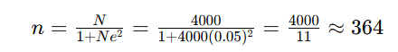

Thus, the ideal sample size is 364 respondents. However, due to time and availability constraints, only 150 respondents were able to participate.
Sampling Technique
- Simple Random Sampling was used to select end-users among residents and barangay staff.
- Purposive Sampling was used to select IT experts for the technical evaluation of the system.
Respondents of the Study
- End-users: Students, Faculty and Non-Faculty of Pampanga State University.
- IT Experts: Evaluated the technical performance and quality.
Data Gathering Procedure
- Qualitative Data Collection - Initial data were gathered through interviews and open-ended questionnaires to understand the issues in managing barangay records and services.
- Quantitative Data Collection - After system development, evaluation was conducted through a 4 Likert-scale questionnaire based on ISO/IEC 25010 Software Quality Assurance. The instrument was distributed to both End-users and IT experts.
System Evaluation Framework
The system was evaluated based on ISO/IEC 25010 with the following Criteria:
Functional Suitability | 1  SD | 2 D | 3 A | 4  SA
The system provides all features required for hazard reporting
The information submitted is accurately processed and displayed
The system meets the safety reporting needs of the campus

Performance Efficiency | 1  SD | 2 D | 3 A | 4  SA
The system loads pages quickly.
The system responds efficiently to user actions
The system performs well when many users are active

Compatibility | 1  SD | 2 D | 3 A | 4  SA
The system works well on different browsers (Chrome, Firefox, Edge).
The system does not conflict with device configurations

Usability | 1  SD | 2 D | 3 A | 4  SA
The system is easy to learn for first-time users.
The interface is clear and understandable.
Icons , buttons and labels are clear and meaningful

Reliability | 1  SD | 2 D | 3 A | 4  SA
The system runs without crashes or errors
Submitted reports are saved accurately and securely
The system consistently performs as expected

Security | 1  SD | 2 D | 3 A | 4  SA
User data is protected from unauthorized access.

The login and authentication processes are secure

Maintainability (For IT Expert only) | 1  SD | 2 D | 3 A | 4  SA
The system can be updated or modified easily when requirements change.

The code structure supports efficient debugging

Portability | 1  SD | 2 D | 3 A | 4  SA
The system works properly when accessed on different computers.
The system can be deployed in other campuses with minimal changes

4-Point Likert Scale
Scale | Verbal Interpretation
4 | Strongly Agree
3 | Agree
2 | Disagree
1 | Strongly Disagree

Statistical Treatment of Data
Quantitative Analysis
To analyze the evaluation results, the following computations were applied:
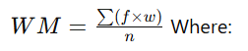
- Weighted Mean (WM) per question

- f: frequency of responses per scale
- w: weight assigned (4 for Strongly Agree to 1 for Strongly Disagree)
- n: total number of respondents
- Weighted Average Mean (WAM) per System Evaluation Category
Average of the weighted means of all items under a specific ISO/IEC 25010 category.
- Total Weighted Average Mean (TWAM) per Group of Respondent
Average of WAMs across all categories for each respondent group (End Users and IT Experts).
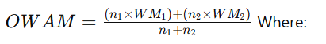
- Overall Weighted Average Mean (OWAM)

- n1, n2: number of respondents in each group
- WM1, WM2: total average means of each group
Interpretation of Results
To interpret the values obtained from WM, WAM, TWAM, and OWAM, the following scale will be used:
Scale Range | Verbal Interpretation | Description
3.26 – 4.00 | Strongly Agree | The system fully satisfies the requirement or criterion.
2.51 – 3.25 | Agree | The system satisfactorily meets the requirement or criterion.
1.76 – 2.50 | Disagree | The system partially meets the requirement or criterion.
1.00 – 1.75 | Strongly Disagree | The system does not meet the requirement or criterion at all.

This interpretation scale will guide the analysis of each item, ISO/IEC 25010 criteria, respondent group total, and the overall system evaluation.

Software Development Methodology
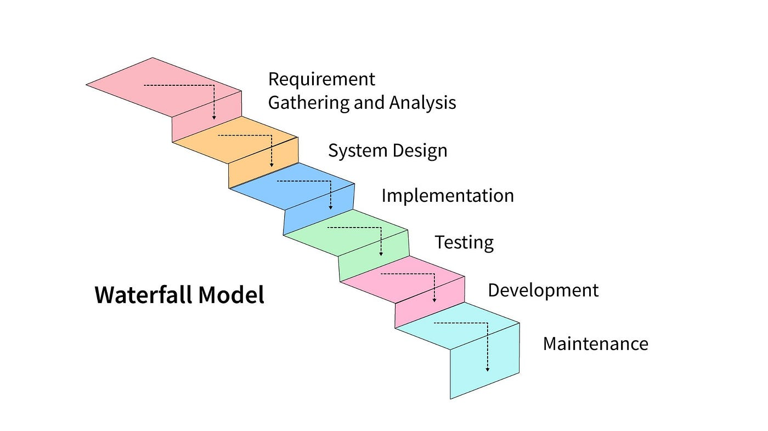This study used the Waterfall Model as the software development methodology, consisting of the following phases
Figure 1: Waterfall Methodology

1. Requirements Phase
This phase involved gathering detailed information from users and stakeholders. Interviews with students revealed that many hazards around the campus often went unreported because the process was unclear or inconvenient. Administrators and safety officers added that they did not have a central record of past incidents, making it difficult to track improvements or recurring safety risks. From these conversations, the researchers established the project’s critical requirements. Functionally, the system needed a hazard submission module that allowed users to report issues with descriptions, photos, and geolocation. It also needed an administrative module through which safety officers could classify, update, and respond to hazard reports. Non-functional requirements included usability, security (especially for user data), and compatibility across different devices and browsers.3. Implementation Phase
Developed the actual system based on the finalized designs and requirements using appropriate tools and technologies.
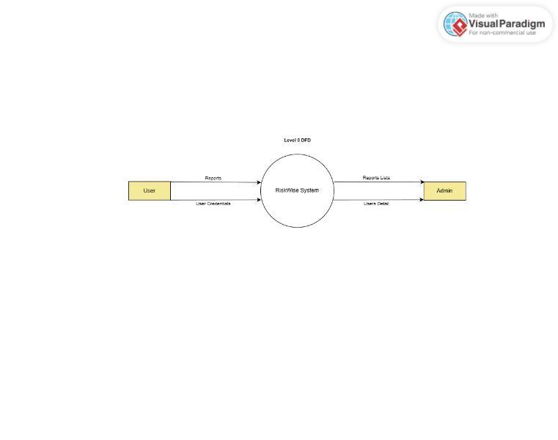

Figure 2.
Data Flow Diagram Level 0
The diagram of Level 0 DFD showcases the total information flow between the two major external actors, User and Admin, and the RiskWise System as a singular and unified action. At this point, the application is considered a single entity that takes input, maintains internal operations, and gives output. The Users give the system mainly two types of input: User Credentials for authentication and Reports for submitting hazards. The RiskWise System gets these inputs and carries out internal validation and processing. Once the system processes the data, it sends back Reports Lists and User Details to the Admin for review and management. Therefore, the Level 0 diagram indicates the high-level relationship where the system is placed like a middleman, accepting user-submitted hazards and authentication data, storing or processing this information, and then providing the necessary outputs to the admins who are authorized. No internal processes are represented here, which is natural at this level of abstraction. Its aim is to delineate system boundaries and the primary directions of data flow.
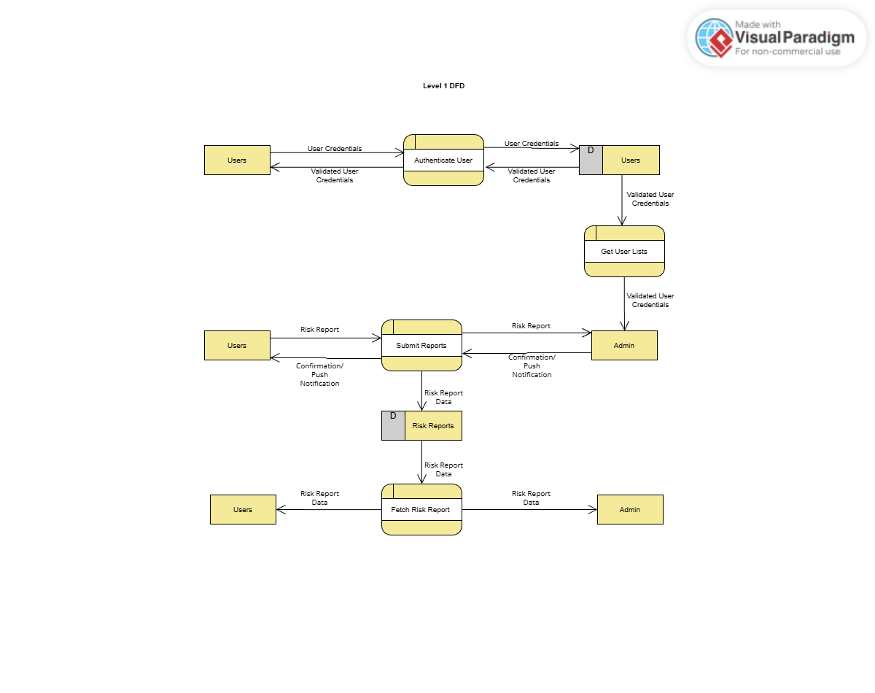
Figure 3
Data Flow Diagram Level 1
The Level 1 DFD, the primary diagram of the system, goes down to the process level depicting the entire operation of RiskWise in its strong areas like authentication, hazard reporting, data accessing, and user handling. The very first subprocess in the sequence is Authenticate User, which queries the user inputted credentials and compares them against the Users Data Store to determine if they are valid. It only lets the validated people move on and feedback is given to both the Users and Admin when it is appropriate. This provision assures that the system is strictly controlled and logged in only by persons with permission. The process of Submit Reports, the second major process after Authenticate User, which, according to the name, covers the submission of hazards. The users report through this the process their risks and the details are put into the Risk Reports Data Store. The whole action is followed by some kind of notification or alert, either by sending the confirming message or to the Admin through the fax machine, etc. at the same time the Admin gets a report copy for the purpose of review. This workflow is confirming that the system is mainly for the documentation of hazards with all necessary data. The Fetch Risk Report process is the extraction of data from the DB to be displayed to users in the form of their previously submitted reports. Admin also gets the same copies. This factor makes the whole thing open and tracking is done through this so that users can get the situation and the position of already reported hazards. In the end, the subprocess Get User Lists allows the administrator to acquire the lists of the users who have been authenticated. This would simplify the internal administration, e.g. by ascertaining the source of reports or verifying the identity of students or staff. To sum up, the Level 1 DFD illustrates the internal logic of RiskWise by showing how data gets authenticated, submitted, stored, retrieved, and managed across system actors. It provides a better understanding of the interlocking process.

4. Testing Phase
Before the system was released for evaluation, it underwent several testing activities. Unit testing was conducted on individual components of the system to ensure each feature behaved as expected. Integration testing checked compatibility between the front-end and back-end services. The team also performed usability testing by selecting several volunteer users to try the system with minimal instructions, this was done to simulate real-world conditions and check if users could navigate the system intuitively.
5. Deployment Phase
The development phase combined various technologies that worked together to deliver the system’s functionality. The front-end was built using React, chosen because its component-based approach allowed for cleaner and more predictable UI development. The backend logic was separated into two parts: a main API built with Node.js, and a microservice component (used mainly for internal handling and auxiliary operations) written in Flask. Data was stored and retrieved using Firestore, a cloud-hosted NoSQL database known for fast document-style storage, making it suitable for storing hazard reports that vary in content. Notifications, particularly alerts sent to users when administrators updated report statuses, were delivered through Firebase Cloud Messaging. Finally, the system was deployed using Salesforce, which provided reliable hosting and stable runtime behavior.The development phase combined various technologies that worked together to deliver the system’s functionality. The front-end was built using React, chosen because its component-based approach allowed for cleaner and more predictable UI development. The backend logic was separated into two parts: a main API built with Node.js, and a microservice component (used mainly for internal handling and auxiliary operations) written in Flask. Data was stored and retrieved using Firestore, a cloud-hosted NoSQL database known for fast document-style storage, making it suitable for storing hazard reports that vary in content. Notifications, particularly alerts sent to users when administrators updated report statuses, were delivered through Firebase Cloud Messaging. Finally, the system was deployed using Salesforce, which provided reliable hosting and stable runtime behavior.
6. Maintenance Phase
The maintenance stage guarantees the risk evaluation and management reporting system to work, and to be up to date with all the changes in user and institution necessities after its initial deployment. This stage calls for the examination of the system regularly for bugs, performance issues, or any other behavior that might be seen only when the system is accessed by more users under actual conditions. All the errors discovered are enfranchised to be gotten rid of through the installation of patches or by making minor adjustments of the code. The maintenance phase is also characterized by the surveillance of the system's interface for its quality of interaction, testing the correctness of the risk data stored in the cloud database and making sure that the notifications and status updates are working normally. Updating the system whenever new hazard categories, user roles, or reporting guidelines are introduced by the institution is one of the maintenance activities. Regular improvements are also carried out on the basis of feedback from end-users and administrators, including refining interface elements, improving loading performance, and enhancing data security. The system may also be subject to improvements to facilitate new features or integrations as the institution's safety needs change. Maintenance phase, in general, is a very important stage in the life cycle of the RiskWise system as it keeps the system reliable and effective throughout its operational life.

Chapter IV
Result and Discussion
This chapter presents the results of the study, which include the system design and the evaluation of the system based on ISO 25010 software quality standards. The discussion focuses on how the developed system meets the research objectives and addresses the problems identified in Chapter I.
System Flowcharts and Descriptions
To provide visual clarity on system processes, the researchers created 10 flowcharts representing the logical flow of core system functionalities. These include the admin dashboard, reporting process, offline mode, push notification setup, scoring module, and analytics. Each chart has been described in detail in this chapter.
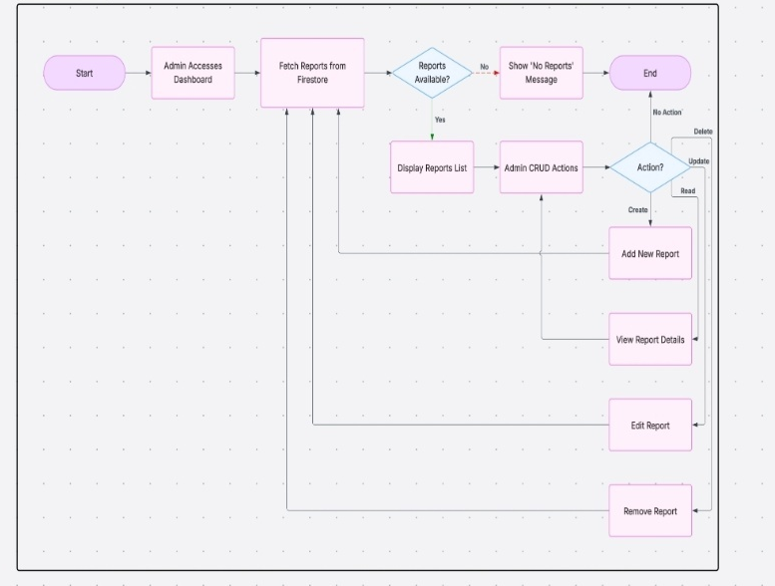
Figure 3
Admin Risk Dashboard Flowchart

The Figure 2 illustrates the Admin Risk Dashboard, where administrators begin by accessing the dashboard interface. The system fetches incident data from Firestore and checks if there are any existing reports. If reports are available, the system displays a list that enables administrators to perform CRUD operations such as viewing, editing, adding, or deleting reports. If no data is found, a “No Reports” message is shown. This feature empowers administrators to have centralized control and visibility over submitted incident data, ensuring that they can act promptly and appropriately in response to campus risks.
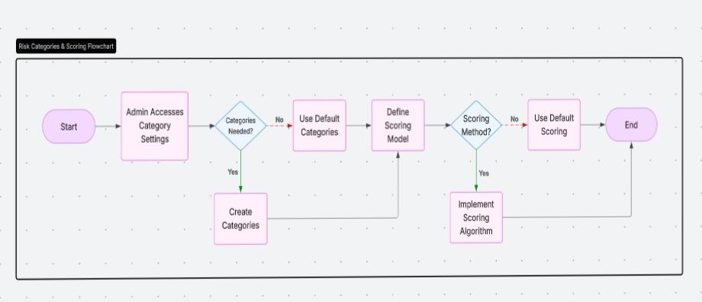
Figure 4
Risk Categories and Scoring Flowchart

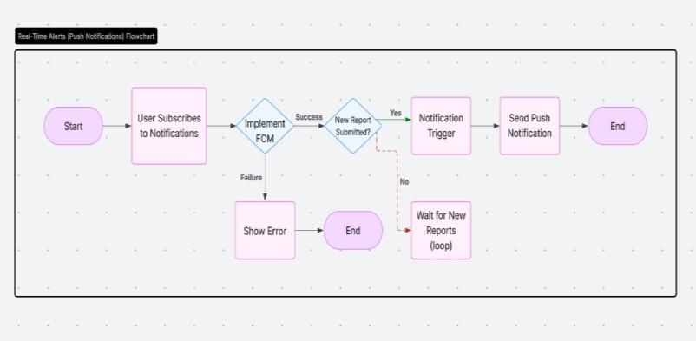
The figure 3 focuses on Risk Categories and Scoring, outlining how the system enables administrators to configure incident types and assign severity levels. When administrators access category settings, they can either use default categories or create customized ones based on institutional needs. They are then given the option to define a scoring model or apply a predefined one. If a custom scoring method is chosen, the administrator can implement a scoring algorithm to better classify risks. This capability provides flexible risk management tailored to the university’s specific requirements.

Figure 5
Real-time Alerts Flowchart

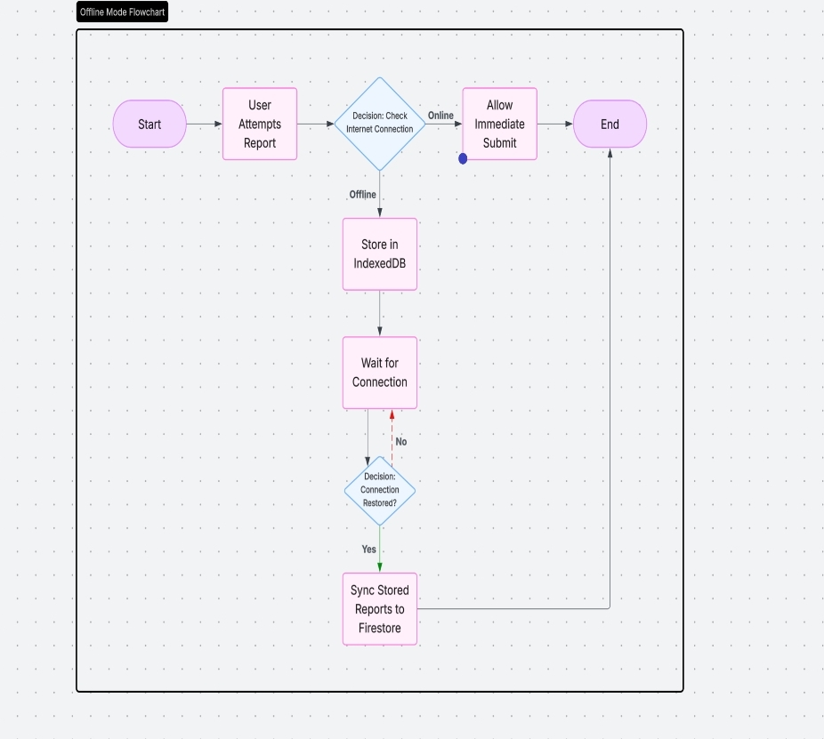
The figure 4 shows the flow of Real-Time Alerts through Push Notifications. Users can subscribe to receive push alerts, which are managed through Firebase Cloud Messaging (FCM). When a new report is submitted, the system checks if FCM is properly implemented. If successful, a notification trigger is activated and a push notification is sent to subscribers. If there is an error in the subscription or implementation process, the system displays an error message. This module ensures that users are informed in real time of new hazards or critical incidents on campus.
Figure 6
Offline Mode Flowchart

The figure 5 demonstrates the Offline Mode Logic, a critical feature in environments with unstable internet. When a user attempts to submit a report, the system checks connectivity. If the device is offline, the report is temporarily stored in IndexedDB. The system continuously checks for internet availability and, once reconnected, automatically syncs the locally stored report to Firestore. This ensures uninterrupted risk reporting, allowing users to submit reports at any time without data loss.
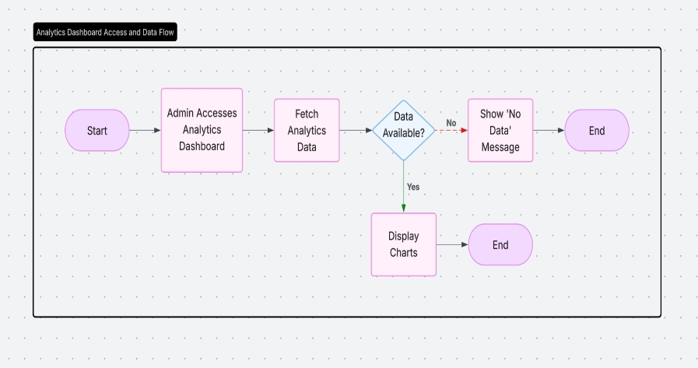
Figure 7
Analytics Dashboard Access and Data flow

The Figure 6 represents the Analytics Dashboard, which administrators use to analyze historical and current risk data. Upon accessing the dashboard, the system fetches analytics data and checks for availability. If data is present, charts are displayed; if not, a “No Data” message appears. This module equips administrators with insights for strategic safety planning and tracking of incident trends over time.

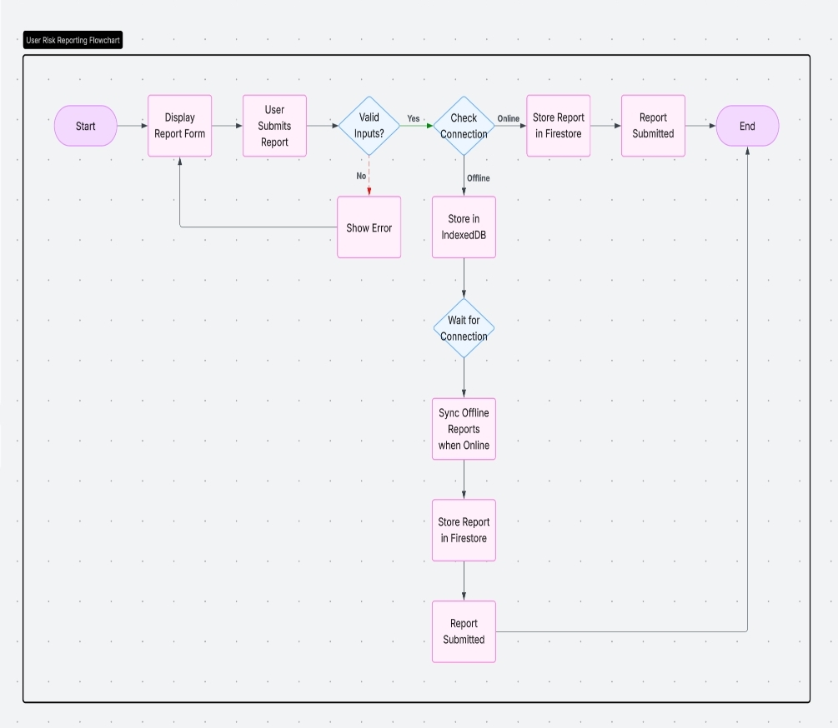
Figure 8
User Risk Reporting Flowchart

The ninth diagram depicts the User Risk Reporting Flow, where users fill out and submit the reporting form. The system validates user inputs and checks for internet connectivity. If online, the report is sent to Firestore. If offline, it is stored in IndexedDB and synchronized once the internet connection is restored. This logic is tightly integrated with the offline mode to guarantee consistent user experience and reliable submission flow.

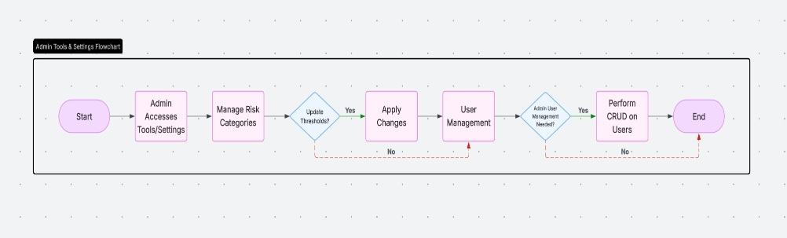
Figure 9
Admin Tolls and Settings Flowchart

The Figure 8 presents Admin Tools and Settings, showing how administrators manage advanced settings and user access. From the dashboard, administrators can update risk thresholds, manage categories, and perform user management tasks. If user management is required, the system allows administrators to perform CRUD operations on user accounts. This functionality ensures secure and flexible control over system administration.

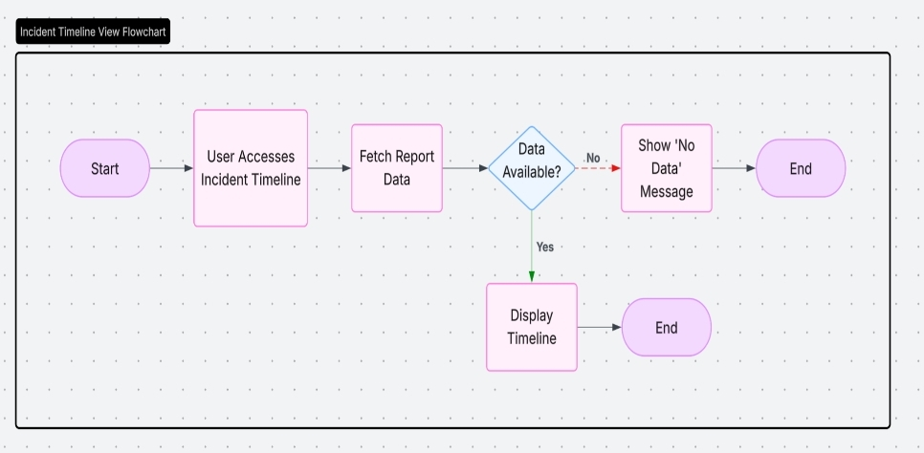
Figure 10
Incident Timeline View Flowchart

The figure 9 shows the Incident Timeline View, a feature that provides end-users with a chronological log of past risk incidents. When users access this view, the system retrieves report data and checks availability. If data is found, the timeline is displayed, offering transparency and historical context. If no data exists, a message is shown indicating the absence of records.
Together, these flowcharts validate the technical feasibility and logical consistency of the RISKWISE system. They reflect the modular, responsive, and user-centered design that underpins the platform, ensuring reliable performance whether online or offline. They also serve as visual documentation of how modern PWA technology is effectively applied in academic risk management systems.
Figure 10-13.
Front Page
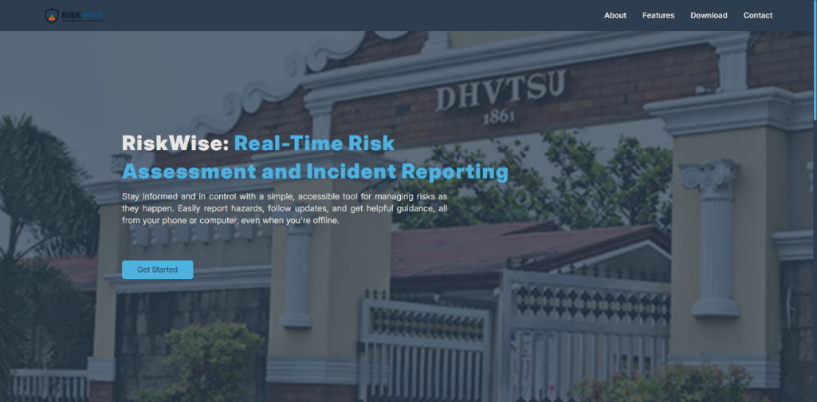
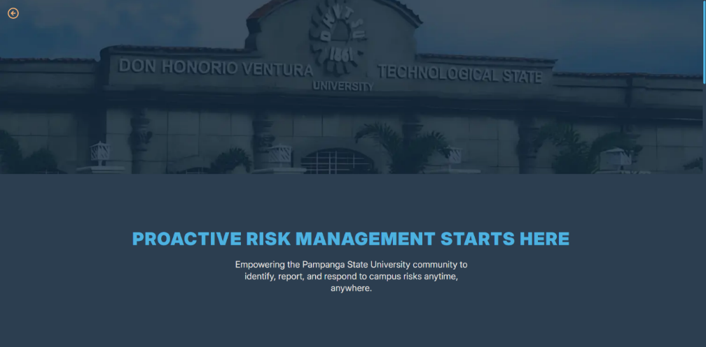
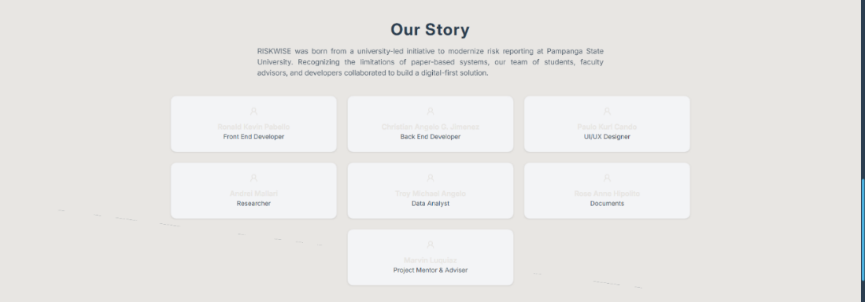
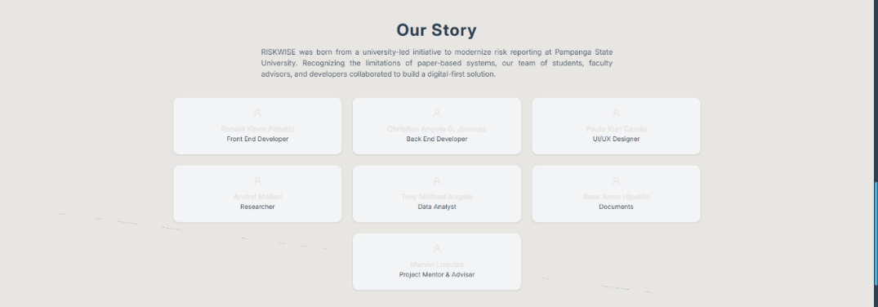

The front page serves as the system’s entry point and is designed to be visually appealing and informative. It features a background image of the university, creating a sense of institutional identity. At the center, the system name “RISKWISE” is prominently displayed along with a short sentence A “Get Started” button is positioned below the sentence, guiding users toward the login or sign-up process. The top navigation menu includes links to About, Features, Download, and Contact, ensuring easy access to essential information.

Figure 14 .
Login and Sign-Up Page


The login interface is designed for simplicity and security. Users can enter their email and password, with an option to show or hide the password for convenience. Below the login fields, an alternative Google Sign-In option is provided to streamline authentication. A “Forgot Password” button allows users to recover their accounts. For every sign-up and password reset request, the system sends a confirmation email to validate the user’s identity before granting access.

Figure 15.
Admin Dashboard
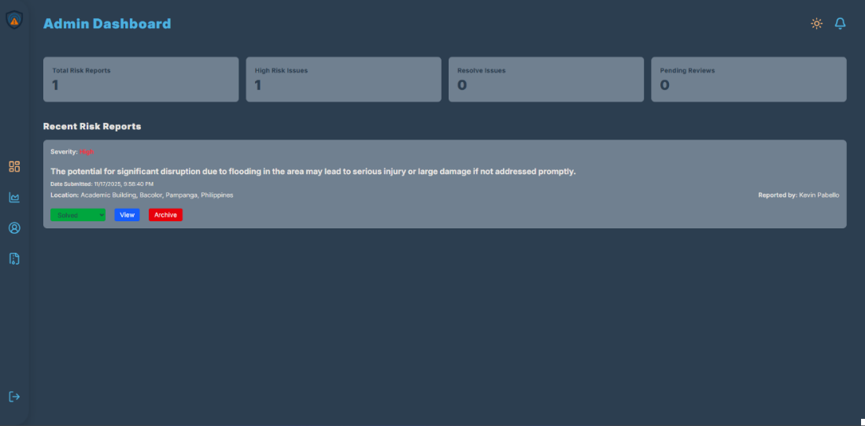

The admin dashboard displays a list of recent reports, each tagged with a severity level indicator. Reports with higher severity are automatically prioritized and appear at the top of the list, enabling administrators to address urgent issues promptly. The dashboard also provides quick access to report details, including location, timestamp, and attached photos.

Figure 16.
Analytics Page
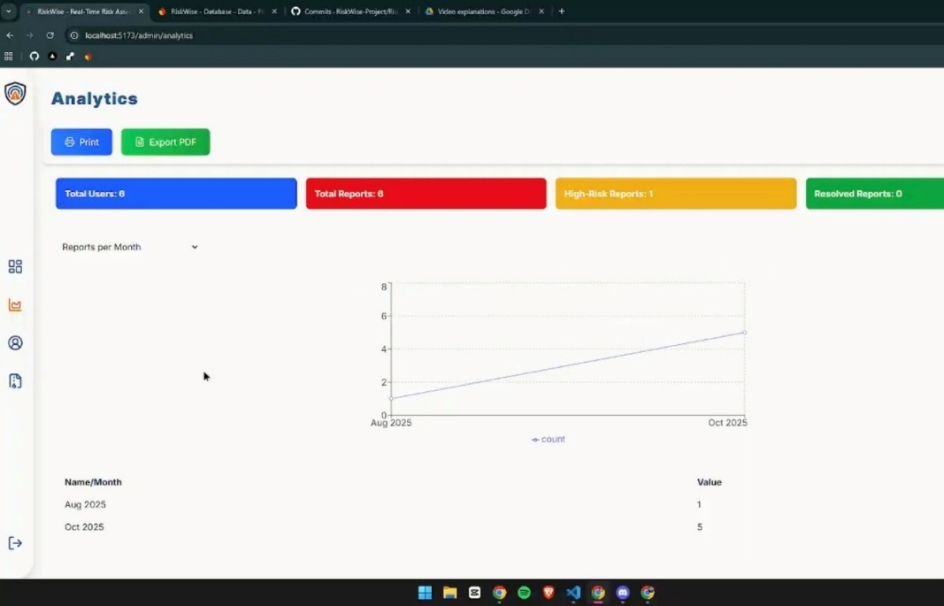

The analytics interface offers administrators a visual representation of incident data through charts and graphs. These analytics summarize trends such as the frequency of hazards, their categories, and locations within the campus. By analyzing these patterns, administrators can make data-driven decisions to implement preventive measures and allocate resources effectively.

Figure 17.
User Report Submission Page
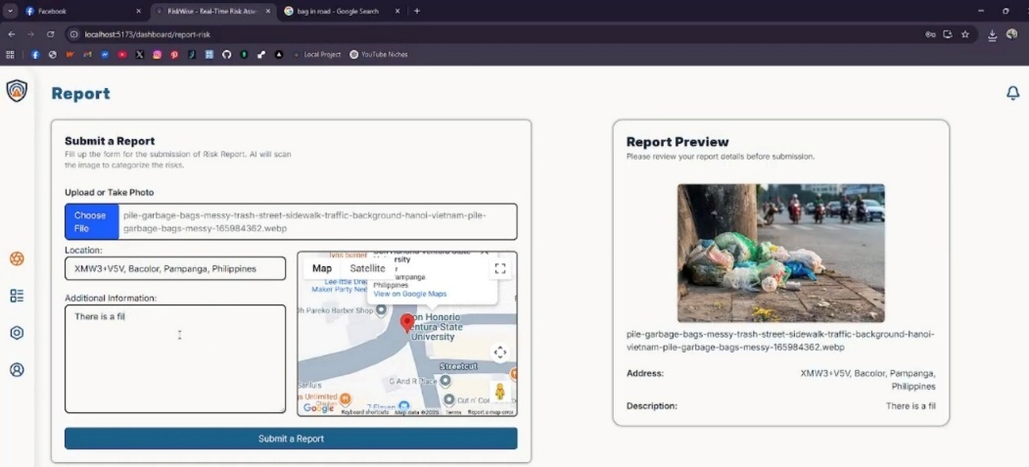

The report submission page allows users to describe the hazard, attach photos, and pin the exact location of the incident on a map. This geolocation feature ensures precise reporting, while the photo attachment provides visual evidence for verification. The interface also includes an auto-timestamp to maintain accurate records.

Figure 18.
Profile View
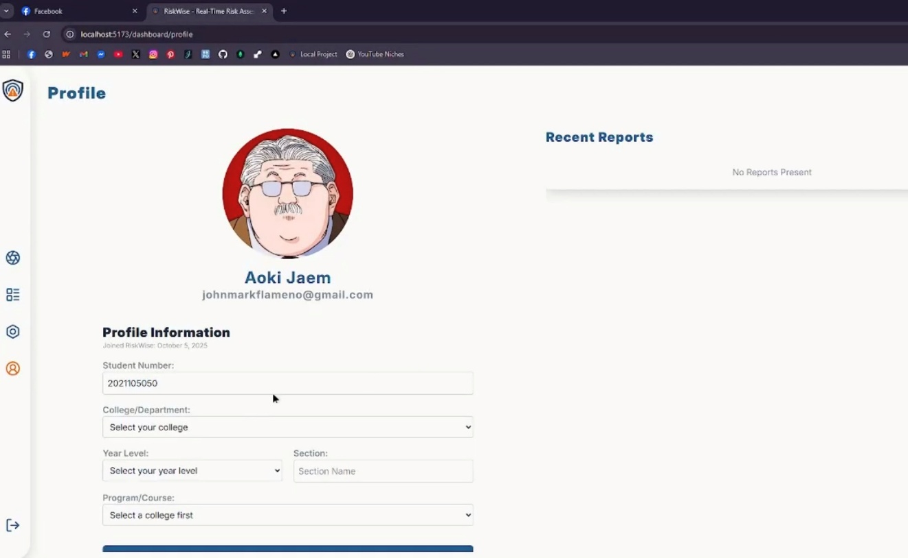

The profile view enables users to manage their personal information and account settings. Users can update their password with email validation, upload a profile picture, and view their recent reports, ensuring transparency and personalization.

Figure 19.
Notification Panel
The notification panel keeps users informed about the status and actions taken on their submitted reports. Notifications include updates such as report acknowledgment, status changes, and administrative remarks, ensuring transparency and engagement.
