CHAPTER III
METHODOLOGY OF THE STUDY

This chapter presents the research methodology applied in the development and evaluation of RISKWISE, a Progressive Web Application designed to enhance risk assessment and incident reporting within Pampanga State University (Former Don Honorio Ventura State University). It details the research design, development framework, research environment, participants, data gathering procedures, tools and technologies, evaluation process, and ethical considerations.

Research Design
The study employed a mixed-method design, combining qualitative and quantitative approaches.
- Qualitative Approach: Used during the requirements gathering phase through interviews and open-ended questionnaires with selected university stakeholders (students, faculty, staff, and safety officers). This allowed the researchers to capture detailed insights into existing risk reporting challenges and system requirements.
- Quantitative Approach: Applied in the system evaluation stage using the ISO/IEC 25010 software quality model. Respondents assessed the system’s functionality, usability, reliability, and performance efficiency through a Likert-scale survey.
This design was chosen to ensure both stakeholder needs (qualitative) and measurable system performance (quantitative) were addressed in the study.
Development Methodology
The Waterfall Model was adopted as the software development methodology. This sequential process allowed for systematic planning, development, and testing of RISKWISE.
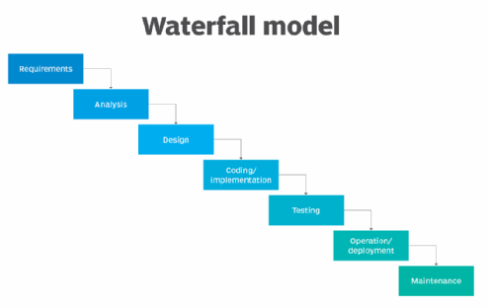
Figure 2.
Phases of Development
- Requirements Gathering and Analysis – Conducted interviews and surveys with end-users and safety officers to determine functional requirements such as geotagging, severity scoring, and administrator dashboards.
- System Design – Created diagrams including Entity-Relationship Diagram (ERD), Use Case Diagram, Data Flow Diagram (DFD), flowcharts, and interface mockups to define data structures, processes, and user navigation.
- Implementation (Coding) – Developed the system using:
3.1. Frontend: HTML5, CSS3, JavaScript (ReactJS)
3.2. Backend: Node.js with Express.js
3.3. Database: Firebase / MongoDB (cloud storage)
3.4. Notifications: Firebase Cloud Messaging (FCM)
- Testing – Conducted unit testing and system testing to ensure reliability, functionality, and responsiveness. Debugging was performed iteratively before evaluation.
- Deployment – The system was deployed on a live hosting environment, accessible via any browser, to allow real-time use and testing.
- Maintenance – Feedback and issues discovered during deployment were logged and addressed to improve usability and stability.

Research Environment and Locale
The study was conducted at Pampanga State University – Main Campus, Bacolor, Pampanga. The location was selected because of its large student population, multiple operational facilities, and existing risk management practices that could benefit from digitization.
Respondents and Sampling
Population
The population included students, faculty, administrative staff, and designated safety officers of Pampanga State University.
Sample Size Determination
The Slovin’s formula with a 5% margin of error was used to determine the minimum number of respondents required. Based on an estimated population of 4,000 individuals, the sample size was computed as:
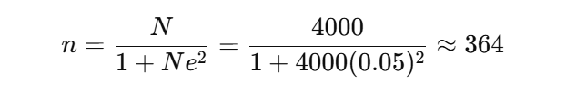
Thus, 364 respondents were ideally needed. However, due to availability and scheduling constraints, the actual number of participants was adjusted accordingly and documented during data collection.
Sampling Technique
- End-users (students, faculty, staff): Selected through simple random sampling.
- IT Experts: Selected through purposive sampling to evaluate the technical aspects of the system.

Research Instruments
Two instruments were used for data collection and evaluation:
- Interview Guide – Open-ended questions to gather requirements and identify pain points in the current risk reporting process.
- Survey Questionnaire (ISO/IEC 25010-based) – Used to evaluate system quality in the following attributes:
  - Functionality
  - Usability
  - Reliability
  - Performance Efficiency
Each criterion included a series of statements evaluated on a 5-point Likert scale ranging from 1 (Strongly Disagree) to 5 (Strongly Agree).

Data Gathering Procedures
The researchers followed these steps for data gathering:

- System Orientation – Respondents were briefed on the purpose of the study and given a guided tour of the system features.
- Simulated Risk Reporting – Users submitted mock incident reports through the RISKWISE application using real locations within the campus.
- Administrator Panel Testing – Selected staff members tested the admin dashboard to classify, respond to, and archive reports.
- Survey Administration – Respondents completed the ISO/IEC 25010-based questionnaire after testing.
- Data Compilation – Responses were tallied, encoded, and prepared for statistical analysis.
Tools and Technologies
  - Frontend: HTML5, CSS3, JavaScript (ReactJS)
  - Backend: Node.js with Express.js
  - Database: Firebase / MongoDB
  - Push Notifications: Firebase Cloud Messaging
  - Version Control: GitHub
  - Design Tools: Figma, Canva (UI mockups)

System Flowcharts and Descriptions
To provide visual clarity on system processes, the researchers created 10 flowcharts representing the logical flow of core system functionalities. These include the admin dashboard, reporting process, push notification setup, scoring module, and analytics. Each chart has been described in detail in this chapter.

Figure 2
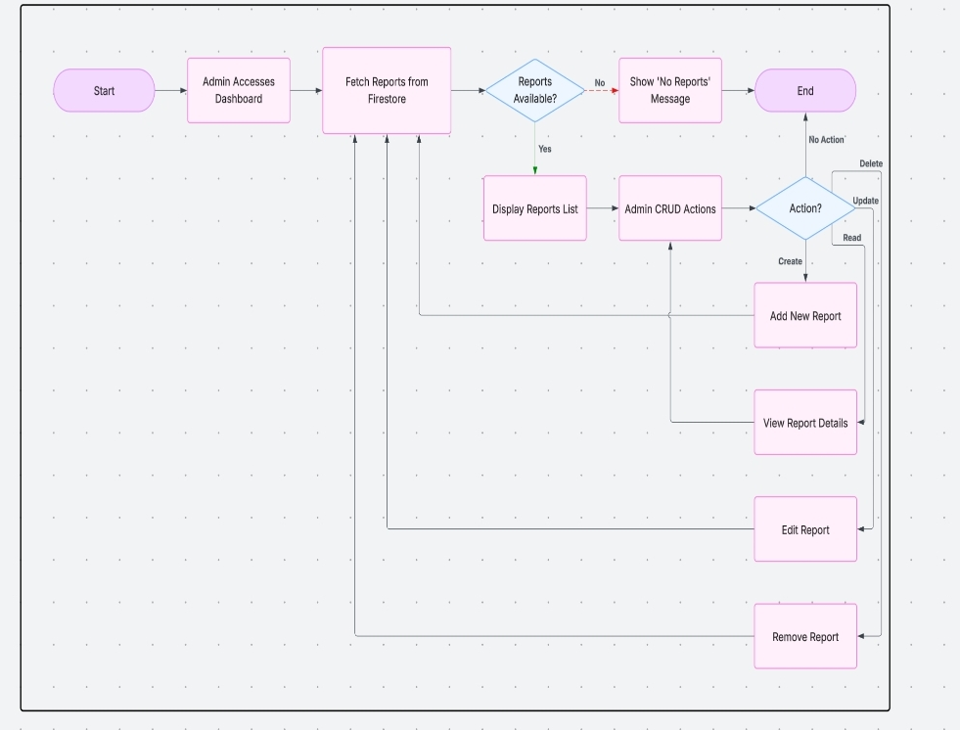
Admin Risk Dashboard Flowchart

The Figure 2 illustrates the Admin Risk Dashboard, where administrators begin by accessing the dashboard interface. The system fetches incident data from Firestore and checks if there are any existing reports. If reports are available, the system displays a list that enables administrators to perform CRUD operations such as viewing, editing, adding, or deleting reports. If no data is found, a “No Reports” message is shown. This feature empowers administrators to have centralized control and visibility over submitted incident data, ensuring that they can act promptly and appropriately in response to campus risks.

Figure 3
Risk Categories and Scoring Flowchart
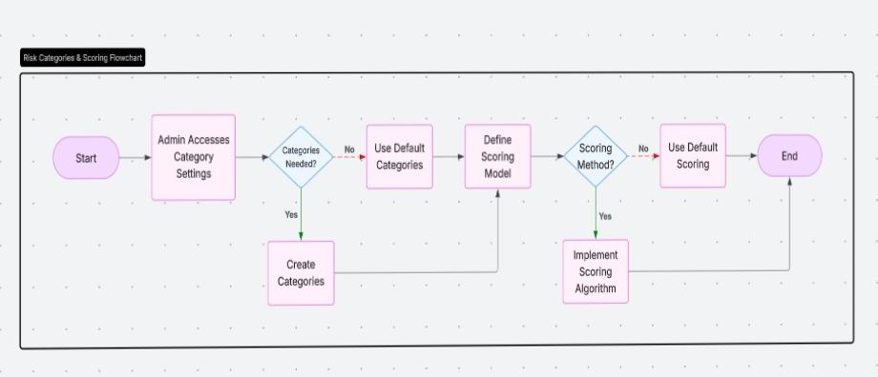
The figure 3 focuses on Risk Categories and Scoring, outlining how the system enables administrators to configure incident types and assign severity levels. When administrators access category settings, they can either use default categories or create customized ones based on institutional needs. They are then given the option to define a scoring model or apply a predefined one. If a custom scoring method is chosen, the administrator can implement a scoring algorithm to better classify risks. This capability provides flexible risk management tailored to the university’s specific requirements.
Figure 4
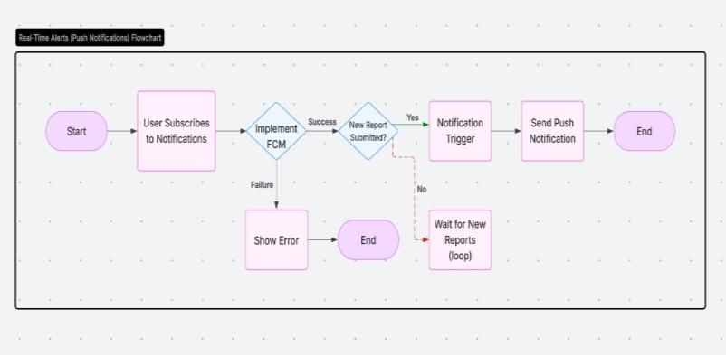
Real-time Alerts Flowchart

The figure 4 shows the flow of Real-Time Alerts through Push Notifications. Users can subscribe to receive push alerts, which are managed through Firebase Cloud Messaging (FCM). When a new report is submitted, the system checks if FCM is properly implemented. If successful, a notification trigger is activated and a push notification is sent to subscribers. If there is an error in the subscription or implementation process, the system displays an error message. This module ensures that users are informed in real time of new hazards or critical incidents on campus.

Figure 5
Analytics Dashboard Access and Data flow
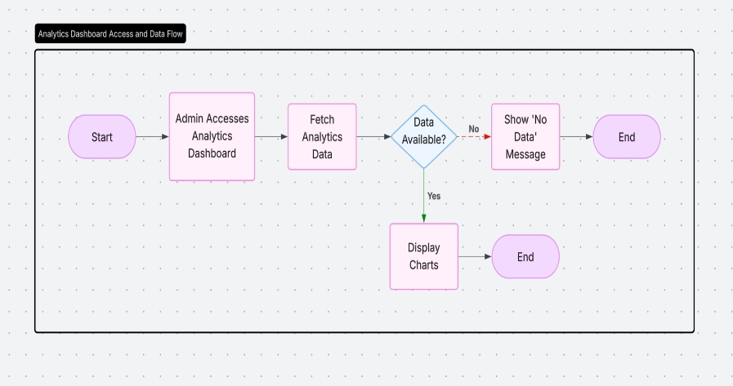

The Figure 6 represents the Analytics Dashboard, which administrators use to analyze historical and current risk data. Upon accessing the dashboard, the system fetches analytics data and checks for availability. If data is present, charts are displayed; if not, a “No Data” message appears. This module equips administrators with insights for strategic safety planning and tracking of incident trends over time.

Figure 6
User Risk Reporting Flowchart
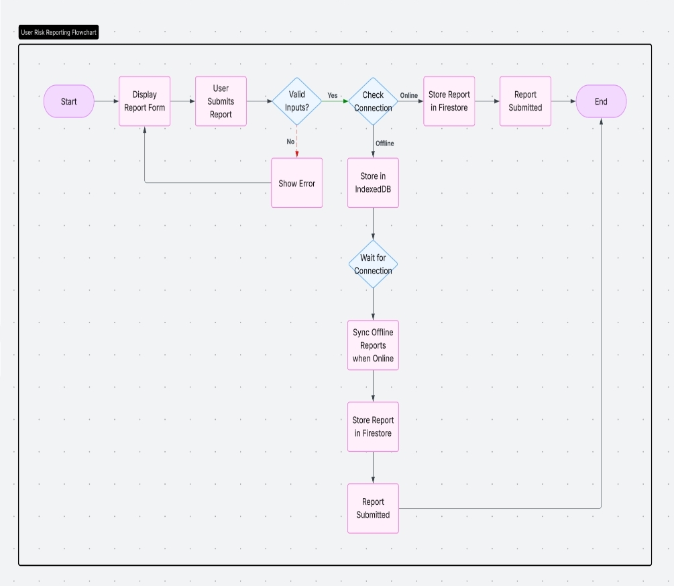
The ninth diagram depicts the User Risk Reporting Flow, where users fill out and submit the reporting form. The system validates user inputs and checks for internet connectivity. If online, the report is sent to Firestore.

Figure 7
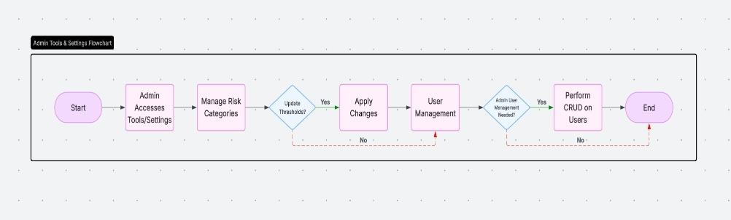
Admin Tolls and Settings Flowchart

The Figure 7 presents Admin Tools and Settings, showing how administrators manage advanced settings and user access. From the dashboard, administrators can update risk thresholds, manage categories, and perform user management tasks. If user management is required, the system allows administrators to perform CRUD operations on user accounts. This functionality ensures secure and flexible control over system administration.

Figure 8
Incident Timeline View Flowchart
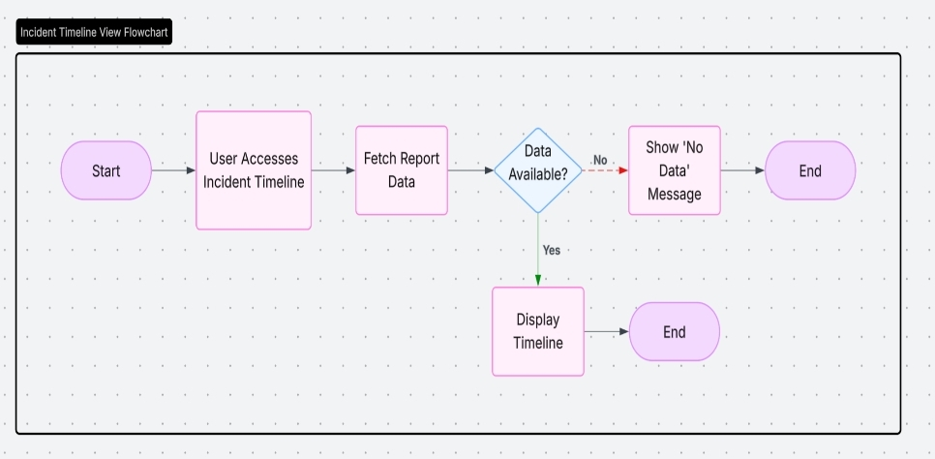
The figure 8 shows the Incident Timeline View, a feature that provides end-users with a chronological log of past risk incidents. When users access this view, the system retrieves report data and checks availability. If data is found, the timeline is displayed, offering transparency and historical context. If no data exists, a message is shown indicating the absence of records.
Together, these flowcharts validate the technical feasibility and logical consistency of the RISKWISE system. They reflect the modular, responsive, and user-centered design that underpins the platform, ensuring reliable performance whether online. They also serve as visual documentation of how modern PWA technology is effectively applied in academic risk management systems.
Data Analysis
Responses from the ISO/IEC 25010-based survey were analyzed using weighted mean per quality attribute.
Formula:
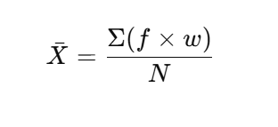
Where:
- f = frequency of responses per scale
- w = weighted score (1–4)
- N = total number of responses
Interpretation Guide:
- 3.25 – 4.00 → Strongly Agree
- 2.50 – 3.24 → Agree
- 1.75 – 2.49 → Disagree
- 1.00 – 1.74 → Strongly Disagree

Ethical Considerations
The researchers ensured that ethical research principles were observed throughout the study. Informed consent was obtained from all participants. No personal data or identifiable information was collected, and all reports used in testing were simulated to avoid any risk. Participants were assured that their responses would be kept confidential and used solely for academic purposes.

