- Functional Specification

- Functional Description

The Internal Projects Cockpit provides a centralized application for users to request to create, modify, capitalize, and close projects and their associated WBS elements, ensuring compliance with organizational governance and financial reporting standards. It enables efficient handling of key project management activities while maintaining full integration with SAP financial and controlling modules.

The following functions are covered within the scope of this specification:

A. Create New Project – Initiate a new project and establish its WBS hierarchy.
B. Modify Project – Add new or update existing WBS elements, including budget changes.
B1. Request CAR Project for Approved ESR – Initiate A CAR project based on approved ESR
B2. Budget Distribution and Reporting Information
B3. Critical Changes – Define and control high-impact structural or financial modification to the project.
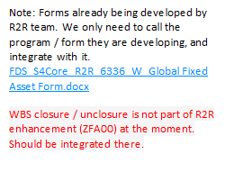C. Partially Capitalize Project (NEW) – Enable partial capitalization of project costs prior to final completion.
D. Close WBS (NEW) – Support the closing process for WBS elements.
D1. Capitalize Project
D2. Write-off (Settlement for ESRs not progressing to projects)
D3. Close WBS (CLSD)
E. Unclose WBS (NEW) – Allow authorized users to reopen closed WBS elements when justified.
F. Edit Saved Requests – Retrieve and continue previously saved project or WBS creation requests.
G. WBS Request Reporting – Provide analytical and operational reporting for WBS-related activities.

IMPORTANT NOTES:
- The functional specification design will be split in three parts:
- Part 1: WBS Creation and WBS reporting
- Part 2: WBS Change
- Part 3: WBS Capitalization and closure/unclosure

During the design of each part, the high level description of the other parts will only be indicative, and may change later on, during the actual detailed design.

- This enhancement may depend on IM data that are not yet available at the moment. In this case, the field(s) whose data are supposed to be read from IM but are not available should be made temporarily editable, so that they can be entered manually in ZCJ00 to proceed with the process.

Pre-requisite for Program Functionality

To ensure the program functions as intended, the following pre-requisites should be considered.

- The below required master data should exist:
- Investment Programs and Positions – the functionality described on this functional document relies on the existence of IM programs. It is where the Project templates and Project Profile will depend on. It is also key to identifying the available budget to be distributed to the WBS level.
- Standard Project Templates - this will aid the creation of operational projects by copying most of the Organizational and basic fields for the Project.

- Creation of Number Range Object for Request Number (ZREQ_NUM) to be generated during submission of request. Below is the summary of steps to configure the number range.
- Go to transaction SNRO.
- Enter and create the object name ZCJ00_REQN
- Create the interval (01 from 0000000001 to 9999999999)

Number Range Object: ZCJ00_REQN - ZCJ00 Request Number

- The following custom table will be used to store entries created throughout the execution of the program itself and will also be referenced in different functionalities and validations across the program.

- ZTB_A2R_CONFTAB1 “ZCJ00 Configuration Table 1”- This table is proposed to store the default assignment of Project Profile and Project Template by different combinations of Investment Reasons and Stages which will be referenced by the program during execution.

The table is to be created as available for user maintenance via transaction code SM30. It must have an authorization group to ensure that only authorized users are allowed to update it.

This table will serve as the repository for storing the following values:

Key Field Indicator | Technical Field Name | Data Type | Length | Field Description | Data Element | Check Table | Population Method
x | MANDT | CLNT | 3 | Client | MANDT | T000 | System-generated (SAP standard field)
x | IZWEK | CHAR | 2 | Investment Reason | IZWEK | T087I | User maintenance via transaction code SM30
x | Z***** | - | - | Stage (from IM) | - | - | Custom field to be developed by A2D team
 | PROFL | CHAR | 7 | Project Profile | PROFIDPROJ | TCJ41 | User maintenance via transaction code SM30
 | PSPID | CHAR | 24 | Project Template | PS_SPDID | PROJS | User maintenance via transaction code SM30
Table 4.1.1 – ZTB_A2R_CONFTAB1 Table Structure

Below is an example of how the table ZTB_A2R_CONFTAB1 will typically be populated:

Investment Reason (from IM) (Key)​ | Stage (from IM) (Key)​ | Project Profile​ | Template​
LS​ | Any​ | Capex​ | Lumpsum template​
Opex​ | Project​ | Opex​ | Opex template​
Opex​ | ESR​ | Opex​ | Opex ESR template​
* (BM, AM;GR,..)​ | Project​ | Capex​ | Capex template​
* (BM, AM;GR,..)​ | ESR​ | Capex​ | Capex ESR template​
Table 4.1.2 – Sample populated table for ZTB_A2R_CONFTAB1

- ZTB_A2R_REQTYPE – This table is designed to store the mapping between the landing screen’s field radio button (refer Figure 4.1.1 – Initial screen) and the corresponding technical field name (Z_Z_REQUEST_TYPE). This ensures that the program can accurately identify the selected request type and execute the appropriate backend process.
Technical Field NameRequest Type | On-Screen FieldRequest Type Description
A1 | Create Project
B1 | Add CAR
B2 | Non-critical change
B3 | Critical change
C1 | Partial Capitalization
D1 | Close WBS
E1 | Unclose WBS
F1 | Edit Request
G1 | WBS Request Reporting
Table 4.1.3 – Request Types

Key Field Indicator | Technical Field Name | Data Type | Length | Field Description
x | MANDT | CLNT | 3 | Client
x | Z_REQTYPE | CHAR | 2 | Request Type
x | Z_REQTYPE_DESC | CHAR | 40 | Request Type Description
Table 4.1.3 – Request Types Table Structure

- ZTB_A2R_WBSHDR – This table will store the Header Information of the request upon submission. The details of the table is documented below Table 4.1.5 – Field Mapping for Header Information (Screen 2).

- ZTB_A2R_WBSITEM – This table will store the WBS Element Information of the request upon submission. The details of the table is documented below Table 4.1.6 – Field Mapping for WBS Element Information (Screen 2)

Internal Projects Cockpit Entry Screen Overview (Screen 0)

The entry screen of the Internal Projects Cockpit acts as the central hub for all Project-related activities. It provides users with a clear processing overview and quick navigation to key functions through actions and status indicators.

The following is the mockup of initial screen. Please note that the items shown below are radio-buttons, users will only be able to select one at a time.

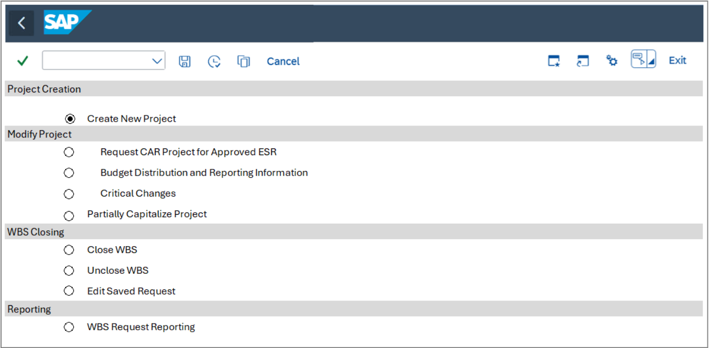
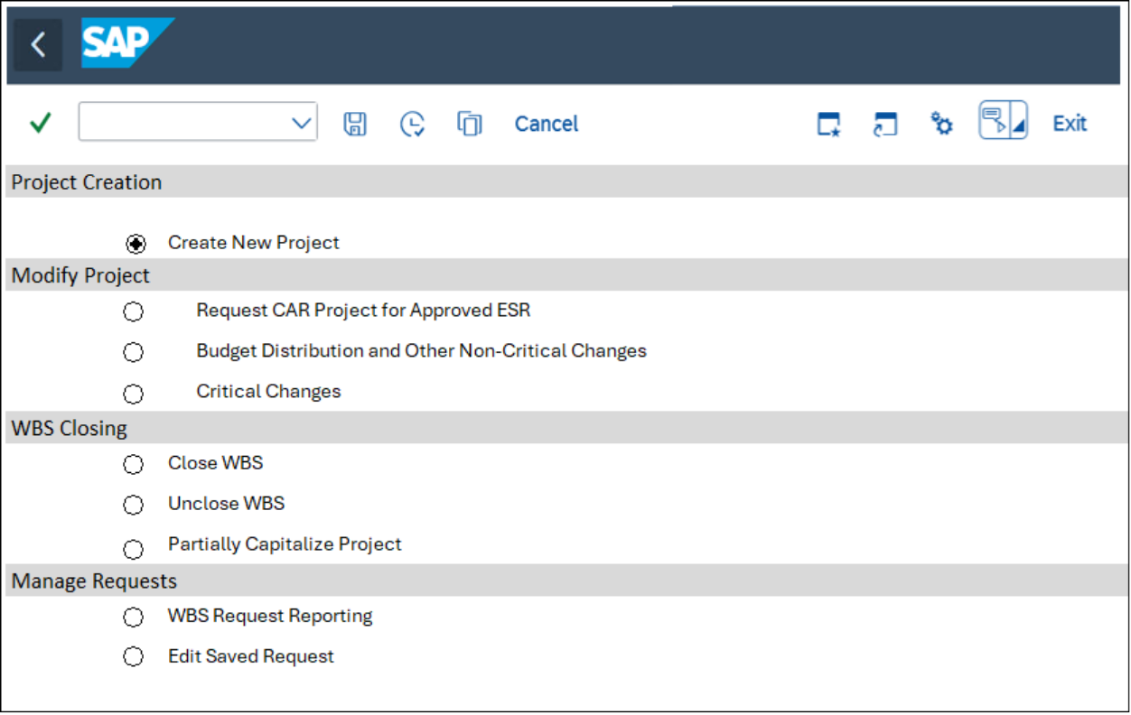
Figure 4.1.1 – Initial screen

Expected System Behavior:
- Initial Screen Behavior:
- The initial screen displays a list of options for users to select a request type.
- Upon selection, the program retrieves the corresponding Z_REQUEST_TYPE value from the ZTB_A2R_REQTYPE table to determine the appropriate screen or process to execute.

- Backend Processing:
- The Z_REQUEST_TYPE field is used to pass the selected option to backend tables for further processing.
- This field is not visible to the user and is solely utilized for backend operations.

- The Execute button is present on the initial screen. The next screen will be shown when this is clicked.

- Request Type A1– Create New Project

The following section describes the screens and the processes for Request Type A1–Create New Project. Below is the proposed mockup screen to be displayed when user selects the Request Type A1– Create New Project.
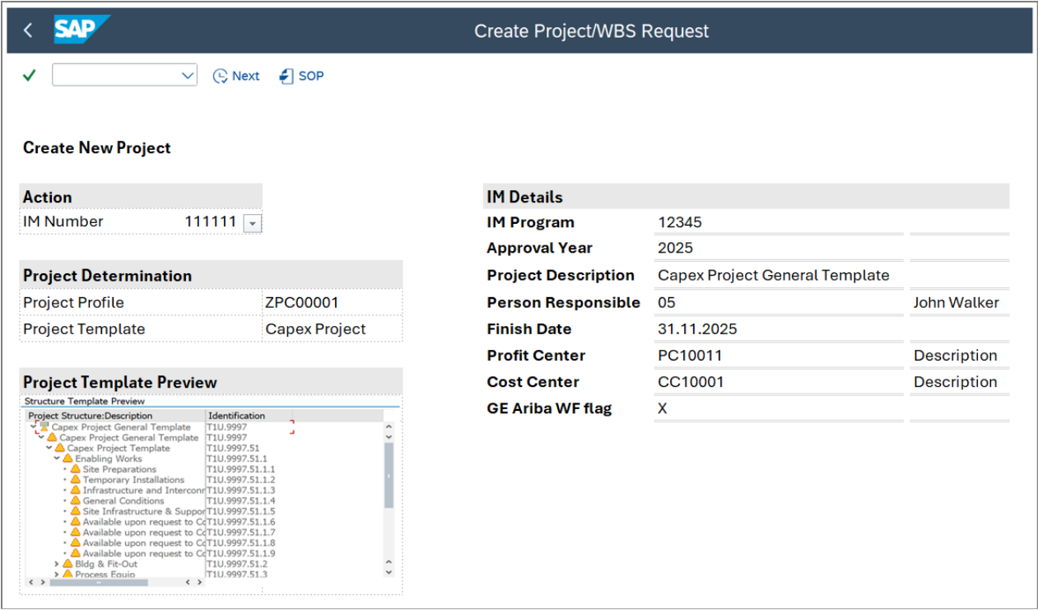
Figure 4.1.2 – Create New Project Screen 1

The fields are mapped as follows:
Field name | Tech Field Name | Table | Check Table | Primary | Data Type | Data Element | Population Method of Default Values | Editable | Mandatory
IM Program Position | POSNR | IMPR | - | X | NUMC | IM_POSNR | Selected by user | Yes | Yes
Project Profile | PROFL | PROJS | TCJ41 | - | CHAR | PROFIDPROJ | 1.From the user-selected IM Program Position (IMPR-POSNR), get Investment Reason (IMPR-IZWEK) and stage [Clarify where is the stage going to be read from].  2. Using Investment Reason (IMPR-IZWEK), get ZTB_A2R_CONFTAB1 -PROFL | Yes | Yes
Project Template​ | PSPID | PROJS | - | - | CHAR | PS_SPSID & PS_SPDID | 1.From the user-selected IM Program Position (IMPR-PSPNR), get Investment Reason (IMPR-IZWEK) and stage [Clarify where is the stage going to be read from].  2. Using Investment Reason (IMPR-IZWEK), get ZTB_A2R_CONFTAB1 -POSID. | Yes | Yes
Project Template​ Preview | - | - | - | - | - | - | Create a preview based on CJ93 as a sample using selected Project Template PROJS-PSPID.  - Get Project Template PROJS- PSPID.  - Get the WBS hierarchy of this template in PRPSS using PROJS-PSPID.  - Display the preview in heirarchycal view including Project Template ID (PROJS-PSPID) and Description PROJS-POST1, PRPSS-POST1  *Developer may refer to the same mechanism used in ECC for reference*
IM Program | PRNAM | IMPR | IMPT | - | CHAR | IM_PRNAM | Get IMPR-POSID where user selected IM Program Position (IMPR-POSNR) = IMPR-POSNR | No
Approval Year | GJAHR | IMPR | - | - | NUMC | IM_GNJHR | Get IMPR-GJAHR where user selected IM Program Position (IMPR-POSNR) = IMPR-POSNR | No
Project Description​ | POST1 | PROJS | - | - | CHAR | PS_POST1 | Manual input from user | Yes | Yes
Person Responsible​ | VERNA | TCJ04 | - | - | CHAR | PS_VERNA | Manual input from user | Yes | Yes
Finish Date​ | PLSEZ | PROJS | - | - | DATS | PS_PLSEZ_CHG | For Lumpsum Project Template, it automatically populates by last day of current year. E.g. 31.12.2025 | Conditional:  Yes for Projects/ESR  No for Lumpsum | Yes
Profit center​ | PRCTR | IMPR | CEPC | - | CHAR | PRCTR | Get IMPR-PRCTR where user selected IM Program Position (IMPR-POSNR) = IMPR-POSNR | Conditional:  Yes for Projects/ESR  No for Lumpsum | Yes
Cost center | KOSTL | IMPR | CSKS | - | CHAR | KOSTL | Get IMPR- KOSTL where user selected IM Program Position (IMPR-POSNR) = IMPR-POSNR | Yes | Yes
GE Ariba WF flag​ | USR10 | IMPR | - | - | CHAR | ZDE_ZUNIFIER_PROJ | Automatically selected if IM <<Project management>> field = <<GE>> (Global Engineer) | Yes
Table 4.1.4 – Field Mapping for Create New Project Screen 1

Expected system behavior:
- Selecting the IM Program Position (IMPR-POSNR) with a drop-down function (list of existing IM in SAP) will automatically propose the Project Profile (ZTB_A2R_CONFTAB1 ZTB_A2R_CONFTAB1 -field) and Project Template (ZTB_A2R_CONFTAB1 ZTB_A2R_CONFTAB1 -field) based on custom table ZTB_A2R_CONFTAB1ZTB_A2R_CONFTAB1 . Refer to Table 1.1 for the ZTB_A2R_CONFTAB1 ZTB_A2R_CONFTAB1 Table Structure.The algorithm to determine the two values is as follows:
- From the user- selected IM Program Position (IMPR-POSNR), get Investment Reason (IMPR-IZWEK) and stage [Clarify where is the stage going to be read from].
- Using Investment Reason (IMPR-IZWEK), get ZTB_A2R_CONFTAB1 ZTAB1ZTB_A2R_CONFTAB1 -field Project Profile and ZTB_A2R_CONFTAB1 ZTAB1ZTB_A2R_CONFTAB1 -field Investment Profile
- If no suitable entry is found in table ZTB_A2R_CONFTAB1ZTAB1ZTB_A2R_CONFTAB1 , then a warning message must be displayed on the screen, with the following text: “No entry was found for the project profile and template of the selected IM”.
- When Lumpsums Investment Reason is selected, the Finish Date (TABLE-FIELD) is not editable and will be automatically populated by last day of current year. E.g. 31.12.2025.
- Profit Center and GE Ariba WF Flag will be inherited from IM. GE will auto populate if the program management field is GE (Global Engineering) in IM.
- Only Lumpsum projects can edit the Profit Center field.
- Execute button “Next” to proceed to the next screen. At this moment, the following validations should take place

- Cost center Validation
- Read table CSKS where KOSTL and KOKRS value are equal to table IMPR
- Check the Validity Period (fields DATBI and DATAB).
- If DATBI ≥ Finish Date, the cost center is valid.
- WRITE: 'Cost center is valid in current year', else WRITE: 'Cost center is not valid in current year'.
- Profit Center Validation
- Read table CEPC where PRCTR and KOKRS value are equal to table IMPR
- Check the Validity Period (fields DATBI and DATAB).
- If DATBI ≥ Finish Date, the cost profit center is valid.
- WRITE: ‘Profit center is valid in current year', else WRITE: 'Profit center is not valid in current year'.
- Validation for cost center is assigned to profit center and that belong to the same company code.
- Cost Center must have the selecteda Profit Center assigned (CSKS-PRCTR = Profit center in selection screen).
- The Profit Center’s Company Code (CEPC-BUKRS) must equal the Cost Center’s Company Code (CSKS-BUKRS).
- If CEPC_BUKRS has no company assigned, it means PC is available across and entry should be allowed
- System validation for Profit Center to check that IM will have the same Functional Reporting Unit assigned to Profit Center in table ZTXCA_ORG01.
- Select FR unit from table ZTXCA_ORG0 and check if the the fiscal year + co.code + profit center in selection screen is equal to fiscal year + co.code + profit center in IM
- If FR unit in IM with ZTXCA_ORG01 is not the same as the one of the profit center in selection screen, throw an error message.
- FR unit in ECC of IM stored in table ZIMP_REQ_HEADER, field FR_UNIT, data element ZZFRUNIT- For further discussion since this is a custom field on IM

When all validations are successful, go to next screen.

The following is the mockup of next screen (detailed screen) after completing all details on screen 1.

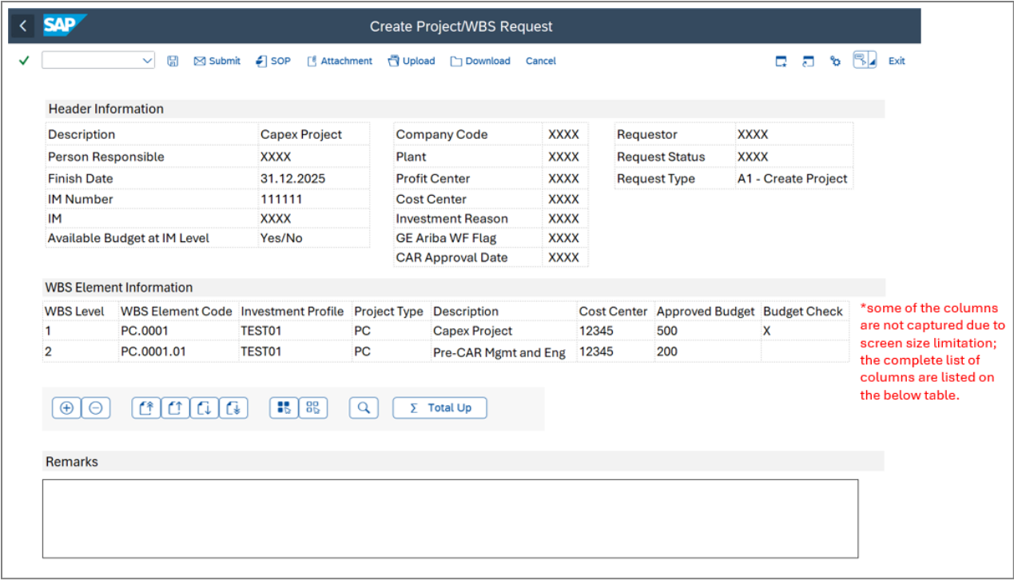
Figure 4.1.3 – Create New Project Detailed Screen 2

The fields are mapped as follows:

Header Information
Field Name | Technical Field Name | Table | Check Table | Primary Key | Data Type | Data Element | Default | Editable
Description​ | PSPNR | PROJS | - | - | NUMC | PS_INTNR | Inherited from previous screen – Refer to Table 4.1 – Field Mapping for Create New Project Screen 1 | Yes
Person Responsible​ | VERNR | TCJ04 | - | - | CHAR | PS_VERNR | Inherited from previous screen – Refer to Table 4.1 – Field Mapping for Create New Project Screen 1 | Yes
Finish Date​ | PLSEZ | PROJS | - | - | DATS | PS_PLSEZ_CHG | Inherited from previous screen – Refer to Table 4.1 – Field Mapping for Create New Project Screen 1 | Conditional:  Yes for Projects/ESR  No for Lumpsum
IM Program Position | POSNR | IMPR | - | X | NUMC | IM_POSNR | Inherited from previous screen – Refer to Table 4.1 – Field Mapping for Create New Project Screen 1 | No
IM Program | PRNAM | IMPR | IMTP | - | CHAR | IM_PRNAM | Inherited from previous screen – Refer to Table 4.1 – Field Mapping for Create New Project Screen 1 | No
Company Code​ | BUKRS | IMPR | T001 | X | CHAR | BUKRS | Get IMPR-BUKRS using IMPR-POSNR | No
Plant​ | WERKS | IMPR | T001W | - | CHAR | WERKS_D | Get IMPR- WERKS using IMPR-POSNR | No
Project currency |  |  |  |  |  |  | From Company code – T001 | No
Profit Center​ | PRCTR | IMPR | CEPC | - | CHAR | PRCTR | Inherited from previous screen – Refer to Table 4.1 – Field Mapping for Create New Project Screen 1 | Conditional:  Yes for Lumpsum  No for Projects/ESR
Cost Center | KOSTL | IMPR | CSKS | - | CHAR | KOSTL | Inherited from previous screen – Refer to Table 4.1 – Field Mapping for Create New Project Screen 1 | Yes
Investment Reason​ | IZWEK | IMPR | T087I | - | CHAR | IZWEK | Get IMPR-IZWEK using IMPR-POSNR | No
Available Budget at IM Level​ | - | - | - | - | - | - | Get IMPR-OBJNR using IMPR-POSNR from user  Using IMPR-POSNR get BPGE-WLGES – BPGE-WTGEV  if >0 Write Yes else, write “No” | No
GE Ariba WF Flag​ | USR10 | IMPR | - | - | CHAR | ZDE_ZUNIFIER_PROJ | Inherited from previous screen – Refer to Table 4.1 – Field Mapping for Create New Project Screen 1 | Yes
CAR Approval date​ | USR008 | IMPR | - | - | DATS | USER08PRPS | Get IMPR-USR008 using IMPR-POSNR | No
Requestor | BNAME | USR01 | - | - | CHAR | BNAME | Option A: Use SAP standard field SY-UNAME (Created By)  Option B: The system should retrieve the user ID or relevant user information from the SAP session (e.g., logged-in user credentials) and populate the "Requestor" field by default.  Proposed standard BAPI: BAPI_USER_GET_DETAIL | No
Request Type | Z_REQUEST_TYPE | ZWBS_HEADER | - | - | CHAR |  | Get ZTB_A2R_REQTYPE-Z_REQUEST_TYPE | No
Request Status | Z_REQSTAT | ZWBS_HEADER | - | - | CHAR |  | - Draft Status:  - When the user clicks the "Save" button, the request is tagged as "Draft".  - This indicates that the request is still being worked on and has not been submitted for approval.  - 2. Pending Approval Status:  - When the user clicks the "Submit" button, the request is tagged as "Pending Approval".  - This means the request has been submitted and is awaiting action from an approver.  - 3. Workflow Status:  - After submission, the request status should reflect the outcome of the workflow:  - If the request is approved, the status changes to "Approved".  - If the request is rejected, the status changes to "Rejected". | No
Remarks | Z_Remarks | ZWBS_HEADER | - | - | CHAR |  | - Allows users to enter long text | Yes

Table 4.1.5 – Field Mapping for Header Information (Screen 2)

WBS Element Information:
Field Name​ | Technical Field Name | Table | Check Table | Primary Key | Data Type | Data Element | Default | Editable​
WBS Level​ | STUFE | PRPS | - | - | PS_STUFE | INT1 | Get STUFE from PRPSS where PRPSS-POSID is = User selected Project Template | Yes/No. No, if lines are created automatically from the template
WBS Element Code​ | POSID | PRPS | - | - | PS_POSID | CHAR | Get POSID from PRPSS where PRPSS-POSID is = User selected Project Template | Conditional  Yes if added via + button​  No if lines are created automatically from the template
Description​ | POST1 | PRPS | - | - | PS_POST1 | CHAR | If STUFE = 1, write PROJS-PSPNR (from header)  If STUFF ≠ 1, get POST1 from PRPSS where PRPSS-POSID is = User selected Project Template | Yes​
Cost Center | KOSTL | From Header | CSKS |  | KOSTL | CHAR | From Header | No
Approved budget | ZAPPROVED_BUDG | - | - | - | - | - | Manual input from user at lowest level.  Higher level will be populated upon clicking “Total Up“ button (refer to Action Buttons below | Conditional  Yes for lowest level WBS  No for higher level WBS  To identify the lowest level WBS
Budget Check | ZBUDGET_CHECK | ZWBS_ITEM |  |  |  |  | Activated by default if STUFE = 1 | Conditional  No for level 1 WBS  Yes for the rest of the WBS
Investment profile​ | IMPRF | PRPS | TAPRF | - | IM_PROFIL | CHAR | Get IMPRF from PRPSS where PRPSS-POSID is = User selected Project Template | No​
Project type​ | PRART | PRPS | TCJ1 | - | PS_PRART | CHAR | Get PRART from PRPSS where PRPSS-POSID is = User selected Project Template | No​
Table 4.1.6 – Field Mapping for WBS Element Information (Screen 2)

Expected system behavior:

- The following fields will be inherited from the Header:
- Fields description
- Person responsible
- Finish Date
- IM Program Position
- IM
- Profit Center
- Cost Center
- GE Ariba
- The following fields will be inherited from the IM Program selected by the user:
- Company code
- Plant
- Investment Reason
- Available Budget at IM Level
- CAR Approval Date
- The following fields will be copied from the selected Project Template by user. Developer may refer to Function Module CJWB_PROJECT_COPY.
- WBS Level and hierarchical structure
- WBS Element code
- WBS Description except for Level 1
- Project type
- Investment Profile
- Approved Budget
- Note: For custom transactions, Lonza terminology keeps the word “Budget”, even though in SAP this is saved in a Planning Version
- Budget for higher level WBS is automcatically updated when “Total Up“ button is clicked.
- Budget for level 1 WBS should not exceed IM available budget. Utilize the following SAP standard Function Modules.
- IM_CHECK_WBS_ASSIGNMENT - Verifies if a WBS element is assigned to an investment program position.
- IM_AVAILABILITY_CHECK - Performs availability control for investment program positions, similar to WBS budget checks
- If all system validation passes, user can submit the request, and entries will be saved in custom tables ZWBS_HEADER and ZWBS_ITEM respectively.
- Note that validations are only triggered when “Check Data” or “Submit” button is clicked. If the request is only saved, there is no need to perform a check.
- Actions buttons in screen 2 – Header Info level:​
- Submit – Workflow trigger
- Attachment – Allows user to attach related documents to support the request.
- Save – Request will be saved with status “Draft”. There will be no workflow approval and/or checks at this stage.
- Actions buttons in screen 2 – WBS level:​
- Standard SAP buttons to:
- Add/Delete row for WBS elements
- Page up/down,
- Select/Deselect all
- Search
- Total Up – this button is key to update the budget at higher level WBS based on the total amount entered at the lower level WBS.
- Custom button “Check data”

- System Validations (upon sSubmit or “Check data”)

Validation | Logic | Warning/Error | Message
Overall Project Structure checks | Leverage SAP standard structure checks including but not limited to:  - Heirarchy levels in place  - No duplicate WBS elements | Error
A mandatory field is missing from the Project details | If field it tagged as mandatory and value is blank, throw an error message | Error | Fill in all required entry fields
Cost Center Validation | - Read table CSKS where KOSTL and KOKRS value are equal to Cost center in Header  - Check the Validity Period (fields DATBI and DATAB).  - If DATBI ≥ today’s date (or ≥ 31.12 of the current year), the cost center is valid.  - WRITE: 'Cost center is valid in current year', else WRITE: 'Cost center is not valid in current year'. | Error | Cost center is not valid in <Finish date>.
Profit Center Validation | - Read table CEPC where PRCTR and KOKRS value are equal to Profit center in Header  - Check the Validity Period (fields DATBI and DATAB).  - If DATBI ≥ today’s date (or ≥ 31.12 of the current year), the cost center is valid.  - WRITE: ‘Profit center is valid in current year', else WRITE: 'Profit center is not valid in current year'. | Error | Profit center is not valid in <Finish date>.
Level 1 WBS Budget versus IM Budget | Budget for level 1 WBS should not exceed IM available budget. Utilize the following SAP standard Function Modules.  - IM_CHECK_WBS_ASSIGNMENT - Verifies if a WBS element is assigned to an investment program position.  - IM_AVAILABILITY_CHECK - Performs availability control for investment program positions, similar to WBS budget checks | Error | Amount is greater than the available IM budget.
Attachment Validation | Attachment should exist to store necessary documentation. | Error | Please attach supporting document.
Validation if approver matrix are existing in config table (ZTB_A2R_CONFTAB2) | Upon clicking Submit button, combination of Company Code, Project Profile, and Request Type does not exist. | Error | The combination of Company Code, Project Profile, and Request Type does not exist. Approvers cannot be determined.
Table 4.1.6 – System Validations

The following table are proposed to store the entries once request is submitted:
- ZTB_A2R_WBSHDR – to store the entries from WBS header
- ZTB_A2R_WBSITEM. – to store the entries from WBS ITEM
- Attachments will be securely stored in SAP backend tables. These are linked to the request and can be retrieved as needed.

Table ZTB_A2R_WBSHDR

Tech Field name | Table | Primary Key | Field Name | Data type | Data Element | Check Table | Population Method
MANDT |  | X | Client | CLNT | MANDT | T000 | System-generated (SAP standard field)
POSNR | IMPR | - | IM Program Position | NUMC | IM_POSNR | - | Get from Table 4.1.5 – Field Mapping for Header Information (Screen 2)
PRNAM | IMPR | - | IM Program | CHAR | IM_PRNAM | IMTP | Get from Table 4.1.5 – Field Mapping for Header Information (Screen 2)
PSPNR | PROJS | - | Project ID | NUMC | PS_ISPSP | - | Equals to level 1 WBS Inherited from previous screen – Refer to Table 4.1.2 – Field Mapping for Header Information (Screen 2)  *not displayed on the screen
PSPNR | - | - | Description | NUMC | PS_INTNR | - | Get from Table 4.1.5 – Field Mapping for Header Information (Screen 2)
VERNR | TCJ04 | - | Person Responsible | CHAR | PS_VERNR | - | Get from Table 4.1.5 – Field Mapping for Header Information (Screen 2)
PLSEZ | - | - | Finish Date | DATS | PS_PLSEZ_CHG | - | Get from Table 4.1.5 – Field Mapping for Header Information (Screen 2)
BUKRS | IMPR | - | Company Code | CHAR | BUKRS | T001 | Get from Table 4.1.5 – Field Mapping for Header Information (Screen 2)
WERKS | IMPR | - | Plant | CHAR | WERKS_D | T001W | Get from Table 4.1.5 – Field Mapping for Header Information (Screen 2)
WAERS |  |  | Project currency |  |  | T001
PRCTR | IMPR | - | Profit Center | CHAR | PRCTR | CEPC | Get from Table 4.1.5 – Field Mapping for Header Information (Screen 2)
IZWEK | PRPS | - | Investment Reason | CHAR | IZWEK | T087K | Get from Table 4.1.5 – Field Mapping for Header Information (Screen 2)
ZUNIFIER_PROJ | PRPS | - | GE Ariba WF Flag | CHAR | ZDE_ZUNIFIER_PROJ | - | Get from Table 4.1.5 – Field Mapping for Header Information (Screen 2)
USR008 | PRPS | - | CAR Approval date | DATS | USER08PRPS | - | Get from Table 4.1.5 – Field Mapping for Header Information (Screen 2)
ERNAM | PRPS | - | Requestor | CHAR | ERNAM | - | Get from Table 4.1.5 – Field Mapping for Header Information (Screen 2)
Z_REQTYPE |  | - | Request Type (Key) | CHAR | ZWBS_REQUESTTYPE |  | Get from Table 4.1.5 – Field Mapping for Header Information (Screen 2)
Z_REMARKS | - | - | Remarks | CHAR | - | - | Get from Table 4.1.5 – Field Mapping for Header Information (Screen 2)
ZREQ_NUM | - | X | Request Number | NUMC | - | - | Fetch the created number range object ZREQ_NUM (Refer to pre-requisites) to identify the next available number  Add locking mechanism to ensure no duplicate entries will be generated.
ERDAT | - | - | Request Created On | DATS | - | - | Use SAP standard field SY-DATUM (Created On)
ZREQUEST_APPROVED ON | - | - | Request Approved On | DATS | - | - | Auto-generated based on Workflow item  If workflow is not yet approved, keep blank
ZAPPROVED_BY | - | - | Approved By | CHAR | - | - | Auto-generated based on Workflow item  If workflow is not yet approved, keep blank
ZREQUEST_REJECTED_ON | - | - | Request Approved On | DATS | - | - | Auto-generated based on Workflow item
ZREJECTE_BY | - | - | Approved By | CHAR | - | - | Auto-generated based on Workflow item
ZREJECTIONREASON | - | - | Reason of Rejection | CHAR | - | - | Logs rejected reason from Workflow item
Z_REQSTAT | - | - | Request Status | CHAR | - | - | Get from Table 4.1.5 – Field Mapping for Header Information (Screen 2)
Table 4.1.7 – ZTB_A2R_WBSHDR Table Structure

Table ZWBS_ITEM ZTB_A2R_WBSITEM

Tech Field  Name | Table | Primary Key | Field Name | Data type | Data Element | Check Table | Population Method
MANDT | - | X | Client | CLNT | MANDT | T000 | ZTB_A2R_WBSHDR
ZREQ_NUM | - | X | Request Number | NUMC | - | - | Fetch the created number range object ZREQ_NUM (Refer to pre-requisites) to identify the next available number  Add locking mechanism to ensure no duplicate entries will be generated.
BUKRS | IMPR | X- | Company Code | CHAR | BUKRS | T001 | Get from Table 4.1.6 – Field Mapping for WBS Element Information (Screen 2)
STUFE | PRPSS | - | WBS Level | INT1 | PS_STUFE | - | Get from Table 4.1.6 – Field Mapping for WBS Element Information (Screen 2)
POSID | PRPSS | -X | WBS Element Code | CHAR | PS_POSID | - | Get from Table 4.1.6 – Field Mapping for WBS Element Information (Screen 2)
POST1 | PRPSS | - | Description | CHAR | PS_POST1 | - | Get from Table 4.1.6 – Field Mapping for WBS Element Information (Screen 2)
KOSTL | IMPR | - | Cost Center | CHAR | KOSTL | CSKS | Get from Table 4.1.6 – Field Mapping for WBS Element Information (Screen 2)
WERT2 | BPEJ/BPJA | - | Approved Budget | CURR | BP_WERT2 | - | Get from Table 4.1.6 – Field Mapping for WBS Element Information (Screen 2)
ZBUGET_  CHECK | - | - | Budget Check | - | - | - | Get from Table 4.1.6 – Field Mapping for WBS Element Information (Screen 2)
IMPRF | PRPS | - | Investment Profile | CHAR | IM_PROFIL | TAPRF | Get from Table 4.1.6 – Field Mapping for WBS Element Information (Screen 2)
PRART | PRPS | - | Project Type | CHAR | PS_PRART | TCJ1 | Get from Table 4.1.6 – Field Mapping for WBS Element Information (Screen 2)

Table 4.1.8– ZTB_A2R_WBS_ITEM Table Structure

The “Submit” button will trigger the approval workflow à Why do you continue the description in chapter 5 instead of here
Once the workflow approval is completed, the system will automatically create a project based on the request submitted. This can be achieved by using batch input to populate the PROJ and PRPS standard table based on the entered values from users and inherited values from Project Templates.
There are two ways to approve the workflow:

Option 1: Through following the approver matrix in table ZTB_A2R_CONFTAB2. For this approach, the determination of approver is through using the combination of Company Code, Project Profile, and Request Type.

The ZTB_A2R_CONFTAB2 table is proposed to store approver information required for workflow execution. The table is to be created as available for user maintenance (via transaction SM30). It must have an authorization group to ensure that only authorized users are allowed to update it.

Tech Field name | Table | Primary Key | Field Name | Data type | Data Element | Check Table
MANDT |  | X | Client | CLNT | MANDT | T000
BUKRS | IMPR | X | Company Code | CHAR | BUKRS | T001
PROFL | PRPS | X | Project Profile | CHAR | PROFIDPROJ | TCJ41
Z_REQTYPE | ZWBS_HEADER | X | Request Type | CHAR |  | ZTB_A2R_REQTYPE
ZAPPROVAL_1 |  | - | 1st Approval PPOME Code | CHAR |  | -
ZAPPROVAL_2 |  | - | 2nd approval MD Team PPOME code | CHAR |  | -
ZERROR_HANDLING |  | - | Error handling MD Team PPOME code​ | CHAR |  | -
Table 4.1.9 – ZTB_A2R_CONFTAB2 Table Structure

Company Code (Key)​ | Project profile​ (Key) | Request type​ (Key) | 1st Approval PPOME Code​ | 2nd approval MD Team PPOME code​ | Error handling PPOME code​ | Comment (not part of the table)
CH12​ | ​ | ​ |  |  | 1111 | No approval
US02​ | ​ | ​ | 654​ | 111​1 | 1111 | Approval 1 & 2
US02 | XXX |  | 654 |  | 1111 | Only 1st approval
Table 4.1.10 - Sample table view of ZTB_A2R_CONFTAB2

Note: 1!st approval, 2nd approval and Error handling are done by people belonging to the HR organizational structure indicate in the table. They should receive communications in My Inbox.

Below is the process on how the workflow item is handled from submission to completion of the request for Option 1:
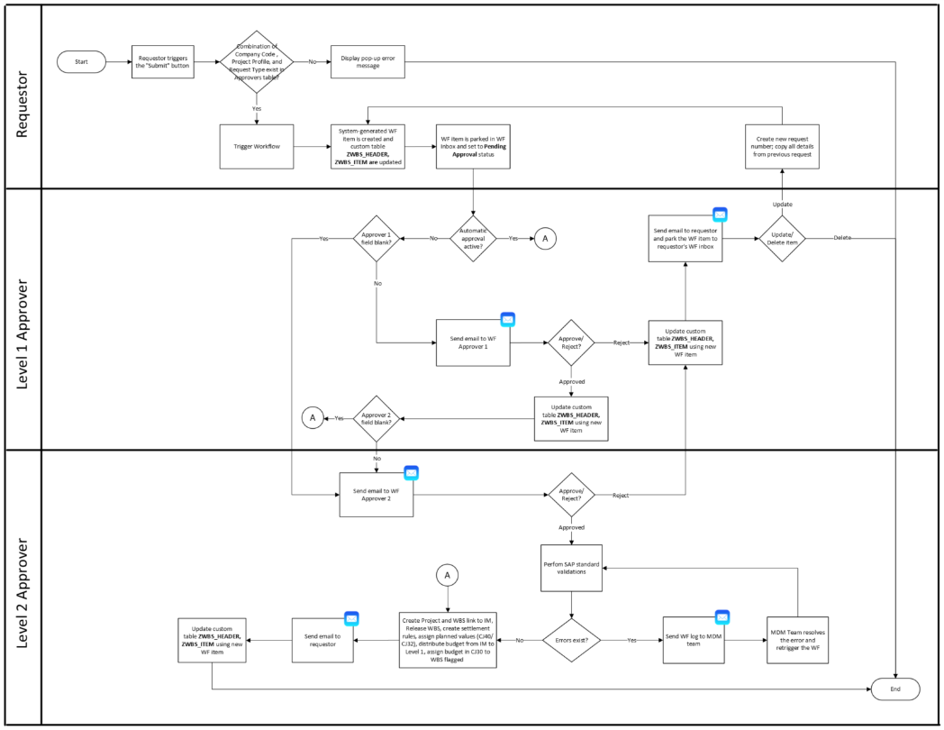
Figure 4.1.3 – Create New Project Workflow Process – Option 1 (Using Custom Table Approval Matrix)
Proposed Workflow Logic for Option 1:

1. Upon clicking the “Submit” button, the program verifies if the combination of Company Code, Project Profile, and Request Type exists in approvers table (ZTB_A2R_CONFTAB2).

Check if the combination of:
ZWBS_HEADER-BUKRS
ZWBS_HEADER-PROFL
ZWBS_HEADER- Z_REQTYPE

is existing/match the values as:
ZTB_A2R_CONFTAB2-BUKRS
ZTB_A2R_CONFTAB2-PROFL
ZTB_A2R_CONFTAB2- Z_REQTYPE

If values matched:
Trigger the workflow and proceed with the process in Step 2.
If values do not match:
Display a pop-up error message “The combination of Company Code, Project Profile, and Request Type does not exist. Approvers cannot be determined.” Workflow is not triggered/started for this scenario.

2. Workflow is triggered and workflow item is generated via SAP standard functionality. Custom table ZWBS_HEADER and ZWBS_ITEM are updated based on the workflow item. Workflow item is parked in Workflow Inbox and the status is set to Pending Approval status.

4. Check if ZTB_A2R_CONFTAB2-ZAPPROVAL_1 = blank
If yes: Perform another check if ZTB_A2R_CONFTAB2-ZAPPROVAL_2 = blank
If yes: Proceed to Step 9
If no: Email is sent to Approver 2 to either approve or reject the request. Note that rejection reason should be indicated. Proceed to step 7.
If no: Email is sent to Approver 1 to either approve or reject the request. Note that rejection reason should be indicated

5. If Approver 1 rejects the workflow perform the following:
- Update Status of the request in custom table ZWBS_HEADER and ZWBS_ITEM using new Workflow item.
- Send an Email to requestor that the workflow has been rejected
- The workflow item is parked to requestor’s inbox for them to either update/amend the request based on the rejection reason or delete/terminate the workflow item.
If Update/Amend – a new request number is created; the details of the request are copied for the user to easily amend the request (repeat the process from step 2 onwards)
If delete/terminate – process ends
6. If Approver 1 approves the workflow perform the following:
- Update Status of the request in custom table ZWBS_HEADER and ZWBS_ITEM using new Workflow item.
- Check if ZTB_A2R_CONFTAB2-ZAPPROVAL_2 = blank
If yes: Proceed to step 9
If no: Email is sent to Approver 2 to either approve or reject the request. Note that rejection reason should be indicated

7. If Approver 2 rejects the workflow perform the following:
- Update Status of the request in custom table ZWBS_HEADER and ZWBS_ITEM using new Workflow item.
- Send an Email to requestor that the workflow has been rejected
- The workflow item is parked to requestor’s inbox for them to either update/amend the request based on the rejection reason or delete/terminate the workflow item.
If Update/Amend – a new request number is created; the details of the request are copied for the user to easily amend the request (repeat the process from step 2 onwards)
If delete/terminate – process ends
8. If Approver 2 approves the workflow perform the following:
- Update Status of the request in custom table ZWBS_HEADER and ZWBS_ITEM using new Workflow item.
- Proceed to step 9
9. Perform SAP standard validations similar to the following:
- Creation of Project and WBS in CJ20N.
- Assign planned values in CJ40 / CJ32
- Distribution of budget from IM to 1st level of WBS

If errors exist:
- Store the error logs as per SAP Standard workflow functionality
- Send the error to MDM Team (ERROR_HANDLING). MDM team to manually update the record to resolve the error and re-trigger the workflow. Repeats step 9.
If errors do not exist: Proceed to Step 10 – Project Creation
10. Once all approvals are met and validations are performed with no errors, perform the following action:
- Create Project and WBS (tables PROJ and PRPS)
- Incorporate standard functionality to check the next available running number (similar to “Check next open number” functionality in CJ20N.)
- Create WBS based on data saved in tables ZWBS_HEADER and ZWBS_ITEM, removinge all WBS elements with no budget.
- If ZAPPROVED_BUDG = blank, skip WBS element creation
- Link the WBS to IM Position (POSNR)
- Create settlement rule for WBS. Settlement rule should be the higher WBS.
Step 1: Call standard tcode CJB2, enter the Project Definition, Period = Current Period, Year = Current Year
- Step 2: If not yet included in CJB2, upon successful creation of Settlement rule,
- Step 3: Assign plan values ZAPPROVED_BUDG. Reference standard transaction code CJ40.
- Distribute budget from IM to Level 1 WBS. Reference standard transaction code:IM52
- Assign budget to WBS with flagged budget check field ZBUDGET_CHECK
If budget check is not ticked for the WBS, skip this part. Reference standard transaction code: CJ30
- Activate BUDG and AVAC status using standard approach STATUS_CHANGE_INTERN_VB
- Release WBS.
- Activates AUC status for WBS with Investment Profile as well in (Level 1 WBS) using standard approach
- Activate user status BLKD - Block Direct Posting for higher level WBS using standard BAPI_BUS2054_SET_STATUS
Step 1. Identify the higher level WBS.
Get PRHI-UP where PRHI-PSPHI = PROJ-PSPNR
Step 2. Activate User Status BLKD - Block Direct Posting using BAPI_BUS2054_SET_STATUS
Fill the tables parameter I_WBS_USER_STATUS:
WBS_ELEMENT = PRHI-UP
SET_USER_STATUS = BLKD

11. Send an email to the requestor that the Project has been approved and created.
12. Update custom table ZWBS_HEADER, ZWBS_ITEM using new Workflow item. Process ends.

Option 2: Through manual action by MDM team. Through this exception approach, MDM team uses standard transaction to modify the workflow and change the approver. MD team may manually “steal” the workflow item and assign it to themselves or change the approver.

- B1 Modify WBS – Add new or update existing WBS elements, including budget changes.

- NOTE: B1, B2 and B3, same as in A, the user needs to be able to save the request with the standard “Save” button. In that case, no validation is done on the entered data, and they are saved in the requests table.
- B1. Request CAR Project for Approved ESR – Initiate A CAR project based on approved ESR

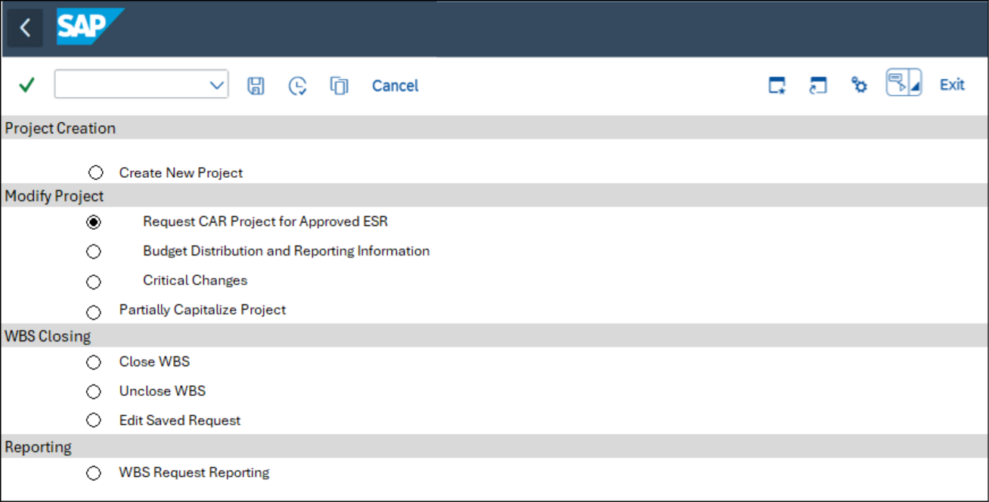

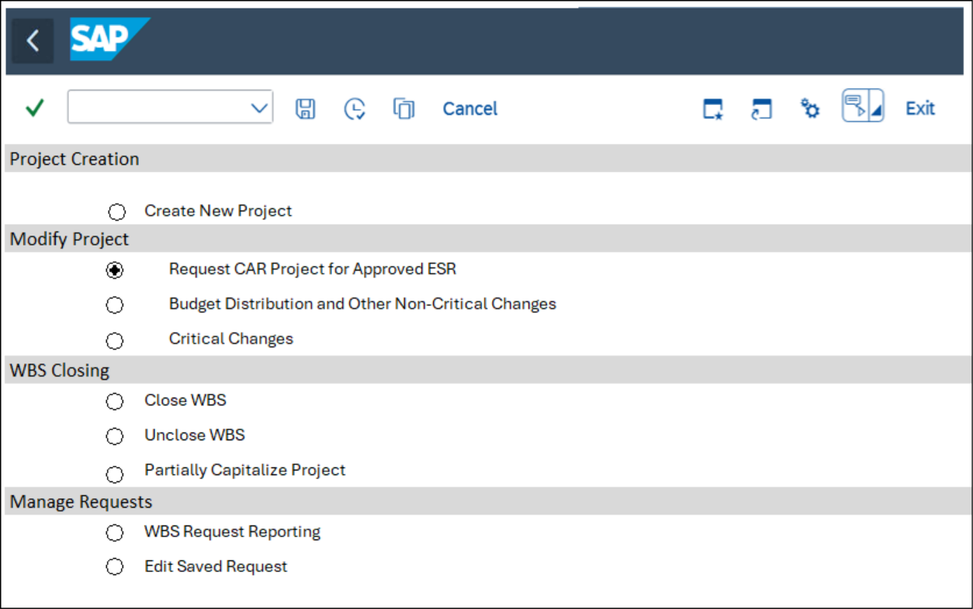
Figure 4.1.2.1 – Screen 0 with Modify B1 Selected

Upon selection, the program retrieves the corresponding Z_REQUEST_TYPE value from the ZTB_A2R_REQTYPE table to determine the appropriate screen or process to execute. For request CAR Project for Approved ESR, request type to be processed is B1 – Add CAR. The following are the 7screens and processes to be executed.
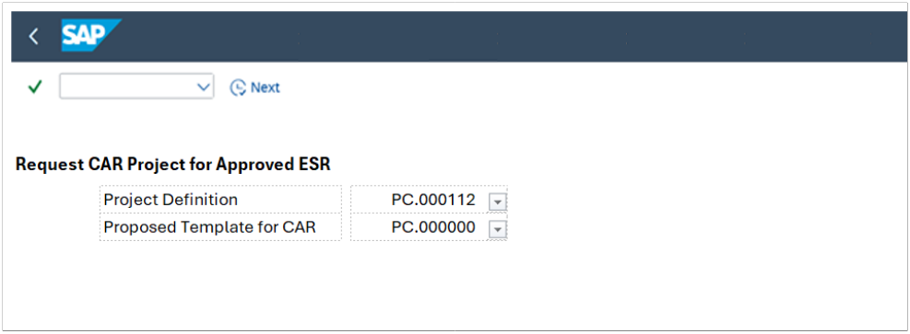
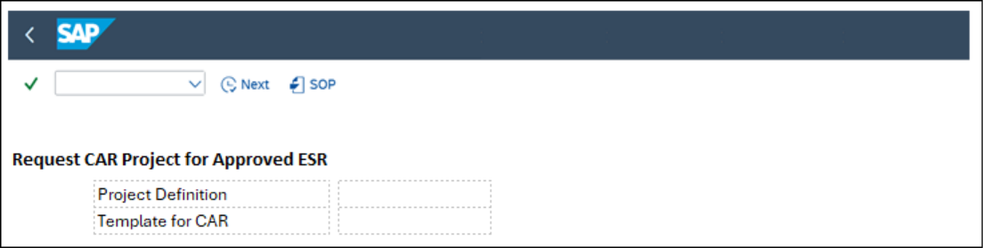
Figure 4.1.2.2 – Screen 1 upon selecting B1 – .Request CAR Project for Approved ESR

Field name | Tech Field Name | Table | Check Table | Population Method of Default Values | Editable | Mandatory
Project Definition | PSPNR | PROJ | PROJ | Drop down value from PROJ table | Yes | Yes
Proposed Template for CAR | PSPNR | ZTB_A2R_CONFTAB1 |  | Get default value from PROJ-PROFL using PSPNR, then using PROJ-PROFL and the other key fields of table ZTB_A2R_CONFTAB1 (information coming from IM number) get ZTB_A2R_CONFTAB1- PSPNR | Yes | Yes
Table 4.1.2.1.1 – Filed Mapping for Screen 1

Once selection is filled and “Next” button is clicked, perform the following system validations:
- Check the Project is active and not in CLSD (Closed) or TECO (Technically completed) status.
Get PROJ OBJNR using selected project PROJ-PSPID
Check JEST-STAT using OBJNR, JEST-STAT should not equal to I0046 (CLSD) or I0045 (TECO)
If STAT = I0046 or STAT = II0045 ) display message “Project is already in Cclosed / Technically Completed status. Modification not allowed”

- Check if Template is existing
Get ZTB_A2R_CONFTAB1-PSPNR and check if existing in PROJS- PSPNR
If value does not exist, display message “Project Template does not exist
If both conditions are met, display the below screen.
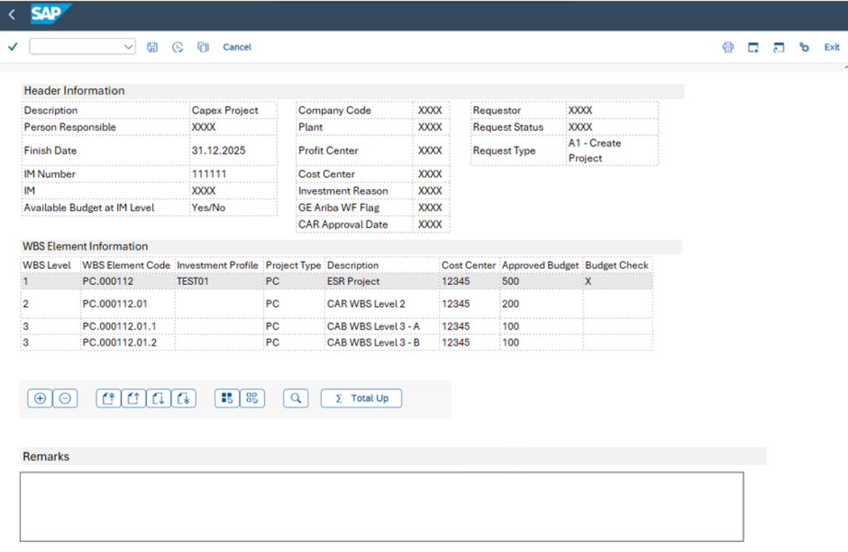
Figure 4.1.2.3 – Screen 2 when Modify B1 is selected

Header Information
- The sSame header information is changeable as for critical changes as creation. The available budget should be read again from IM and displayed.
- The main difference is that in creation, the table and technical fields used are from Project Template (PROJS and PRPSS); in Modify mode, tables for operational Project and WBS are is used (PROJ and PRPS).

Field Name | Technical Field Name | Table | Check Table | Primary Key | Data Type | Data Element | DefaultPopulation Method | Editable
Description​ | PSPNR | PROJ | - | - | NUMC | PS_INTNR | Get PROJ-PSPNR using selected PSPNR in previous screen | Yes
Person Responsible​ | VERNR | TCJ04 | - | - | CHAR | PS_VERNR | Get PROJ-VERNR using selected PSPNR in previous screen | Yes
Finish Date​ | PLSEZ | PROJ | - | - | DATS | PS_PLSEZ_CHG | Get PROJ-PLSEZ using selected PSPNR in previous screen | Conditional:  Yes for Projects/ESR  No for Lumpsum
IM Program Position | POSNR | IMPR | - | X | NUMC | IM_POSNR | 1. Select PRPS-PSPNR where PRPS-PSPHI = user-selected PROJ-PSPNR and PRPS-STUFE = 1  2. Get V_IVP_PR-POSNR using PRPS-PSPNR | No
IM Program | PRNAM | IMPR | IMTP | - | CHAR | IM_PRNAM |  | No
Company Code​ | BUKRS | IMPR | T001 | X | CHAR | BUKRS | Get PROJ-BUKRS using PROJ-PSPNR | No
Plant​ | WERKS | IMPR | T001W | - | CHAR | WERKS_D | Get PROJ- WERKS using PROJ-PSPNR | No
Project currency |  |  |  |  |  |  | Get PROJ- PWHIE using PROJ-PSPNR | No
Profit Center​ | PRCTR | IMPR | CEPC | - | CHAR | PRCTR | Get PROJ-PRCTR using selected PSPNR in previous screen | Conditional:  Yes for Lumpsum  No for Projects/ESR
Cost Center | KOSTL | IMPR | CSKS | - | CHAR | KOSTL | Get PROJ-KOSTL using selected PSPNR in previous screen | Yes
Investment Reason​ | IZWEK | IMPR | T087I | - | CHAR | IZWEK | Get IMPR-IZWEK using IMPR-POSNR | No
Available Budget at IM Level​ | - | - | - | - | - | - | Get IMPR-OBJNR using IMPR-POSNR from user  Using IMPR-POSNR get BPGE-WLGES – BPGE-WTGEV  if >0 Write Yes else, write “No” | No
GE Ariba WF Flag​ | USR10 | IMPR | - | - | CHAR | ZDE_ZUNIFIER_PROJ | Get PROJ-USR10 using selected PSPNR in previous screen | Yes
CAR Approval date​ | USR008 | IMPR | - | - | DATS | USER08PRPS | Get IMPR-USR008 using IMPR-POSNR | No
Requestor | BNAME | USR01 | - | - | CHAR | BNAME |  | No
Request Type | Z_REQUEST_TYPE | ZWBS_HEADER | - | - | CHAR |  | Get ZTB_A2R_REQTYPE-Z_REQUEST_TYPE using | No
Request Status | REQUEST_STATUS | ZWBS_HEADER | - | - | CHAR |  | 1. Draft Status:  o When the user clicks the "Save" button, the request is tagged as "Draft".  o This indicates that the request is still being worked on and has not been submitted for approval.  · 2. Pending Approval Status:  o When the user clicks the "Submit" button, the request is tagged as "Pending Approval".  o This means the request has been submitted and is awaiting action from an approver.  · 3. Workflow Status:  o After submission, the request status should reflect the outcome of the workflow:  1. If the request is approved, the status changes to "Approved".  2. If the request is rejected, the status changes to "Rejected". | No
Remarks | Z_Remarks | ZWBS_HEADER | - | - | CHAR |  | - Allows users to enter long text | Yes

Table 4.1.2.4 – Field Mapping for Header Information

WBS Element Information:
- The same WBS information is changeable for critical changes as creation. The available budget should be read again from IM and displayed.
- The main difference is that in creation, the table and technical fields used are from WBS Template (PRPSS); in Modify mode, table for operational Project is used (PROJ) for ESR WBS elements, CAR WBS Elements which are being requested to be inserted will still come from CAR Template (PRPSS table).
- The existing ESR elements (from the user-input project in Screen 1) are display-only, including all values. except for Approved Budget (ZAPPROVED_BUDG) where user can enter the new/updated budget.
- The WBS elements belonging to the CAR template selected on screen 1 (without its level 1) are added below the already existing ESR elements.
- The logic to insert CAR template is as follows:
1. Get the list of WBS PRPSS-PSPNR using the selected CAR template (PROJS-PSPNR) from Screen 1 where PRPSS-PSPHI = PROJS-PSPNR.
2. Insert the CAR WBS template PRPSS-PSPNR to ESR Project selected in Screen 1 (PRPS-PSPNR) except for Level 1 WBS (PRPSS-STUFE = 1)
3. Replace the Project and WBS code with the WBS number of ESR project.
Example of expected results below:
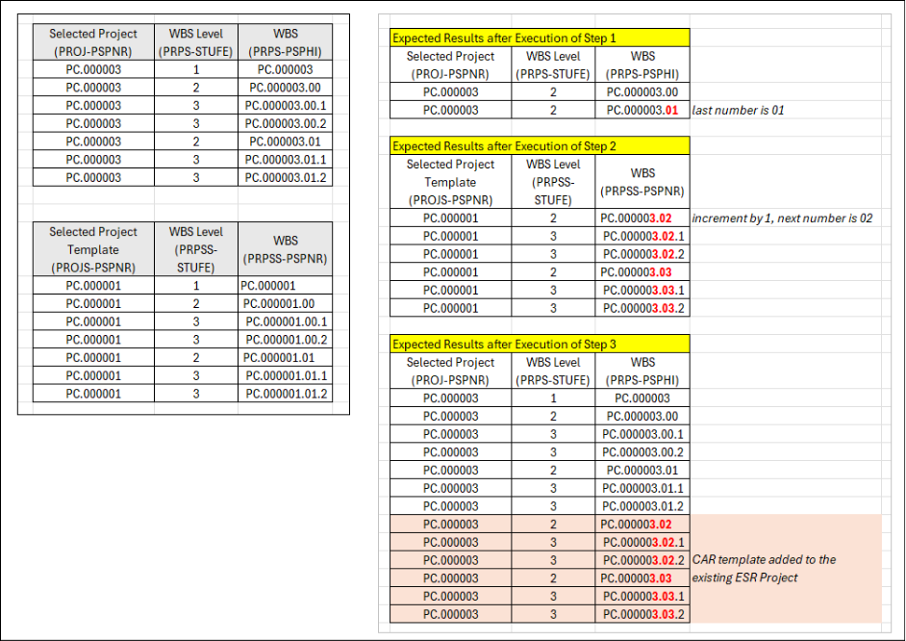
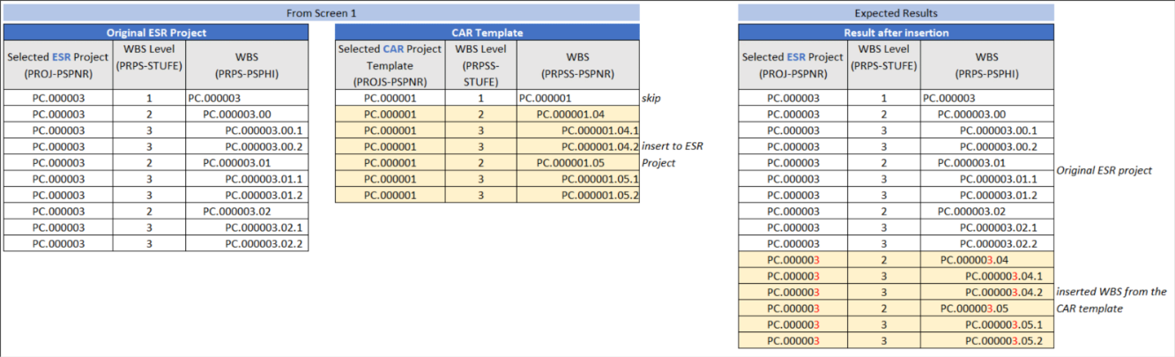
Figure 4.1.2.1 – Illustration of Project Structure Update

- For the new CAR elements, the same fields are editable at WBS element level as during creation (description, approved budget, flag “Budget check”
- For the CAR elements, the same actions and rules apply as during the creation.
Field Name​ | Technical Field Name | Table | Check Table | Primary Key | Data Type | Data Element | Default | Editable​
WBS Level​ | STUFE | PRPS | - | - | PS_STUFE | INT1 | Get STUFE from PRPS where PRPS-POSID is = User selected Project from Screen 1 | Yes/No. No, if lines are created automatically from the template
WBS Element Code​ | POSID | PRPS | - | - | PS_POSID | CHAR | Get POSID from PRPS where PRPS-POSID is = User selected Project from screen 1 | Conditional  Yes if added via + button​  No if lines are created automatically from the template
Description​ | POST1 | PRPS | - | - | PS_POST1 | CHAR | Get POST1-PRPS where PRPS-POSID is = User selected Project from Screen 1 | Yes​
Cost Center | KOSTL | From HeaderIMPR | CSKS |  | KOSTL | CHAR | From Header | No
Approved budget | ZAPPROVED_BUDG | - | - | - | - | - | Manual input from user at lowest level.  Higher level will be populated upon clicking “Total Up“ button (refer to Action Buttons below | Conditional  Yes for lowest level WBS  No for higher level WBS  To identify the lowest level WBS
Budget Check | ZBUDGET_CHECK | ZWBS_ITEM |  |  |  |  | Activated by default if STUFE = 1 | Conditional  No for level 1 WBS  Yes for the rest of the WBS
Investment profile​ | IMPRF | PRPS | TAPRF | - | IM_PROFIL | CHAR | Get IMPRF from PRPS where PRPS-POSID is = User selected Project from Screen 1 | No​
Project type​ | PRART | PRPS | TCJ1 | - | PS_PRART | CHAR | Get PRART from PRPS where PRPS-POSID is = User selected Project from Screen | No​
Table 4.1.2.5 – Field Mapping for WBS Element Information

- Include the same Actions buttons from Create functionality.
- Perform the same validations as indicated in Table 4.1.6 – System Validations only for the newly WBS being inserted.
- Similarly, ZTB_A2R_WBSHDR and ZTB_A2R_WBSITEM are also updated upon clicking Submit.
- The same workflow approval process is triggered, following request type B1 in the approver matrix (ZTB_A2R_CONFTAB2)
- Perform the same workflow logic including Option 1 – following the approval matrix and Option 2 – Manual option by MD team.
- Once workflow is completed, update the Project and insert the newly added WBS as indicated in Figure 4.1.2.1 – Illustration Project Structure Update.
- During creation/insertion of WBS, exclude those without values in Approved Budget (ZAPPROVED_BUDG)
- Perform the same actions similar to creation process such as creation of settlement rules, assign plan values and budget values for those with budget check indicator, and activation of relevant system status—REL, BUDG, and SETC.
- Update plan values and budget values for existing elements for which it was changed

- B2. Budget Distribution and Other Non-Critical Changes

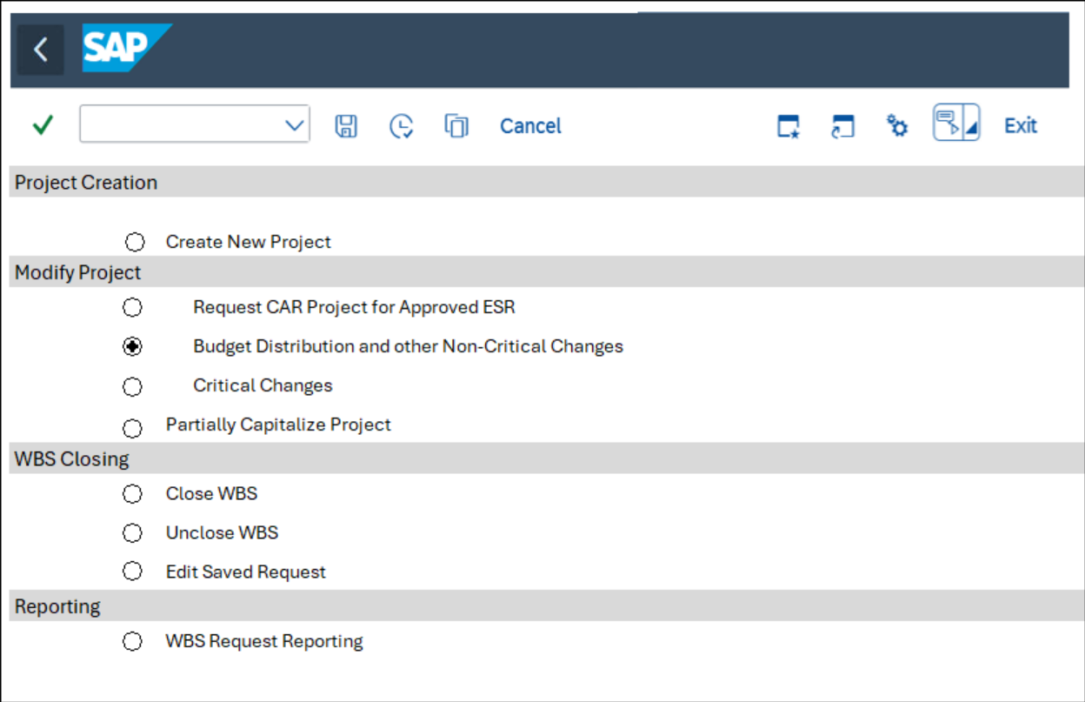
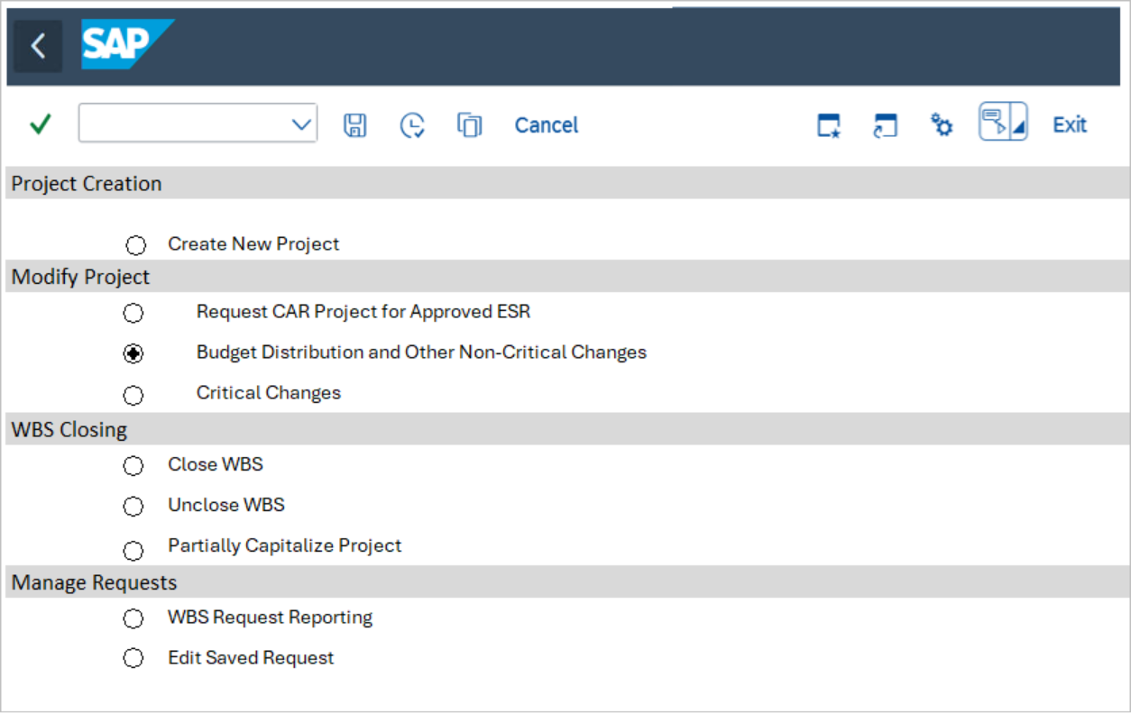
Figure 4.1.2.2.1 – Screen 0 with Modify - B2 Budget Distribution and other Non-Critical Changes Selected

Upon selection, the program retrieves the corresponding Z_REQTYPE value from the ZTB_A2R_REQTYPE table to determine the appropriate screen or process to execute. For Budget Distribution and Other Non-Critical Changes, request type to be processed is B2 – Budget Distribution and other Non-Critical Changes.

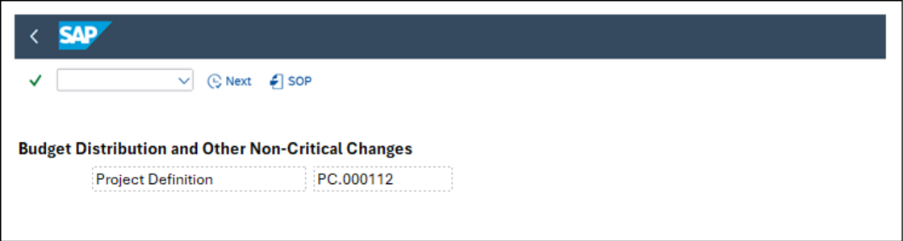
Figure 4.1.2.2.2 – Screen 1 upon selecting B2 – Budget Distribution and other Non-Critical Changes

Field name | Tech Field Name | Table | Check Table | Population Method of Default Values | Editable | Mandatory
Project Definition | PSPNR | PROJ | - | Drop down value from PROJ table | Yes | Yes
Table 4.1.2.2.1 – Filed Mapping for Screen 1

Once selection is filled and “Next” button is clicked, perform the following system validation:
Check the Project is active and not in CLSD (Closed) or TECO status.
Get PROJ OBJNR using selected project PROJ-PSPID
Check JEST-STAT using OBJNR, JEST-STAT should not equal to I0046 (CLSD) or TECO (see above)
If STAT = I0046 display message “Project is already closed. Modification not allowed”
If successful, display the same screen as B1, with only the following fields as editable:

- Description (PSPNR)
- Person Responsible (VERNR)
- Finish Date (PLSEZ)
- Approved budget (only at levels 2+)
- Budget check (only at levels 2+)

- Include the same Actions buttons from Create/B1 – Modify functionality except for Add/Delete buttons, these buttons should not be available as only existing WBS can be updated..
- Exception: Attachment is not required for Request Type B2, skip this validation.
- Similarly, ZTB_A2R_WBSHDR and ZTB_A2R_WBSITEM are also updated upon clicking Submit.
- The same workflow approval process is triggered, following request type B2 in the approver matrix (ZTB_A2R_CONFTAB2)
- Perform the same workflow logic, although B2 will most likely have blank approvers. Perform the same logic for flexibility in case approvers are needed in the future.
- Once workflow is completed, update the WBS accordingly, including planned and budget values.

- B3. Critical Changes – Define and control high-impact structural or financial modification to the project.

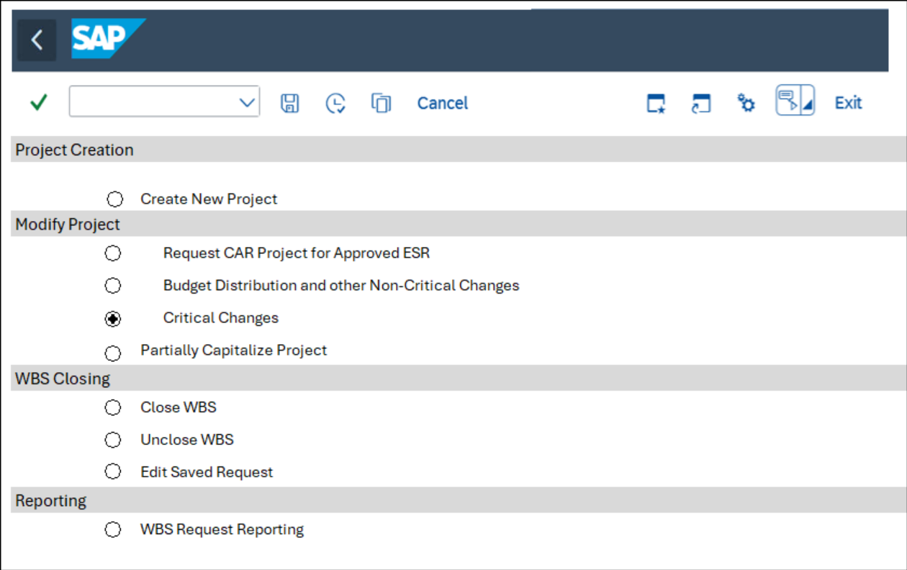
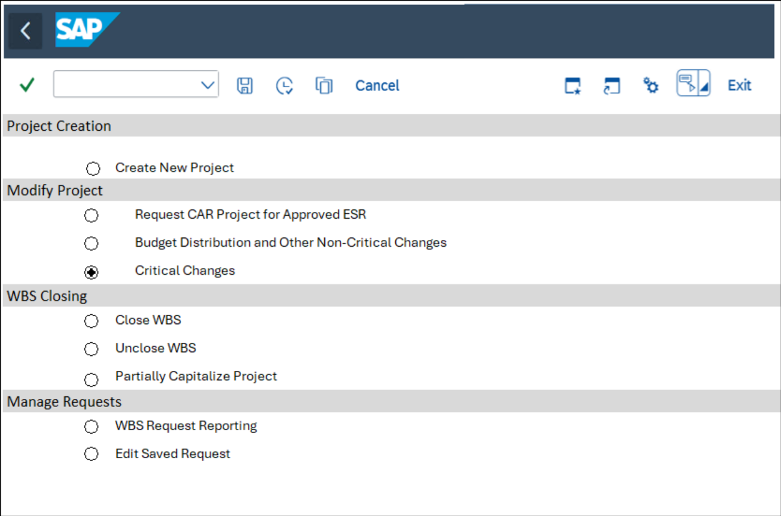
Figure 4.1.2.3.1 – Screen 0 with Modify – B3 Critical Changes Selected

Upon selection, the program retrieves the corresponding Z_REQTYPE value from the ZTB_A2R_REQTYPE table to determine the appropriate screen or process to execute. For Critical Changes, request type to be processed is B3 –Critical Changes. The following are the screens and processes to be executed.

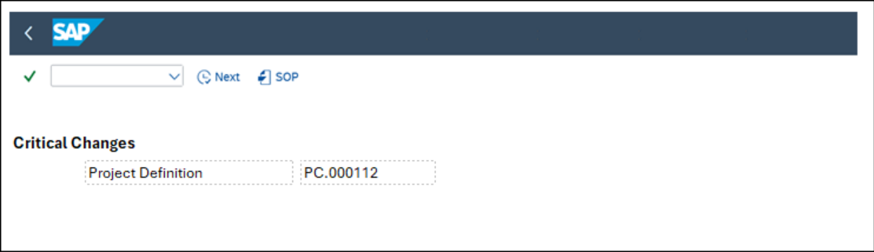
Figure 4.1.2.3.2 – Screen 1 upon selecting – B3 Critical Changes

Field name | Tech Field Name | Table | Check Table | Population Method of Default Values | Editable | Mandatory
Project Definition | PSPNR | PROJ | - | Drop down value from PROJ table | Yes | Yes

Table 4.1.2.3.1 – Filed Mapping for Screen 1

Once selection is filled and “Next” button is clicked, perform the following system validation:
Check the Project is active and not in CLSD (Closed) status or TECO.
Get PROJ OBJNR using selected project PROJ-PSPID
Check JEST-STAT using OBJNR, JEST-STAT should not equal to I0046 (CLSD) or I0045 (TECO)
If STAT = I0046 display message “Project is already closed. Modification not allowed”
If successful, display the same screen as B1, with the following fields as editable:

- Description (PSPNR)
- Person Responsible (VERNR)
- Finish Date (PLSEZ)
- IM Program Position (POSNR)
- IM Program (PRNAM)
- Company Code (BUKRS)
- Plant (WERKS)
- Profit Center (PRCTR)
- Investment Reason (IZWEK)

- Include the same Actions buttons from Create/B1 – Modify functionality.
- Perform the same validations as indicated in Table 4.1.6 – System Validations only for WBS being updated. No checks should be done for WBS with no updates
- Similarly, ZTB_A2R_WBSHDR and ZTB_A2R_WBSITEM are also updated upon clicking Submit.
- The same workflow approval process is triggered, following request type B3 in the approver matrix (ZTB_A2R_CONFTAB2)
- Perform the same workflow logic including Option 1 – following the approval matrix and Option 2 – Manual option by MD team.
- Once workflow is completed, update the WBS accordingly.

- C Partially Capitalize Project
- D Close WBS
- D1 Capitalize Project
- D2 Write Off
- Close WBS
- E1 Unclose WBS
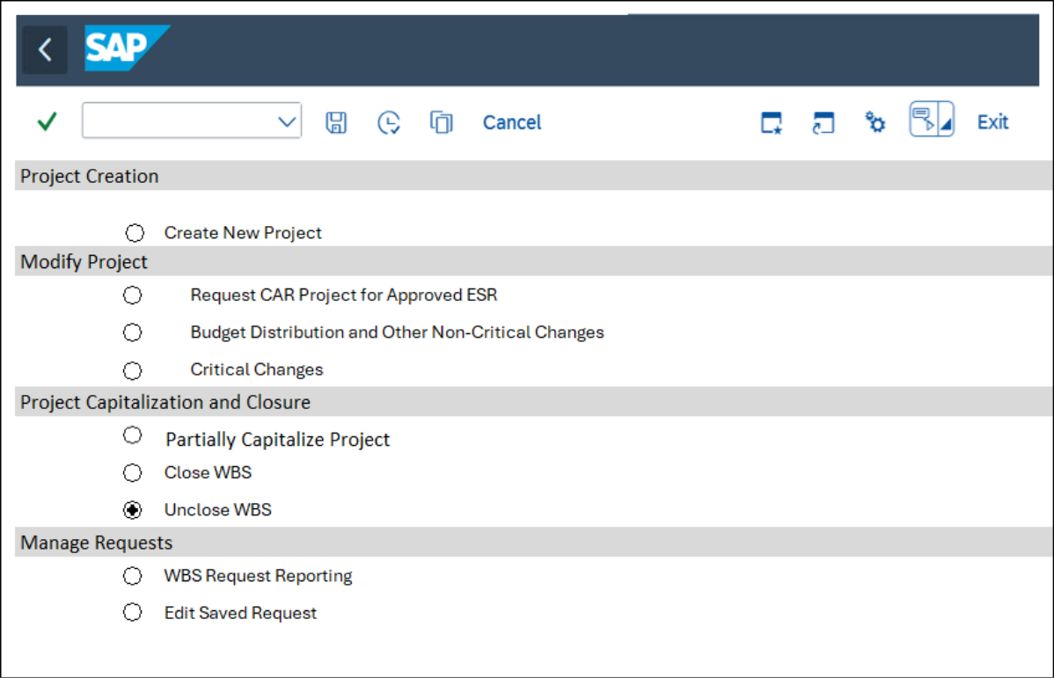
Figure 4.1.5.1 – Screen 0 with E1 Unclose WBS Selected

Upon selection, the program retrieves the corresponding Z_REQTYPE value from the ZTB_A2R_REQTYPE table to determine the appropriate screen or process to execute. For Unclose WBS, request type to be processed is E1 – Unclose WBS. The following are the screens and processes to be executed.

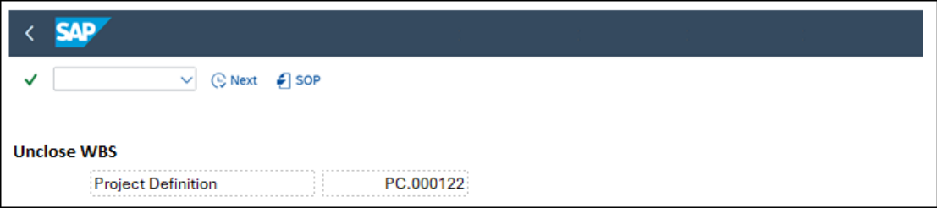
Figure 4.1.5.2 – Screen 1 upon selecting – E1 Unclose WBS

Field name | Tech Field Name | Table | Check Table | Population Method of Default Values | Editable | Mandatory
Project Definition | PSPNR | PROJ | - | Drop down value from PROJ table | Yes | Yes

Table 4.1.5.1 – Filed Mapping for Screen 1

Once selection is filled and “Next” button is clicked, perform the following system validation:
Check the Project is active and not in CLSD (Closed) status or TECO.
Get PROJ OBJNR using selected project PROJ-PSPID
Check JEST-STAT using OBJNR, JEST-STAT should not equal to I0046 (CLSD) or I0045 (TECO)
If STAT = I0046 display message “Project is already closed. Modification not allowed”
If successful, display the same screen as B1, with the following fields as editable:

- Include the same Actions buttons from Create functionality.
- Perform the same validations as indicated in Table 4.1.6 – System Validations only for the newly WBS being inserted.
- Similarly, ZTB_A2R_WBSHDR and ZTB_A2R_WBSITEM are also updated upon clicking Submit.
- The same workflow approval process is triggered, following request type E1 in the approver matrix (ZTB_A2R_CONFTAB2)
- Perform the same workflow logic including Option 1 – following the approval matrix and Option 2 – Manual option by MD team.
- Once workflow is completed, update the Project status:
- Undo CLSD (Closed) status
- Undo TECO (Technically Completed) status
- Activate REL (Release) status

- F1 Edit Saved Request
Edit saved request is simply opening and editing the requests that are saved and have not been submitted.
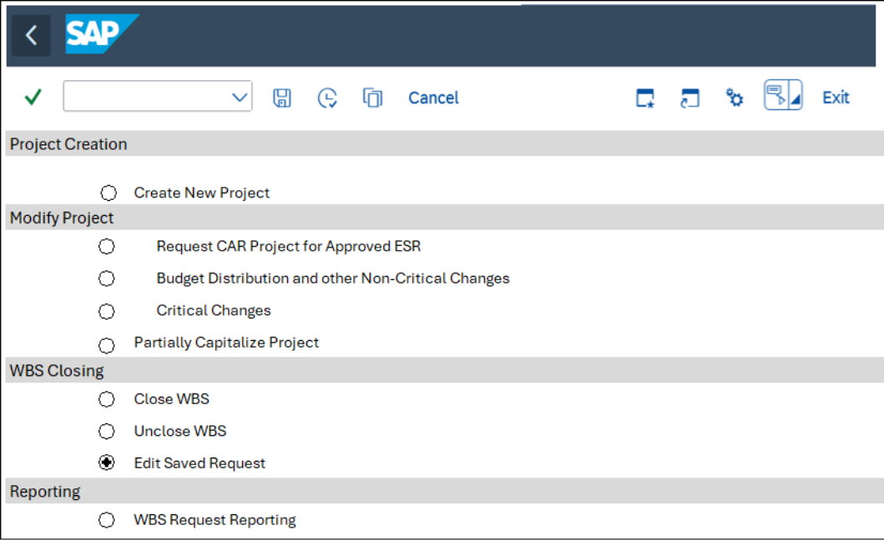
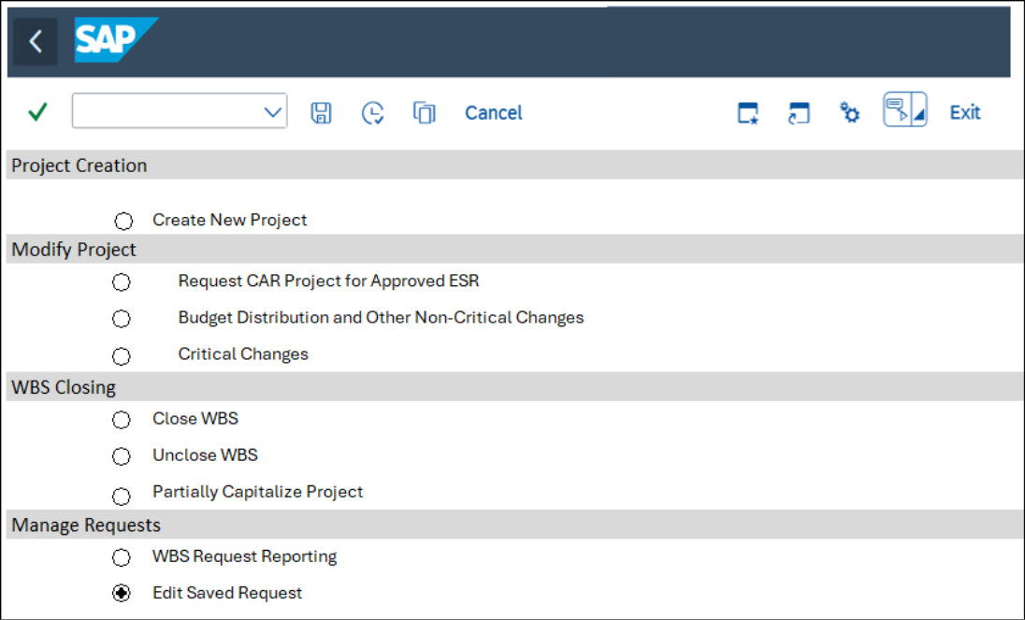
Figure 4.1.3.1 – Screen 0 with F1 Edit Saved Request Selected

Upon selection, the program retrieves the corresponding Z_REQTYPE value from the ZTB_A2R_REQTYPE table to determine the appropriate screen or process to execute. For Edit Saved Request, request type to be processed is F1 – Edit Saved Requests.

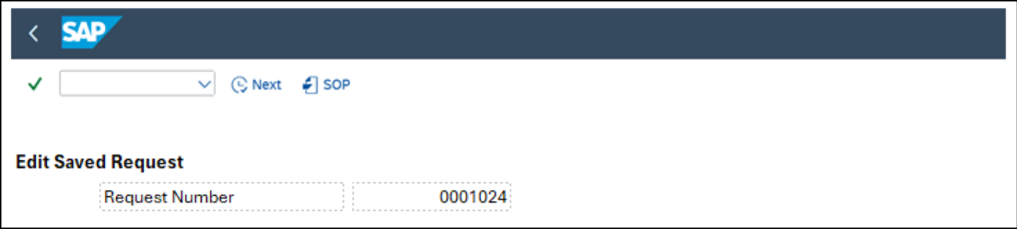
Figure 4.1.3.2 – Screen Upon Selecting F1 – Edit Saved Request

Field name | Tech Field Name | Check Table | Population Method of Default Values | Editable | Mandatory
Request Number | ZREQ_NUM | ZTB_A2R_WBSHDR | Drop down value from ZTB_A2R_WBSHDR table | Yes | Yes
Table 4.1.3.1 – Screen 1 Upon selecting F1 – Edit Saved Request
- Once selection is filled and “Next” button is clicked, perform the following system validation:
Check the status of the request in ZTB_A2R_WBSHDR-Z_REQSTAT
If status is not DRAFT, display error message “Request Number already submitted, modification no longer allowed.”

- The same screen is displayed according to the Request Type.
- Depending on the request Type, checks are also performed upon submission of the request.
- Un-submitted request may be deleted/cancelled.

- G1 Request Type - WBS Request Reporting

- Selection screen

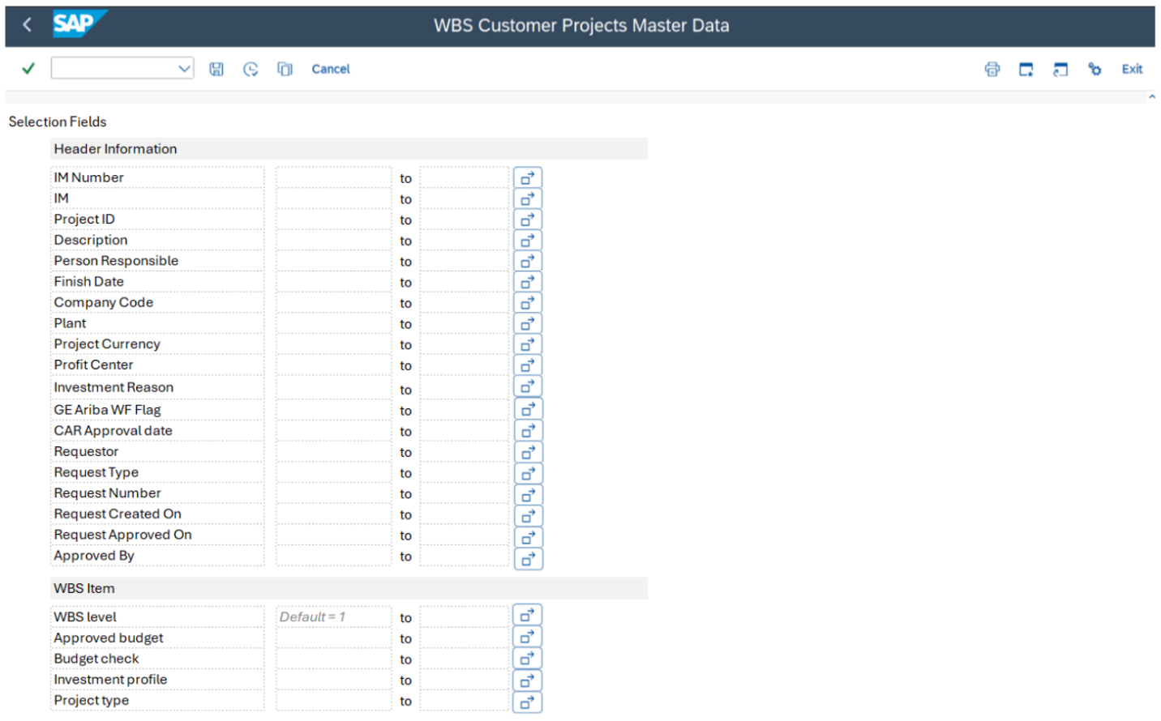
Figure 4.1.2.1 – WBS Request Reporting Selection Screen

Expected system behavior:
- The custom report will leverage the standard SAP functionality to execute and generate the required output. This includes utilizing the standard execution framework provided by SAP. The report will incorporate standard selection fields, allowing users to input parameters and filter data as per their requirements.
- Program to select all the data from custom table ZTB_A2R_WBS_HEADER & ZTB_A2R_ZWBS_ITEM, all fields in the tables must be present on the WBS Request report.

Tech Field name | Field Name | Population Method
MANDT | Client | ZTB_A2R_WBS_HEADER
POSNR | IM Program Position | ZTB_A2R_WBSHDR
PRNAM | IM IM Program | ZTB_A2R_WBSHDR
PSPNR | Project ID | ZTB_A2R_WBSHDR
PSPNR | Description | ZTB_A2R_WBSHDR
VERNR | Person Responsible | ZTB_A2R_WBSHDR
PLSEZ | Finish Date | ZTB_A2R_WBSHDR
BUKRS | Company Code (Key) | ZTB_A2R_WBSHDR
WERKS | Plant | ZTB_A2R_WBSHDR
 | Project Currency | ZTB_A2R_WBSHDR
PRCTR | Profit Center | ZTB_A2R_WBSHDR
IZWEK | Investment Reason | ZTB_A2R_WBSHDR
ZUNIFIER_PROJ | GE Ariba WF Flag | ZTB_A2R_WBSHDR
USR008 | CAR Approval date | ZTB_A2R_WBSHDR
ERNAM | Requestor | ZTB_A2R_WBSHDR
Z_REQTYPE | Request Type (Key) | ZTB_A2R_WBSHDR
ZREQ_NUM | Request Number | ZTB_A2R_WBSHDR
ERDAT | Request Created On | ZTB_A2R_WBSHDR
ZREQUEST_APPROVED ON | Request Approved On | ZTB_A2R_WBSHDR
ZAPPROVED_BY | Approved By | ZTB_A2R_WBSHDR
STUFE | WBS Level | ZTB_A2R_WBS_ITEM
POSID | WBS Element Code | ZTB_A2R_WBS_ITEM
POST1 | Description | ZTB_A2R_WBS_ITEM
KOSTL | Cost Center | ZTB_A2R_WBS_ITEM
WERT2 | Approved Budget | ZTB_A2R_WBS_ITEM
ZBUDGET_  CHECK | Budget Check | ZTB_A2R_WBS_ITEM
IMPRF | Investment Profile | ZTB_A2R_WBS_ITEM
PRART | Project Type | ZTB_A2R_WBS_ITEM

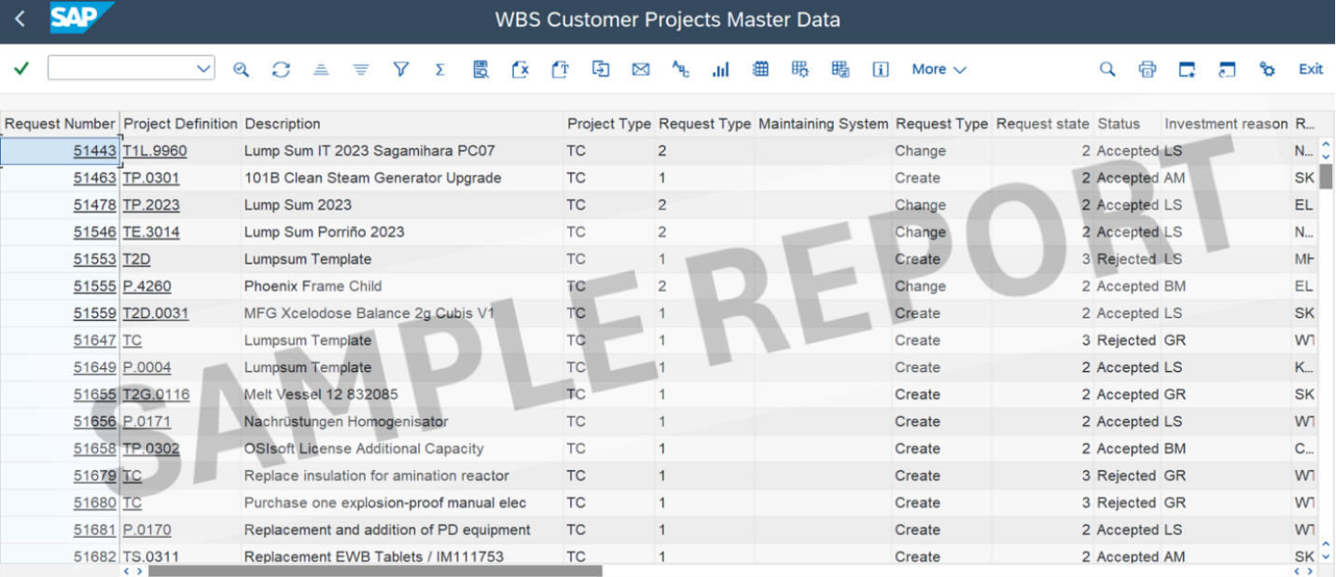
Figure 4.1.2.2 – WBS Request Reporting Sample Screen
- Flow Diagram
See the attached complete workflow agreed with the business.

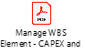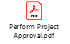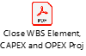

- Unit Testing

Scenario A: Create New Project

Test ID | Test Scenario | Expected Result
A1.01 | Submit a request for the creation of a new project via ZCJ00 transaction. Check that mandatory and default fields are in place for each screen. | Project is created with IM assignment, plan values and budget amount are maintained.
A1.02 | Save a request. | Values entered are saved. No check/validations in place.
A1.03 | Submit a request with Workflow approver 1 and 2 | Request is submitted and workflow is triggered. Project is created upon approval.
A1.04 | Submit a request with only Workflow approver 1 | Request is submitted and workflow is triggered. Project is created upon approval.
A1.05 | Submit a request with only blank approver 1 and 2 (Automatic approval) | Workflow is triggered and is automatically approved. Project is created.
A1.06 | Submit a request with missing entry in config table. | Error is encountered, workflow is not triggered.
A1.07 | Approver rejects a request | Workflow is parked in requestor inbox to amend/delete.
A1.08 | Requestor amends a rejected request | Workflow is retriggered.
A1.09 | Requestor deletes a rejected request | Workflow is stopped/cancelled.
A1.10 | Workflow is completed with errors upon Project creation | Validations are not met and errors are logged. (Im assignment and Available Budget not sufficient)
A1.11 | Exception scenario: MD team re-assigned a workflow to themselves or to a different approver. | Workflow is re-assigned and approved. Project is created.
Table 4.3.1 – Test Scenarios for Project Creation

Scenario B: WBS Request Reporting
- Users can execute the WBS request report, the system will display the lists available WBS requests.
- Design Specification

Scope and Limitation

In Scope:

- Project creation and WBS hierarchy setup

- WBS modification and ESR-to-CAR project initiation

- Budget distribution and reporting

- Capitalization (partial and full), write-offs, and WBS closure

- Reopening closed WBS elements

- Reporting and analytics for WBS activities

Out of Scope:
- Integration with external ESR systems (unless explicitly defined)

- Custom Fiori app development (unless specified)

- Non-PS modules (e.g., SD, MM) unless directly impacted

Assumptions:

- Users have access to SAP Fiori Launchpad and relevant PS apps

- ESR approval workflow is already established

- Budgeting is managed via Investment Management (IM)

- Asset Accounting (FI-AA) is configured for capitalization

- Change control process is defined for critical modifications

- Master data (project profiles, cost centers, asset classes) is available

Functional Area / Sub Area

Functional Area | Sub Area
Project System (PS) | Project Definition, WBS Management
Investment Management (IM) | Budgeting
Controlling (CO) | Settlement Rules, Cost Tracking
Asset Accounting (FI-AA) | Capitalization, Asset Creation
Workflow | Approvals
Reporting | WBS Analytics, Budget Reports

Affected Objects:

- Project Definitions (PROJ)

- WBS Elements (PRPS)

- Settlement Rules

- Investment Programs / Measures

- Assets (AUC and Final)

- Budget Documents

- Workflow Templates

- CDS Views / Reports

Authorization:

To perform these tasks, the Master Data Team and Requestors must be granted appropriate roles and authorizations within the SAP S/4HANA particular to ZCJ00. The authorizations ensure that the Master Data Team and Requestors can perform all relevant activities in ZCJ00. Tables ZTAB1ZTB_A2R_CONFTAB1 and ZTAB2 will be created to allow user maintenance via transaction SM30. An authorization group will be assigned to ensure that only authorized users can perform updates.

- Configuration

- Configuration reference

Configuration path
(IMG, table, …)

- Purpose of configuration

- Workflow
- Technical Reference

Object Name | Object Type | Object Description
N/A | N/A | N/A
N/A | N/A | N/A

- Flow Diagram
- Steps Description
- Technical Details

Trigger Mechanism | N/A
Start Condition | N/A
Business Object | N/A
Standard Workflow Task / Template | N/A
Level of Approval Required | N/A
Agent Determination Technique | Role - Security Role  Org Unit - HR Org Structure  Custom Table - Agents in custom table  Distribution Lists  Unspecified - To be decided in Functional Specification  Other
Mention Logic for Agent Determination (if any) | N/A
Notification Destination | Internal User (Mail Inbox)  External User (email address)
Workflow Notifications Text | N/A
Escalation Handling (if any) | N/A
Integration with Portal | N/A
Configuration Dependencies | N/A
Error Handling (if any) | N/A
Substitution | N/A

- Authorization

No | Business Catalog | Authorization Parameter | Parameter Value
N/A | N/A | N/A | N/A
N/A | N/A | N/A | N/A

- Report
- Technical Reference

Object Name | Object Type | Object Description
ZCL_A2R_WBS_BUILDER | CLASS | Class Builder for ZCJ00
ZTR_A2R_WBSCJ00 | Executable Program | Main Program for Screen 0
ZTR_A2R_WBSCJ00_SEL | Include Program | Selection screen for Screen 0
ZTR_A2R_WBSCJ00_TOP | Include Program | Global variables and constant for Screen 0
ZTR_A2R_WBSCJ00_F01 | Include Program | Routine for Screen 0
ZTR_A2R_WBSCJ01 | Executable Program | Main Program for Screen 1 and 2
ZTR_A2R_WBSCJ01_SEL | Include Program | Selection screen for Screen 1 and 2
ZTR_A2R_WBSCJ01_TOP | Include Program | Global variables and constants for Screen 1 and 2
ZTR_A2R_WBSCJ01_F01 | Include Program | Routine for Screen 1 and 2
ZTR_A2R_WBSCJ01_PAI | Include Program | PAI for Screen 1 and 2
ZTR_A2R_WBSCJ01_PBO | Include Program | PBO for Screen 1 and 2

- Selection Screen Details

Name | Type | Parameter or Select Option | Comments (Range, Single/Multiples selections, Patterns Mandatory etc.) | Default Value
N/A | Table-Field  Check Box  Radio Button with Group | Parameter  Select Option | N/A | N/A
N/A | Table-Field  Check Box  Radio Button with Group | Parameter  Select Option | N/A | N/A

- Desired Screen Design
- Technical Details
- Starting Conditions
- Data Mapping Tables

Field Name | Field Description | Output Length | Output Type | Format | Position | Screen No / Field Name
N/A | N/A | N/A | N/A | N/A | N/A | N/A
N/A | N/A | N/A | N/A | N/A | N/A | N/A

- Report Example
- Authorization

No | Business Catalog | Authorization Parameter | Parameter Value
N/A | N/A | N/A | N/A
N/A | N/A | N/A | N/A

- Interface
- Technical Reference

Object Name | Object Type | Object Description
N/A | N/A | N/A
N/A | N/A | N/A

- Technical Details

Interface Name
Direction (with respect to this system) | Inbound Outbound other  If other, please specify exactly
Interface Type | Batch near real-time real-time other  If other, please specify exactly
Interface  Frequency | Hourly Details:  Daily Details:  Weekly Details:  Monthly Details:  Quarterly Details:  Yearly Details:  On-Demand Details:  Other Details:
Type of Records Sent | Delta Fields Delta full-record other  If other, please specify exactly
Volume  (per single execution) | N/A

- Flow logic

- Interface Data Layout

Source Structure | Source Field | Description | Data Type | Length | Transformation | Target Structure | Target Field | Description | Data Type | Length | Mand / Opt. | Comments/Remarks
N/A | N/A | N/A | N/A | N/A | N/A | N/A | N/A | N/A | N/A | N/A | N/A | N/A
N/A | N/A | N/A | N/A | N/A | N/A | N/A | N/A | N/A | N/A | N/A | N/A | N/A

- Mapping Rules & Conversion Criteria
- Special Case: Bi-Directional Real-Time Interface
- Sample Data
- Data Retention

Selection |  | Comments
 | None | N/A
 | 7 Days | N/A
 | 15 Days | N/A
 | 30 Days | N/A
 | Other | N/A

- Middleware Solution

- Interface Scheduling

- Authorization

No | Business Catalog | Authorization Parameter | Parameter Value
N/A | N/A | N/A | N/A
N/A | N/A | N/A | N/A

- Other system documentation

- Conversion
- Technical Reference

Object Name | Object Type | Object Description
N/A | N/A | N/A
N/A | N/A | N/A

- Technical Details

Conversion Name | N/A

- Conversion Data Layout

Source Structure | Source Field | Description | Data Type | Length | Transformation | Target Structure | Target Field | Description | Data Type | Length | Mand / Opt. | Comments/Remarks
N/A | N/A | N/A | N/A | N/A | N/A | N/A | N/A | N/A | N/A | N/A | N/A | N/A
N/A | N/A | N/A | N/A | N/A | N/A | N/A | N/A | N/A | N/A | N/A | N/A | N/A

- Mapping Rules & Conversion Criteria
- Sample Data
- Authorization

No | Business Catalog | Authorization Parameter | Parameter Value
N/A | N/A | N/A | N/A
N/A | N/A | N/A | N/A

- Enhancement
- Business Add-Ins (BADIs)

BADI Property | Value/Object
System | For ABAP
Transaction | For ABAP
Enhancement Spot | For ABAP
BADI Name | For ABAP
Enhancement Implementation | For ABAP
BADI Implementation | For ABAP
Class | For ABAP
Method | For ABAP
Filter | For ABAP
OData Service | For ABAP

- Implicit Enhancement

Property | Value/Object
Transaction | For ABAP
Enhanced Object | For ABAP
Implementation | For ABAP

- User-Exits

Property | Value/Object
Transaction | For ABAP
Main Program | For ABAP
Includes | For ABAP
Form Routines | For ABAP

- CDS Views Extension
- Technical Reference

Property | Value/Object
Original CDS View Name | For ABAP
Extended CDS View Name | For ABAP
Purpose of Extension | For ABAP
Extension Type | ​☐​CDS View Extension  ​☐​Custom CDS consuming Standard CDS  ​☐​View with Additional Associations or Joins  ​☐​Metadata Extension
Odata Exposure | ​☐​Yes  ​☐​No
Input Field Parameters | For ABAP
Service Definition | For ABAP
Service Binding | For ABAP

- Fields Added
Field Name | Data Element | Source Table | Description | Annotations
N/A | N/A | N/A | N/A | N/A
N/A | N/A | N/A | N/A | N/A

- Function Exits

Property | Value/Object
Transaction | N/A
Enhancement | N/A
Function Module Name | N/A
Includes | N/A

- Field Exits

Property | Value/Object
Enhancement | N/A
Main Program Name | N/A
Function Module Name | N/A
Field Exit Id | N/A
Screen Number | N/A
Screen Field Name | N/A
Conditions for execution | N/A

- Menu Exits

Property | Value/Object
Enhancement | N/A
Menu/Path | N/A
Function/Transaction Code | N/A

- Screen Exits

Property | Value/Object
Enhancement | N/A
Main Program Name | N/A
Screen Number | N/A
Program Name & Sub-Screen Number | N/A

- Search Help Exits

Field Name | Field Description | Import / Export  (I/E) | Key Field  (Y/N) | Data Element | Type (CHAR, NUMC) | Length | Default Value
N/A | N/A | N/A | N/A | N/A | N/A | N/A | N/A

- Search Help assignment

Property | Value/Object
Standard Search Help | N/A
Collective Search Help | N/A
Elementary Search Help | N/A

- Business Transaction Events (BTE)

Property | Value/Object
Transaction | N/A
BTE Number | N/A
Product Name | N/A
Function Module | N/A

- Custom Transaction

- Requirement routine
Menu/Submenu | N/A
Routine number | N/A
Business logic required | N/A

- Substitution
Validation Description | Fields required for validation | Point of Validation | Table used in validation | Business Rules
N/A | N/A | N/A | N/A | N/A
N/A | N/A | N/A | N/A | N/A

Substituted Field | Derived from Field | Table used in Substitution | Business Rules
N/A | N/A | N/A | N/A
N/A | N/A | N/A | N/A
N/A | N/A | N/A | N/A
N/A | N/A | N/A | N/A

- Flow logic

- Authorization

No | Business Catalog | Authorization Parameter | Parameter Value
N/A | N/A | N/A | N/A
N/A | N/A | N/A | N/A

- Form
- Technical Reference

Object Name | Object Type | Object Description
For ABAP | For ABAP | For ABAP
For ABAP | For ABAP | For ABAP

- Form Layout

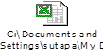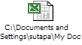

- Layout Windows
Reference | Print on page | Label Position
For ABAP | For ABAP | X :  Y :
For ABAP | For ABAP | X :  Y :
For ABAP | For ABAP | X :  Y :
For ABAP | For ABAP | X :  Y :
For ABAP | For ABAP | X :  Y :
For ABAP | For ABAP | X :  Y :
For ABAP | For ABAP | X :  Y :

- Field Mapping
Field | Field Description | Functionality | Logic | Print on page | Font | Font Format | Window
For ABAP | For ABAP | For ABAP | For ABAP | For ABAP | For ABAP | For ABAP | For ABAP
For ABAP | For ABAP | For ABAP | For ABAP | For ABAP | For ABAP | For ABAP | For ABAP

- Standard Texts / Text Modules
Reference | Text | Print on page | Label Position | Font | Output Format | Font Format
For ABAP | For ABAP | For ABAP | For ABAP | For ABAP | For ABAP | For ABAP
For ABAP | For ABAP | For ABAP | For ABAP | For ABAP | For ABAP | For ABAP

- Translation
Reference | Description of use (in Language1) | Description of use (in Language2) | Description of use (in Language3) | Text Module Name | Notes
For ABAP | For ABAP | For ABAP | For ABAP | For ABAP | For ABAP
For ABAP | For ABAP | For ABAP | For ABAP | For ABAP | For ABAP

- Layout Details
Position of Left Margin  (specify unit) | For ABAP
Position of Right Margin  (specify unit) | For ABAP
Position of Logo  (specify unit) | For ABAP
Logo  (specify logo) | For ABAP
Position of Main Window  (specify unit) | For ABAP

- Flow logic

- Authorization

No | Business Catalog | Authorization Parameter | Parameter Value
TBD | TBD | TBD | TBD
TBD | TBD | TBD | TBD

- Fiori Application
- Header Information
Application Title | For ABAP
Application ID | For ABAP
Type of Enhancement | For ABAP
Development Type | For ABAP
Application Type | For ABAP
UI Enhancements | For ABAP

- Technical Reference
Object Name | Object Type | Object Description
<<< Odata Object >>> | For ABAP | For ABAP
<<< CDS View >>> | For ABAP | For ABAP
<<< Custom Fields >>> | For ABAP | For ABAP
<<< Catalogs >>> | For ABAP | For ABAP
<<< Rules >>> | For ABAP | For ABAP

- Desired Screen Design
- Technical Details
- Authorization

No | Business Catalog | Name of Space (L2) | Name of Page (L3) | Name of Section (L4) | Name of App/Tile(L5) | Authorization Parameter | Parameter Value
For ABAP | For ABAP | For ABAP | For ABAP | For ABAP | For ABAP | For ABAP | For ABAP
For ABAP | For ABAP | For ABAP | For ABAP | For ABAP | For ABAP | For ABAP | For ABAP

- Custom Tables/Structure

Table Name |  | N/A
Short text |  | N/A
Size category |  | N/A
Table maintenance allowed |  | N/A
Maintenance Type |  | Manual / Automatic Maintenance (application table)  Transportable Maintenance (customizing table)
Data class |  | N/A
Buffering |  | N/A
Table maintenance generation |  | N/A
Authorization Group |  | N/A
Change Log Enabled (Y/N)  (mandatory for GxP related table) |  | N/A
SPRO Path  (mandatory for customizing tables) |  | N/A
Field Name | Data Element | Domain | Type | Length | Check Table-Field | Key Field | Foreign Key | Description
N/A | N/A | N/A | N/A | N/A | N/A | N/A | N/A | N/A
N/A | N/A | N/A | N/A | N/A | N/A | N/A | N/A | N/A
N/A | N/A | N/A | N/A | N/A | N/A | N/A | N/A | N/A
Comments

- Error Handling

- Error Messages

- Validation
- Test Case References

