U3158894 Production Journal

Live site: <http://brandtv.sgedu.site/>

Code repository: <https://github.com/ShortyVee/CMSProject>

# Initiation and development:

During the first week working on this assessment, our team was already made so it was a matter of assigning roles to see who would work on which tasks. Originally I had expected to take on the project owner role, and develop the wireframes and sketches for how the site would look during development. However, due to time constraints this role was never assigned. Instead Ashleigh and Mickey took it upon themselves to help develop the overall look for the website.

This left starting development to be carried out by first getting a base WordPress site up on SiteGround. Brandt set this up with his own account and gave everyone admin permissions and accounts. Next was to choose a theme, we opted for the Bootstrap theme. This theme was set up in our Git repository for everyone to clone and then start developing on their local machines.

During the first set of development tasks, I wanted to understand how to change the parent theme rather than creating a child theme. This wasn’t easy as I haven’t dived into Bootstrap or WordPress in such depth. However, after some time playing around with Chrome Dev Tools it was clear enough that targeting existing Bootstrap in the custom CSS file given by the template, allows us to add our own styles and override the ones used by Bootstrap.

During this phase the Trello board was being used to keep track of individual tickets. The use of sprints was planned for, however not followed very well. The team’s schedules didn’t allow for weekly meetings about sprints, so following the mythology behind scrum and sprints wasn’t achieved well.

Specific development tasks I underwent were making a mandatory footer with the information we needed to provide, however the footer didn’t fit our needs aesthetically, so Ashleigh and Mickey took over the development of the footer. I aided in the CSS fixes necessary for it to work with the rest of the sites content and then styled it to match the existing content.

Then the later development processes I underwent were to create the Index page, fill it with the necessary content and do the same to the about page. This was done using the plugin (Elementor) and adding my own custom styles to our CSS file. The custom styles target the Elementor elements specific to our Dev site, so working locally was to test the visual representation of those widgets rather than the final code.

# Testing / Lessons learned:

Testing was a matter of looking online for tutorials abut WordPress and pushing code to our master branch on Git to see what changes would take effect. It’s not the method I had planned on, as I set up the Trello board in the hopes that most items would be reviewed before being pushed to our live site. Despite this the main issues with development work is the way in which content is saved for WordPress. Since it’s using a database, importing and exporting content when it was worked on locally between the team made it tedious to work on. Eventually I started to just add content to the live site and then style it locally, so I could push that code to master for the team.

What I’ve learned from this is structuring workloads between group members, would be the best option. Unfortunately for us, we weren’t able to follow this. The way we had worked on this project was hindered by our individual schedules, so it became a matter of asking for help when needed, and checking up with group members on progress over Facebook.

This leads to needing set goals and tasks for each group member in order for each of us to know what content we could be missing, and who might be able to explain where and why it’s missing. For example, our News page has a widget displaying some posts. This pages widget had changed without anyone knowing when or why. If we had assigned more specific work with regular updates reflected somewhere like Trello or GitHub, it would have been much easier to track down where the problem came from and potentially revert it.

# Finishing up

Overall the amount of work put in by each team member was a nice change of pace compared to some project work. Although we are all strapped for time, the sites final progression and development was an interesting task to take on. Content Management Systems are heavily adopted by Government agencies and working on this project has helped further my interests and knowledge into the development of these types of websites.

# Development Scrum board screen shot:

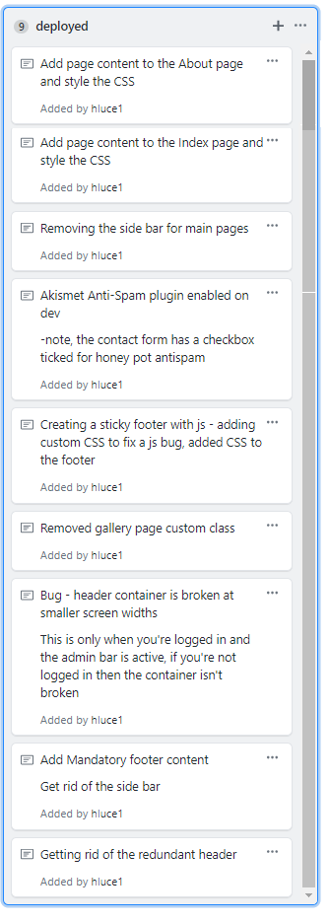

* Other work carried out can be found on our Trello page: <https://trello.com/b/8lum7bmf/11085-cms>
* And out GitHub repository commits:

<https://github.com/ShortyVee/CMSProject/commits/master>