SYMBIOSIS INSTITUTE OF TECHNOLOGY PUNE

Maharashtra Works Tender Explorer
  - Database Concepts for Data Science Mini Project Report
A Python application using MySQL and MongoDB
Course detail | Value
Course | Database Concepts for Data Science
Course code | TEE7423
Department | Artificial Intelligence and Machine Learning
Semester and batch | Semester III, Batch 2025-2029
Report snapshot | 12 October 2026

Prepared for team review and completion before submission

Project Summary
We built a Python and Streamlit application for browsing a reviewed snapshot of Maharashtra works tenders. MySQL stores the fields needed for filtering, sorting, joins and summaries. MongoDB stores flexible source details for the same tender. The application joins the two views through a source-prefixed key, so a listing selected from MySQL can retrieve its matching MongoDB document. [3]
The accepted workbook set contains 1,572 official records. The final check confirmed that MySQL, MongoDB and the source import plan contain the same keys and shared field values. The live database-mode dashboard displayed 1,572 matching tenders, INR 2,886.86 crore in reported estimates and estimate coverage for 1,332 of 1,572 tenders. Missing estimates remain NULL. These are published estimates, not award values or actual spending. [4][5]

Project Background
Tender notices combine structured listing fields, such as identifiers, categories, dates and estimates, with less uniform details such as work scope, eligibility, document references and corrigendum status. A single flat table would make source-specific details harder to manage, while a collection alone would make relational grouping and foreign-key checks less direct. This project uses both database models and presents them through one local dashboard.

Objectives and Course Alignment
The course outcomes cover DBMS concepts and schema design, SQL languages, normalization, and MongoDB operations. The saved lab ESE rubric maps the miniproject to CO1 through CO5 and evaluates application functionality, Python implementation, database integration, advanced queries, documentation and testing. [1][2]
Course area | Project evidence | Boundary
CO1 - DBMS and relational design | Separate categories, locations and tenders; primary keys, foreign keys and a schema diagram. | The project demonstrates a practical model; it does not claim a formal proof of every normal form.
CO2 - SQL | SQL schema, importer writes, joins, grouping, a subquery and HAVING output. | Saved query examples show retrieval and aggregation; a DCL demonstration is not included.
CO3 - Normalization | Reusable category and location rows reduce repeated labels in tender records. | The report describes the implemented separation without claiming a complete normalization proof.
CO4 - MongoDB | Document retrieval, category aggregation and temporary create/read/update/delete operations. | The temporary CRUD document was removed after the demonstration.
CO5 - Lab rubric mapping | The saved lab rubric maps the miniproject to CO5. | The supplied course-outcome sheet states CO1-CO4 only; confirm the CO5 wording before final submission.

Project Scope and Data
The import source is the reviewed MahaTenders workbook snapshot dated 11 October 2026. It contains 1,619 unique Tender Log IDs: 1,574 official records and 45 third-party rows. Two official rows remain held because their detail-page evidence is incomplete, so 1,572 official records were accepted into the database. Third-party rows marked Include? = No were excluded from this official import. [4]
The repository also includes a 129-record Tender247 category-listing sample for offline demonstration. Those records are a fallback dataset, not official notice details. The application does not depend on live portal scraping during a demo. The reviewed workbook and raw source captures remain outside the repository because the original material may contain session-bearing portal links. [3][4]

System Requirements and User Flow
- Load the reviewed workbook through a plan that accepts only included rows with required fields and exact captured official detail URLs; hold incomplete rows for review.
- Normalize money, dates, source IDs and category values while preserving missing values and source provenance.
- Write shared listing fields to MySQL and matching source-specific details to MongoDB using the same source-prefixed key.
- Let the user filter by category and source-reported location, search by title, location or source record ID, and optionally limit results by closing date; show counts, estimate summaries, a compact table and selected tender details.
- Offer sample mode as an offline fallback and database mode for records loaded into both local databases.
The dashboard reads filterable listing fields from MySQL. When the user selects a tender, it uses that tender key to retrieve the corresponding MongoDB document. Database mode includes a manual refresh for the cached listing and detail data. The checker compares both key sets, shared values and, when given the workbook, the expected import plan. [3]

Database Design

Shared Record Identity
The original source ID is retained in source_record_id. A namespaced tender_key prevents an ID from one source from colliding with an ID from another. MySQL stores this value as the tenders primary key, and MongoDB uses the identical string as the document _id.
Source | Original ID example | Shared key
MahaTenders | 2026_NMC_1342575_23 | mahatenders:2026_NMC_1342575_23
Tender247 sample | 104833153 | tender247:104833153

MySQL Relational Schema
The relational schema has three tables. categories and locations store unique lookup names. tenders stores each listing and references those lookup tables through foreign keys. The tender key is unique; a second unique constraint covers source_type with source_record_id. Estimated value and EMD use DECIMAL(18,2), and missing values stay NULL. [3][6]
Table | Purpose and key fields
categories | category_id primary key; unique category name.
locations | location_id primary key; unique location name.
tenders | tender_key primary key; source ID/type; title; category and location foreign keys; dates; estimated value; EMD; source URL.

MongoDB Document Model
The tender_details collection keeps one document for each shared tender key. A document repeats the fields needed to identify and check the listing, then adds source-specific details such as department, work scope, eligibility, document references and status snapshot. Collection validation checks required fields and types, and a unique index protects the source_type and source_record_id pair. Flexible detail fields can be missing when the source did not provide them. [3]
MySQL cannot create a foreign key into MongoDB. The project therefore checks the one-to-one relationship with a reconciliation command that verifies source-derived keys and shared field values across both stores and the workbook plan. [3]

Implementation
Component | Role
app.py | Streamlit mode selection, category/location filters, title/location/source-ID search, metrics, compact table, privacy-filtered source link and detail view.
tender_explorer/normalize.py | Validate sample data, map workbook rows, normalize values and create shared keys/documents.
tender_explorer/load_data.py | Prepare import plans, choose deterministic pilot rows and write accepted records.
tender_explorer/database.py | Connect to MySQL and MongoDB; create/check schema and read/write records.
tender_explorer/check_data.py | Compare source-derived keys and shared values across source plan, MySQL and MongoDB.
sql/schema.sql and sql/queries.sql | Relational DDL and three SQL retrieval examples.
tender_explorer/mongo_queries.py | MongoDB document operations and category aggregation.

The local database ports bind to loopback, and passwords are kept in an ignored .env file. The app can use Sample data without database services. On the local setup used for verification, MySQL 8.4.9 and MongoDB 7.0.28 ran as portable user processes. [5]

Database Query Demonstrations

SQL Examples
The first SQL query joins tenders to categories and groups counts and total estimated values. It returned 8 categories. The second query selects estimates above the average of non-NULL estimates and returned 75 tenders. The third query joins locations, groups source-reported labels and uses HAVING COUNT(*) >= 3; it returned 113 labels. Those location values are source labels and are not all verified district names. [5][6]
SELECT c.name AS category, COUNT(*) AS tender_count,
SUM(t.estimated_value_inr) AS total_estimated_value_inr
FROM tenders AS t
JOIN categories AS c ON c.category_id = t.category_id
GROUP BY c.category_id, c.name
ORDER BY tender_count DESC;
MongoDB examples read one imported document by its _id and count documents by category with an aggregation pipeline. A separate schema-valid demo document exercised create, read, update and delete. The final lookup confirmed that the temporary document was absent; no imported tender was changed or deleted. [5]

Results and Verification
Check | Observed result
Unit tests | 7 of 7 tests passed on 12 October 2026 after the current normalization and database changes.
Repeatable pilot | The deterministic 25-record official pilot was imported twice and reconciled after each import.
Full import | 1,572 MySQL tenders, 1,572 MongoDB documents and 1,572 expected source-plan rows.
Final reconciliation | Both stores matched the source plan; shared fields and source-derived keys agreed.
Dashboard mode | 1,572 matching tenders; INR 2,886.86 crore reported estimates; estimate coverage 1,332 of 1,572.
Missing estimates | 240 records have no reported estimate; the database keeps those values NULL.
SQL results | 8 category groups; 75 above-average estimates; 113 source-reported location labels meeting HAVING COUNT(*) >= 3.
MongoDB results | 8 category groups; imported document read passed; temporary CRUD create/read/update/delete and final absence check passed.

All values describe the reviewed workbook snapshot used for the import. They should be recomputed if the workbook changes. An estimate is a published tender estimate; it is not evidence of a contract award or public spending. [4][5]

Application Evidence
The embedded images show database mode, imported-record metrics, the category chart and MongoDB-backed scope and eligibility. They were captured before the 12 October UI refinement and should be refreshed before final submission. The current app adds location filtering and source-ID search and provides a host-checked source link with query strings and fragments removed; the full captured URL remains in the local database. [5]
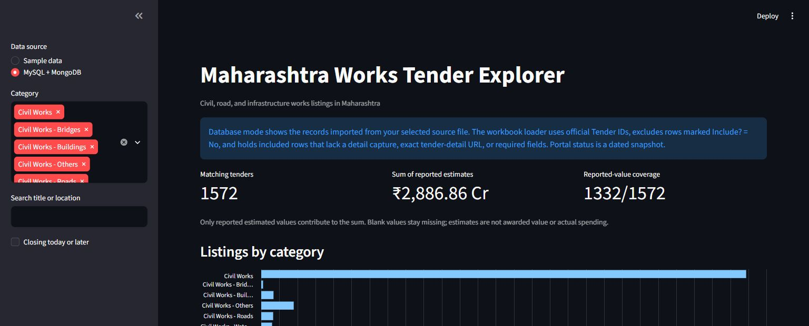
Figure 1. Dashboard overview in database mode.
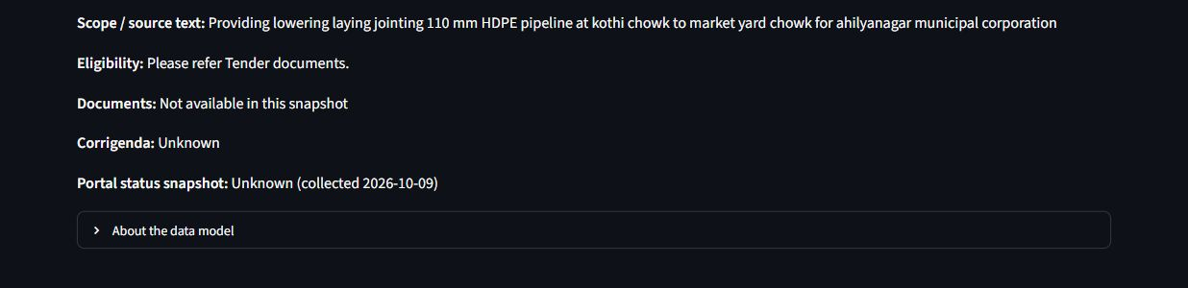
Figure 2. Source-specific details displayed for a selected tender.

Limitations
- The application uses a reviewed snapshot. It does not scrape a live portal during the demonstration, and portal deadlines or status can change after capture.
- Two included official rows were held because exact detail-page evidence was missing. They were not loaded. The 45 third-party workbook rows marked No were not part of the official import.
- The Tender247 sample contains category listings, not complete official notices. Its records do not prove eligibility, corrigenda, bids, awards or actual spending.
- Some location labels are not standardized geographic names. The SQL output counts source-reported labels; further data review is needed before presenting every label as a district.
- The reviewed workbook and raw captures are held outside the repository. A fresh clone cannot independently reproduce the official workbook import without access to those source files.
- The saved lab rubric marks its 26 to 30 October 2026 ESE window as tentative and the supplied materials do not state a report template. Confirm the current format, schedule and CO5 wording before final submission. [1][2]

Conclusion
The project demonstrates a local tender-browsing workflow that uses relational tables for structured filtering and SQL analysis, MongoDB documents for flexible details, and a Streamlit interface to connect the two. The full accepted source set was imported and reconciled, the saved SQL and MongoDB examples ran, and the dashboard was checked in database mode. The main remaining submission work is to confirm course-specific requirements, add team details and prepare the final report package and rehearsal.

References
[1] Department of Artificial Intelligence and Machine Learning, Database Concepts for Data Science Course Outcomes, TEE7423, course material file DCDS COs.pdf.
[2] Department of Artificial Intelligence and Machine Learning, DCDS Lab ESE Rubrics, Detailed Evaluation Plan, Batch 2025-2029, course material file DCDSL Evaluation Plan_with detailed rubrics.pdf.
[3] DCDS-Project, docs/ARCHITECTURE.md and docs/DATA_SOURCES.md, current project design and source-handling notes, accessed 12 October 2026.
[4] Reviewed MahaTenders workbook, 01_CURRENT_Maharashtra_Works_TenderBook_Reviewed_2026-10-11.xlsx, locally retained source snapshot outside the repository.
[5] DCDS-Project, docs/WORK_LOG.md and docs/evidence/database_demo_outputs_2026-10-12.md, recorded checks and sanitized query outputs, 12 October 2026.
[6] DCDS-Project, sql/schema.sql and sql/queries.sql, relational schema and SQL examples, accessed 12 October 2026.

