Experiment/Practical 12 Project /Case Study on Classification
1. Title
A comparison of three supervised models for classifying UNSW-NB15 network flows
2. Aim
I aim to classify the prepared UNSW-NB15 flow records as normal traffic or attacks. I compare three standard machine-learning models on the same data and look at both missed attacks and false alarms.
3. Problem Statement
A network flow is a summary of traffic between computers. In the prepared UNSW-NB15 data, each flow has a label: 0 means normal traffic and 1 means an attack. In this case study, I check whether common supervised-learning models can learn this difference from the flow fields.
I used the published training and testing CSV files. I compared Logistic Regression, Random Forest and Histogram Gradient Boosting, with a simple Dummy model as a reference. The models predict a label for each complete, prepared flow record. I did not test them on a live network or measure whether they could detect an attack while a flow was still in progress [8, 9].
4. Literature Work
4.1 Scope of the review
I focused this review on five recent journal studies related to the choices in this case study: model selection, the information included in each flow, class imbalance, and how results are tested. This is a focused review for a lab report, not a complete review of intrusion-detection research. I checked the papers using publisher pages or accessible full-text copies. For Mohiuddin et al. [4], I could check only the accessible publisher material, so I do not use its detailed results as a direct comparison.
In the tables, I summarize each paper's reference, data and task, method, main finding, contribution, limitation and the gap it leaves for this project. I treat scores as comparable only when the target, input fields, data split and metric are also similar.
4.2 Five journal papers
Table 1. Maseno, Sun and Wang (2026) [1]: points used in this review
Field | Notes from the paper
Reference | Journal of Computer Virology and Hacking Techniques, 22, article 80. DOI: 10.1007/s11416-026-00664-7.
Dataset and task | UNSW-NB15 and IoT-ToN. Normal versus attack is a binary task; the official UNSW train and test files are retained.
Method | Logistic Regression, Random Forest and XGBoost. Settings are selected on training data with five-fold validation. The authors also test whether SHAP explanations stay reliable.
Main finding | Random Forest and XGBoost have similar held-out UNSW results. A high detection score does not by itself make a feature explanation dependable.
Contribution | The paper adds several checks for explanation reliability instead of stopping at prediction scores.
Paper limitation | Its main question is explanation quality. Its feature cleaning, model search and XGBoost are different from the fixed flow-field comparison in this project.
Research gap here | A small, transparent comparison of fixed models on the same prepared fields, with repeated input vectors considered in validation and actual false alarms reported.

Maseno et al. [1] came closest to the binary model comparison I carried out. Their use of the official UNSW test file helped me plan my evaluation. I did not treat their F1 scores as a target to beat because their features, preprocessing and model-selection steps differ from mine.
Table 2. Kiflay and colleagues (2024) [2]: points used in this review
Field | Notes from the paper
Reference | Array, 22, article 100349. DOI: 10.1016/j.array.2024.100349.
Dataset and task | UNSW-NB15, using prepared flow information together with payloads taken from raw packet captures. Binary and multiclass results are discussed.
Method | One Random Forest uses six flow fields; a second uses the first 32 payload bytes. Their probability outputs are combined by soft voting.
Main finding | In the authors’ tested sample, combining the two kinds of information performed better than either single-view model.
Contribution | It shows why the information given to a model can matter as much as the model family.
Paper limitation | Matching payloads to flows removes records without usable payload and filters traffic. Its evaluated rows and split are different from the prepared CSV pair I used.
Research gap here | State clearly what a flow-only classifier can do with the available CSV fields, without suggesting that it has inspected packet contents.

I did not use packet-payload bytes as model inputs. Kiflay et al. [2] helped me describe this boundary, but their reported detection rate is not directly comparable with my results.
Table 3. Pospíchal and colleagues (2026) [3]: points used in this review
Field | Notes from the paper
Reference | Information, 17(9), article 836. DOI: 10.3390/info17090836.
Dataset and task | UNSW-NB15, but as five separate attack-versus-normal problems: DoS, Exploit, Backdoor, Analysis and Reconnaissance. Other attack families are removed from each task.
Method | Random Forest with feature selection, parameter and threshold choices, and versions using SMOTE to balance classes.
Main finding | The effect of balancing varies by attack family. More attack detections can also bring more false alarms; SMOTE is not automatically helpful.
Contribution | The paper makes class-specific errors and the choice of decision threshold visible.
Paper limitation | Its tasks are narrower than normal versus all supplied attacks. It also uses part of the official test partition for threshold validation before a final subset is scored.
Research gap here | Report both missed attacks and false alarms for one mixed binary task on the full official test file, without threshold tuning on that file.

Pospíchal et al. [3] reminded me that accuracy by itself can hide different types of mistakes. In my experiment, I grouped all supplied attack families into one positive class. Their F1 values answer a different question from my macro-F1, so I do not compare them as if the tasks were the same.
Table 4. Mohiuddin and colleagues (2023) [4]: points used in this review
Field | Notes from the paper
Reference | Expert Systems with Applications, 232, article 120596. DOI: 10.1016/j.eswa.2023.120596.
Dataset and task | The publisher description includes UNSW-NB15 and a CICIDS dataset in intrusion-detection experiments.
Method | A wrapper search based on Whale and Sine-Cosine methods chooses features, followed by a weighted XGBoost classifier.
Main finding | The accessible abstract and highlights present the combined feature-search and weighted-boosting method as useful for intrusion detection.
Contribution | It studies feature selection and class weighting together with boosting.
Paper limitation | The complete methods and result tables were not accessible in this review. The publisher material does not let us verify one exact UNSW binary score, split and feature list.
Research gap here | Use a stated 42-field feature set and fixed model settings so the classroom result can be traced to saved data and code, without claiming to reproduce the paper.

Mohiuddin et al. [4] use a more complex approach than I use in this case study. I did not use their feature search or XGBoost. Because I could check only the publisher material that was available, I have not treated its headline accuracy as a verified UNSW binary result.
Table 5. Telikani and colleagues (2024 issue; online 2023) [5]: points used in this review
Field | Notes from the paper
Reference | IEEE Transactions on Industrial Informatics, 20(3), pages 3880–3890. DOI: 10.1109/TII.2023.3314208.
Dataset and task | UNSW-NB15 and BoT-IoT. The study pays attention to rare attack categories and a test where an attack type is withheld from training.
Method | A stacked autoencoder learns features, then cost-sensitive SVM tasks share information. In the UNSW unknown-attack experiment, Exploits is removed from training.
Main finding | Rare groups remain difficult; the paper reports noticeable errors for Backdoor and Worms. Its unknown-attack setup asks a harder question than ordinary binary testing.
Contribution | It combines class-sensitive training with an explicit test of an attack category not shown during training.
Paper limitation | Its category-level objective, 80/10/10 split and deep/SVM pipeline differ from the official binary split I used. Some summary metrics differ between sections of the paper.
Research gap here | In this project, I classify normal and attack records using the binary label supplied with UNSW-NB15. I have not tested an attack family held out from training.

Telikani et al. [5] helped me keep one limitation clear: good results on known labels do not show that a model can detect an attack type it never saw during training. I did not repeat their withheld-category experiment or use their deep model.
4.3 What the papers show together
The five papers answer different questions. Maseno et al. [1] and Mohiuddin et al. [4] change the model and, in different ways, the features or selection process. Kiflay et al. [2] add packet payloads, while Pospíchal et al. [3] and Telikani et al. [5] handle attack classes and errors differently. Those choices can affect the reported scores. To keep my comparison consistent, I used the same 42 input fields for the learned models and scored all four models on the official test file.
The papers also use different definitions of an attack. Pospíchal et al. [3] test five attack families one by one. Telikani et al. [5] train without one attack type and then test on it. In my project, all attack families in the supplied binary label are grouped together. These are different tasks, so comparing the papers' headline F1 scores with mine would be misleading.
I also used two papers that discuss how models should be evaluated. Apruzzese et al. [6] study testing across different intrusion datasets, and Viegas et al. [7] discuss changes in network traffic over time. Their work helped me keep my conclusion narrow: my score comes from one UNSW test set. It does not show how the model would work on another organisation's network or at a later time.
4.4 Research gap and place of this case study
This project does not propose a new detector. I compare one simple model with two tree-based models using the same fields, one validation holdout that keeps identical input vectors together, and the official test file. The literature review led me to three choices: leave out fields that reveal the answer, report both kinds of error, and explain what the test results do and do not show.
5. Objectives
• Check the published flow data and prepare inputs without using the row ID or the attack category as predictors.
• Compare Logistic Regression, Random Forest and Histogram Gradient Boosting using the same train, validation and test boundaries.
• Explain the results using class-aware metrics and confusion counts, with particular attention to missed attacks and false alarms.
6. Methodology
6.1 Data preparation and split
I used the CSV column label as the target y, with 1 meaning an attack. The input X contains the other 42 flow fields. I left out id because it identifies a row rather than measuring traffic, and I left out attack_cat because it gives the known attack family. The 42 input fields include 39 numeric fields and three text categories: proto, service and state. I kept the source value “-” in service as a category instead of treating it as missing.
The audit found no empty or invalid predictor values in either prepared file. I standardised numeric values for Logistic Regression because the fields use different scales, and left numeric values unchanged for the two tree models. I used one-hot encoding for the text categories and kept encoding and scaling inside each training pipeline, so those steps learned from fitting rows only. I did not need to fill missing values or resample the data.
Many rows have the same 42 predictor values. To keep identical vectors from appearing on both sides of the fit/validation split, I used a fixed-seed split from the first fold of StratifiedGroupKFold. It gave me 140,274 fitting rows and 35,067 validation rows, with no shared predictor groups between them. The splitter can produce five folds, but I used only its first fold as a holdout. The validation scores are not five-fold averages.
6.2 Steps followed
• I checked both source CSV files against the saved file sizes, row counts and SHA-256 hashes, then read the labels and predictor columns.
• I built X from the 42 allowed fields and y from label, then checked the numeric values and category entries.
• I grouped identical predictor vectors and used one fixed-seed split to create fitting and validation sets.
• I fitted a Dummy reference and the three classifiers. Each model's preprocessing was fitted on the fitting rows only.
• I recorded the validation metrics, then fitted each model again with the same settings using all 175,341 official training rows.
• I predicted labels for all 82,332 official test rows once and saved the metrics, confusion matrices and graphs.
• I also ran a secondary check on test rows whose full predictor vector did not appear in the training file.
I chose settings that were manageable for this comparison. I did not search for the best parameters or adjust a decision threshold after checking the test results. Random seed 42 makes the split and the models' random choices repeatable.
6.3 Models and key settings
Model | What it does in this report | Fixed setting
Dummy | Uses the training class proportion as a simple reference; it learns no flow pattern. | Training-prior strategy.
Logistic Regression | A linear probability model that gives a basic learned comparison. | C = 1; balanced class weights; up to 500 iterations.
Random Forest | Combines many decision trees trained on different samples and feature choices. | 150 trees; maximum depth 20; minimum 2 rows per leaf; balanced subsample weights.
Histogram Gradient Boosting | Adds small trees one after another to improve earlier predictions. | 100 iterations; learning rate 0.1; at most 31 leaves; minimum 20 rows per leaf; balanced weights; early stopping off.

For Logistic Regression, p = 1 / (1 + exp(-(b + w·x))). The equation shows how a linear score becomes an estimated attack probability. In a Random Forest, each tree estimates class probabilities and the model averages them before choosing a class. In boosting, each new tree adjusts the current score: new score = old score + learning rate × new tree output. These equations give the main idea; scikit-learn does the model fitting.
6.4 How performance was measured
I read the confusion matrix using four counts: TP is an attack correctly flagged, FN is a missed attack, FP is a normal flow flagged as an attack, and TN is a normal flow correctly recognised. These counts make it easier for me to explain what each score represents.
Measure | Calculation or meaning | Why it is included
Accuracy | (TP + TN) / all test rows | Overall fraction of correct labels.
Attack precision | TP / (TP + FP) | Of the alerts, how many were attacks? Low precision means more false alarms.
Attack recall | TP / (TP + FN) | Of the attacks, how many were found? Low recall means more misses.
Attack F1 | 2 × precision × recall / (precision + recall) | Combines attack precision and recall.
Macro-F1 | Average of normal F1 and attack F1 | Gives the two classes equal weight.
Balanced accuracy | Average of normal recall and attack recall | Checks both classes even when counts differ.
ROC-AUC | Ranking score over possible thresholds | Shows how well attack scores separate the classes, apart from the fixed prediction rule.

I did not rely on accuracy alone because it can hide important errors. The Dummy model predicted attack for every test row. That gave it 100% attack recall, but it also flagged all 37,000 normal rows. For this reason, I read macro-F1, attack precision and recall, and the confusion counts together.
7. Implementation
7.1 Tools and libraries used
I ran the saved experiment with Python 3.12.10, pandas 3.0.6, NumPy 2.5.3, scikit-learn 1.9.1 and Matplotlib 3.11.2. Pandas and NumPy handle the flow table and checks; scikit-learn provides the preprocessing pipelines, split, models and metrics; Matplotlib makes the two result figures. I read the source CSV files without editing them.
I saved the project audit in scripts/audit_unsw_nb15.py. The model results in this report come from the dated source snapshot at reports/runs/20261014-022808-214-models/source/train_unsw_nb15_models.py. The working copy of the training script has changed since that run, so I traced the reported numbers to the archived source and its saved outputs. The dated run also contains the JSON results and execution notes.
7.2 Data and input
I used the prepared training and testing CSV files published by UNSW Canberra: https://research.unsw.edu.au/projects/unsw-nb15-dataset [8, 9]. The dataset creators describe normal activity and synthetic attack behaviour from a cyber-range setting. I used their prepared CSV files rather than extracting new records from raw PCAP files.
Prepared file | Normal | Attack | Total rows | Use
Training | 56,000 | 119,341 | 175,341 | Model fitting and internal validation
Testing | 37,000 | 45,332 | 82,332 | Final evaluation

Each prepared file has 45 columns: 42 predictors, the binary label, attack_cat and id. The data audit found 8,541 official test rows with a predictor vector also found in training; 296 of those rows have a label that conflicts with a matched training vector. This check is diagnostic and does not prove that the full published split is invalid. For the secondary result below, I removed the matched rows only to show performance on test vectors not seen in training.
7.3 Saved project evidence
I saved the data checks, full metrics and confusion counts in reports/unsw_nb15_data_audit.md and reports/unsw_nb15_model_results.md. The dated run folder also contains the source snapshot, settings, input hashes and generated outputs. The audit records the full SHA-256 hashes so I can identify the exact prepared CSV files used.
8. Results and Insights
8.1 Internal validation
On the single grouped holdout from the official training set, the macro-F1 scores were 0.9225 for Logistic Regression, 0.9437 for Random Forest and 0.9428 for boosting. Random Forest was slightly ahead on this split. The difference is small, and because I used one holdout, I cannot tell whether this ordering would stay the same across other splits.
8.2 Official test results
Table 8. Scores on all 82,332 rows of the official prepared test file
Model | Accuracy | Macro-F1 | Attack precision | Attack recall | ROC-AUC
Dummy | 0.5506 | 0.3551 | 0.5506 | 1.0000 | 0.5000
Logistic Regression | 0.8353 | 0.8292 | 0.8020 | 0.9306 | 0.9560
Random Forest | 0.9036 | 0.9008 | 0.8678 | 0.9731 | 0.9848
Histogram Boosting | 0.9102 | 0.9080 | 0.8818 | 0.9665 | 0.9855

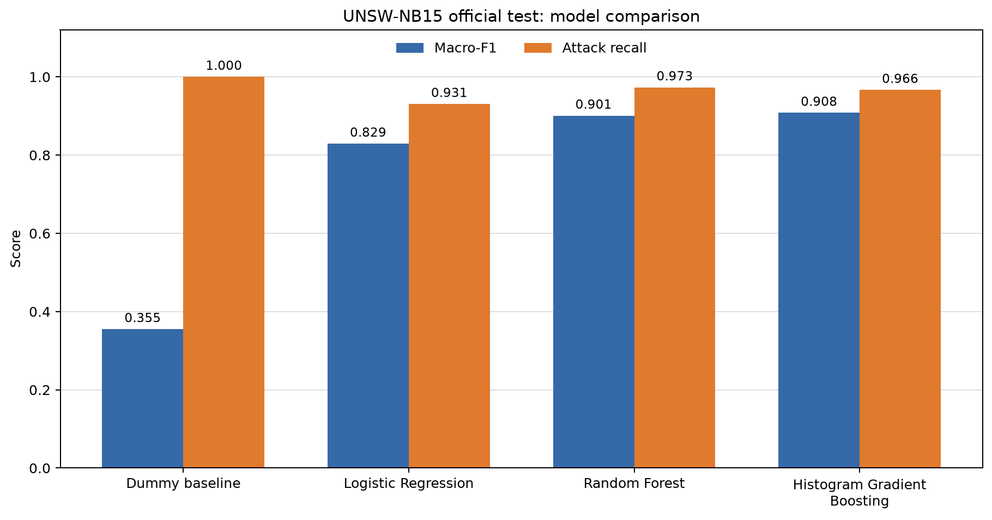
Figure 1. Official-test macro-F1 and attack recall for the four models (saved run output).
On the official test file, both tree-based models scored above Logistic Regression. Histogram Gradient Boosting had the highest macro-F1 (0.9080) and accuracy (91.02%). Random Forest found a slightly larger share of attacks: its recall was 0.9731, compared with 0.9665 for boosting. I see this as a trade-off rather than a clear winner because each model made a different number of missed attacks and false alarms.
8.3 Reading the errors
Table 9. Actual mistakes made by the two leading models on the official test file
Model | Missed attacks (FN) | False alarms (FP) | Correct attacks (TP) | Correct normal (TN)
Random Forest | 1,221 | 6,719 | 44,111 | 30,281
Histogram Boosting | 1,520 | 5,874 | 43,812 | 31,126

Random Forest found 299 more attacks than boosting, but it also raised 845 more false alarms. Boosting flagged 5,874 of the 37,000 normal flows (15.88%); Random Forest flagged 6,719 (18.16%). These are sizeable false-alarm rates, even though both models have good overall scores. I would choose between the models only after deciding how much a false alarm costs compared with a missed attack. This project did not set those costs, so I cannot recommend one model for a real network.
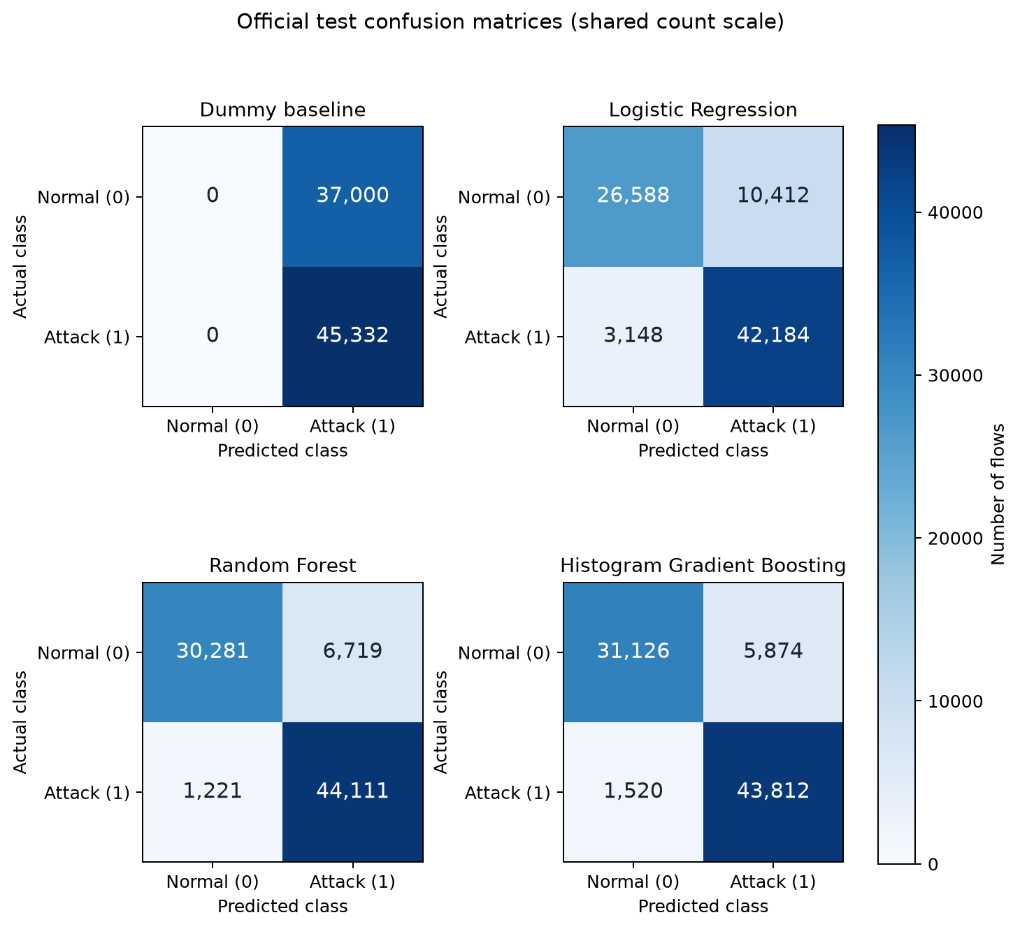
Figure 2. Official-test confusion matrices, with actual labels in rows and predicted labels in columns (saved run output).
8.4 Secondary check and limits of the result
I also checked the 73,791 test rows whose 42-field predictor vector did not appear in training. Their macro-F1 scores were 0.8200 for Logistic Regression, 0.8973 for Random Forest and 0.9048 for boosting. This is a subset of the same official test file, not a new dataset. “Unseen vector” means a new combination of the supplied values; it does not mean an unknown attack family.
My validation split kept identical predictor vectors from appearing on both the fitting and validation sides, but I did not separate the captures by host, day or session. The test data come from a controlled dataset with synthetic attacks. I used one validation holdout, fixed model settings and no threshold search, and I had no later network capture for testing. These limits mean the results support a comparison on this benchmark, not a claim that the model is ready to deploy as an intrusion detector [6, 7].
9. Conclusion
In this case study, I compared models that classify the prepared UNSW-NB15 records as normal or attack. On the official test file, Histogram Gradient Boosting had the highest observed macro-F1 (0.9080), while Random Forest found 299 more attacks and raised 845 more false alarms. The Dummy result helped me see why recall alone would give an incomplete picture. Using the same 42 fields for the learned models and reporting the confusion counts made the comparison easier to explain.
I can draw only a limited conclusion from these results: they compare the models on this published test split. I did not test live or early-flow detection, another network, or an attack family withheld from training.
10. Future Scope
If I continue this work, I would repeat the group-aware validation over several folds and report how much the scores vary. I would also define the relative cost of missed attacks and false alarms before choosing a decision threshold, using training-side data for that choice. Another useful check would be to compare errors by attack category after prediction, without giving attack_cat to the models. Finally, I would need a later or independent network capture to see how well the results transfer beyond this benchmark. I would save results for each extension before making a stronger claim.
References
[1] Maseno, E. M., Sun, Y., & Wang, Z. (2026). Reliability auditing of explanations for machine-learning-based intrusion detection systems. Journal of Computer Virology and Hacking Techniques, 22, article 80. https://doi.org/10.1007/s11416-026-00664-7
[2] Kiflay, A., Tsokanos, A., Fazlali, M., & Kirner, R. (2024). Network intrusion detection leveraging multimodal features. Array, 22, 100349. https://doi.org/10.1016/j.array.2024.100349
[3] Pospíchal, J., Augustín, A., Huraj, L., Střelec, P., & Gabriška, D. (2026). Random Forest-Based Network Intrusion Detection with Feature Selection and Class Balancing on UNSW-NB15 Traffic. Information, 17(9), 836. https://doi.org/10.3390/info17090836
[4] Mohiuddin, G., Lin, Z., Zheng, J., Wu, J., Li, W., Fang, Y., Wang, S., Chen, J., & Zeng, X. (2023). Intrusion Detection using hybridized Meta-heuristic techniques with Weighted XGBoost Classifier. Expert Systems with Applications, 232, 120596. https://doi.org/10.1016/j.eswa.2023.120596
[5] Telikani, A., Rudbardeh, N. E., Soleymanpour, S., Shahbahrami, A., Shen, J., Gaydadjiev, G., & Hassanpour, R. (2024). A Cost-Sensitive Machine Learning Model With Multitask Learning for Intrusion Detection in IoT. IEEE Transactions on Industrial Informatics, 20(3), 3880–3890. https://doi.org/10.1109/TII.2023.3314208
[6] Apruzzese, G., Pajola, L., & Conti, M. (2022). The Cross-evaluation of Machine Learning-based Network Intrusion Detection Systems. IEEE Transactions on Network and Service Management, 19(4), 5152–5169. https://doi.org/10.1109/TNSM.2022.3157344
[7] Viegas, E. K., Santin, A. O., & Tedeschi, P. (2023). Toward a Reliable Evaluation of Machine Learning Schemes for Network-Based Intrusion Detection. IEEE Internet of Things Magazine, 6(2), 70–75. https://doi.org/10.1109/IOTM.001.2300106
[8] Moustafa, N., & Slay, J. (2015). UNSW-NB15: a comprehensive data set for network intrusion detection systems. Military Communications and Information Systems Conference. https://doi.org/10.1109/MILCIS.2015.7348942
[9] Moustafa, N., & Slay, J. (2016). The evaluation of Network Anomaly Detection Systems: Statistical analysis of the UNSW-NB15 data set and the comparison with the KDD99 data set. Information Security Journal: A Global Perspective, 25(1–3), 18–31. https://doi.org/10.1080/19393555.2015.1125974

