Experiment/Practical 12 Project /Case Study on Classification
1. Title
A comparison of three supervised models for classifying UNSW-NB15 network flows
2. Aim
To classify the prepared UNSW-NB15 flow records as normal or attack, compare three standard machine learning models on the same data, and study both missed attacks and false alarms.
3. Problem Statement
A network flow is a record that summarises traffic between computers. The UNSW-NB15 dataset gives each prepared flow a label: 0 for normal traffic and 1 for an attack. The question in this case study is whether common supervised learning methods can learn this difference from the supplied flow fields.
The project uses the published training and testing CSV files. It compares Logistic Regression, Random Forest and Histogram Gradient Boosting, with a simple Dummy model as a reference. The experiment predicts labels for complete, prepared records. It does not run on a live network or show how quickly an attack could be detected while a flow is still in progress [8, 9].
4. Literature Work
4.1 Scope of the review
This review considers five recent journal studies that use UNSW-NB15 and raise questions close to this case study: model choice, the information available in a flow, class imbalance, and the way results are tested. This is a focused review for a lab report, not a claim to have found every paper on intrusion detection. The papers were read through the publisher pages or accessible full-text copies. For Mohiuddin et al. [4], only the accessible publisher material could be checked, so its detailed result is not used as a direct comparison.
The tables record the reference, data and task, method, contribution, useful finding, limitation and research gap for this project. Each table also explains why the paper matters to this project. A published percentage is only comparable if the target, input fields, split and metric are also the same.
4.2 Five journal papers
Table 1. Maseno, Sun and Wang (2026) [1]: points used in this review
Field | Notes from the paper
Reference | Journal of Computer Virology and Hacking Techniques, 22, article 80. DOI: 10.1007/s11416-026-00664-7.
Dataset and task | UNSW-NB15 and IoT-ToN. Normal versus attack is a binary task; the official UNSW train and test files are retained.
Method | Logistic Regression, Random Forest and XGBoost. Settings are selected on training data with five-fold validation. The authors also test whether SHAP explanations stay reliable.
Main finding | Random Forest and XGBoost have similar held-out UNSW results. A high detection score does not by itself make a feature explanation dependable.
Contribution | The paper adds several checks for explanation reliability instead of stopping at prediction scores.
Paper limitation | Its main question is explanation quality. Its feature cleaning, model search and XGBoost are different from our fixed flow-field comparison.
Research gap here | A small, transparent comparison of fixed models on the same prepared fields, with repeated input vectors considered in validation and actual false alarms reported.

This is the closest of the five studies to our binary model comparison. Its treatment of the official test file is useful for planning our evaluation. Its F1 values are not a target to beat: the features, preprocessing and selection procedure differ from ours [1].
Table 2. Kiflay and colleagues (2024) [2]: points used in this review
Field | Notes from the paper
Reference | Array, 22, article 100349. DOI: 10.1016/j.array.2024.100349.
Dataset and task | UNSW-NB15, using prepared flow information together with payloads taken from raw packet captures. Binary and multiclass results are discussed.
Method | One Random Forest uses six flow fields; a second uses the first 32 payload bytes. Their probability outputs are combined by soft voting.
Main finding | In the authors’ tested sample, combining the two kinds of information performed better than either single-view model.
Contribution | It shows why the information given to a model can matter as much as the model family.
Paper limitation | Matching payloads to flows removes records without usable payload and filters traffic. Its evaluated rows and split are different from our prepared CSV pair.
Research gap here | State clearly what a flow-only classifier can do with the available CSV fields, without suggesting that it has inspected packet contents.

Our models never read packet payload bytes. Kiflay et al. therefore help explain the boundary of our inputs, but their reported detection rate is not a fair score comparison with this project [2].
Table 3. Pospíchal and colleagues (2026) [3]: points used in this review
Field | Notes from the paper
Reference | Information, 17(9), article 836. DOI: 10.3390/info17090836.
Dataset and task | UNSW-NB15, but as five separate attack-versus-normal problems: DoS, Exploit, Backdoor, Analysis and Reconnaissance. Other attack families are removed from each task.
Method | Random Forest with feature selection, parameter and threshold choices, and versions using SMOTE to balance classes.
Main finding | The effect of balancing varies by attack family. More attack detections can also bring more false alarms; SMOTE is not automatically helpful.
Contribution | The paper makes class-specific errors and the choice of decision threshold visible.
Paper limitation | Its tasks are narrower than normal versus all supplied attacks. It also uses part of the official test partition for threshold validation before a final subset is scored.
Research gap here | Report both missed attacks and false alarms for one mixed binary task on the full official test file, without threshold tuning on that file.

This paper is useful because a single accuracy figure can hide different error costs. Our experiment keeps all supplied attack families in one positive class, so its F1 figures cannot be placed next to our macro-F1 as if the questions were identical [3].
Table 4. Mohiuddin and colleagues (2023) [4]: points used in this review
Field | Notes from the paper
Reference | Expert Systems with Applications, 232, article 120596. DOI: 10.1016/j.eswa.2023.120596.
Dataset and task | The publisher description includes UNSW-NB15 and a CICIDS dataset in intrusion-detection experiments.
Method | A wrapper search based on Whale and Sine-Cosine methods chooses features, followed by a weighted XGBoost classifier.
Main finding | The accessible abstract and highlights present the combined feature-search and weighted-boosting method as useful for intrusion detection.
Contribution | It studies feature selection and class weighting together with boosting.
Paper limitation | The complete methods and result tables were not accessible in this review. The publisher material does not let us verify one exact UNSW binary score, split and feature list.
Research gap here | Use a stated 42-field feature set and fixed model settings so the classroom result can be traced to saved data and code, without claiming to reproduce the paper.

Mohiuddin et al. show a more complex route than this case study. We did not use their feature search or XGBoost. Since the detailed UNSW procedure could not be checked from the accessible material, this report does not repeat a headline accuracy [4].
Table 5. Telikani and colleagues (2024 issue; online 2023) [5]: points used in this review
Field | Notes from the paper
Reference | IEEE Transactions on Industrial Informatics, 20(3), pages 3880–3890. DOI: 10.1109/TII.2023.3314208.
Dataset and task | UNSW-NB15 and BoT-IoT. The study pays attention to rare attack categories and a test where an attack type is withheld from training.
Method | A stacked autoencoder learns features, then cost-sensitive SVM tasks share information. In the UNSW unknown-attack experiment, Exploits is removed from training.
Main finding | Rare groups remain difficult; the paper reports noticeable errors for Backdoor and Worms. Its unknown-attack setup asks a harder question than ordinary binary testing.
Contribution | It combines class-sensitive training with an explicit test of an attack category not shown during training.
Paper limitation | Its category-level objective, 80/10/10 split and deep/SVM pipeline differ from our official binary split. Some summary metrics differ between sections of the paper.
Research gap here | Keep the claim about our result narrow: we classify the benchmark’s supplied known attack labels and have not tested a held-out attack family.

Telikani et al. are a reminder that good results on known labels do not prove unknown-attack detection. This project does not repeat their withheld-category experiment or their deep model [5].
4.3 What the papers show together
The five papers answer different questions. Maseno et al. [1] and Mohiuddin et al. [4] change the model and, in different ways, the feature or selection process. Kiflay et al. [2] change the information available by adding payloads. Pospíchal et al. [3] and Telikani et al. [5] change how attack classes and their errors are treated. Each choice can change a reported score. This is why this report holds the 42 input fields and the official test file fixed while comparing models.
The studies also differ in their meaning of “attack.” Pospíchal et al. [3] test one attack family at a time; Telikani et al. [5] deliberately hide one during training; our project groups every attack in the supplied binary label. Those are three different questions. Comparing their headline F1 numbers would give a misleading impression of which approach works best.
Two further evaluation papers support a limit on our conclusion. Apruzzese et al. [6] study testing across different intrusion datasets, and Viegas et al. [7] discuss how network traffic can change over time. Their point is relevant here: one official UNSW test result is evidence for this benchmark, not proof that the same model would work equally well in another organisation or at a later date.
4.4 Research gap and place of this case study
This project does not claim a new detector. It gives a clear comparison of a simple model and two tree models using the same fields, one group-aware validation holdout, and the official test. The review led to three decisions: remove fields that reveal the answer, report both kinds of error, and state what the test results do and do not show.
5. Objectives
• Check the published flow data and prepare inputs without using the row ID or the attack category as predictors.
• Compare Logistic Regression, Random Forest and Histogram Gradient Boosting using the same train, validation and test boundaries.
• Explain the results using class-aware metrics and confusion counts, with particular attention to missed attacks and false alarms.
6. Methodology
6.1 Data preparation and split
The target y is the CSV column label, where 1 means attack. The input X contains 42 other flow fields. The row identifier id is not a traffic measurement, and attack_cat names the known attack family, so both are excluded before any model is fitted. The 42 fields consist of 39 numeric fields and three text categories: proto, service and state. The source token “-” in service is kept as a category, not treated as a missing value.
The audit found no empty or invalid predictor values in the two prepared files. For Logistic Regression, numeric values are standardised because the fields use very different scales. The two tree models keep the numeric values as supplied. Text categories are one-hot encoded for each model. Encoding and scaling are placed inside training pipelines, so they learn their values from fitting rows only. No missing-value filling or resampling was needed.
Many rows have exactly the same 42 predictor values. A first, fixed-seed split from StratifiedGroupKFold keeps each identical predictor vector on only one side of the internal fit/validation boundary. This produced 140,274 fit rows and 35,067 validation rows, with zero shared exact predictor groups. Although the splitter has five possible folds, only its first fold was used as a holdout. These are not five-fold average results.
6.2 Steps followed
• Check both source CSV files against the saved sizes, row counts and SHA-256 hashes; read the labels and predictor columns.
• Create X from the 42 allowed fields and y from label; check numeric values and category entries.
• Group identical predictor vectors, then take one fixed-seed training-side fit/validation split.
• Fit a Dummy reference and the three chosen classifiers. Preprocessing is fitted inside each model pipeline on fit rows only.
• Record validation metrics. Fit each unchanged model setting again on all 175,341 official training rows.
• Predict the 82,332 official test rows once and save metrics, confusion matrices and graphs.
• As a secondary check, score the test rows whose full predictor vector did not appear in training.
The model settings were chosen as manageable starting settings. The run did not search for the best parameters or change a decision threshold after looking at test results. Random seed 42 makes the split and the models’ random choices repeatable.
6.3 Models and key settings
Model | What it does in this report | Fixed setting
Dummy | Uses the training class proportion as a simple reference; it learns no flow pattern. | Training-prior strategy.
Logistic Regression | A linear probability model that gives a basic learned comparison. | C = 1; balanced class weights; up to 500 iterations.
Random Forest | Combines many decision trees trained on different samples and feature choices. | 150 trees; maximum depth 20; minimum 2 rows per leaf; balanced subsample weights.
Histogram Gradient Boosting | Adds small trees one after another to improve earlier predictions. | 100 iterations; learning rate 0.1; at most 31 leaves; minimum 20 rows per leaf; balanced weights; early stopping off.

For Logistic Regression, the attack probability is p = 1 / (1 + exp(-(b + w·x))). A larger linear score gives a larger estimated attack probability. Random Forest averages class probabilities from its trees before choosing a class. For boosting, each new tree adjusts the current score: new score = old score + learning rate × new tree output. These equations describe the model ideas; the library performs the fitting.
6.4 How performance was measured
In the confusion matrix, TP is an attack correctly flagged, FN is a missed attack, FP is a normal flow flagged as an attack, and TN is a correctly recognised normal flow. These four counts help explain a score in ordinary terms.
Measure | Calculation or meaning | Why it is included
Accuracy | (TP + TN) / all test rows | Overall fraction of correct labels.
Attack precision | TP / (TP + FP) | Of the alerts, how many were attacks? Low precision means more false alarms.
Attack recall | TP / (TP + FN) | Of the attacks, how many were found? Low recall means more misses.
Attack F1 | 2 × precision × recall / (precision + recall) | Combines attack precision and recall.
Macro-F1 | Average of normal F1 and attack F1 | Gives the two classes equal weight.
Balanced accuracy | Average of normal recall and attack recall | Checks both classes even when counts differ.
ROC-AUC | Ranking score over possible thresholds | Shows how well attack scores separate the classes, apart from the fixed prediction rule.

Accuracy alone could be misleading. The Dummy reference labels every test row as an attack: it has 100% attack recall but wrongly flags all 37,000 normal test flows. For this reason the results section reads macro-F1, attack precision and recall, and the actual confusion counts together.
7. Implementation
7.1 Tools and libraries used
The saved successful run used Python 3.12.10, pandas 3.0.6, NumPy 2.5.3, scikit-learn 1.9.1 and Matplotlib 3.11.2. Pandas and NumPy handle the flow table and checks; scikit-learn supplies the preprocessing pipelines, split, models and metrics; Matplotlib produces the two result figures. The source CSVs were read without editing them.
The project audit is in scripts/audit_unsw_nb15.py. The model results cited here came from the dated source snapshot at reports/runs/20261014-022808-214-models/source/train_unsw_nb15_models.py. The working copy of the script has changed since that run. The numbers in this report therefore refer to the archived source and its saved outputs. The dated run also contains JSON results and execution notes.
7.2 Data and input
The source is the UNSW-NB15 dataset published by UNSW Canberra: https://research.unsw.edu.au/projects/unsw-nb15-dataset [8, 9]. The creators describe normal activity and synthetic attack behaviour from a cyber-range setting. This project uses their prepared training and testing CSV pair rather than extracting new records from raw PCAP files.
Prepared file | Normal | Attack | Total rows | Use
Training | 56,000 | 119,341 | 175,341 | Model fitting and internal validation
Testing | 37,000 | 45,332 | 82,332 | Final evaluation

Each file has 45 columns: 42 predictors, the binary label, attack_cat and id. The data audit found 8,541 official test rows with a predictor vector also found in the training file; 296 of these rows have a label conflicting with a matched training vector. These figures are diagnostic, not proof that the whole published split is invalid. The separate unseen-vector result below removes the matched rows only for a secondary view.
7.3 Saved project evidence
The files reports/unsw_nb15_data_audit.md and reports/unsw_nb15_model_results.md contain the data checks, full metrics and confusion counts. The dated run folder also stores the source snapshot, settings, input hashes and generated outputs. The audit lists the full SHA-256 hashes, which identify the exact prepared CSV files used.
8. Results and Insights
8.1 Internal validation
On the one grouped holdout from the official training set, the macro-F1 scores were 0.9225 for Logistic Regression, 0.9437 for Random Forest and 0.9428 for boosting. Random Forest was slightly ahead on this holdout. The difference is small, and one split cannot tell us whether this ordering would stay the same on many other splits.
8.2 Official test results
Table 8. Scores on all 82,332 rows of the official prepared test file
Model | Accuracy | Macro-F1 | Attack precision | Attack recall | ROC-AUC
Dummy | 0.5506 | 0.3551 | 0.5506 | 1.0000 | 0.5000
Logistic Regression | 0.8353 | 0.8292 | 0.8020 | 0.9306 | 0.9560
Random Forest | 0.9036 | 0.9008 | 0.8678 | 0.9731 | 0.9848
Histogram Boosting | 0.9102 | 0.9080 | 0.8818 | 0.9665 | 0.9855

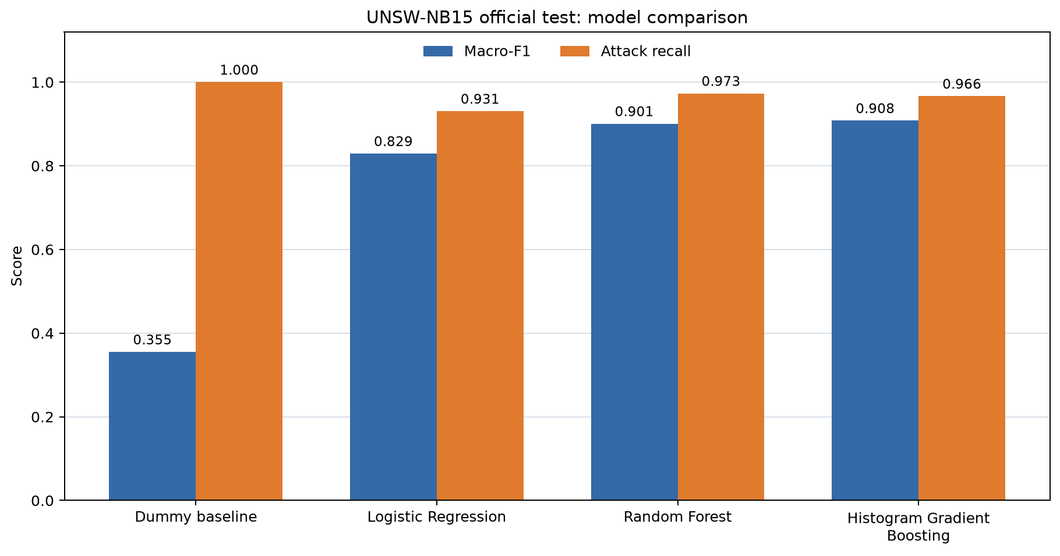
Figure 1. Official-test macro-F1 and attack recall for the four models (saved run output).
Both tree-based models scored above Logistic Regression on this test file. Boosting had the highest macro-F1 (0.9080) and accuracy (91.02%). Random Forest found a slightly larger share of attacks: recall 0.9731 compared with 0.9665 for boosting. This is a trade-off, not a simple winner in every measure.
8.3 Reading the errors
Table 9. Actual mistakes made by the two leading models on the official test file
Model | Missed attacks (FN) | False alarms (FP) | Correct attacks (TP) | Correct normal (TN)
Random Forest | 1,221 | 6,719 | 44,111 | 30,281
Histogram Boosting | 1,520 | 5,874 | 43,812 | 31,126

Random Forest detected 299 more attacks than boosting, but it also raised 845 more false alarms. Boosting incorrectly flagged 5,874 of 37,000 normal flows, or 15.88%. Random Forest incorrectly flagged 6,719, or 18.16%. These are sizeable false-alarm rates even though both models have good overall scores. Which model to prefer would depend on the cost of investigating an alert compared with missing an attack; this project did not set such a cost.
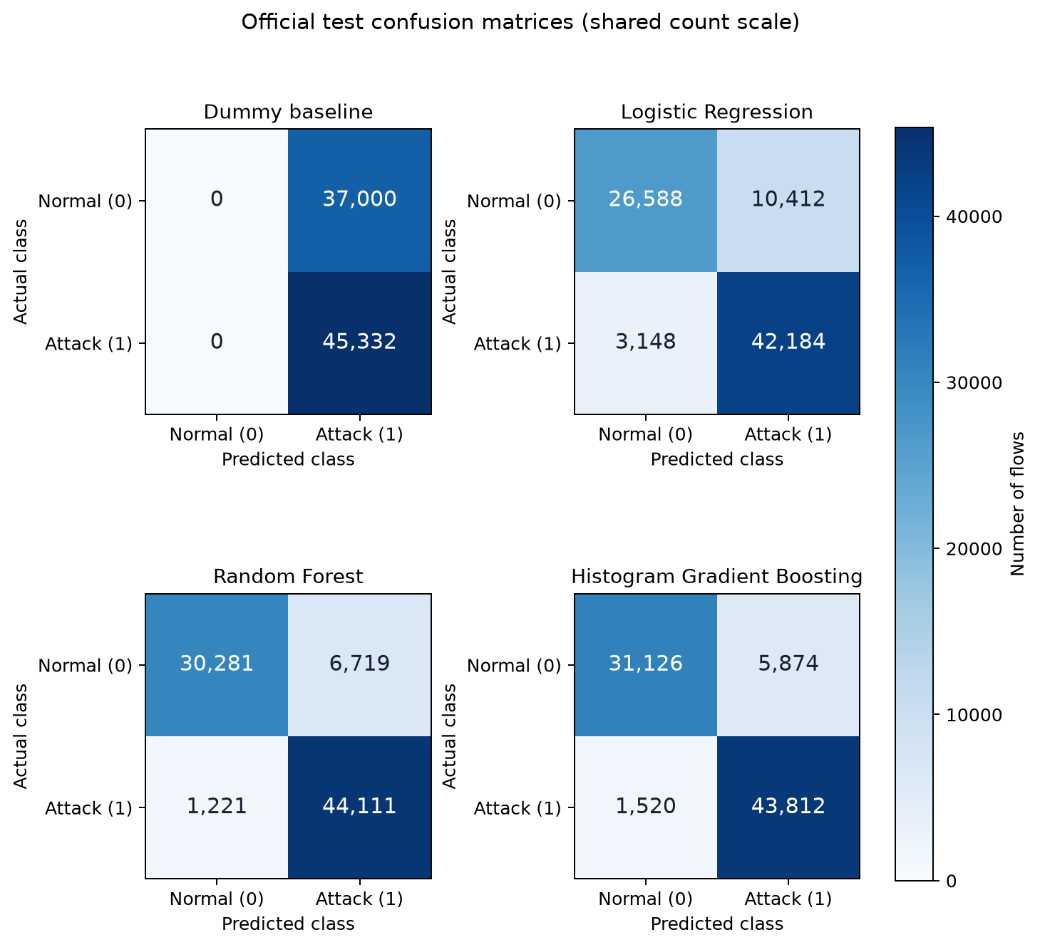
Figure 2. Official-test confusion matrices, with actual labels in rows and predicted labels in columns (saved run output).
8.4 Secondary check and limits of the result
For the 73,791 test rows whose 42-field predictor vector did not appear in training, macro-F1 was 0.8200 for Logistic Regression, 0.8973 for Random Forest and 0.9048 for boosting. This is a subset of the same official test file, not a new dataset. “Unseen vector” means a new combination of the supplied values; it does not mean an unknown attack family.
The internal split prevents exact input vectors from appearing on both fit and validation sides, but it does not separate captures by host, day or session. The test data come from a controlled dataset with synthetic attacks. We also have one grouped holdout, fixed settings, no threshold search and no later network capture. The numbers therefore support a comparison on this benchmark, not a claim of a ready-to-deploy intrusion detector [6, 7].
9. Conclusion
The case study completed a binary normal-versus-attack comparison on the prepared UNSW-NB15 training and test files. On the official test file, Histogram Gradient Boosting had the best observed macro-F1 of 0.9080, while Random Forest found 299 more attacks and caused 845 more false alarms. The Dummy result shows why recall or accuracy alone would give an incomplete picture. Keeping the same 42 fields for the learned models and reporting their actual error counts made the comparison easier to explain.
These results answer a limited question about this published test split. They do not show live detection, early-flow detection, performance on another network or detection of an attack family held out from training.
10. Future Scope
A next experiment could repeat group-aware validation over several folds and report the variation in scores. A separate training-side study could choose a decision threshold after defining the relative cost of missed attacks and false alarms. Error counts could also be examined by attack category after prediction, without feeding attack_cat into the model. Finally, a later or independent network capture would be needed to test transfer beyond this benchmark. Each extension would need its own saved results before making a stronger claim.
References
[1] Maseno, E. M., Sun, Y., & Wang, Z. (2026). Reliability auditing of explanations for machine-learning-based intrusion detection systems. Journal of Computer Virology and Hacking Techniques, 22, article 80. https://doi.org/10.1007/s11416-026-00664-7
[2] Kiflay, A., Tsokanos, A., Fazlali, M., & Kirner, R. (2024). Network intrusion detection leveraging multimodal features. Array, 22, 100349. https://doi.org/10.1016/j.array.2024.100349
[3] Pospíchal, J., Augustín, A., Huraj, L., Střelec, P., & Gabriška, D. (2026). Random Forest-Based Network Intrusion Detection with Feature Selection and Class Balancing on UNSW-NB15 Traffic. Information, 17(9), 836. https://doi.org/10.3390/info17090836
[4] Mohiuddin, G., Lin, Z., Zheng, J., Wu, J., Li, W., Fang, Y., Wang, S., Chen, J., & Zeng, X. (2023). Intrusion Detection using hybridized Meta-heuristic techniques with Weighted XGBoost Classifier. Expert Systems with Applications, 232, 120596. https://doi.org/10.1016/j.eswa.2023.120596
[5] Telikani, A., Rudbardeh, N. E., Soleymanpour, S., Shahbahrami, A., Shen, J., Gaydadjiev, G., & Hassanpour, R. (2024). A Cost-Sensitive Machine Learning Model With Multitask Learning for Intrusion Detection in IoT. IEEE Transactions on Industrial Informatics, 20(3), 3880–3890. https://doi.org/10.1109/TII.2023.3314208
[6] Apruzzese, G., Pajola, L., & Conti, M. (2022). The Cross-evaluation of Machine Learning-based Network Intrusion Detection Systems. IEEE Transactions on Network and Service Management, 19(4), 5152–5169. https://doi.org/10.1109/TNSM.2022.3157344
[7] Viegas, E. K., Santin, A. O., & Tedeschi, P. (2023). Toward a Reliable Evaluation of Machine Learning Schemes for Network-Based Intrusion Detection. IEEE Internet of Things Magazine, 6(2), 70–75. https://doi.org/10.1109/IOTM.001.2300106
[8] Moustafa, N., & Slay, J. (2015). UNSW-NB15: a comprehensive data set for network intrusion detection systems. Military Communications and Information Systems Conference. https://doi.org/10.1109/MILCIS.2015.7348942
[9] Moustafa, N., & Slay, J. (2016). The evaluation of Network Anomaly Detection Systems: Statistical analysis of the UNSW-NB15 data set and the comparison with the KDD99 data set. Information Security Journal: A Global Perspective, 25(1–3), 18–31. https://doi.org/10.1080/19393555.2015.1125974

