Dispute Integrity Gate / FECL

CARVE: Cost-aware, Risk-controlled Financial Evidence Verification

STATUS  Implemented synthetic research prototype |  | OWNER  Dispute Integrity Gate team |  | LAST UPDATED  September 2, 2026

Authors | Dispute Integrity Gate team
Reviewers | Razorpay AI Buildathon judges; fintech risk and ML reviewers
Related docs | docs/00-SOURCE-OF-TRUTH.md; docs/05-PRD.md; docs/06-SRS.md; CARVE research paper
Scope | Read-only refund-not-processed financial evidence consistency verification

1. Abstract
CARVE is a defense-only verifier for refund/credit-not-processed disputes. It turns untrusted communication into exact grounded claims, reconciles those claims against authoritative payment/refund state, compiles supported financial invariants, and returns PASS, REVIEW, or a provenance-grounded BLOCK certificate.
The synthetic research system supports interactive evidence import, deliberate failure cases, active acquisition of missing authoritative evidence, replayable artifacts, and human repair. It does not submit disputes, move money, predict dispute wins, claim production prevalence, or let learned models override deterministic truth.

2. Goals and Non-Goals
Goals | Non-goals
Ground every learned claim to an exact source span | Predict dispute wins or legal validity
Keep authoritative financial invariants outside models | Automate accept, contest, refund, or payment actions
Measure false-PASS exposure and safe abstention | Claim production performance from synthetic data
Make evidence acquisition and repair auditable | Support every dispute reason, language, document, or network

3. Background and Problem Statement
Refund disputes can contain plausible but mutually inconsistent emails, refund exports, amounts, references, currencies, and timestamps. Generic summaries obscure causality; manual checking is slow; and missing evidence can be mistaken for absence. The narrow loss is merchant exposure caused by submitting internally inconsistent evidence.
The boundary is a read-only merchant-side pre-submission gate. Evidence ingestion and semantic extraction are untrusted. Immutable structured state and compiled invariants own financial truth. Unsupported, OOD, malformed, incomplete, or unavailable inputs fail closed to REVIEW.

4. Proposed Architecture

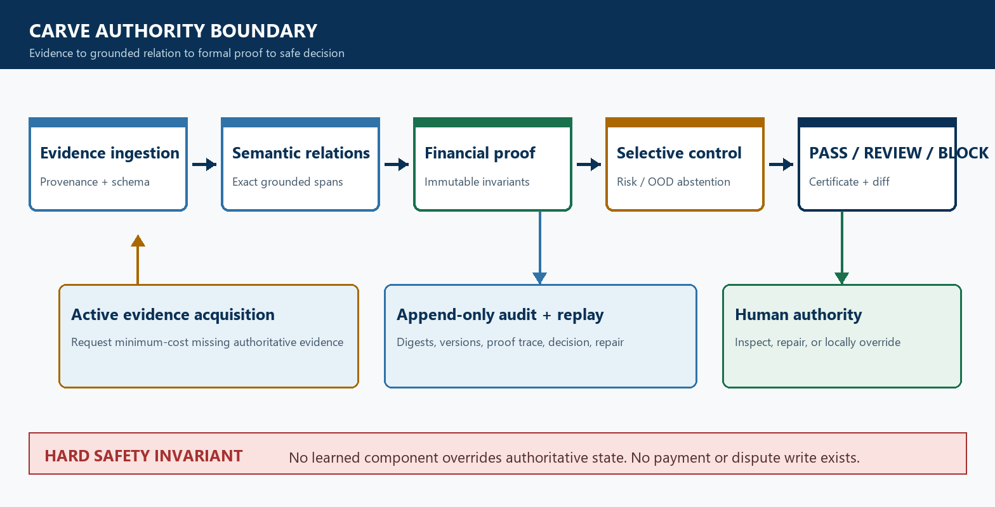
Figure 1. CARVE authority boundary and evidence-to-decision flow.

Core components

Component | Responsibility | Primary storage | Failure behavior
Evidence ingestion/provenance | Validate bounded input, identifiers, digests, and source metadata | Ephemeral request plus append-only local audit | Malformed or unsupported input returns REVIEW/rejection
Semantic relation extractor | Nominate typed claims with exact source quotes and spans | Frozen model artifact plus versioned schema | Outage, ungrounded output, or OOD returns REVIEW
Deterministic verifier/proof compiler | Reconcile amounts, references, currency, state, and time; emit certificate | Authoritative snapshot plus constraint trace | Incomplete state returns REVIEW; proven conflict returns BLOCK
Residual risk/selective controller | Compare frozen research candidates and abstain under unsupported risk | Model/calibration artifacts | Cannot override hard truth; invalid certificate returns REVIEW
Evidence acquisition/audit UI | Request minimum supported missing evidence; show repair and decision diff | Local sample bundles and artifact hashes | No network or money write; acquisition failure remains REVIEW

5. Request Lifecycle
- 1. A synthetic case bundle or local JSON/TXT input enters the evidence boundary with provenance metadata.
- 2. Schema, money precision, source type, digest, scope, and exact-span grounding are validated.
- 3. The reason profile, authoritative payment/refund snapshot, frozen model artifacts, and risk policy are loaded by version and digest.
- 4. The semantic layer nominates typed relations; deterministic reconciliation and the proof compiler decide whether supported constraints are SAT, UNSAT, or INCOMPLETE.
- 5. The run digest, grounded spans, constraint trace, decision, acquisition request, and certificate are appended to local audit output before analyst handoff.
- 6. If evidence is incomplete, CARVE requests the minimum-cost supported evidence item. Timeouts, outages, OOD inputs, or invalid artifacts terminate in REVIEW.
- 7. The UI renders the exact evidence, decision authority, before/after repair diff, and zero-network-write boundary; generated metrics remain isolated under /evaluation and /research.

6. API and Data Contracts

Primary data contract

Field | Type | Required | Description
raw_reason_code | string | Yes | Preserved verbatim; bounded to the supported local reason profile
customer_communication | string | Yes | Untrusted semantic source; exact quotes and offsets required
payment_amount_inr | decimal string | Yes | Parsed deterministically into integer minor units
refund_ledger_complete | boolean | Yes | Controls whether absence can be treated as authoritative
refund_status | enum | Yes | Local refund lifecycle state; never inferred by a model
refund_amount_inr | decimal string/null | Conditional | Required when a refund record exists; at most 2 decimals
simulation | enum | No | Bounded failure injection for local model-outage testing

Contract guarantees

- Every decision-relevant semantic claim must be schema-valid and resolve to an exact source span before deterministic verification.
- Runs use content digests and stable case/evidence identifiers; local replays are idempotent and perform no external financial action.
- Dataset, split, model, threshold, calibration, code, request, evidence, proof, and result digests are captured for audit and replay.
- Learned scores are advisory residual-risk evidence only; authoritative payment/refund state and failed financial invariants remain the source of truth.
Versioned contracts are maintained in backend/app/carve.py, backend/app/sandbox_api.py, and data/financial-evidence-integrity/v4.5/.
Any schema or supported-relation change requires an explicit benchmark version bump and a new freeze protocol.

7. Consistency, Idempotency, and Replay

Evidence digests protect identity relative to recorded content, not source authenticity. Family-grouped splits keep causal pairs together. The frozen TEST receipt prevents reruns after threshold selection. Duplicate local runs produce stable request digests; partial proof state is REVIEW, never an inferred PASS.
Scenario | Expected behavior | Reasoning
Duplicate local request | Stable request digest; repeatable result; no side effect | The sandbox is ephemeral and read-only
Missing authoritative refund export | REVIEW plus REQUEST_REFUND_EXPORT cost 1 | Missing state cannot prove agreement or contradiction
Model outage, OOD, or malformed semantics | REVIEW or input rejection; never PASS | Degraded semantics cannot silently clear the gate
Artifact or policy changes during execution | Use the frozen version/digest captured at run start | Mid-run authority changes would break replayability

8. Security and Privacy Considerations

- Webhook ingestion uses raw-body HMAC and event identifiers; the live research instrument accepts only bounded local synthetic inputs.
- Evidence text is treated as untrusted and remains local in the demo; logs must exclude secrets and avoid claiming full de-identification.
- Models receive no payment credentials, database credentials, write tools, or unrestricted network access.
- Replay, debugging, and acquisition default to read-only behavior; malformed artifacts, digest failures, and provider outages route to REVIEW.
- Production retention, deletion, residency, tenant isolation, and consent policy remain deployment prerequisites and are not claimed by the synthetic prototype.

9. Operational Readiness
Signal | SLO or alert | Owner | Launch gate
False-PASS count and rupee exposure | 0 on frozen synthetic TEST; production target NOT YET MEASURED | Risk/ML | Required
End-to-end latency | Artifact-backed p50/p95 reported; production SLO NOT YET MEASURED | ML platform | Required before production
REVIEW, outage, and OOD rate | Slice and trend monitoring; production thresholds NOT YET MEASURED | Risk operations | Required before shadow launch
Dataset/model/policy drift | Digest mismatch fails closed; drift thresholds need governed real data | Model risk | Required
Replay and certificate integrity | Every frozen release reruns integrity tests; TEST receipt remains one-shot | Engineering | Required
Rollout constraint: synthetic demo only. Real-data validation, security review, provenance integration, browser/accessibility QA, rollback rehearsal, and owner approval are required before read-only shadow deployment.

10. Alternatives Considered

Alternative | Why it was considered | Why it was not selected
Rules-only verifier | Perfect frozen financial reconciliation and simplest authority boundary | Retained as selected decision baseline, but cannot generalize semantic relation extraction alone
End-to-end LLM decision | Flexible language handling | Ungrounded outputs, calibration limits, cost, and unacceptable authority leakage
Model-stacked ensemble | Potential aggregate predictive lift | No justified lift over simpler deterministic truth and increased failure surface
Autonomous dispute agent | Could reduce operator steps | Outside defense-only scope and unsafe for consequential financial actions

11. Open Questions
- Which governed real-dispute corpus can support external validation?
- Which authoritative read surfaces can production acquisition use?
- Which prevalence and rupee cost matrix should set risk thresholds?
- Who owns model risk, incidents, drift, and override policy?

12. Decision and Next Steps
Retain deterministic proof as the decision authority and learned relations only in their measured narrow role. Next: governed real-data validation, browser/accessibility QA, and a safety-approved read-only shadow deployment.
Milestone | Deliverable | Exit criteria
M1 | Frozen synthetic CARVE and live debugger | Integrity, one-shot receipt, sample replay, and no-write gates pass
M2 | Governed real-data validation | Blind holdout, annotation agreement, intervals, and cost review pass
M3 | Read-only shadow | Provenance, monitoring, rollback, accessibility, and incident gates pass
M4 | Limited analyst pilot | Stable safety metrics, human-factors evidence, and model-risk approval

Use footnotes for definitions, assumptions, or terms that need precision without interrupting the main narrative.

