# Correlation and Regression Practice

1. For each of the following, would you expect a positive, negative, or zero correlation:
   1. the height of an individual and the number of children that he has 0
   2. the price of a house and its' size 1
   3. The height of an individual and his shoe size 1
   4. the relationship between Esav and Yaakov -1
   5. the age of an individual and his blood pressure 1
   6. how happy one is and how sad one is -1
   7. the number of children in a family and the family's wealth -1
   8. A company's advertising expenditure and its sales revenue 1
2. Draw a scatter diagram using sns.lmplot(), and compute the coefficient of correlation using .corr(). Is salary related to the number of years of schooling?

|  |  |
| --- | --- |
| Number of Years of Schooling beyond High School (x) | Salary (in thousands of dollars) (y) |
| 2 | 25 |
| 3 | 27 |
| 5 | 30 |
| 1 | 24 |
| 0 | 22 |
| 7 | 38 |
| 6 | 33 |
| 4 | 29 |

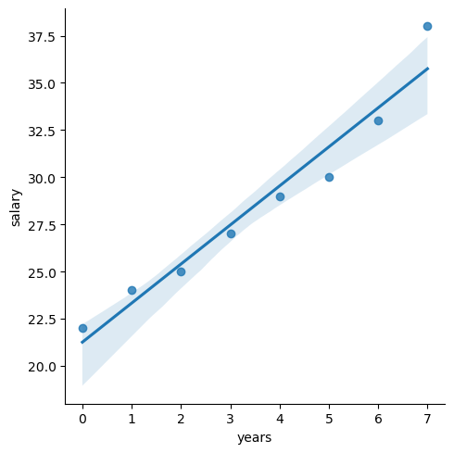

*Correlation:*

*years salary*

*years 1.000000 0.973908*

*salary 0.973908 1.000000*

3. A correlation coefficient of -0.97 :

* 1. indicates a strong negative correlation
  2. indicates a weak negative correlation.
  3. is insignificant
  4. is impossible

4. The regression equation $\hat{y}⋅=-10.86x+54.8$ could be represented by which of the following graphs?

a. b. c.

5. The regression equation $\hat{y}=5+x$ could represent which of the following scatter diagrams:

a.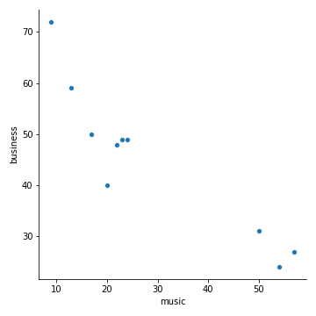b.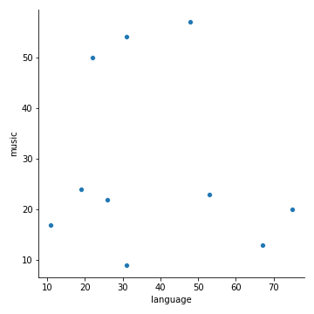c.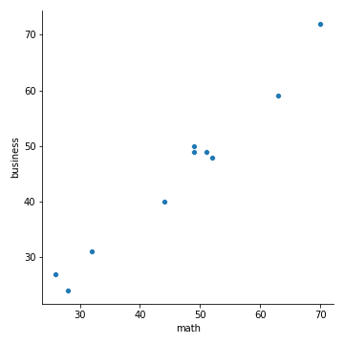

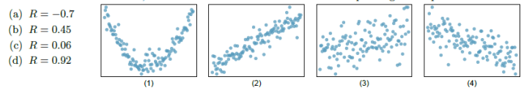6.

b d c a