Histograms and Boxplots Classwork

1. 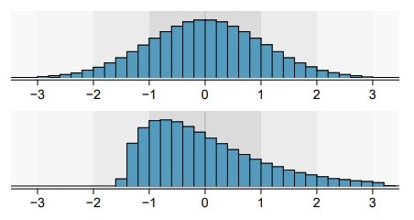Are the following histograms left skew, right skew or symmetric?

*symmetric*

*right skew*

1. Comparing Boxplots

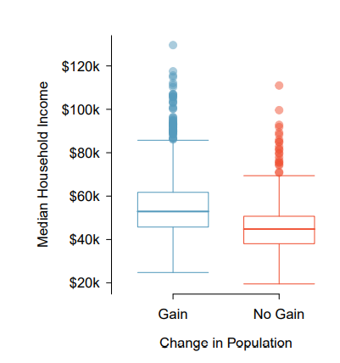

a) Find the median, lower and upper quartiles for both box plots. Use this to find the IQR.

*Gain:*

*Median: 52 | LQ: 45 | UQ: 61 | IQR: 16*

*No Gain:*

*Median: 45 | LQ: 38 | UQ: 50 | IQR: 12*

b) Which boxplot has a higher IQR? *Gain*

c) Which boxplot has a higher range? *Gain*

d) Are these box plots left skewed, right skewed or symmetric? *No gain – symmetric, gain – right skew*

(Hint: imagine drawing a histogram from the date)